AGR 235 Name: _______________________
Determine percolation rate of soil.
- Pull a core sample. Pull a core sample of the area to determine bulk density
Carefully remove the core without disturbing the soil. Measure the length (L) and Diameter (D) of the soil cylinders. Calculate its volume (V). V = 3.14 x (D/2)² x L
D = ______________cm L = __________ cm V soil = ___________ cm³
- Holes should be round and at least 6 inches, but no larger than 8 inches, in diameter. Dig each test hole 8” deep. Collect the soil you excavate to determine texture.
- Prepare the percolation test holes. The shovel is likely to smear the soil along the sidewalls of the test hole. Therefore, the sidewalls and the bottom of the hole should be scratched or scarified with a sharp, pointed instrument. Fill the hole with water, measuring the depth you begin. You will need to know how much the water level dropped (in inches) during a given measure of time (minutes).
- Record water level and time you begin.
Begin time: ___________ End time: ____________ Water Drop: ______
- Calculate percolation rate. Divide the time interval by the drop in water level to determine the percolation rate in minutes per inch (MPI). Examples:
If the drop in water level is 5/8 inch in 30 minutes, the percolation rate is 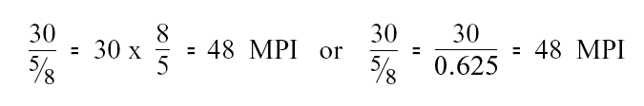
If the drop is 2 1/2 inches in 10 minutes, then the percolation rate is
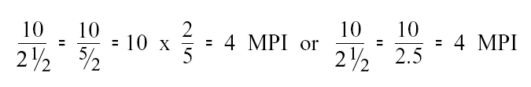
Name: ______________________
Soil | A | B
Volume

Percolation Rate

Texture

Observations:

This document is 100% funded by a $2.2 million grant from the U.S. Department of Labor, Employment and Training Administration (TAACCCT). The product was created by the grantee and does not necessarily reflect the official position of the U.S. Department of Labor. The Department of Labor makes no guarantees, warranties or assurances of any kind, express or implied, with respect to such information, including any information on linked sites and including, but not limited to, accuracy of the information or its completeness, timeliness, usefulness, adequacy, continued availability, or ownership.

This work is licensed under a Creative Commons Attribution 4.0 International License.

