Name: _______ ______________________________________________________
Date: _______________________________________________________________

Petroleum Regulations Homework
Review the Required Reading, the class power points, and Calculating Containment Size.
Answer the following. Include this sheet or the questions with your answers. Home work is due the following week from when assigned.

- Identify four things that are usually required in a SPCC Plan.
  - Location details
  - Facility diagram
  - Contact list with phone numbers
  - Inspections and tests
  - Personnel training
  - Security
  - Source control & mitigation
  - Spill volume estimating
  - Spill Prevention Countermeasures
  - Spill Prediction
  - Spill Response
  - Source control & mitigation
  - Spill volume estimating
  - Engineers Certification

- When is a SPCC Plan required?
  - When a spill could reasonably be expected to discharge oil into navigable waters of the United States or adjoining shorelines, and
  - A total aboveground storage capacity greater than 1,320 gallons (counting only containers with a capacity of 55 gallons or more), or
  - A total underground storage capacity greater than 42,000 gallons

- You had a spill into a Lake Corsicana identify four agencies you should contact and tell four things you should be able to relate to the agencies.
  - Texas Rail Road Commission
  - Texas Commission on Environmental Quality
  - National Response Center
  - Local Agencies

- Review the containment calculation handout to assist in answering the following.

Your company has just acquired in Montana the single well tank battery location depicted. You have been asked to evaluate the site for compliance to SPCC regulations. The site is approximately 250 ft. x 250 ft. in size. The site consists of 4- 400 barrel (BBL) oil tanks, 1-400 BBL produced water tank a 100 BBL heater treater, recycle pump, gas scrubber, an emergency pit flare , and an electric well jack. The 400 BBL tanks are 12 ft. Diameter by 20 ft. tall. The water tank is 12ft diameter by 20 ft. tall. The recycle pump and gas scrubber sit on 3.5 ft. tall stands. The 100 BBL vertical treater is approximately 6ft diameter by 20 ft. tall. The building associated with the treater is approximately 10 ft. by 12 ft. The site produces approximately 100 BBL of oil and 50 BBLs of water a day. Oil and water are trucked from the site daily and gas is either sold by pipeline of flared on site. The site is approximately 0.25 miles west of a creek that flows into a recreational lake. The surrounding land drains southwest. The current containment is approximately 100 ft x 30ft x 2ft tall. Use 6” rainfall event to calculate your freeboard.
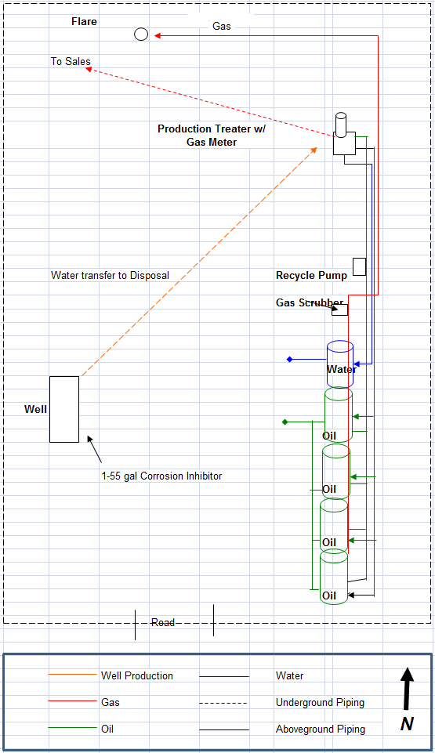

General Formulas: 1BBL= 42 gals 1 cuft = 7.48 gals Area of a circle = pi r²

  - What size tank does the containment have to hold?
    - BBLs: 400 BBL

    - CuFt : 400BBL x 42gal/BBL x 1cuft/7.48gals = 2,245.99 cuft

  - Calculate the following
    - The area taken up by the tanks. (Hint: Do not include the tank you are containing)
Area of 4 12 ft, Diameter Tanks: = πr² = 3.14 x (12/2)² = 113.04 x 4 tanks = 452.16 sqft

    - Identify the other equipment taken up containment space. (Hint: Only include that equipment that sits within the containment walls. For example if the walls are two feet tall and the equipment sits on stilts three feet high then you would not include the equipment since it sits above the height of the wall) 100 BBL vertical treater and 10ft x 12ft building

    - Area being taken up by other equipment or buildings.
Area of 6 ft diameter vertical treater = πr² = 3.14 x (6/2)² = 28.26
Area of 10ft x 12 ft building = 10 x 12 = 120 sqft
Total Area of Equipment = 120 + 28.26 = 148.26

    - Identify Height of containment wall: 2 ft tall

    - Total volume of equipment and tank displacement.
Area of Tanks and Equipment X berm height = (452.16 + 148.26) x 2 ft = 1,200.84 cuft

    - Volume of Containment: 100ft x 30ft x 2 ft = 6,000 cuft

    - Volume of Freeboard: Area of containment x rainfall event = 100ft x 30ft x (6in/12in) = 1,500cuft

  - What is the current volume of spill material that can be held in the containment? (Hint: Volume of Containment - Volume of Freeboard – Volume of Equipment and Tank Displacement)
6,000cuft – 1,500cuft – 1,200.84cuft = 3,299.16cuft

  - Is the containment large enough? YES

  - How could you increase its volume? Increase length, width, and/or height of containment. Add a berm around the entire site.

  - Identify other containers that need to be contained. 55gal Corrosion Inhibitor

  - Identify any additional BMPs you may use on the site.
    - Container capacity adequate to assure that a container will not overfill if a pumper/gauger is delayed in making regularly scheduled rounds
    - Overflow equalizing lines between containers so that a full container can overflow to an adjacent container
    - Vacuum protection adequate to prevent container from collapse during a pipeline run or other transfer of oil from the container
    - High level sensors to generate and transmit an alarm signal to the computer where the facility is subject to computer production control system
    - Training
    - Inspections
    - Spill prevention procedures for transfer operations
    - Position equipment to prevent discharges
    - Maintenance

5. Answer all the same questions in problem 4 using a 500 BBL, 12ft. diameter x 25 ft. tall Produced Water Tank and freeboard equaling 20% of largest tank.

  - What size tank does the containment have to hold?
    - BBLs: 500 BBL
    - CuFt: 500 BBL x 42 gal x 1cuft/7.48gals = 2,807.49cuft

  - Calculate the following
The area taken up by the tanks.
Area of 4 12 ft, Diameter Tanks: = πr² = 3.14 x (12/2)² = 113.04 x 4 tanks = 452.16 sqft

    - Area being taken up by other equipment or buildings
Area of 6 ft diameter vertical treater = πr² = 3.14 x (6/2)² = 28.26
Area of 10ft x 12 ft building = 10 x 12 = 120 sqft
Total Area of Equipment = 120 + 28.26 = 148.26

    - Identify Height of containment wall 2 feet

    - Total volume of equipment and tank displacement.
Area of Tanks and Equipment X berm height = (452.16 + 148.26) x 2 ft = 1,200.84 cuft

    - Volume of Containment: 100ft x 30ft x 2 ft = 6,000 cuft

    - Volume of Freeboard =
20% of largest tank = 500BBL x 0.20 = 100BBL x42 gal x (1cuft/7.48gal) = 561.50cuft

  - What is the current volume of spill material that can be held in the containment?
6,000cuft – 561.5cuft – 1,200.84cuft = 4238.16cuft

  - Is the containment large enough? YES

  - How could you increase its volume? See Question 4

- Determine the containment size that should be built for the following facility. The tanks are 15 ft Diameter by 10 feet tall. The separator sits 30 inches off the ground. Use 25% of the largest tank as your freeboard. Identify what needs to be contained; the length, width, and height of the containment; and draw your containment.
Berm

Largest Container is 300 BBLs the containment must be built large enough to contain this tank. The Separator and the other tank should also be contained within the containment. As long as the containment is constructed to contain the largest container it should be able to contain the other containers. Containment should not need to be constructed to handle a release from all tanks simultaneously. My containment is going to be 2 feet tall. This means that I do not have to worry how much the separator will displace spilled material since the separator sits above the berm height.
Volume to be contained = Largest Container = 300 BBL = 300BBL x 42gal x (1cuft/7.48gal) = 1,684.49 cuft
Volume of other equipment within containment = Other tank = π x (15ft/2)² x 2 ft berm = 353.43cuft
Volume of Freeboard = 25% of Largest Tank = 25% of 300BBL = 300 x 0.25 = 75BBL = 75 x 42 x (1/7.48) = 421.12 cuft
Minimum Volume of Containment = Volume to be contained + Volume of other equipment within containment + volume of freeboard = 1,684.49 + 353.43 + 421.12 = 2,459.04
Minimum Area of containment with 2 foot berm = 2,459.04cuft / 2ft = 1,229.52 sqft
To determine the length and width divide by either number that the equipment can fit into. For example if you chose 50ft for the length then: 1,229.52sqft / 50ft = 24.59ft. So 50ft x 25 ft x 2ft containment would be sufficient minimum size.

