Multiple Choice – Clearly circle the correct answer. There is ONLY one answer to each statement.
- The subsystem of a workover rig that allows lifting is called:
  - The hoisting system.
  - The circulating system
  - The rotating system
  - The vertical displacement system

- The component of the rotary system that transfers torque to the kelly is called:
  - The rotary table
  - The rotary bushing
  - The kelly bushing
  - None of the above

- One of the reasons that Triplex pumps are more commonly used to circulate fluids is because:
  - They are less expensive than duplex pumps.
  - They provide smooth displacement at low volumes.
  - They don’t have cylinder liners
  - They don’t require pressure relief valves

- To convert a water volume measured in cubic feet into a water volume measured in barrels you start with the volume in cubic feet and then:
  - Divide by 5.614 ft³/bbl
  - Multiply by 5.614 ft³/bbl
  - Multiply by 5.614 bbl/ft³
  - Ask an engineer for the correct answer

- One of the advantages of a wireline rig over other types of workover units is:
  - They are less economical that other options
  - They can often rig up, complete a task, and rig down faster than other alternatives
  - They allow heavy drilling operations to be conducted quickly
  - None of the above.

- The total load on the wireline is typically measured with:
  - A line-speed indicator.
  - A stuffing box.
  - A lubricator.
  - A weight indicator.

- The device that moves the tubing in and out of the well on a coiled tubing rig is called:
  - The reel
  - The stuffing box
  - The injector head
  - The BOP

- Snubbing refers to the following type of operation:
  - Removing sand from the bottom of the well
  - Ignoring the directions of the engineering staff
  - Removing pipe from a well
  - Forcing pipe into a well that is under pressure.

- The best of these reasons to adjust the density of a completion and workover fluid is:
  - To force completion and workover fluid into the formation
  - To balance the formation pressure with a column of fluid of the correct weight
  - To increase the cost of the well control
  - To block the flow paths in a fracture to prevent reservoir fluids from entering the well bore.

- One reason that limits the amount of salt you can add to water in order to increase its density is:
  - You will exceed the saturation value of the brine and no longer get the salt into solution.
  - The fluid ends up with salt dissolved in it.
  - The salt changes into Sodium and Chloride ions when dissolved in water.
  - The formation of crystals allows you to add additional salt into the water.

Fill in the Blanks:
- The _________________________ is a stable fluid added to the annular space between the tubing and the casing.
- An increase in the _______________________ will cause the density of brine to decrease.
- Another name for a large complex polysaccharide is _______________.
- The ________________________ will be added to remove the plug after a predictable amount of time.
- A ________________ is a low-pressure preventer used for running tubing in or out of the hole without using a type of ram.
- There are two types of slips which provide force to move the tubing in or out of the well in a snubbing unit, they are the __________________ and the ________________ slips.
- The ______________ is the primary means on converting liquid nitrogen into high pressure gaseous nitrogen.
- The boiling temperature of liquid nitrogen is ______________ ⁰F which is also equal to _____________ ⁰R.
- To remove sand from the well you may use a _______________.
- The ______________________ is typically mounted above the master valve on the Christmas Tree or above the __________________________ if one is installed.

Match the name of the equipment to the correct drawing by placing the correct letter in the blank next to the drawing from this list:
- Hydraulic Jar
- Rig-assisted Snubbing Unit
- Stuffing Box
- Wireline Pulling Tool
- Master Bushing
- Power Swivel
- Rotary Table
- Lubricator
- Weight Indicator
- Rope Socket
- Kelly Bushing

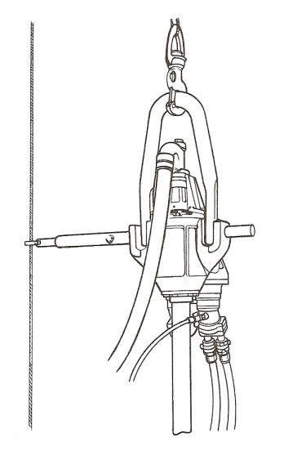 __________

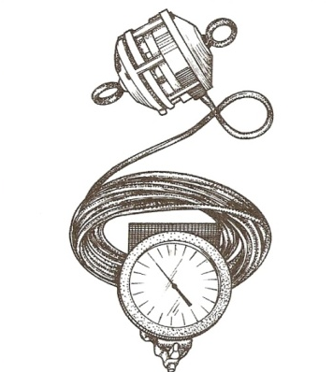___________

___________

_____________

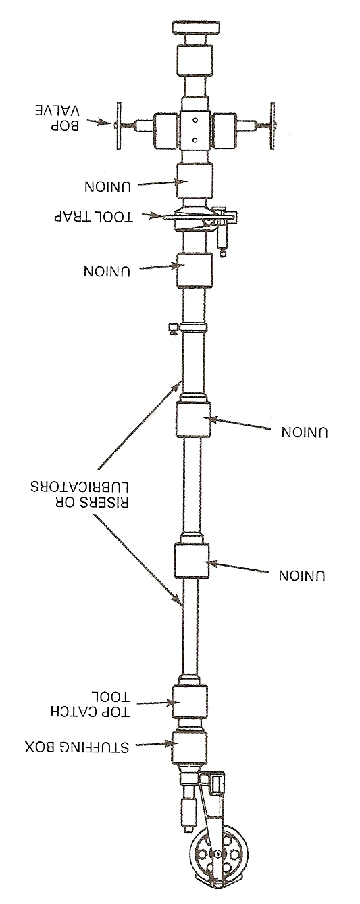
______
_______

__________

_______
_______
_______

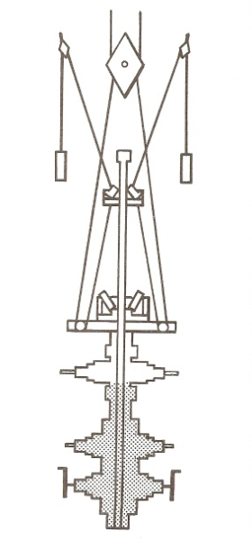 ______________

Extra Credit (5 points)
Think about the wells that you have been assigned for this class and answer the following questions.
    - What is the typical production rate for the 10 wells you have been assigned? Just give me a ballpark average for the group. Do not concern yourself with the exact value just give me a ballpark number based upon your observations of the past two weeks. Please include the units. _________________.

    - Approximately what fraction of your wells are using EFM instead of orifice plate meters? _______________

    - What route number and wells have you been assigned? Route _________; Wells ___________

- What is the most recent date for which data from the field is available? ______________

