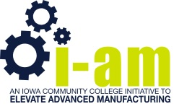

**Iowa-Advanced Manufacturing Consortium**

Year Two – Participant Outcomes

**Eligible Veterans TAA-Eligible Incumbent Workers Pell-Grant Eligible Persons with a Disability**



**242 21 1,291 915 73**



This workforce solution is funded in part by the I-AM Consortium which is 100% financed through a $12,951,165 grant from the Department of Labor’s Employment & Training Administration and

is licensed under the Creative Commons Attribution 3.0 Unported License. To view a copy of this license, visit <http://creativecommons.org/licenses/by/3.0/>.

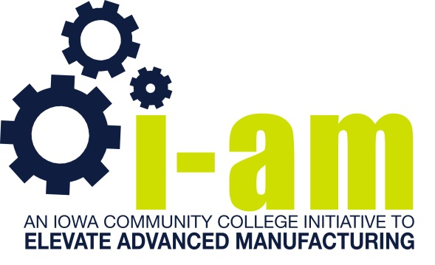

**PARTICIPANT DATA**

YTD Spending:

**$2,363,243.03**

Amount Granted:

**$12,951,165.00**

YTD Leveraged Resources:

**$499,650.55**

**CONSORTIUM FIGURES**

**27**

of 32

Signature Programs Launched



**7% Female 93% Male**

**PARTICIPANT DEMOGRAPHICS**



**92% Male 8% Female**

**28**

Average

Age of Participants

C:\Users\semetheny\AppData\Local\Microsoft\Windows\Temporary Internet Files\Content.IE5\J0M1FKT0\MC900053965[1].wmf

*The product was created by the grantee and does not necessarily reflect the official position of the U.S. Department of Labor. The Department of Labor makes no guarantees, warranties, or assurances of any kind, express or implied,*

*with respect to such information, including any information on linked sites and including, but not limited to, accuracy of the information or its completeness, timeliness, usefulness, adequacy, continued availability, or ownership.*