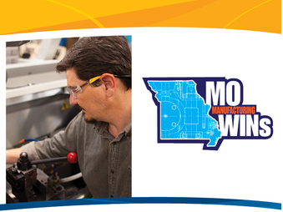
MACHINE TOOL TECHNOLOGY
Program Overview
- Program Length: 17 weeks
- Schedule: Mon-Thurs, 11a.m.-5p.m.
- Certifications:
- College Credit: 32 credits
- Cost: $1318 approximately

TOPICS COVERED:

Computer Numerical Control
- Fanuc Control G&M code programming
- Setup procedures using various workholding devices and tooling
- Compensation methods using common Tool Length and Diameter Offsets
Precision Machining
- Fundamental Concepts of manual machining on Vertical Mills, Engine Lathes, Surface Grinders, band saws
- Proper Tool selection and setup methods using lathe collets, chucks, and tailstocks
- Various mill setup techniques using vises, clamps, and collet closer attachments
Quality Control
- Fundamental concepts of blueprint reading and interpretation
- Precision measurement using micrometers, calipers, and gauges

This work is licensed under a Creative Commons Attribution 4.0 International License.

