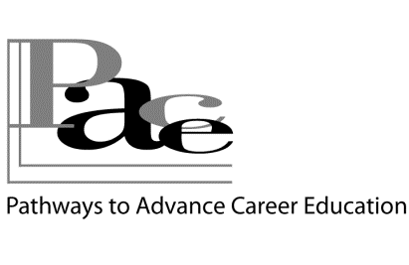

Certificate of Completion PACE.2.Employment

**Adam B. Participant**

**has successfully studied &**

**completed the following activities.**

**The Marketable Person & Rhode Island's Job Market**

**Work Values, Skills Inventory, Assessments**

**Designing & Practicing “Elevator Speech**

**Dressing for Success**

**Cover Letters, References, Résumés, Networking**

**Succeeding at Job Interviewing**

**Locating & Applying for Actual Job Openings**



***PACE supported by***

***TAACCCT Funds from the***

***U.S. Department of Labor***

[**pace@ccri.edu**](mailto:pace@ccri.edu) **401-825-2072**