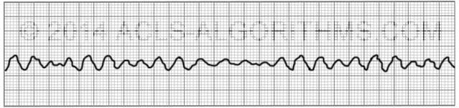
Ventricular Fibrillation

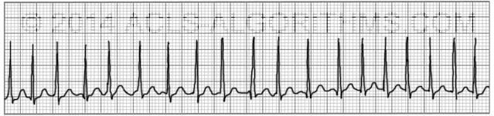
Supraventricular Tachycardia (SVT)
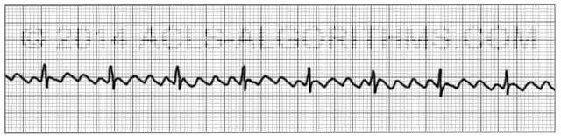
Atrial Flutter
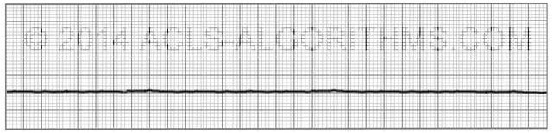
Asystole

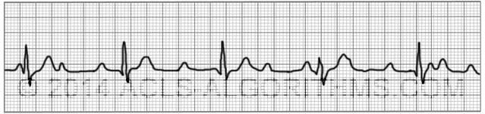
You have no pulse with this rhythm :PEA
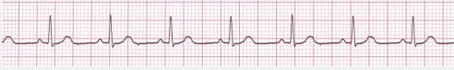
Normal Sinus
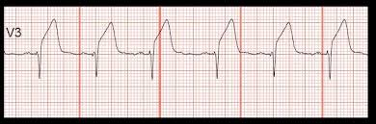
ST Elevation
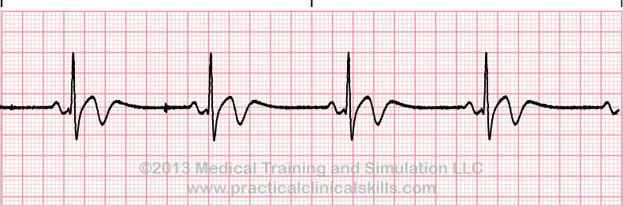Sinus Bradycardia
Consortium for Healthcare Education Online project material by CHEO Project TAACCCT Round 2 is licensed under a Creative Commons Attribution 4.0 International License“This product was funded by a grant awarded by the U.S. Department of Labor’s Employment and Training Administration. The product was created by the grantee and does not necessarily reflect the official position of the U.S. Department of Labor. The Department of Labor makes no guarantees, warranties, or assurances of any kind, express or implied, with respect to such information, including any information on linked sites and including, but not limited to, accuracy of the information or its completeness, timeliness, usefulness, adequacy, continued availability, or ownership.”

