mergency Response P1an

In the event of an emergency on campus...
+ You will be alerted via:
- A campus-wide voice notification over the phone system in each classroom
- Fire alarm or other audible alert systems
- A text message to your cell phone (Sign up for text blasting in your Portal under "My Campus")

+ You will be told what to do:
•Evacuation
When thefire alarm sounds OR an order from the Emergency Response Team (ERT) is issued:
- Do not panic.
- Listen carefully to instructions.
- Gather immediate personal belongings (those directly next to you).
- Do not return to lockers.
- Do not use the elevators.
- Evacuate to the pre-designated "Assembly Area" noted in the chart below.
- Do not go to your cars or attempt to leave the campus.
- Evacuate via the nearest stairway or as directed in the evacuation order.
- I/ you are in class, stay with your class at the designated "Assembly Area" until directed otherwise.
- If instructed to evacuate the campus, we will proceed on foot to Lawrence High School as a gathering point.
- At all Assembly Areas noted below:
  - Move out of the roadway to allow emergency vehicles access.
  - Move to the far end of the parking lot away from the affected building

If you are in: | Go to the Assembly Area:
King Hall | Overflow parking area below King Parking Lot (lower)
Lunder Library | Overflow parking area below King Parking Lot (lower)
Carter Hall | Far end of Carter Parking Lot (near access road to King)
Frye - Front of building near Western Ave | Far end of Frye Parking Lot (near Carter Hall)
Frye - Whitney Wing | King Parking Lot (other side of Cafe building)
Annex on Eskelund Drive | Right corner of front parking lot (facing Eskelund Drive)

,I.. Lockdown
In the event that the Emergency Response Team (ERT) decides a building, or the campus, should be locked down, you will be instructed to:
- Remain in the classroom you are in.
- Lock the door to the classroom and move to an area away from the windows.
- Move to a designated "Area of Refuge" if you are in an open area:

If you are in an open area: | Go to an Area of Refuge:
Campus Center, King Hall | Fitness Center located near the Vending Machines
Lunder Library | Side emergency exits - Enter the nearest classroom
Gym in Carter Hall | Nearest Classroom
Hallways | Nearest Classroom
Open Lunch Space, Frye Building | Nearest Classroom

7/11/2012

- When Will I Get My Award?
. Approximately 4 weeks if you have...
- Read and Responded to all Mail and e-mails from Financial Aid
When in Doubt Call Financial Aid

3. Types of Aid
Pell Grants• ...Scholarships ...Loans•
*Pell Grants and Loans Have Strict Limits
4. Is it Really Free Money?
Not Really - You're being "paid" to produce a grade

5. How is Progress Monitored?
GPA - §rade oint Average - must be 2.0 or higher SAP - atisfactory Academic rogress - must pass 66% of the credits you attempt

6. Limits on Aid - 150% and Pell
150% of Time means that if there are 62 credits in a program + 50% (31) = up to 93 credits of aid.

Pell eligible students have 12 Full Time semesters of Pell aid to earn an associate's and/or bachelor's degree.

7. Dropping or Withdrawing
Drop Period for Fall Ends on September 4th
-+ You can drop with no financial or academic consequences until the dates above

-+ Withdrawing from all courses before 60% of semester is over may result in having to pay repay some of your aid

-+ Talk with your advisor before you withdraw from any course
-+ Let Financial Aid Office know whenever add or drop courses
8. What Happens if I Have Some Problems?
-+ Semester of Warning
-+ Aid may be suspended permanently if GPA/SAP remains low
At KVCC we have three terms (Fall,Spring and Summer) and they all count as a semester of aid.
-+ Semester of Probation (aid suspended need to appeal)
9. Change in Life Circumstances
Divorce, Job Loss,or Change in Size of Family

10. You Must Do a FAFSA Every Year
O Always go to FAFSA.gov

O First F is for Free Never Pay to do your FAFSA O Complete FAFSA any time after January 1"
O Transferring Students· sooner is better than later O Always Get 'er Done before May 1 "
Financial Aid
Everyone listed below can be found in
the Enrollment Services Center Inthe Frye Buildlng.
Anne Connors, Director
Enrollment Services Center Frye Building
453-5126
- Dove Gordon, Loon Counselor
Enrollment Services Center Frye Building
453-5149
- Jill MocLean, Asst. Director
Enrollment Services Center Frye Building
453-5121
- Bobbilo Seamans
Enrollment Services Center Frye Building
453-5160

1

CAMPUS MAP
- .,...._., _-----,,,,.._..·.1 -- - - -- - -- --· - - --· - .. ·- ..... -· • • i • . ·- ·- --- -- - ·· ·

KENNEBEC VALLEY COMMUNITY COLLEGE
... ..

"VCC ANNEX
Administration
Conferencl! Room
KING HALL
Bookstore Campus Center

Co,ifinuing Educ?tii"'n Fimmce "nd H President's orr, ,,
Scir.OCP. L b<;

CARTER HALL
Classrooms Computer labs
Lecture Hall
Multi-Purpose Room I Gym
Food for Thought C;,fP.
Classrooms Ilife Science L"bs Computer Labs
FllneS9 Center
Marden Leaming Center Student DevP.lopmPnt TRIO

LI.INOER LIBRARY
library
,
Classroom
A A
Ai ,I

A :,
A , '\

A '\\
v r
s,,r"' A \ t\

l / 1
.l" l
ili J1,
1
,, , ·/' I

. I...

FRYE ANNEX

f"PYE BUILDING
Academic Aff,.irs Admissions
Advising Center Businfl'SS Offif'e I Cnc.hif"II"" Fin,.ncial A id
Reqitrr
ComputP.r Lnhs
,I
,._oq,
A I\ I\ 8\ lt

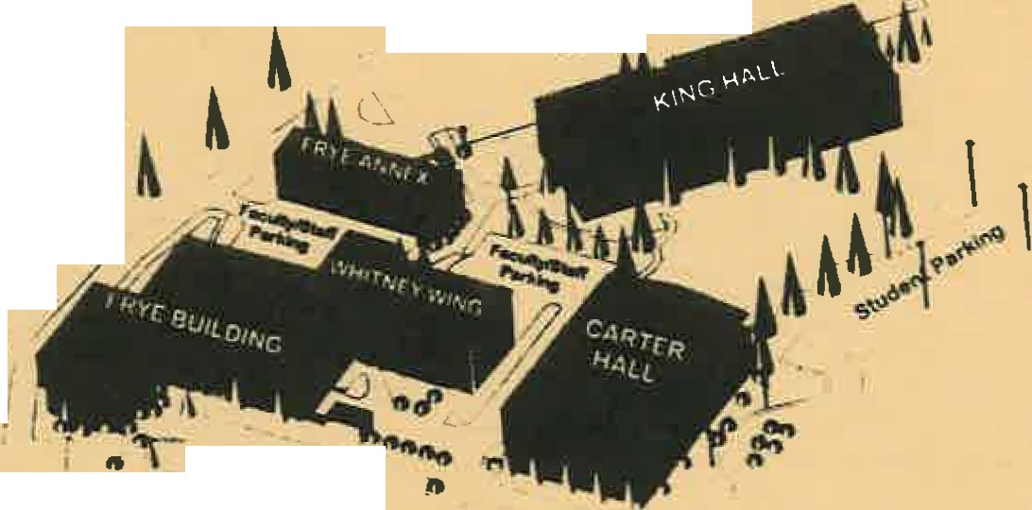I
,
...,,,
i A
I'\
,..,.,.
I

f

1\!HITNEY WING
Trarles Are"
Cl;'lc; rf")Ofl1<:i I l .1h<::
_ t . . II
0 .Sl""'li"lr•,.,._;.i;;_
I ---..
I
f-95 Exit 132 Ii

A #'
OQ
,i'
c...t,-..r

..
/!'
q-,&
,._o':i

;if
"'·

,.... ,
"'t:
"""
I I I 11 I I I I 1 1
"'i;sTE11,,,""i;,,uE

,\ I
" /•
E f\

.,o

.;'
a''t

.
...i
,
::°:, '

·ianager: Diane Bilodeau
:\ssistant Manager: 3rianne Pusher Phone:
( 207) 453-5135 or
1-800-528-5882
ext 5135

Other services and items we offer:

Consignment

Logo Merchandise
Ken neb ec V a lley Co m m unity Col lege

Textbooks and Student Accounts

U.S. Postal Service and UPS Service

Gift Items Software for PC/Mac
Daily Book Buyback And much more

Regular Store Hours
- Monday through Wednesday 7: 30 to 4
You will have to have
your schedule with you when you come to buy your textbooks, because this is how we determine which textbooks you need as the College Store policy has changed and students are no longer able to pull their own books. Also, all students that are being sponsored by an outside agency (ex. Career Center, TDC, etc...) have your sponsor fax a voucher to the Cashier's office (207) 453-5010.
Before you get your books, have the KVCC College Store staff check to ensure your name is on our finan­ cial aid/sponsor list. If it is
not, you will need to contact the cashier's office before you can charge your books.
Student accounts close
the last day of drop/ add. After accounts close, books/supplies may no longer be purchased on account.

Please check our online return policy.

Textbook Reservations/ Bundling is available for your convenience.
Please provide the following information: a copy of your schedule, if you want new or used copies pulled for you, and how you're going to pay (Financial Aid or credit card). Due to the amount of time involved for the staff to process these Reservations, we must end
receiving requests the Mon­ day prior to Financial Aid beginning for that semes­
ter. You may pick up your Bundle during the Financial

We accept Visa, Master card, and Discover credit cards, as well as cash or checks.

Aid period through the end of the first week of classes for that semester. This ser­ vice is easy and fast for
you.-No lines; no waiting!

Textbook Rentals
Rent and save on your text­ books, please see the link on our website for details. http://www.kvcc.me.edu/ Website/Frames/ Departments/CollegeStore/ CollegeStore.aspx

,• Thursday 9 to 6
, • Friday
End of Fall and Spring Used Book Buyback

7:30 to 2
{ Please note when
·school is cancelled and ' on major holidays we
- will also be closed .
: **"'Hours subject to
,, change during summer
. and school vacations.
J
We hold a used book buy­ back two times a year, dur­ ing the week of finals for the
fall and spring semesters ONLY. During these two weeks, we will be buying books back for the College Store. Guidelines are as follows:
1. Book buyback is the week of finals for the fall and spring semesters. There is no buyback at the end of summer semes­ ter. Check with the College
Store for exact dates and times .
- Books being used for the following semester may be pur­ chased at 50% of retail.
- Books no longer used may be purchased for a used book com­ pany.
- Study guides, software, or books with diskettes may be purchased at our discretion. We will not know the price that we will pay for books until buyback time.

Kennebec Valley Community College is an equal opportunity/affirmative action Institution and employer .
KVCC
t"'lr' mnrP lnfnrm::lltlnn nlPco r-::::t.11 f ')n/) ,1 c;:7_ c;: 1 'lC::

TRiO STUDENT SUPPORT SERVICES AT KVCC
Helping KVCC Students Succeed Since 1993

You're Invitec{J
To Join KVCC's TRiO Project!

What is TRiO?

  - Workshops offering proven strategies for college success
  - Support in math, science, or basic computer skills throughout the first year
  - Skilled advisors who help you create an academic plan that meets your needs
  - Prep for program entrance exams such as (HOBET and PAX-RN)

Why- You'll Want to Join Us?
  - 96% of students who joined TRiO in 2010-11were in good academic standing at the end of that year
  - 92% of those same TRiO Students continued on into their second year of school
  - 93% of the students receiving learning assistance from TRiO in the last academic year earned a grade of C or better in those courses.
  - TRiO makes transferring to 4-year colleges and universities easy
  - Access to FREE courses that provide help with Math and Science

Tuesdays Thursdays Tuesdays Wednesdays
SSS 010 01- TRiO Seminar
SSS 015 01- TRiO Technology SSS 025 01- TRiO Math I
SSS 050 01- TRiO Science I
(study skills for all TRiO students) (computer skills for all TRiO students) (for students taking Intro to Algebra)
(for students taking Anatomy & Physiology I)

What Do I Have to Do to Join?

  - Meet TRiO Eligibility requirements - www.kvcc.me.edu/trio
  - Make an appointment to fill out an application with the First Year Coordinator

• • I •;
    - • I

Michelle Bardsley TRiO Project
First Year Coordinator 453-5017
mbardsley@kvcc.me.edu

...... .
......
u
c '-
:::::s ::J
0u u
...... .
..ro Vl
..... c
Student Success @ KVCC
are you ...

Feeling a little in over your head and need to talk with someone about your academics?

- Majoring in Liberal Studies or waiting in this program until you get into another and unsure of where to go and what to take?

0
QJ
+,I
:::::s v,

c
+,I
c
0u
0
+,I
QJ
tr:olO
'-
:::::s
0u
QJ
.

......
v,

.
.r..o...

ro
'.+...-.,
0
c
v,
QJ
'-
::J

...
ro
c
+""
0
c
II)

II)
II)
QJ
u u
:::::s
(./')
...
...
·c-::
I

Needing to develop an academic plan to keep you here until you graduate or transfer?

  - Wanting to learn about campus services and resources?

  - In need of a referral for personal counseling?

  - Hoping for someone to monitor your academic progress and encourage academic persistence?

  - Getting back on your feet after academic probation or dismissal?

Student Success Coordinator
Michelle Gayne, M.Ed•
Carter Hall,Room 1 19
453-5039
mgayne@kvcc.me.edu

Success be9is with tl,\e basics!

