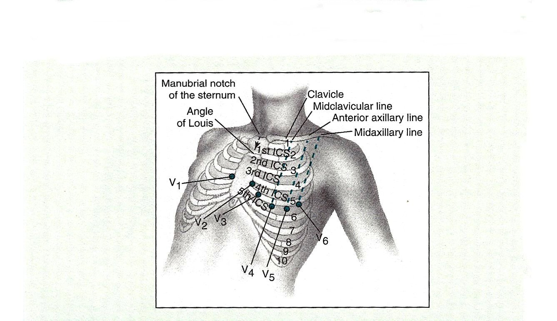

**This project was funded $3,000,000 (100% of its total cost) from a grant awarded under the Trade Adjustment Assistance Community College and Career Training Grants, as implemented by the U.S. Department of Labor’s Employment and Training Administration. Rogue Community College is an equal opportunity employer/program. Auxiliary aids and services, alternate form and language services are available to individuals with disabilities and limited English proficiency free of cost upon request.**

[Creative Commons License](http://creativecommons.org/licenses/by/4.0/)  
This work is licensed under a [Creative Commons Attribution 4.0 International License](http://creativecommons.org/licenses/by/4.0/).