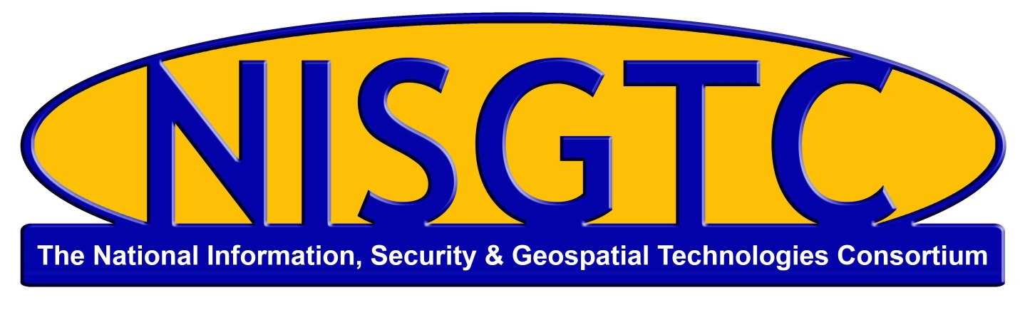

This work by the National Information Security and Geospatial Technologies Consortium (NISGTC), and except where otherwise noted, is licensed under the Creative Commons Attribution 3.0 Unported License.
Authoring Organization: Collin College
Written by: Scott Stephenson
Copyright: © National Information Security, Geospatial Technologies Consortium (NISGTC)
Development was funded by the Department of Labor (DOL) Trade Adjustment Assistance Community College and Career Training (TAACCCT) Grant No. TC-22525-11-60-A-48; The National Information Security, Geospatial Technologies Consortium (NISGTC) is an entity of Collin College of Texas, Bellevue College of Washington, Bunker Hill Community College of Massachusetts, Del Mar College of Texas, Moraine Valley Community College of Illinois, Rio Salado College of Arizona, and Salt Lake Community College of Utah.
This workforce solution was funded by a grant awarded by the U.S. Department of Labor's Employment and Training Administration. The solution was created by the grantee and does not necessarily reflect the official position of the U.S. Department of Labor. The Department of Labor makes no guarantees, warranties or assurances of any kind, express or implied, with respect to such information, including any information on linked sites, and including, but not limited to accuracy of the information or its completeness, timeliness, usefulness, adequacy, continued availability or ownership.

Syllabus

Please provide a complete syllabus. All elements of the syllabus are required unless noted as “if applicable.”
Course Title: Computer Maintenance 2: Windows Networking, Maintenance, Virtualization & Network Printing, and Security | Course Number (If applicable): CMPT1405AB
COURSE DESCRIPTION:
This is the second of a series of three courses that provides in-depth exposure to computer software, mobile devices, security, and troubleshooting. Students learn the functionality of operating system software as well as suggested best practices in maintenance, and security. Through hands on activities and labs, students learn how to install, upgrade and maintain an operating system. This course includes the following topics: Networking, Maintenance, Virtualization, Network Printing, and Security. By completing all three courses in the series, students will review the objectives covered on the CompTIA A+ certification – Exam #2.

Note: There is a “Final Exam” to assess student learning across the three courses (CMPT1405AA Computer Maintenance 2: File Systems, Windows Installation, Command Prompt & Tools, OS & Accounts, and Control, CMPT1405AB Computer Maintenance 2: Windows Networking, Maintenance, Virtualization & Network Printing, and Security, and CMPT1405AC Computer Maintenance 2: Mobile Devices and Troubleshooting) which occurs at the end of the series in Lesson 4 of CMPT1405AC.
PREREQUISITES:
Knowledge of computer components, peripherals, and how they work together.
Knowledge of Windows XP, Vista, and 7 operating systems.
REQUIRED MATERIALS:
- Physical or virtual computer
- Windows 7 installation disk
- Internet access
- Wireless router or access point
ADDITIONAL RESOURCES (if applicable):

All-in-One CompTIA A+ Certification Exam Guide, 8th Ed. (2012 Objectives), Mike Meyers, McGraw-Hill, 2012, ISBN# 978-0071-795128 (Paid)
http://certification.comptia.org/getCertified/certifications/a.aspx
http://www.examforce.com/offer/free-comptia-aplus-examprep?sid=1548
http://www.practicequiz.com/CompTIA-220-802-Certification-Practice-Test
The series of three courses includes these LEARNING OUTCOMES/COMPETENCIES:
Student will be able to
- Identify and install Windows operating systems.
- Identify and configure mobile devices.
- Identify and configure printer components.
- Compare and contrast different desktop and mobile operating systems.
- Implement a preventative maintenance schedule.
- Identify and troubleshoot common hardware problems.
- Identify and troubleshoot common software problems.
- Identify and troubleshoot common security issues.

COURSE ASSESSMENT:
The course content, PowerPoints, study guides, and hands-on-labs will prepare students for the CompTIA A+ Exam #2. Module/Lesson tests, and exams are scheduled weekly throughout the course. Assignments, labs, and supplementary material are included with the course.

Grading Scale
Category Weight  Module Tests 30%  Homework/Study Guides 10%  Labs 20%  Mid-term and Final Exams 40%  Final Grade 100% | Percentage Grade  90%-100% A  80%-89% B  70%-89% C  60%-69% D  0%-59% F

The grading scale is administered equally to all students in the course. Do not expect to receive a grade higher than what you earn based on your total points. No point adjustments will be made for such things as class participation or other subjective factors.

COURSE SCHEDULE:
Note: This partial example shows a course that combines lecture and lab components.
Module/  Lesson | Module/Lesson Title & description (if applicable) | Learning Outcomes  Students will be able to: | Assignment
 | Windows Networking | - Setup and configure Windows networking. | Lab: Networking Essentials  Study Guide #6  - Test #6
 | Maintenance and Security | - Perform preventive maintenance procedures.  - Identify basic operation system (OS) security settings. | Lab: Disk Maintenance and Data Recovery  Study Guide #7  - Test #7
 | Mid-Term Review | - Review computer software. | Mid-Term Exam
 | Virtualization and Network Printing | - Identify and compare basic client-side virtualization.  - Configure network printing. | Lab: Remote Access  Study Guide #8  - Test #8
 | Security Fundamentals | - Identify and compare the importance of security.  - Compare common prevention methods.  - Identify security threats. | Study Guide #9  - Test #9
 | Security Methods | - Secure a workstation.  - Define wireless and wired security methods.  - Customize features of Windows 7. | Lab: Security  Study Guide #10  - Test #10

