EET 107 Fall 2012

Resistor R
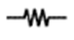
Capacitor C
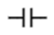
Transistor Q
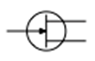
DC Power (Direct Current)
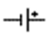
AC Power 9Alternating Current
LED (Light Emitting Diode)
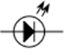
PCB (Printed Circuit Board) Through Hole and Surface Mount
LOGIC SYMBOLS
