EET 107 Fall 2012 Final Study Guide

Be able to identify an aircraft’s:
wings, ailerons, fuselage, horizontal stabilizer, vertical stabilizer, elevator and rudder.

Know
Coaxial cable is used as a transmission line for radio frequency signals.
Physical dimensions of the cable determine the cable's electrical properties.
Never kink, drop anything on, step on, bend sharply or pull (except in a straight line) on coaxial cable.
Coax cable shielding prevents other signals from entering the cable and leakage of cable signals out of the cable.

Be able to define:

A Switch is a device for turning on or off or directing an electric current or for making or breaking a circuit.

A Circuit Breaker is an automatic switch that stops the flow of electric current in a suddenly overloaded or otherwise abnormally stressed electric circuit.

A Fuse is a current limiting device.

A Bus is a distribution point in an aircraft electrical system to which the battery and the generator(s) are connected and from which the electrical loads derive their power.
In computer architecture, a bus is a subsystem that transfers data between components inside a computer, or between computers.

Electrical Units of Measure:
Voltage unit of measure is the Volt
Current unit of measure is the Ampere (amp)
Resistance unit of measure is the Ohm
Power unit of measure is the Watt
Be able to identify electronic components and their symbols:
Antenna, Capacitor, Resistor, Transistor, LED, Fuse, Diode, Circuit breaker, IC
AND gate, OR gate

Sine wave amplitude, weather describing alternating current or radio waves can be measured as peak, peak to peak, average or RMS know the difference.
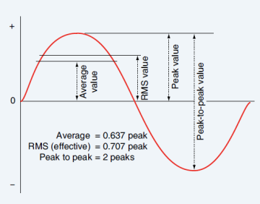

AC Alternating Current
AWG American Wire Gauge
CVR Cockpit Voice Recorder
DC Direct Current
ESD Electro Static Discharge
FAR Federal Aviation Regulation
FDR Flight Data Recorder
TCAS Traffic collision avoidance system or traffic alert and collision avoidance system

Textbook reading study guide:
Chapter Questions
18 1,4,5,6
19 2,9,11,12,15
20 4,8,9,10,11
21 4,8,12
22 1,3,4,5,6,9
23 6,7,8,9
24 3,4,5,6
25 3,5,8,16,19
26 4,7
27 1,2,4,12
28 None
29 1,5,8

