EET 107 Fall 2012 Midterm Study Subjects

REVIEW: Chapter 3-10, 12-15
Chapter Questions:
3: 2, 7, 8 VHF Com (Very High Frequency Communications)
4: 1, 3, 5, 7 HF Com (High Frequency Communications)
5: 1, 2, 9, 12 Satcom (Satellite Communications)
6: 1, 2, 5, 7 ACARS (Aircraft Communication Addressing Reporting System)
7: 2, 5, 7 Selcal (Selective Calling)
8: 1, 4, 7 ELT (Emergency Locator Transmitter)
9: 1, 4, 5, 9, 10 VOR (VHF Omnidirectional Range)
10: 4, 5, 7, 8, 12 ILS (Instrument Landing System)
12: 1, 4, 5, 6 ADF (Automatic Direction Finder)
13: 1, 2, 3, 5, 6, 7 DME (Distance Measuring Equipment)
14: 1, 2, 5, 6, 7, 8 Transponder
15: 2, 4, 7, 8 Radar Altimeter

Know that the Pitot Static System is used for the Air Speed Indicator (ASI).
The Static port is used for the Altimeter (ALT) and Vertical Speed Indicator (VSI)
On board simple aircraft the instruments are directly connected in more complex aircraft the sensor are usually connected to a computer and then to the flight deck instrumentation.

Know the 6 standard flight instruments:
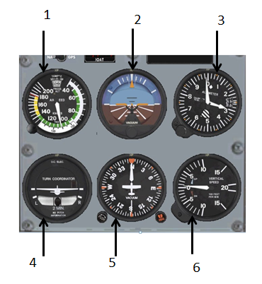

ACARS: Aircraft Communications Addressing and Reporting System.
ADF: Automatic Direction Finder.
ADI: Attitude Director Indicator.
ALT: Either; Altimeter or Altitude.
AM: Amplitude Modulation
ANT: Antenna.
ATC: Air Traffic Control
ATT: Attitude.
ARINC: Aeronautical Radio Inc.
Avionics: Aviation electronics.

CDI: Course Deviation Indicator.
CLK: Clock
COMM or COM: Communications Receiver..

DG: Directional Gyroscope.
DME: Distance Measuring Equipment.

ELT: Emergency Locator Transmitter.

FAR: Federal Aviation Administration
FM: Frequency Modulation
FREQ: Frequency.

GND: Ground.

HF: High Frequency.
Hz: Hertz.
IDENT: Identify/Identifier.
ILS: Instrument Landing System.

LOC: Localizer.
LRU: Line Replaceable Unit
MHz: Megahertz.
MIC: Microphone.
Mode A: Transponder code reporting.
Mode C: Transponder altitude reporting.
Mode S: Transponder code, altitude, and TCAS reporting.

NAV: Navigation receiver.
NAVCOMM: Navigation and Communications equipment or receiver.
NDB: Non-Directional radio Beacon.

PTT: Push To Talk.
PWR: Power.

RALT: Radar or Radio Altimeter.
RCVR: Receiver.
REC: Receiver
RF: Radio Frequency.
RMI: Radio Magnetic Indicator.
RX: Receiver.
SATCOM: Satellite Communication.
SATNAV: Satellite Navigation.
Selcal: Selective Calling.
SPKR: Speaker.
SSB: Single Sideband
SSR: Secondary Surveillance Radar.

TACAN: Tactical Air Navigation system.
TRANS: Transmit, Transmission.
TX: Transmit.

UHF: Ultra-High Frequency.

VHF: Very High Frequency.
VOR: VHF Omnidirectional Radio and Ranging.
VOR/DME: VOR with Distance Measuring Equipment.
VORTAC: VOR and TACAN combination.

XCVR: Transceiver.
XMIT: Transmit.
XMSN: Transmission.
XMTR: Transmitter.
XPDR: Transponder.

