Name_____________________________EET 107 Winter 2013 January ###
Quiz
Identify 1-6
1._____________ 2.____________ 3._____________

4._____________ 5.____________ 6._____________
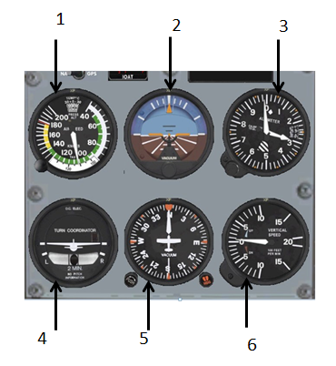
7. Avionics stands for what?

8. What does AM stand for?

9. What does FM stand for?

10. Radio is used only for voice communications? True or False

12. Satcom is replacing HF for most uses? True or False

13. Which of the below indicates half duplex communications A, B or C?
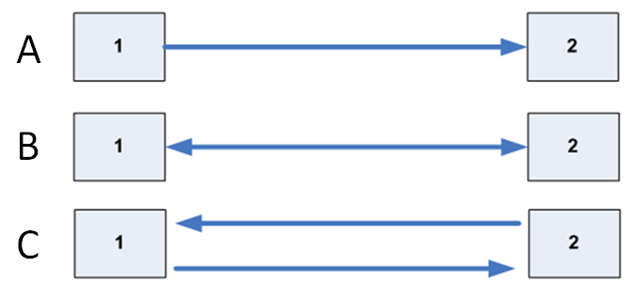
14. In an emergency, the three emergency action steps you should take (in order) are:

C ___________________ C ___________________ C ___________________

