>>>>>>>>>>>>>>>>>.
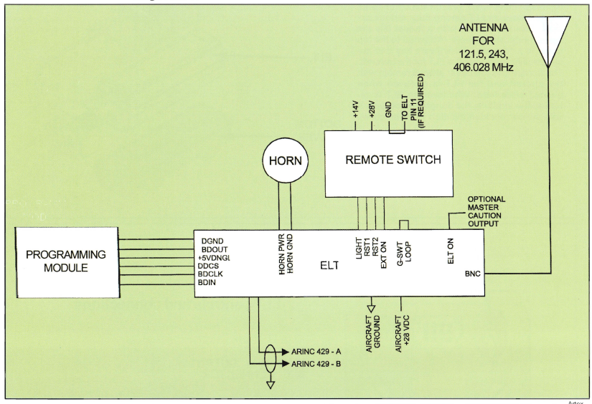

The Programming Module (lower left) sets up the 406 ELT for it’s 24 bit code (the aircraft’s tail number).

The horn at the top center sounds to warn the crew of a false activation.

The remote switch controls the ELT from the flight deck.

At the bottom center, a ARINC 429 connections bring a signal from the airplane’s navigation system into the ELT for accurate location of a downed airplane.

At the upper right, the single antenna transmits a signal on the 3 ELT frequencies (121.5, 243 & 406 MHZ).

