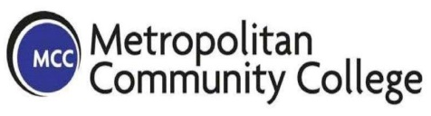 | MoHealthWINs  Open Course Library  Learning Activities  Pharmacology Enrichment Class for Nursing Path  MCCKC | 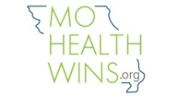

Learning Activities:

- Apply what was taught during the class in specific scenarios.
- Identify and solve any difficulties identifying and applying key terms related to pharmacology.
- Take the pretest and posttest on the book chapters about Conversions between Measurement Systems. Exercises to convert among metric, household, and apothecary systems using ratio/proportion
- Exercises to convert among metric, household, and apothecary systems using dimensional analysis
- Apply what was taught during the class in specific scenarios using the Public Health Nursing Manual as reference.
- Identify and solve any difficulties identifying and applying the knowledge of the ethical and legal responsibilities of the nursing profession when administering medications.
- Students create scenarios based upon instructor’s guidelines and solve them.
- The instructor describes a scenario including classification, dosages, action, side effects and contraindications. The students need to find errors. Reference Toolbox meds.
- The instructor describes a scenario including classification, dosages, action, side effects, contraindications and error in charting. The students need to find the errors. Reference Toolbox meds
The student creates scenarios and using a rubric classifies the quality of client support. Meeting educational needs through accurate, clear communication is measured by the MO Standards regulating the Nursing profession.

This template is based on the work by the Washington State Colleges licensed under a Creative Commons Attribution 3.0 Unported License. The Open Course Library is funded by the Bill & Melinda Gates Foundation and the Washington State Legislature.

MoHealthWINS
This workforce solution was funded by a grant awarded by the U.S. Department of Labor’s Employment and Training Administration. The solution was created by the grantee and does not necessarily reflect the official position of the U.S. Department of Labor. The Department of Labor makes no guarantees, warranties, or assurances of any kind, express or implied, with respect to such information, including any information on linked sites and including, but not limited to, accuracy of the information or its completeness, timeliness, usefulness, adequacy, continued availability, or ownership.

This work is licensed under the Creative Commons Attribution 4.0 International License. To view a copy of this license, visit http://creativecommons.org/licenses/by/4.0/.

