What Is Wealth Inequality
Video: htt p: // mashable.com / 20tJ / 03/ 02/ wealth-

- Q: What do you think of thi s information?
- Q: How does ft make you feel?
- Q: What do you think the cause of this disparity is?

.,. What ls your money's job for 'Ou? (\'/ri le your a nswer)
11> Wha t are your frustrations when It comes to work and money

Session 13 -- Presentation Thumbnails 9/17/2015

If it Ain't About the
Money
Intro
A rea l·w orl d guide to a more balanced life.

)
The System
- The welfare system is not a system set up for financial
growth .

.. Minimum wage for the state of Ohio is $7.85. This is not consider a "living wage."

- Why is thi s happe ningn m n

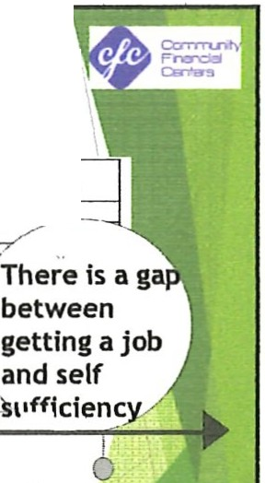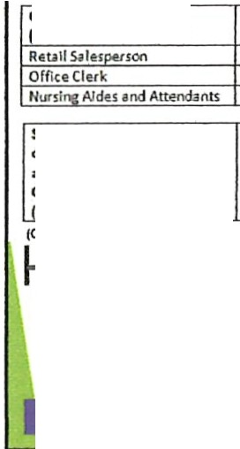
Getting to Self-Sufficiency
Self·Sufficlency Standard measures how much income a family
needs to adequately meet basic needs
OCCUPATlOt,
fromOhlo'1lObr1,it)
HOVRLVMEOIAtl WAOE
f'ERCU,TQfSElF
$9 . 63
Sll.17
.
SUfflCIEtlCYSTANOARO
,.
SU.40
""
Self·Suffld,nr,St1nibrdfor $20.76 on, 1dult , on1 pr1u:haol 11r,
•ndon,1ehool•111chndln Colu mbl1n1 Cou nty
""
100%
I
clou n to st.If median
{Ohlo SdfS uff k:lffKyStancbrd, l01l)
Training Job Search
6
g
Employment Social Support Self
and Sufficiency Asset Building
6
Our Responsibility
- Accocding lo Tope Fajingbe ri we all h<we a mooey color.
11 Grttn: Always thinking about h<ffl yoor money an make mon! money.
11 Sl ue: You yVe, but do not want to inV'Ht uuse o( the rear of
losing money.
41 Gray ; I/ever spe nds money; wilt rotate lhrough the same 4-5 shirts C\''1Y week.
\ i R.!d: In d t. nodelayrd !Rllficatlon mK hanbm , q,end:s H soon
as it's rtteiwd.
Take a moment to think about what color your money ls. What color do you want it to be?

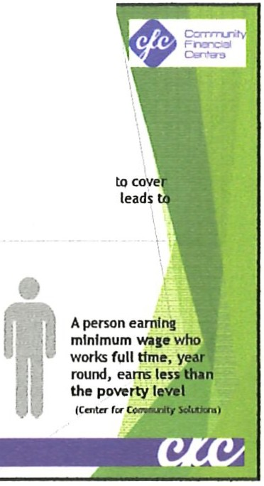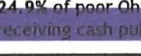9/17/2015
Working Poor Families in Ohio
29% Asset Poverty
10.6% Poverty Rate
famllfes do not have savings or other assets to cove basic expenses for 3 months if an emergency leads loss of Income
In Ohio, people are working minimum wage
but still relying on public assistance:

- 31.8" of Ohio families are low
income
66 . 6% of low income families In Ohio
work

)

Activity
"' List our top 5 money needs.
Discussion
Closing
What have you learned? Has anything been affirmed for you?
As you go through the ne xt week I want you to track your spending for 7 days.
Write down EVERYTHING you spend money on no matter how big or how sma ll. It does not matter if it is a need or a want , if you hand money over to ANYONE write it down.

Discovering the Truth About Your Money
I Spent What?!?
Ove rview: Needs vs Wants video:

)

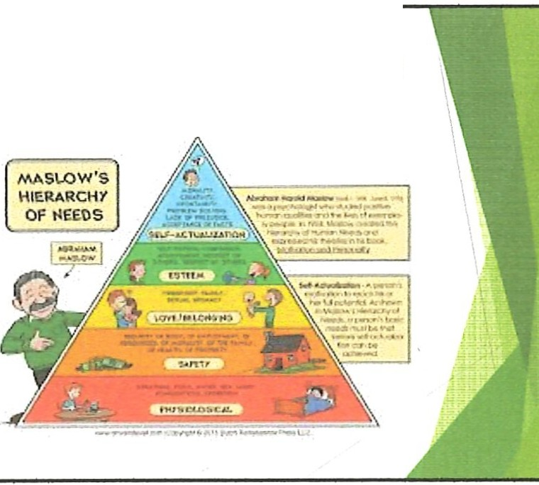
Review
JI- Here's a quick recap of what we talked about.
JI- How much do you plan to pay yourself thi s week?

Maslow's Hierarchy of Needs diagram (MHN)
Basic Needs
Food
Shelter
Physical Safe t y He altl1
'°' Re sources
,o, Achi evement
,o, Res pect - For Other and For Ou elves

)

Building wealth
- Wea lth is....... .

)

)
Definition
- wea lth
- noun
.. a n abundance o r valuable possessionsor money.
- the state of being rich; material prosperi ty.
.. ple ntiful sup plies of a part icular reso urce.
Wealth Creation Basics
- Wha t are assets?
- What are liabilities

Homework
- Write out all of your mandatory expenses for a month .
.. ONLY MANDATORY!!!
- We will talk about how to include the thing s that do not come up regularly.

How to Stop Living Paycheck
to Paycheck
Review
- Pay yourself rir st! ! l
... Keep a record of your monthl y expenses!

)

$$ How Much $$
- The most surprising thing about how to stop living
paycheck to paycheck is t o know much money you nee d eac h month .
Easy Peasy
- Add up alt of your necessary monthly expe nses. This is the amount you nee d to save in order lo sto p living pay check to pay check.

Emergency!!!
How much i s enough?

Emergency expenditures
- Emergency expenditures can range from the bill for an unexpected car repair to living expenses that are tough to cover because of a layo ff.
- Whal are some emergencies you would like to save for?
What are emergencies?
- repairing the brakes on your car; buying your child a new pair of needed shoes j replacing a broke n window in your house; paying for a visit to the doctor when your child has the flu; covering the dental expense of filling a painfu l cav it y; paying for a parking t ic kel j or flying to visit a sick parent. ·

9/17/2015
What is emergency savings?
.,. An emergency savings fund consists of a small amoun t of money, usually in a savings account, that you do not have easy access to. Saving for this fund start s with small, regularly scheduled contributions that build up over time.

)

This Will Happen!!! I
Murphy's Law "If anything can go wrong. it will "
Homework
•

•
Figure out how you will start your emergency fund savings.
Whe n we ha ve our coaching sess io n no t only th e plan1 but START!!

9/17/2015
Where to find extra money
- Start with th e loose change you accumula te.
- 54 Ways to Save i\1Dney

)

Review
- Changing the way you t hink about money
.,.. Tracking e xpenses
.,.. Stop paycheck to paycheck living
- Emergency fund
Debt
- De bt is def ined as, the state of owing money.
- Why do we gel into debt?

9/17/2015

Debt be Gone
Working towards being debt free

)

Common Types
.,. Cre dit card
- Student Loans
.,. Payday loa ns /C as h advances
Basic Steps
The basic steps are things that we have alrea dy talke d about. By the time you are ready lo tackle your debt you would have alr eady:
Budge ted and Saved
z. Cut Expe nses
l . Tracking your expenses
Set some goa ls

11
Next Steps
11> De pending on the amount of de bt and the type you may
want to pay off the one wit h the highes t int e rest.
.,. I like small victories. I personally like th e "snowball" plan. Start small and tackle th em from smallest to
larges t.

Beware!!
- Avoiding payday le nde rs and ti tl e loans
11> Video Watch SPENT:
https:/ / www.yautube.com/wa tch?v•YA L-4T86pmg
Credit Report
- Ch ec k your credit report. Peo ple often find mistakes
that can heavily effec t your credit score.

Discussion on Spending Tracking
..,. Any surpri ses?
- Did you find yourself thinkin g more about what you
spent or gave away?
Was th ere any thin g diff ere nt about your spending on
either of the two days?

Coaching sessions
- How was your homework assignment?
- Wha l were results?
Review
a. Week 1: Ch ange the way you see your money. Is there
money there that you didn' t know??
"' Week 2: Spending. Are your spending habits aligne d wit h the way you see your money? Track your spe ndi ng in order to align your spending with f inancial goals.
..,. Week 3: Payc heck 2 Paycheck . Discove ring your
" magic" numbe r for ending paycheck to paycheck living.

r
Homework Review
- How did it go?
"' Does every S h ave a name?

If you are having challenges using the SkillsCommons.org materials, please contact us at support@skillscommons.org and we will work with you to resolve the accessibility challenges and/or provide an equally effective alternative access using the Equally Effective Access Planning Tool developed by the California State University. SkillsCommons is committed to supporting the progressive standard set by Section 508 of the Rehabilitation Act of 1973.

This workforce solution was funded by a grant awarded by the U.S Department of Labor’s Employment and Training Administration. The solution was created by the grantee and does not necessarily reflect the official position of the U.S Department of Labor. The Department of Labor makes no guarantees, warranties, or assurances of any kind, express or implied, with respect to such information, including any information on linked sites and including, but not limited to, accuracy of the information or its completeness, timeliness, usefulness, adequacy, continued availability, or ownership.

This work is licensed under the Creative Commons Attribution 4.0 International License. It is attributed to Ohio TechNet, HHW Ohio and the Center for Energy Workforce Development (CEWD). To view a copy of this license, visit http://creativecommons.org/licenses/by/4.0/.

