Agenda

- Introduction
- Resume Overview
- Create Your Resume
- Resume Discussion
- Action Planning

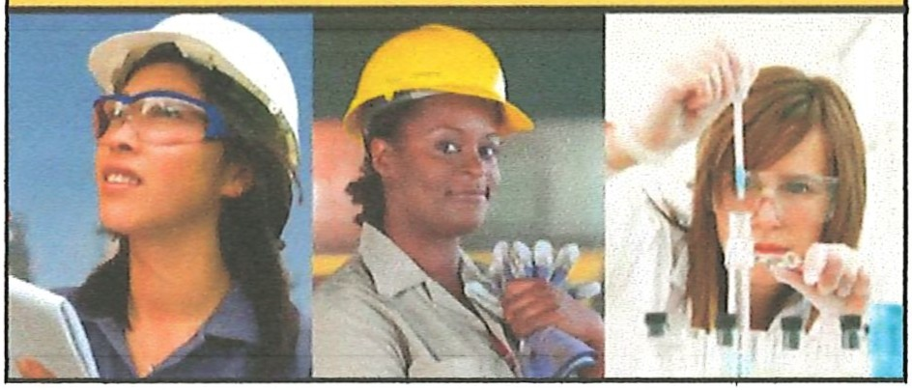Session 10 -- Presentation Thumbnails
WISE Pathways
Women in Sustainable Employment
Building awareness of careers in construction,
energy & utilities, public safety, and manufacturing foor women.

)

)

Introduction

Learning Objectives:
Identify content to include for work experience and skills
- Locate sources of information for content of resumes Understand the difference between types of resumes Select the best type for a given set of work experiences Prepare and print a resume

1

What Should You Include?

- Reflect how your past experiences are related to your desired career or the job you are applying for
- List your strongest suit (or information most relevant to the specific job opportunity) first
- Include search terms relevant to the company or job posting

What is a Resume?

- A resume describes where you have been, what you have done, and where you are currently directing your career
- The quickest way for a potential employer to get a picture of your qualifications
- Give you the opportunity to select only your strongest qualifications and skills

)

2

Types of Resumes
\ .....
Chronological
- Works well for Job see ke rs with a strong, solid work history
Functional
- Often used by people who are changing careers or who have gaps In their
employment history
Combination
- Allows you to highlight the relevant skills you have and also provide the
chronological work history employers prefer
Targeted
Customized so that it specifically highlights the experience and skills you have that are relevant to the Job you are applying for

Developing Your Resume

Take time to consider the following:
What did I do well during my last job? What did I enjoy doing at my last job?
Have I received any training specific to the Job I am seeking to attain?
What do I believe is the best skill I can bring to a company? What do I want out of my next job?

Developing Your Resume

Consider the skills you can bring to an employer
- Job Content Skills
  - Directly related to a specific job
- Transferable Skills
  - Skills that can be used across a var iety of positions
  - Many skills you use at home can be translated into a job duty
- Soft Skills
Skills that are reflective of your personal qualities and characteristics
)

3
Developing Your Resume

Additional Components
- Career History
- Educational History
- Special Skills
- Community lnvolvement/Volunteerism
'·
:
'

Make Your Resume Stand Out
\ .,.,
- Include a cover letter
- Include soft-skills and how you are "ready to work"
- Emphasize action verbs
- Include specific language from the job description and match your experience to those job needs
- Review other resumes / Compare your resume
9/13/2015
,..--
Resume "Must-Have" List
- Clean and Error Free
- Formatted Consistently
- Concise and Easy to Read
- Correct Grammar
I

)

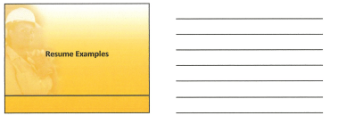

4
Resume Examples

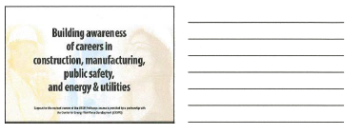

This workforce solution was funded by a grant awarded by the U.S Department of Labor’s Employment and Training Administration. The solution was created by the grantee and does not necessarily reflect the official position of the U.S Department of Labor. The Department of Labor makes no guarantees, warranties, or assurances of any kind, express or implied, with respect to such information, including any information on linked sites and including, but not limited to, accuracy of the information or its completeness, timeliness, usefulness, adequacy, continued availability, or ownership.

This work is licensed under the Creative Commons Attribution 4.0 International License. It is attributed to Ohio TechNet, HHW Ohio and the Center for Energy Workforce Development (CEWD). To view a copy of this license, visit http://creativecommons.org/licenses/by/4.0/.

