Session 3-- Presentation Thumbnails
9/2/2015

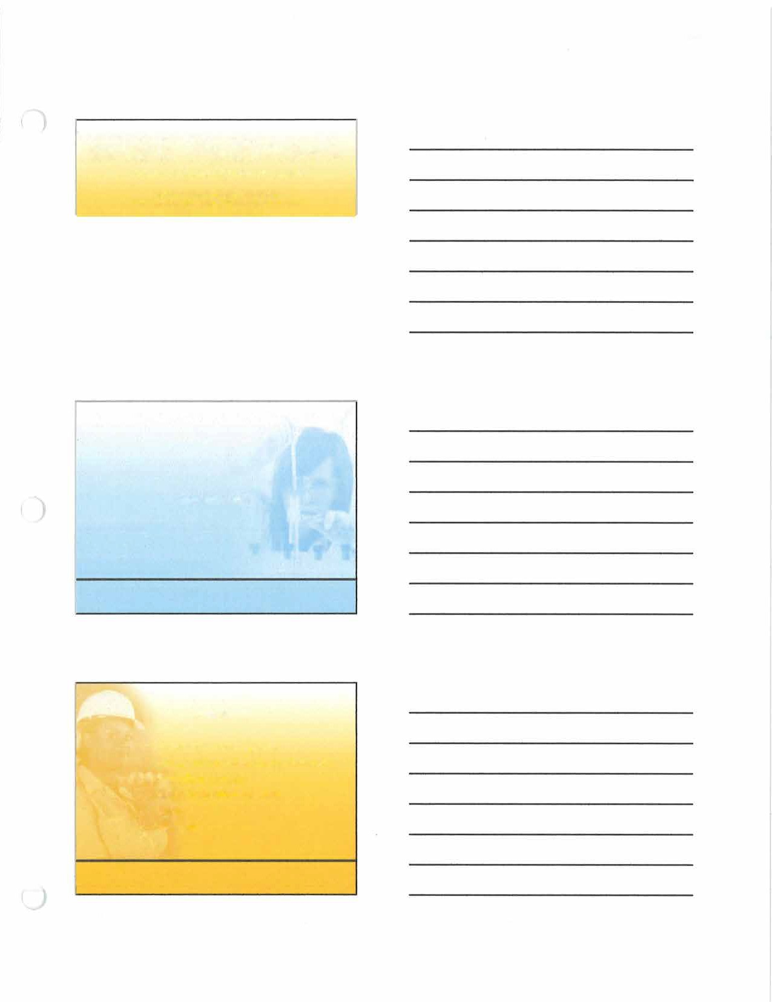
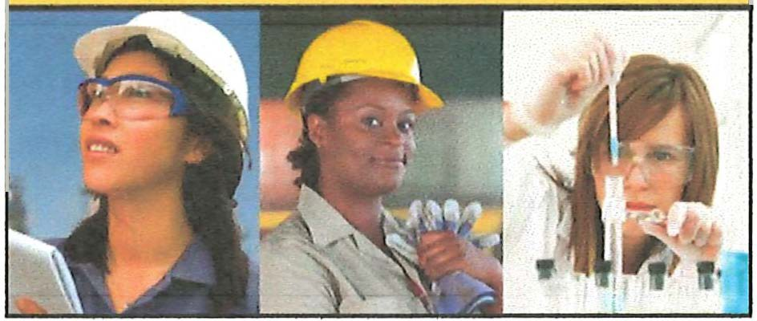

WISE Pathways
Women in Sustainable Employment
Building awareness of careers in construction,
energy & utilities, public safety, and manufacturing for women.

Teamwork

Teamwork
- Everybody works together
- All depend on others to do their part
- Help when you can
- Ask for help when needed
- Listen
- Speak up

1

9/2/2015

Cooperation
  - Work together
  - It IS your job
  - Offer to help when available
  - Life may not seem fair
  - No sulking

i

) Communication & Listening

Listen
Communication

i

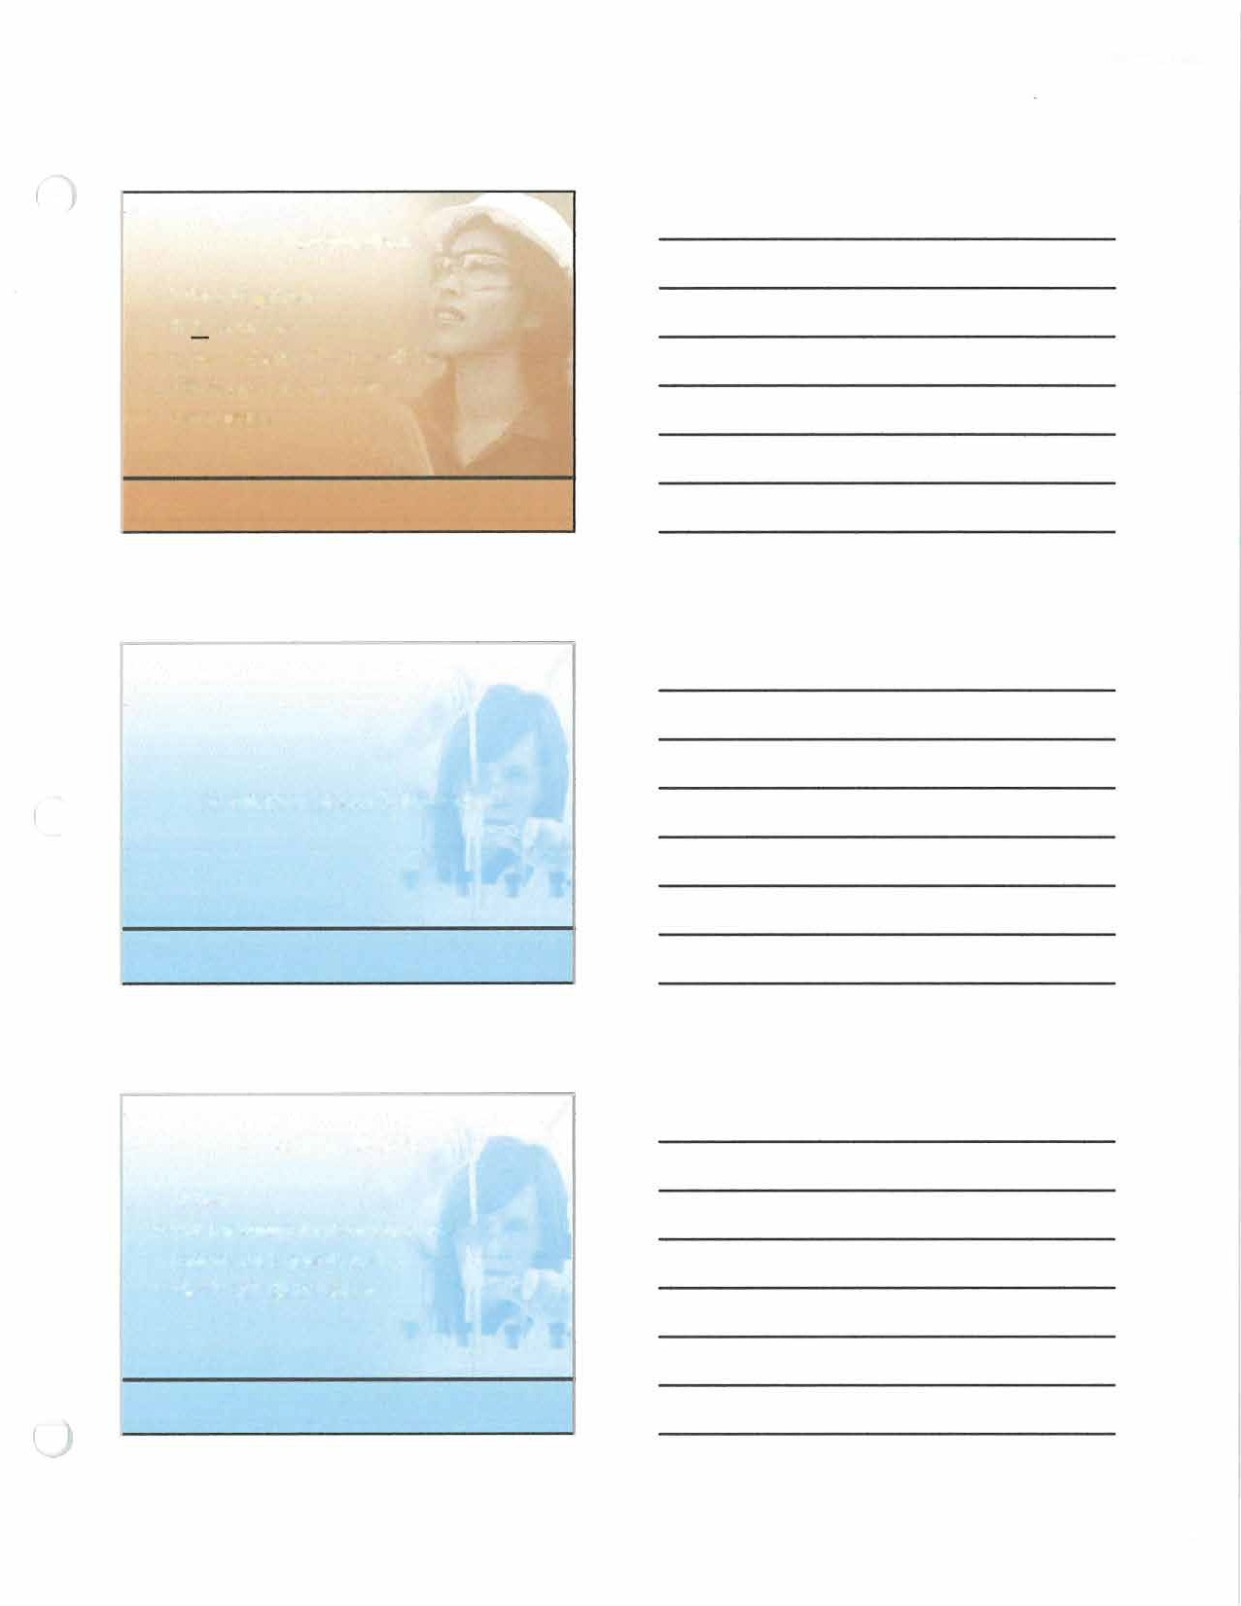
Put message in your own words
i
  - Clarify (ask questions)
  - Block out distractions

2

9/2/2015

Active Listening
- Look the speaker in the eye
- Don't interrupt the speaker
- Don't move around
- Nod your head
- Concentrate
- Repeat instructions and ask appropriate questions when the speaker has finished

Barriers to Listening
- Bias or prejudice
- Language differences or accents
- Noise
- Worry, fear, or anger
- Lack of attention
- Daydreaming
- Distractions

Sending Messages Effective Verbal Messages
  - Are brief, succinct, and organized
  - Are free of jargon
  - Do not create resistance in the listener
  - Require practice/rehearsal
  - Don't include accusations and sarcasm
  - Focus on behavior and actions needed

"\.,.

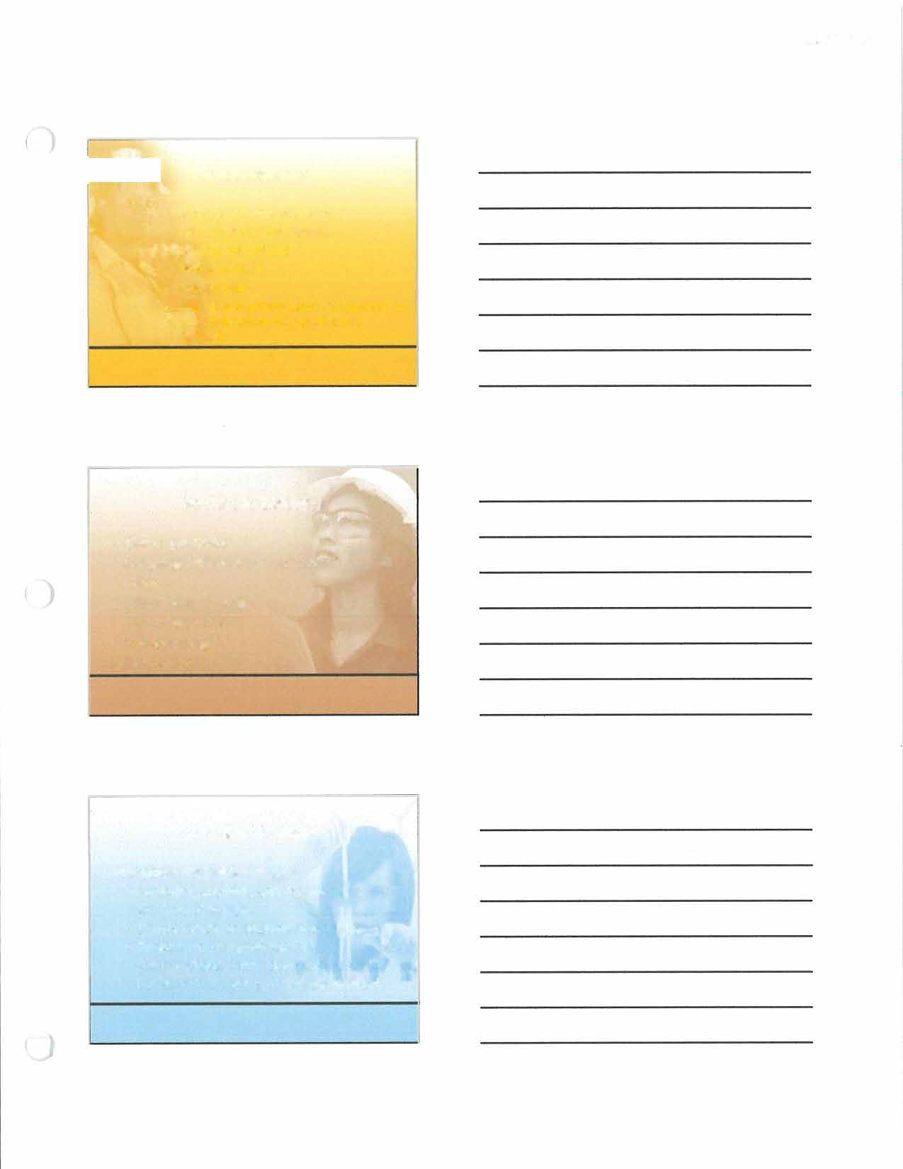

3

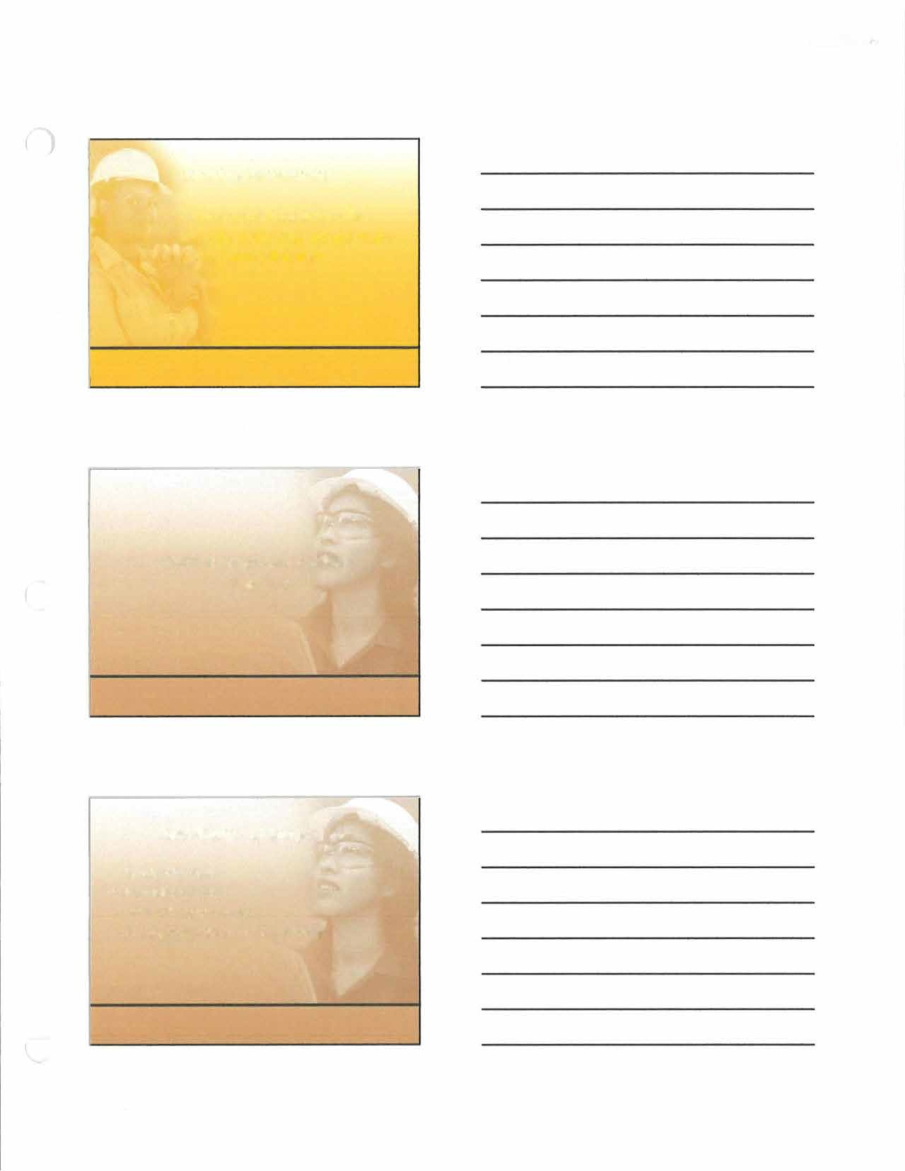
9/2/2015

Listening Assessment
    - Assess your listening skills
    - Identify skills that would make you a better listener

Coded Communication
) Exercise

Case Study - Digging a Hole

Study the case
- Identify options
- What should you do?
- Present decision and reasoning

)

4

9/2/2015

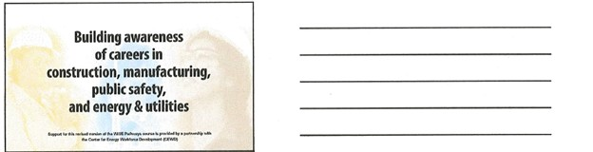

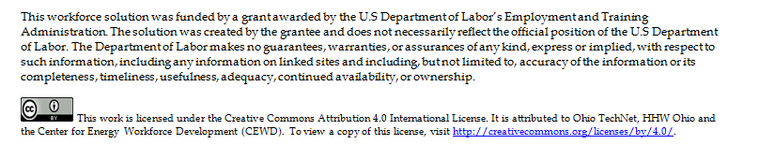

5

