MCC Proto
PROVIDING REALISTIC ON-RAMPS TO TECHNOLOGY OCCUPATIONS
  - Executive Summary of the Final Evaluation Report
  - September 16, 2018
  - Dr. Michael Shain and Dr. Neal Grandgenett, External Evaluators

The following is the executive summary of a larger Final Evaluation Report for the Providing Realistic On-Ramps to Technology Occupations (PROTO) project, funded by the U.S. Department of Labor’s TAACCCT (Trade Adjustment Assistance Community College and Career Training) project. The larger
full report contains extended detailed sections, as well as charts and figures, and supportive appendices.

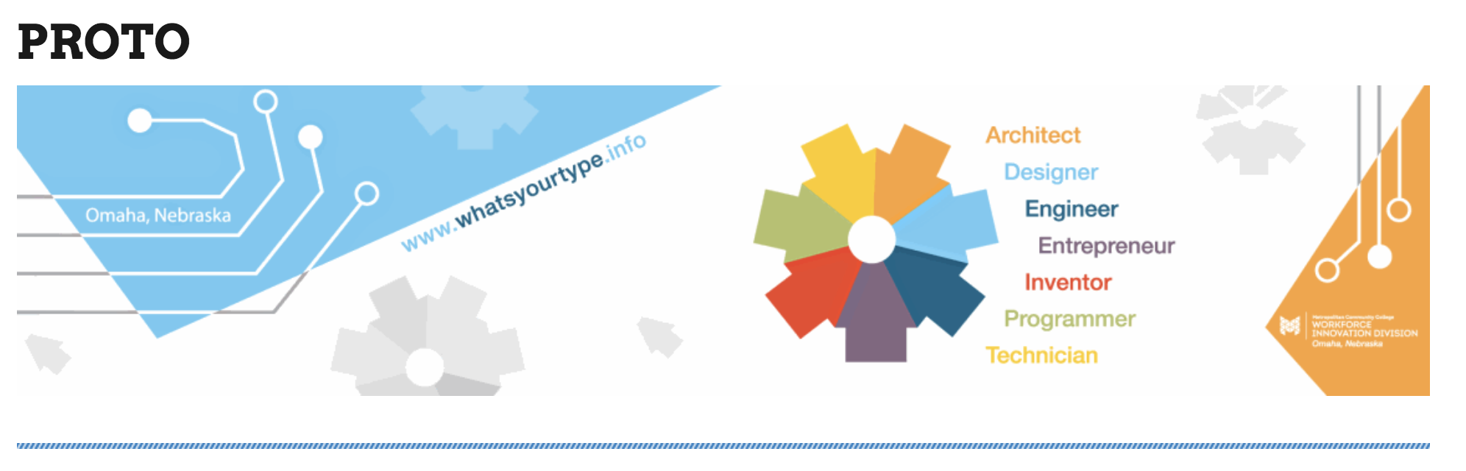

TAACCCT Program/Intervention Description and Activities
- Briefly describe your TAACCCT project and purpose
PROTO, as a TAACCCT – DOL-funded initiative of Metropolitan Community College in Nebraska, sought to increase the achievement of credentials through blended learning combined with experienced instructors, advanced labs, interactive partnerships and modern technology in the context of innovative and accessible Information Technology (IT).

- Describe each program/intervention that was evaluated
PROTO was primarily comprised of a carefully designed, articulated and integrated sets of courses focusing on Information Technology (IT). In addition to this coursework, the programs included “success” coaching; innovative instructional approaches; and project collaboration between Metropolitan Community College (MCC) and local businesses in IT. A total of 557 active student participants were recorded in the project database by the community college. PROTO utilized a research-based student engagement and coaching strategy for conceptual foundations to the interventions.

- Evaluation Design Summary
  - Describe the goals of the evaluation
The purpose of this external evaluation was to assess the ongoing and final effectiveness of PROTO’s project in developing an innovative model for curriculum development, instructional innovation and support services; in training a diverse set of participants to be prepared for information technology careers and passing community college certifications; and to help these students to qualify for and acquire high skill, high wage and high need employment opportunities in IT. The project evaluation team used a systematic Developmental Evaluation approach to undertake the process (Patton, 2014). There were three (3) sets of evaluation related research questions, with two pertaining to the nine TAACCCT – DOL required outcomes and one dealing with implementation, with various related sub-questions for the analysis process.

  - Discuss implementation study design
The project used a case study approach for the implementation study design that carefully followed the ongoing curriculum development and its interventions, with periodic quantitative evaluation summaries of progress that aligned closely with seven TAACCCT implementation research questions below. The full report details answers to each of them.

- How was the curriculum selected, used, and or created to undertake the project intervention and how does it appear to be developing?
- How were related courses, programs and program designs improved or expanded using grant funds? What delivery methods were offered? What was the program administrative structure? What support services and other services were offered?
- What contributions did each of the partners (employers, workforce system, other training providers and educators, philanthropic organizations, and others as applicable) make in terms of program design, curriculum development, recruitment, training, placement, program management, leveraging of resources, and commitment to program sustainability? What factors contributed to partner involvement or lack of involvement in the program? What contributions from partners were most critical to the success of the grant program? Which contributions from partners had less of an impact?
- Was an in-depth assessment of participants’ abilities, skills and interests conducted to select participants into the grant program and to facilitate a project comparison group? What assessment tools and processes were used? Who conducted the assessment? How were the assessment results used? Were the assessment results useful in determining the appropriate program and course sequence for participants? Was career guidance provided, and if so, through what methods?
- Contextually, how are the program implementation components generally aligned with the nine required TAACCCT program indicators?
- How will the evaluation team discover, and the team respond to, unanticipated outcomes of the program, both positive and negative?
- How efficacious are the program interventions being undertaken (defined as “the power to produce a desired result or effect”)?
The conceptual framework of the implementation study was aligned with Developmental Evaluation principals and the context of the Information Technology (IT) work plans in the approved proposal, with its six priorities associated with five curriculum related deliverables (Section 2.5). These deliverables included 1) IT certificates with courses aligned with industry-recognized needs; 2) the development of a variety of resources; 3) an enhanced success coaching model to reduce attrition and accelerate progress toward achieving each student’s success; 4) the work toward articulation of at least twenty-five percent (25%) of courses to coordinate with articulated pathways to four-year baccalaureate programs; and 5) a coordinated effort with the University of Nebraska at Omaha. The five curriculum deliverables were best analyzed using a blended qualitative and quantitative approach within a case study method, as well as various quantitative count summaries and data analyses, and an external expert curriculum review process.

  - Discuss outcomes/ impact study design
The outcomes and impact research questions the evaluation study addressed follow and were aligned with the nine required Department of Labor (DOL) outcomes as represented within the context of 48 different data fields collected for each of the student participants in the project. These research questions included:

- What service delivery and/or system reform innovations resulted in improved impacts for participants?
- Under what conditions can these innovations most effectively be replicated?
- What are the types of emerging ideas for service delivery change and/or system reform that seem the most promising for further research? Under what conditions are these ideas most effective?
- What directions for future research on the country’s public workforce system, and workforce development in general, were learned?
The evaluation design was a longitudinal Quasi-Experimental Study, mixed method study which from a statistical approach, compared data on students who completed elements of the information technology programs of study with those students who had no exposure or very limited exposure. A total of 557 students were included in the dataset. A randomized design was not possible due to the community college policies. Wage and employment data was limited since only aggregate and not individual data could be retrieved from the Nebraska Department of Labor (NDOL). Thus some wage and employment outcome data was limited to a subset of students that self-reported wage and employment outcomes in follow-up student surveys. To assist in the quantitative analyses, a case study format was further utilized to ascertain innovative approaches to curriculum, instruction and support services; and potential impacts on department and the overall community colleges system; and community college and business interactions. Causal inferences from the quantitative data are very limited due to the NDOL data contexts.
The qualitative data were derived on a quarterly basis from the participant colleges who completed quarterly reports, sent routine updates for a coded data spreadsheet, and descriptive information derived from meetings, surveys, and videoconferences. The data were also gathered and checked with quarterly site visits. The outcomes were derived from the TA
ACCCT requirements as specified in the RFA and the approved evaluation plan.

- Implementation Findings
The implementation findings showed a very systematic, organized, and carefully structured intervention that evolved steadily at Metropolitan Community College (MCC). The implementation process and findings are carefully detailed and described in the full report. These findings include the following:
• The IT program piloted a variety of innovative activities and resources, such as “success coaching,” National Career Readiness Certification, “Earn-and-Learn,” “Bring Your ‘A’ Game, a carefully articulated process from “coursework to employment,” and other carefully chosen/developed activities and resources. The project managed grounded her staff in current research in career coaching (Appreciative Coaching), social development (“Bridges Out of Poverty” – Ruby Payne) and functional course delivery. Their work provided the other community college departments insights into how these innovations functioned and how they might be utilized in other contexts.

• MCC provided organized and coordinated logistical support for the IT staff and their activities, ranging from office space, technical assistance, accounting services, recruiting connections and positive administrative supervision.

• The staff of the program was able to effectively design, coordinate and implement their curriculum, as well as the supporting and accompanying resources with a high degree of fidelity. This was an ongoing process that took considerable work and effort.

• The most significant problem in the project (and its evaluation process) was procuring employment, wage and retention data from the Nebraska Department of Labor (NDOL). Although the external evaluation team worked periodically with NDOL in various meetings and email exchanges, policy restrictions limited the data exchanges to aggregated data only, making quantitative data analysis impossible for tracking those variables within the developing individual student data matrices, and limiting such wage and employment data to a subset of self-reported information.

• One of the key operational strengths of the program was the ability to systematically develop a standardized curriculum and find excellent instructional resources, and work together to operationalize those resources. A weakness in the program was the limited ability to gather individual employment, wage and retention data from NDOL as mentioned.

- Participant Impacts & Outcomes – Information Technology program

Participant Impacts & Outcomes
The participant outcomes and overall project impact data were derived on a quarterly basis from the community college which completed quarterly reports, sent routine updates on a coded data spreadsheet, and provided various descriptive measures. The data summaries are extensive in the full report, and only some basic highlights are presented in the following summary bullets. It is important to note that each year’s cohort is broken out (i.e. N1, N2, N3) as well as the grant totals (i.e. N).

Basic Demographics of Study Sample at End of Project
The following are the demographic variables summary at the current time (end of the project) related to PROTO and represents the data that was shared by the project with the external evaluation team.

Total of Student records in SPSS file:
N1 = 97; N2=205; N3=255; N = 557 (Grant Funded)

Gender Totals:
Male: N1 = 62; N2=166; N3=205; N = 433
Female: N1 = 33; N2=38; N3=50; N = 121

Race Totals:
White: N1 = 48; N2=120; N3=146; N = 433
Black: N1 = 21; N2=39; N3=52; N = 112
Asian: N1 = 7; N2=24; N3=30; N = 61
Hispanic: N1 = 10; N2=17; N3=17; N = 44
Two or More: N1 = 8; N2=5; N3=10; N = 23

Veteran Totals:
N1 = 10; N2=20; N3=30; N = 60
Age (Years):
Mean 1 = 29.3; Mean 2=29.6; Mean 3=29.9; Mean = 29.5
SD 1 = 9.8; SD 2=10.5; SD 3=10.2; SD = 10.2
Range 1 = 15-56; Range 2=17-60; Range 3=17-68; Range Total = 15-68

Student Participation by Program Designation
The following table summarizes student participation by program designations. It is important to note that the grant funded participants/students were used in the analyses as the primary intervention participant group, and the wider participant group was used as a control group for some statistical analyses.
Quantitative Table 1. Student Participation in Program
Program Destination | N1 | N2 | N3 | N
Intervention | 43 | 81 | 78 | 202
Control | 54 | 124 | 177 | 355

In addition, data were retrieved across various sources of data as available to the project, as identified in Table 2. These were also provided to the evaluators as distinct spreadsheets for analysis. Some of the participants were involved in multiple initiatives (sources) so these also represent duplicate counts.

Quantitative Table 2. Credit Hours Completed
Data Sources | N1 | N2 | N3 | N
Blank | 17 | 1 | 6 | 24
1-50 Hours | 37 | 123 | 171 | 331
51 or More Hours | 43 | 81 | 78 | 202

Student Enrollment Status
As with most all community colleges across the country, students attended in both the context of full time and part-time enrollment within the PROTO program. The following table represents that context.

Quantitative Table 3. Student Enrollment Status
Enrollment Designation | N1 | N2 | N3 | N
Full Time | 52 | 99 | 141 | 292
Part-Time | 45 | 106 | 114 | 265

Student Employment Status
Again, with most all community colleges across the country, students were working in various states of employment in jobs while in the PROTO program. The following table represents that employment context.

Quantitative Table 4. Student Employment Status
Enrollment Designation | N1 | N2 | N3 | N
Full Time | 27 | 88 | 115 | 230
Part-Time | 41 | 68 | 69 | 178
Unemployed | 25 | 48 | 71 | 144
Left Blank | 4 | 1 | 0 | 5

Additional Status Documentation
As consistent with guidelines from the Department of Labor, additional status on the areas of TAA and Disability for each student was also recorded.

Quantitative Table 5. TAA Eligible
TAA Designation | N1 | N2 | N3 | N
Eligible | 2 | 2 | 4 | 8
Not-Eligible | 79 | 200 | 251 | 530
Unknown / Blank | 16 | 0 | 0 | 16

Quantitative Table 6. Disability Status
Disability Status | N1 | N2 | N3 | N
No | 89 | 189 | 237 | 515
Yes | 8 | 16 | 18 | 42

The status related to program students’ Pell-Grant special statuses are fully summarized in the table below, including veteran status.
Quantitative Table 7. Pell-Grant Status
Pell Status Reported | N1 | N2 | N3 | N
Yes – Eligible | 28 | 45 | 88 | 161
No – Not Eligible | 12 | 45 | 46 | 103
Don’t Know | 57 | 115 | 121 | 293

Highest Education Completed
Students also had a variety of educational backgrounds. The following were reported.

Quantitative Table 8. Highest Education Completion
Education Completion | N1 | N2 | N3 | N
Graduate Study | 6 | 10 | 16 | 32
Bachelor’s Degree | 11 | 24 | 30 | 65
Associates Degree | 6 | 15 | 19 | 40
Some College, No Degree | 50 | 111 | 136 | 297
HS Degree / GED | 14 | 42 | 51 | 107
Less than HS / No GED | 2 | 2 | 0 | 4
Blank | 8 | 1 | 3 | 12

Student Contexts and Goals
Many different student goals are represented within community college educational environment, and it is always touching to see all the employment context, short term goals and long-term goals of students represented within the feedback that they give programs. The following are those three feedback contexts as related to the PROTO program, as represented in Word Cloud format. The three figures show how students desire to lift themselves out of relatively low level jobs into longer term career options.

Quantitative Figure 1. Current Job by Students

Quantitative Figure 2. Short Term Goal

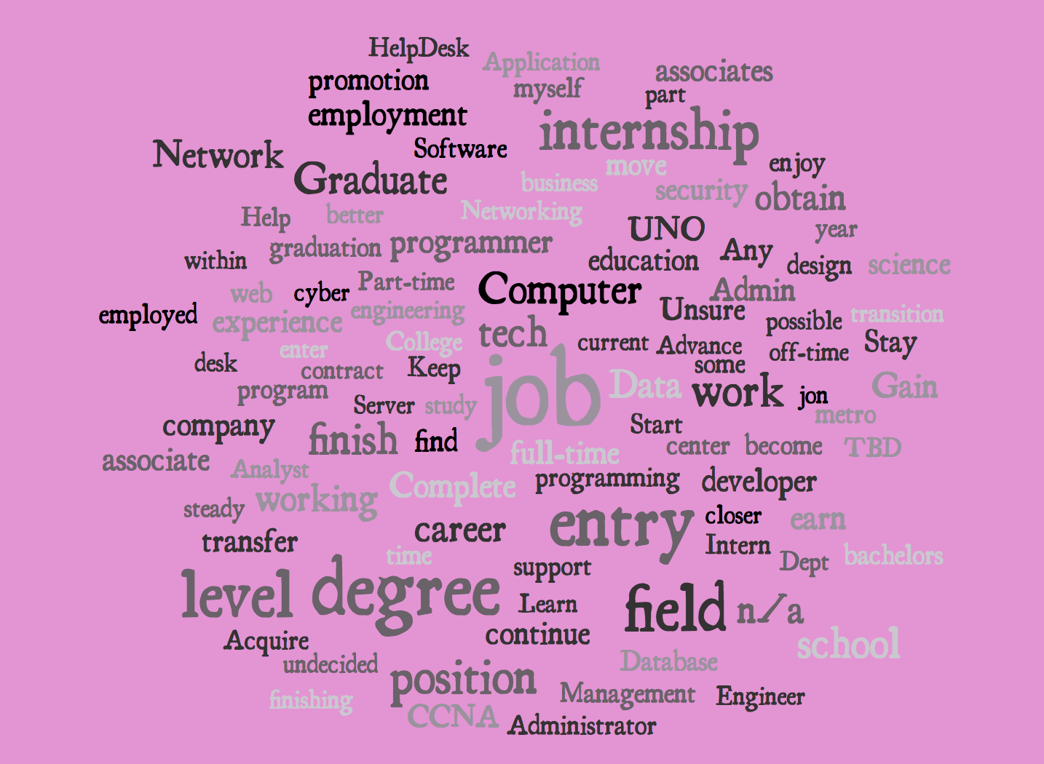
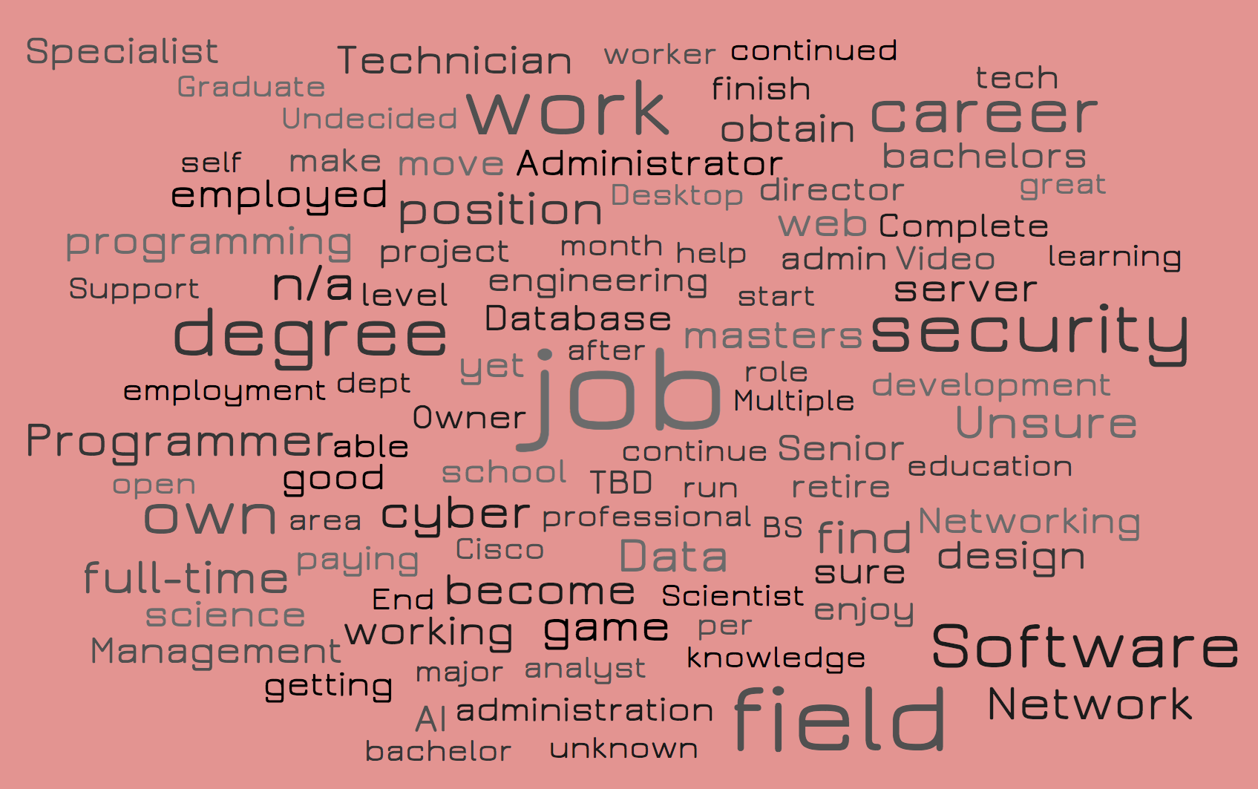
Quantitative Figure 3. Long Term Goal
The available wage data for a sample of students across the PROTO program was available by post-graduation survey. The data were secured by the direct phone call and having contact with a coach that followed up with the student. The wage information is provided in the following table and figure.

Quantitative Table B.1 Unique Participants Served / Enrollees
Unique Participants Served | N1 | N2 | N3 | N
Yes | 96 | 205 | 254 | 555
Blank / No | 1 | 0 | 1 | 2

Quantitative Table B.2 Total Completed a Grant Program of Study
Completed Grant Program | N1 | N2 | N3 | N
Yes | 29 | 25 | 11 | 65
Blank / No | 68 | 180 | 244 | 492

Quantitative Table B.3 Total Incumbents Who Completed Grant Program of Study
Incumbents Completed Study | N1 | N2 | N3 | N
Yes | 21 | 82 | 216 | 319
Blank / No | 76 | 123 | 39 | 238

Quantitative Table B.4 Total Number Retained in Other Education Programs
Incumbents Completed Study | N1 | N2 | N3 | N
Yes | 12 | 23 | 2 | 37
Blank / No | 85 | 182 | 253 | 520

Quantitative Table B.5 Total Number Students Completing Credit Hours
Students Completing Credit Hours | N1 | N2 | N3 | N
Yes | 86 | 124 | 43 | 253
Blank / No | 11 | 81 | 212 | 304

Quantitative Table B.6a Total Number Students Earning Certificates Less Than 1 Year
Earning Certificates Less Than 1 Year | N1 | N2 | N3 | N
Yes | 27 | 75 | 74 | 176
Blank / No | 70 | 130 | 181 | 381

Quantitative Table B.6b Total Number Students Earning Certificates More Than 1 Year
Earning Certificates More Than 1 Year | N1 | N2 | N3 | N
Yes | 1 | 4 | 2 | 7
Blank / No | 96 | 201 | 253 | 550

Quantitative Table B.6c Total Number Students Earning Degrees
Earning Degrees | N1 | N2 | N3 | N
Yes | 28 | 24 | 11 | 63
Blank / No | 69 | 181 | 244 | 494

Quantitative Table B.7 Total Number Enrolled in Further Education After Program of Study
Enrolled in Further Education | N1 | N2 | N3 | N
Yes | 10 | 9 | 8 | 27
Blank / No | 87 | 196 | 247 | 530

Quantitative Table B.8 Total Number Employed After Program of Study Completion
Employed After Program of Study | N1 | N2 | N3 | N
Yes | 5 | 11 | 6 | 22
Blank / No | 92 | 194 | 249 | 235

Quantitative Table B.9 Total Number Retained in Employment After Program of Study
Retained in Employment | N1 | N2 | N3 | N
Yes | 3 | 11 | 4 | 18
Blank / No | 94 | 194 | 251 | 539

Quantitative Table B.10 Total Number Employed Receiving a Wage Increase
Employed Receiving Wage Increase | N1 | N2 | N3 | N
Yes | 7 | 5 | 6 | 18
Blank / No | 90 | 200 | 249 | 539

- Conclusions
The Developmental Evaluation approach utilized by the external evaluators proved to be useful for an evolving, collaborative and complex program such as the Proto interventions. The Project Manager, Navigators/Coaches, curriculum specialist and department Deans and faculty provided open access to the developmental process of the curriculum, services and resources. The evaluators were able to meet on a quarterly basis to talk with all staff members and solicit their feedback in an open and honest manner. The program as a whole attempted a series of innovative activities, such as Appreciative Coaching; interactive partnerships with businesses including the penal system; connected recruiting with such organizations as Heartland Workforce Solutions and departments within the college such as Veteran’s Affairs; and the further partnering with a wide range of businesses, community organizations, and governmental agencies.
The activity that stood out as having the greatest potential of service to students for future projects was the student appreciative coaching and engagement efforts. Students entering the program had a variety of needs that were not being addressed by conventional services. Having this “guide-on-the-side” was so important in helping them successfully navigate the certification programs. One of the limitations and challenges of the overall project was the limited duration of the grant itself, which entailed a relatively short time to hire staff, develop and implement the curriculum and gather any longitudinal data to fully analyze the impacts of the program. The Project Manager and external evaluators were also restricted in the analysis capabilities due to data policies of the Nebraska Department of Labor (NDOL), which only allowed for aggregated data on employment, wage increases and retention.
Three key lessons learned from the evaluation process included: 1) it is essential to have a source of wage and employment data that is able and willing to provide individual data so that appropriate analyses can be conducted; 2) the project has done a great job planning for sustainability and scaling into the processes from day one of the program, and that is certainly a model for other projects, and 3) evaluation of complex projects need a well-articulated quantitative and qualitative mixed methods approach, again as was demonstrated in this project. For future implications for projects such as these, it will be important for evaluation team to work steadily and creatively to establish a detailed agreement with the relative State Departments of Labor. Without a workable state agreement to release individual employment, wage and retention data, causal analysis is challenging and substantially limited.

