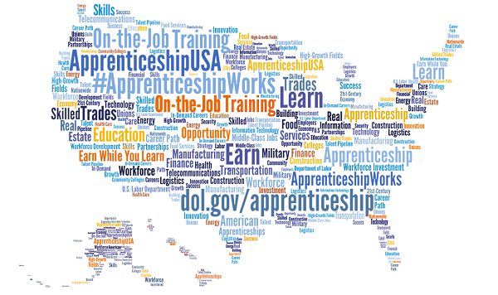

Mechatronics
Apprenticeable Occupations:
- Mechatronics Engineers
- Electrical and Electronics Repairers
- Commercial and Industrial Equipment Repairers
- Industrial Machinery Mechanics
- Maintenance Worker, Machinery
- Cutting, Punching, and Press Machine Setters, Operators, and Tenders, Metal and Plastic
- Engine and Other Machine Assemblers
- Sales Representatives, Wholesale and Manufacturing, Technical and Scientific Products

Oil & Gas Production Technology
Process Technology
Apprenticeable Occupations:

- Wellhead Pumpers
- Industrial Instrument Mechanics
- Pump Operators
- Rig Technicians
- Geological Sample Test Technicians
- Gas Compressor and Gas Pumping Station Operators
- Roustabouts
- Methane/Landfill Gas Generation System Technicians
- Oil Field Equip Mechanic
- Metal-Refining Furnace Operators
- Petroleum Pump System Operators
- Refinery Operators, and Gaugers
- Boilermaker Fitter
- Derrick Operators
- Petroleum Engineers (BS required)
- Rotary Drill Operators
- Gas Plant Operators
- Service Unit Operators, Oil, Gas, and Mining

Construction Management
Apprenticeable Occupations:
- Construction Manager
- Cost Estimators
- Project Superintendent
- Wind Energy Project Manager
- Construction Foreman
- Field Supervisor
- Foreman
- Job Superintendent
- Site Superintendent
- General Operations Manager
- Construction and Building Inspectors

Electronics
Apprenticeable Occupations:
- Electronics Engineering Technologist
- Electronics Engineering Technician
- Robotics Technician
- Electronic Drafter
- Electro-Mechanical Technician
- Telecommunications Equipment Installer and Repairer
- Broadcast Technicians
- Electronic Equipment Installer and Repairer
- Semiconductor Processor

Automation and Controls
Apprenticeable Occupations:
- Industrial Repairman
- Industrial Maintenance Mechanic
- Maintenance Supervisor
- Maintenance Technician
- Industrial Engineering Technician
- Heavy Equipment Mechanic
- Millwrights
- Maintenance Workers, Machinery
- Robotics Technician
- Computer-Controlled Machine Tool Operator
- Industrial Instrument Mechanic
- Manufacturing Production Technician
- Computer Numerically Controlled Machine Tool Programmer

Engineering Graphics
Apprenticeable Occupations:
- Electronic Drafter
- Mechanical Drafter
- Drafter
- Commercial and Industrial Designer
- CAD Drafter
- Drafter/Design Technician
- Mechanical Design Drafter
- 3D Drafter
- Product Design Engineer
- SolidWork Technician
- Design Draftsman
- CAD Operator

Advanced Welding
Apprenticeable Occupations:
- Welding, Soldering, and Brazing Machine Setter, Operator and Tender
- Non-Destructive Testing Specialist
- Pipefitter and Steamfitter
- Structural Metal Fabricator and Fitter
- Structural Iron and Steel Workers
- First-Line Supervisor of Mechanics, Installers and Repairers
- Industrial Machinery Mechanics
- Vocational Education Teachers, Postsecondary
- Solderer and Brazer
- Assembler, Metal Building
- Boilermaker

Cyber Technology
Apprenticeable Occupations:
- Information Security Analysts
- Network and Computer Systems Administrator
- Help Desk Technician
- Computer Programmer
- Computer Operator
- Computer Network Architect
- Web Developer
- Computer User Support Specialist
- Computer Network Support Specialist
- Computer Systems Analyst
- Computer, Automated Teller and Office Machine Repairer
- Web Administrator

