PLA Portfolio-Based
Assessment Rubric Training
Facilitator’s Manual

Table of Contents
Acknowledgements 3
Workshop Timeline 4
Contents 6
Overview of the Training Workshops 6
Intended Audiences for Facilitator and Participant Training 6
Workshop Agenda 6
Learning Outcomes 6
For the Facilitator 7
Workshop Description (For Facilitators Use) 7
Facilitators Duties 7
Training Process 7
During Discussions 8
How to Facilitate the Training Modules 8
Workshop Underlying Methodology 8
Verification 10
Required Materials 10
Keys 11
Trainer/Facilitator's Guide 13
Online: Introductory Pre-workshop Interactive Module Components 13
Learning Objectives 13
Introductory Module Location 13
Face to Face: Workshop 14
Learning Activity 1: Welcome & Introduction 14
Overview: 14
Learning Objectives 15
Learning Activity 2: Rubric Concepts Review 19
Overview: 19
Learning Objectives: 19
Learning Activity 3: The Rubric in Application I 26
Overview: 26
Learning Objectives 26
Learning Activity 4: The Rubric in Application II 32
Overview: 32
Learning Objectives 32
Learning Activities 5: The Rubric in Application III 38
Overview: 38
Learning Objectives 38
Learning Activity 6: Facilitating a Workshop 43
Overview: 43
Learning Objectives 43
Learning Activity 7: Workshop Wrap Up 52
Overview: 52
Learning Activity 8: Workshop Evaluation and Post Test 55
Overview: 55
Learning Objectives 55
Appendix 58
Portfolio Evaluation List 58
Glossary 59
Graded Rubrics (with learning outcomes and grading rationales) 60
Rubric 70
Rubric Key 74
Frequently Asked Questions 78
PLA Rubric & Assessor FAQ’s 78
Assessor FAQ’s 81
Licensing Statement and DOL Disclaimer 83

Acknowledgements
The Ohio Department of Higher Education would like to thank the many people who worked to develop the content of the Common Baseline Portfolio Rubric and the training materials. The Common Baseline Portfolio Rubric was developed by a committee facilitated by Jon Tafel and Don Van Meter and representatives from fourteen public colleges and universities. The Common Baseline Portfolio Rubric was distributed for review to the PLA representatives at each institution. Special thanks go to Carrie Delaney, Lorain County Community College; Barbara Henry, Bowling Green State University; Karin Hooks, Lorain County Community College; and Maureen Schomaker, University of Cincinnati for their invaluable assistance in developing the train-the-trainer materials. Additionally, many of Ohio Department of Higher Education staff contributed to these efforts.

The train-the-trainer manual would not have been developed without the support of the OhioTechNet Consortium’s Trade Adjustment Assistance Community College Career Training grant from the US Department of Labor. It was a truly collaborative effort with OhioTechNet and the support of Linda Feddrix, Bernie Gosky, and Terri Sandu; their financial and thoughtful support led to the creation of this document. Additionally, great thanks go to Debra Beach, Vizul Multimedia, who pulled all the disparate pieces together into a cogent document that will help faculty better understand how to assess portfolios.

Workshop Timeline
TIME | LEARNING ACTIVITY | Page | Slide # | Format | Time
 | Learning Activity 1: Welcome & Introductions | 1 | 2 | Entire Group
9:00 a.m. - 9:15 a.m.  9:15 a.m. –9:20 a.m. | Welcome, introduction of facilitator, handing out manuals, quick overview of the manual and materials, learning outcomes for the workshop, discuss timeline, including breaks and location of facilities.  Preview Learning Activity #6 (Facilitating a Workshop—page 43) |  |  |  | (15 min.)  (5 min.)
9:30 a.m. – 9:45 a.m. | Getting to know you – Icebreaker |  |  |  | (15 min.)
9:45 a.m. 10:00 a.m. | Pre-test: How much do you know? (Computer-based)  (Allows time for logging in, taking test, discussing results) |  |  |  | (15 min.)
 | Learning Activity 2: Rubric Concepts Review | 19 | 10 | Entire Group
10:00 a.m. - 10:30 a.m. | Explanation of the Rubric |  |  |  | (30 min.)
 | Learning Activity 3: The Rubric in Application I | 26 | 24 | Entire Group
10:30 a.m. - 10:50 a.m.  10:50 a.m. –  11:10 a.m. | Comparison of two portfolios, one satisfactory and one unsatisfactory and have learning outcomes available  Focus on:  - What is here  - What is missing  - Discussion about all  Use the same portfolio:  - Now score it  - Discussion how and why scored |  |  |  | (20 min.)  (20 min.)
11:10 a.m. - 11:25 a.m. | BREAK (15 minutes) |  |  |  | (15 min.)
 | Learning Activity 4: The Rubric in Application II | 32 | 32 | Entire Group
11:25 a.m. - 11:45 a.m.  11:45 a.m. –  12:05 p.m. | Ask the same questions as in Activity #3  Use the same portfolio:  - Now score it  - Discussion how and why scored |  |  |  | (20 min.)  (20 min.)
12:05 p.m. - 12:40 p.m. | Learning Activity 5: The Rubric in Application III  Using Rubric Tool evaluate a portfolio on own | 38 | 41 | Entire Group | (35 min.)
 | Learning Activity 6: Facilitating a Workshop  (Previewed in Learning Activity 1) | (43) | (49) | Pairs
12:40 p.m. - 12:50 p.m. | Learning Activity 7: Workshop Wrap Up/Conclusion | 52 | 71 | Entire Group | (10 min.)
 | Review and Questions
12:50 p.m. - 1:00 p.m. | Learning Activity 8: Workshop Evaluation & Post Test | 55 | 74 | Individual | (10 min.)
Post Test: Computer-based
Evaluation
Total workshop hours |  |  |  |  | 4 hours

Contents

Overview of the Training Workshops
The objective for this training is to teach facilitators how to train assessors at their own institution and for current and future assessors to become familiar with the Rubric document, give them guidance in using it, and help them implement it in their assessment process. The training session will also educate participants about the process of portfolio assessment utilizing Ohio's PLA Portfolio Rubric. This training will demonstrate that participants already possess many of the skills to review portfolios through their current instructional activities and will serve as a framework to better utilize the Rubric.

Intended Audiences for Facilitator and Participant Training
Facilitator Training: The people taking the online component and attending the face-to-face workshop will be postsecondary faculty and administrators who will go on to train peers at their own institution.
Assessor Training: The face-to-face workshops held at individual institutions will be attended by postsecondary faculty and administrators who are or will be portfolio assessors.

Workshop Agenda
- Part 1: Twenty-five to thirty minute online/web-based introduction to the rubric (Accomplished before the face-to-face, face-to-face workshop).
- Part 2: Four hours face-to-face training workshop on the use of the rubric.

Learning Outcomes
- Assessor training (At individual institutions)
- In general:
- Describe a rubric and its use.
- Define and label the components of a rubric.
- In particular: Describe the structure of the Portfolio-based rubric.
- Identify the characteristics of effective portfolio review included in the Portfolio-based rubric.
- Discuss the rubric rating and scoring system.
- Interpret the individual rating components and associated rating scale.
- Practice applying the rubric grid on a sample portfolio.
- Examine and appraise a sample portfolio using the rubric.
- Evaluate and justify your review and scoring of a sample portfolio.

- Facilitator training (Initial training to prepare participants to train colleagues at their institution)
- In general:
- Describe a rubric and its use.
- Define and label the components of a rubric.
- In particular: Describe the structure of the Portfolio-based rubric.
- Identify the characteristics of effective portfolio review included in the Portfolio-based rubric.
- Discuss the rubric rating and scoring system.
- Interpret the individual rating components and associated rating scale.
- Practice applying the rubric grid on a sample portfolio.
- Examine and appraise a sample portfolio using the rubric.
- Evaluate and justify your review and scoring of a sample portfolio.
- Use the Facilitator’s Manual and requisite materials and resources to lead workshops at their own institutions.
- Apply and demonstrate the principles learned during their Facilitator’s workshop.

For the Facilitator

Workshop Description (For Facilitators Use)
This training, which includes both a facilitator and Participant Manual, is designed to support post-secondary faculty and administrators who will be evaluating learning portfolios at the college level to determine whether the student/potential student’s knowledge provides the basis for awarding credit towards a degree.
The online introduction and subsequent face-to-face workshop will review the basic components of a rubric and the newly designed Portfolio-based evaluation rubric.
The participants will complete the online introductory component before attending the face-to-face workshop.

Note: It is the workshop facilitators/organizers responsibility to make sure participants know they must complete the short online portion prior to attending the face-to-face workshop.

Facilitators Duties
ODHE experts or trained post-secondary faculty and administrators will facilitate. Their job will be:
- Clarifying the task set
- Identifying stages/steps to take
- Identifying problems and helping learners to find ways of dealing with these
- Identifying areas of strength and how to use them
- Reflecting on activities to identify what went well and not so well, and what can be learned from this
- Discussing evidence that can demonstrate the individual’s learning
- Deciding actions to be taken and identifying short-term goals
- Providing feedback
- Helping the learner to build confidence.
- Support the learners in their reflection on their prior experiences in order to identify their learning and the potential evidence of this learning

Training Process
The workshop training process includes the following:
- Presentation
- Why is this important?
- What do I need to know?
- Discussion/Review
- Practice/Application in groups, pairs and alone
- Assessment of knowledge

During Discussions
Using experiential and social learning, participants will be able to:
- Describe their experience (feelings, thoughts, and reactions).
- Analyze portfolio components and the portfolio as a whole.
- Generalize what principles can be applied to other portfolios.

How to Facilitate the Training Modules
The facilitator's manual is organized to follow the process as noted above. As a facilitator you will see text in the left column that is in normal type; this text is as a “guide” and for your reference. The text noted in Bold, are instructions/extra notes for you as you facilitate (see Key to the Facilitator Guide on the following page).
Participants should follow along in their Participant's Guide, taking notes. Circulate so that they do not get lost. Also, follow the provided script, so participants are not confused by wording that may be different from what they see.

Note: For participants who complete the train the trainer workshop, you will be responsible for training colleagues at your own institutions, and as a facilitator you can use your own judgement as to how many of the learning activities to complete. When customizing your training event, please note that each learning activity builds on the prior one. Make sure to read and review each activity before modifying your training event. For the rubric to be adequately and consistently applied, we need to assure sufficient transfer of learning.

Workshop Underlying Methodology
This training is designed to follow adult learning principles:

Learner Centered
- Prioritize participants’ success
- Characterized by respect, relationship and relevance

Action with Reflection
- Hands-on, action-based
- Capture learning by examining and reflecting on the action of reviewing real portfolios

Problem-Based
- Learning is motivated by having a problem to solve (awareness versus learning)
- See results from learning experiences (construct knowledge through solving problems)

Teamwork
- Draw on synergy rather than competition or independence
- A team provides more substantive and varied input than one person

Self-Discovery
- Do nothing for learners that they can do for themselves
- People believe and assimilate more of what they discover for themselves
- Trainers set and lead problems. They are resource people, consultants and guides

Overall Goals
The overall goal of the pre-training and workshop is to prepare participants to effectively evaluate portfolios by implementing the rubric and to be able to train/educate other potential portfolio evaluators.

Experiential and social learning is used.
As a facilitator you should provide an atmosphere that encourages optimal learning. This serves multiple functions:
- Participants can share experiences and reflect on the content to draw out and strengthen learning.
- Allows participants’ unique strengths to shine.
- Brings out the relevance of learning.
- Organizes learning into the big picture (what we did. what we will do).
- Engages participants using social learning and interaction, which is more fruitful and memorable than learning on your own.
- Builds collegial relationships that extend beyond the classroom.
- Helps participants engage with the process, learning how their strengths and effort benefits others.
- Opens possibilities for insight, or ah-ha moments.
- Provides occasions for teachable moments.
- Allows a safe place for participants to struggle with learning (all learning involves some struggle).
- Provides opportunity to process experiences (both successes and challenges) towards being equipped to maximize successes and mitigate challenges.
- Begins and end the training with positive emotions. (What has gone well?).

Verification
Verification will be done at three levels: Learning (during the workshop).
Participants will:
Understand the need for state-wide consistency in assessing portfolios.
- Gain knowledge and understanding of the Rubric and its application in assessing portfolios.
- Transfer (application of learning during the course and at their respective institutions).
The goal is that after training, participants will:
- Use the rubric to adequately evaluate and assess portfolios and create more consistency across institutions.
- Be able to coach their peers in the portfolio process.
- Troubleshoot and solve problems encountered in the process of evaluating student portfolios.
Impact (Results on the portfolio credit transfer process for institutions and students)
- In the months following the training, post-secondary faculty and administrators and institutions will:
- Deliver a standardized process by which portfolios will be evaluated.
- Provide a clear procedure which assessors can follow.

Required Materials

Manuals
- Online/paper-based Facilitator and Participant Manuals.
- Online/paper-based Sample Portfolios.

Equipment
- Computers with online access.
- PowerPoint slides
- Projector and screen (for facilitator).

Resources/Tools
- Online interactive introduction to the rubric and workshop.
- Online rubric
- Online rubric FAQ’s, Q & A’s
- PowerPoint presentation for face-to-face workshop.
- Graded rubric copies.
- Extra blank rubrics printed out and available. The number should be equal to or greater than the number of portfolio’s to be reviewed by each participant.

Keys

Page Key
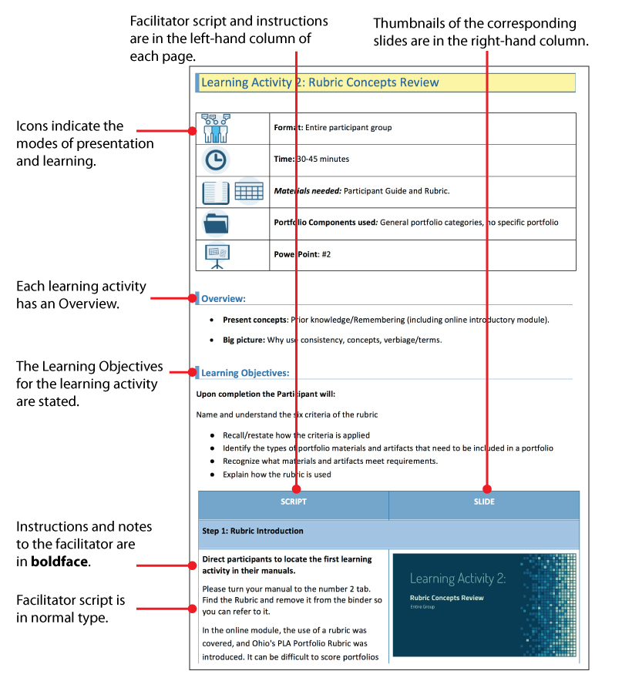

Symbol Key
These symbols will be used to indicate the modes and materials used for the workshop
Materials Modes
Participant’s  Guide | Rubric | Online/  Computer | Portfolio/s | Time | Learn/  Evaluate | Questions/  Reflection
PowerPoint | Test or  Quiz | Documents | Prepare/  Setup | Individual | Small Group | Large Group

Trainer/Facilitator's Guide

Online: Introductory Pre-workshop Interactive Module Components
Format: Individually, online
Time: 15 minutes
Materials needed: Computer with online access
Portfolio Components used: Individual portfolio components taken from the set used for the face-to-face workshop.

Note: This component is to be completed by participants before they attend the face-to-face training.

Learning Objectives
Upon completion the Participant will:
- Understand Prior Learning Assessment (PLA)
- Describe a rubric and its use.
- Define and label the components of a rubric.

Introductory Module Location
The Online Module is located within the ODHE website under PLA Train-the-Trainer Resources: https://www.ohiohighered.org/PLA-resources

Face to Face: Workshop

Learning Activity 1: Welcome & Introduction

Format: Entire participant group
Time: 35 minutes
Materials needed: Participant Manual
Portfolio components used: None
PowerPoint: Learning Activity 1 – Slides 1-9
Pre-Test

SETUP: Prepare the classroom. Set up lab computers, projector, and PowerPoint. Make sure all materials are ready to distribute.
IMPORTANT: You will need copies of the rubric for participants to use when grading portfolios. It is suggested that you make 10 copies of pages 1 &2 of the rubric for each participant to use in each of the learning activities that require an evaluation of a portfolio.

Note: Each institution has policies about administration of PLA. Review of the portfolio will fit within institutional policies. Each trainer will be responsible for having knowledge of their institutional policies/institutional FAQs to share in context of training.

Overview:
- Welcome and Introductions
- Distribution of participant manuals
- Explanation of participant manual and initial questions

Learning Objectives
Upon completion the Participant will:
Locate the introduction/welcome content within their manual
Familiarize themselves with the manual and its components
Recall what they learned in the online pre-workshop module
Discuss thoughts and questions they have about the module content

SCRIPT | SLIDE
Step 1
Welcome to the Portfolio-Based Assessment Rubric Training Workshop.  Introduce yourself and Explain that you will be asking each of the participants to introduce themselves in a few minutes  My name is ___________ and I am pleased you are attending this workshop. Through this session, you will learn about the process of portfolio assessment utilizing Ohio's PLA Portfolio Rubric. That’s a long title, so from here forward we will just refer to it as “the Rubric”. This training will demonstrate that you already possess many of the skills to review portfolios through your current instructional activities and will serve as a framework to better utilize the Rubric.  It will also help you become familiar with the Rubric document, give you guidance in using it, and help you implement it in your assessment process. | Slide 1  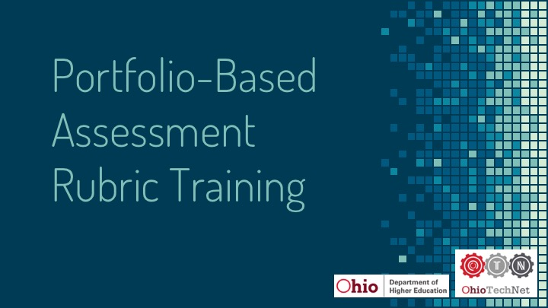  Slide 2  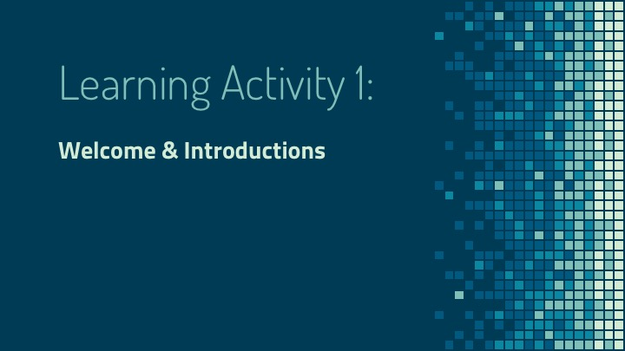
Step 2: Transition: Introductions
Before we begin, let’s introduce ourselves. Tell us your name, institution, your job/position and how you hope to benefit from this training.  Go around the room and have each person introduce themselves.  Before we get started it is important to note how the workshop is organized, how long each activity will take, including breaks, and where you can find restrooms, vending machines, beverages, etc.  Discuss the workshop timeline, including breaks and location of facilities at your location.  Answer any questions participants may have.  Do you have any questions before we begin the first Learning Activity? | Slide 3Slide 4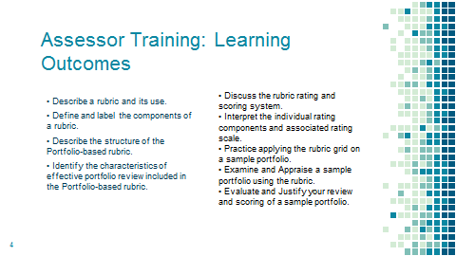  Slide 5  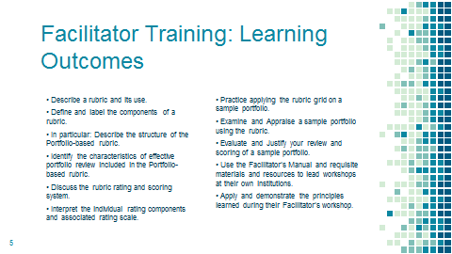
Step 3: Reflection
You’ve completed the online component before this workshop. So, what do you already know about the how to use the Rubric? Think about what you would like to know. What are its criteria? How can we use them? How will they help us in our assessment work? | Slide 6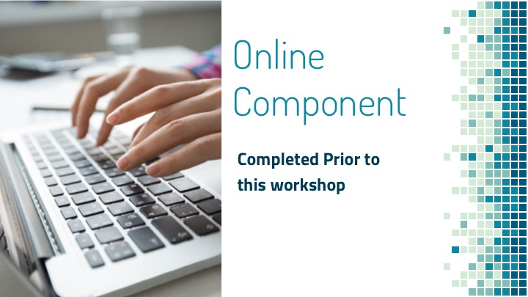
Step 4: Pre-test & Initial Questions
Guide the participants to the “PLA Training Pre-Test.  Before you take the pre-test, briefly look at the rubric to refresh what you previously learned in your homework.  Please answer the questions in the quiz to see what you already know or might guess about the Rubric. | Slide 7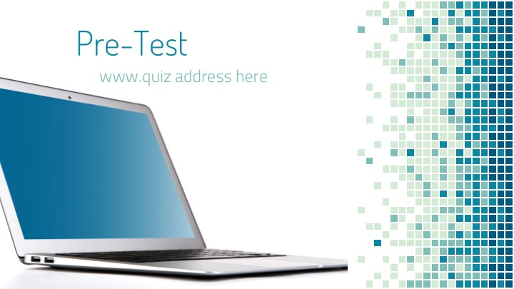
Thank you for completing the quiz. Now, let’s try to answer some of the questions you might have. | Blank/none
Step 5: The Participant Manual
Hand out the participant’s manuals once the group has finished the quiz.  I am passing out the participant’s manuals that we will use for the learning activities. | Slide 8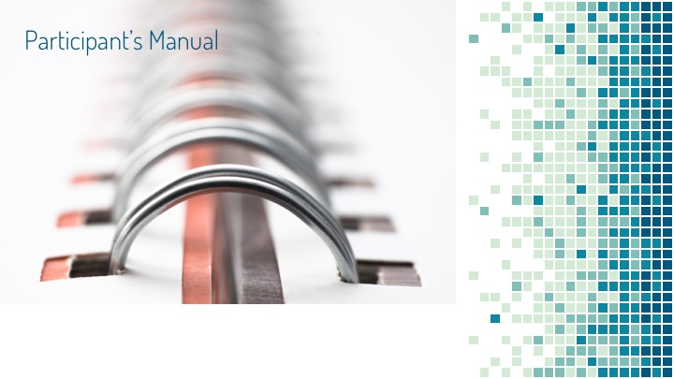
Briefly explain organization of manual and the materials that are included.  You will notice that the content is organized by modules. You can use the Table of Contents in the front to find a particular module or the Appendix in the back to locate a specific topic or term.  In our workshop today, you will learn how to apply the Rubric to a variety of portfolios. You will work as a group, small groups, pairs and/or individually to assess and discuss the portfolios included in the modules. | Blank/None
Step 6: The Rubric (review) & Questions
Review the Online content very briefly.  In the online portion you completed before this workshop, you learned more about Prior Learning Assessment and were introduced to the new Ohio Portfolio Rubric and how it plays an important part in preserving high standards and maintaining consistency. In addition, it briefly covered the rubric criteria and basics of how to apply it. You also applied that knowledge to evaluate two portfolio components.  Questions:  Do you have any initial questions or feedback on the online portion?  Record or address all questions and comments. | Slide 9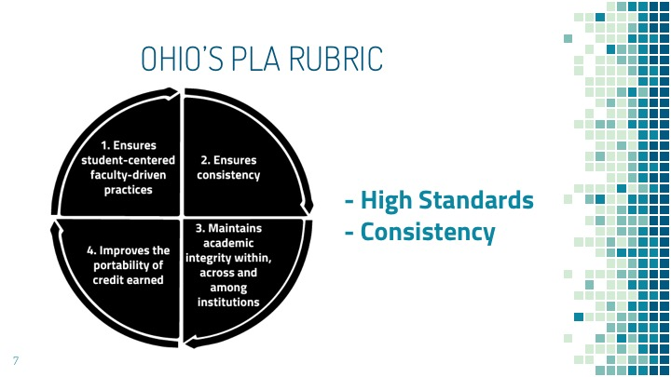
Step 6: Transition/Activity End
Transition:  Now that we've recorded or addressed all of your questions, we'll move on to the next activity. | Blank/None

Learning Activity 2: Rubric Concepts Review

Format: Entire participant group
Time: 30 minutes
Materials needed: Participant Manual and Rubric, Rubric Key
Portfolio Components used: General portfolio categories, no specific portfolio
PowerPoint: Learning Activity 2 – Slides 10-23

Overview:
- Present concepts: Prior knowledge/Remembering (including online introductory module).
- Big picture: Why use consistency, concepts, verbiage/terms.

Learning Objectives:
Upon completion the Participant will:
- Name and understand the six criteria of the rubric
- Recall/restate how the criteria is applied
- Identify the types of portfolio materials and artifacts that need to be included in a portfolio
- Recognize what materials and artifacts meet requirements.
- Explain how the rubric is used

SCRIPT | SLIDE
Step 1: Rubric Introduction
Pass out rubric. Please turn your manual to the Learning Activity 2.  In the homework module, the use of a rubric was covered, and Ohio's PLA Portfolio Rubric was introduced. It can be difficult to score portfolios reliably, since they are an individual expression of a person’s own work and learning achievements. Interpreting them involves a high degree of subjective judgment. The rubric ensures that assessments of portfolios can be uniform and consistent in judgement and application. Students too will find it useful as they develop their portfolios. The rubric, while serving a dual purpose, will be most valuable to those who assess. | Slide 10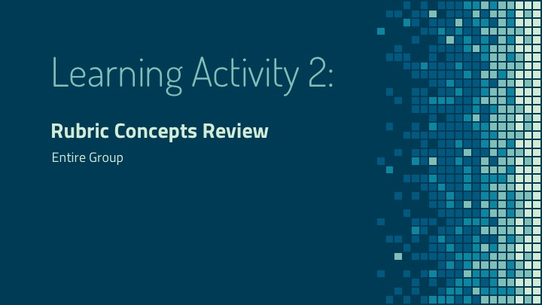  Slide 11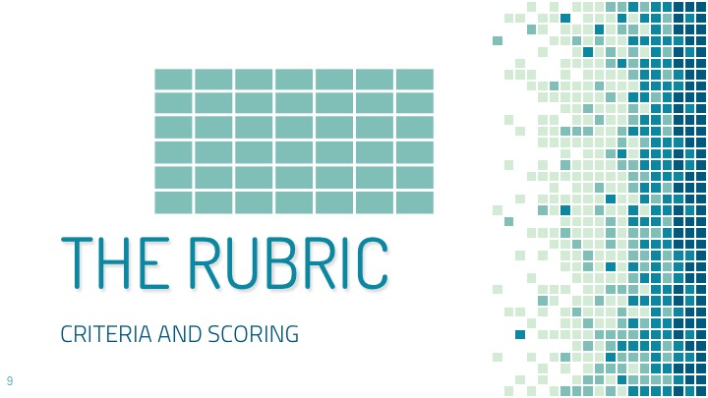
Step 2: Documentation
Let's look at the rubric criteria categories.  Discussion of documentation, the artifacts and elements and where they may fit within each criteria.  The collection of documents in a portfolio that establish and support the claim that the applicant has specific relevant: skills, knowledge, values, attitudes, understanding, achievements, experiences, competencies, training, and certifications that align with specific course objectives. The portfolio should not only describe the relevant experience but should also identify the particular learning outcomes that they satisfy.  These specific course outcomes should be attached to the rubric before assessing a portfolio.  As you review any portfolio it is important to note that the rubric assessment criteria may not correlate to any particular type of portfolio artifact or document. Portfolio artifacts will vary greatly by course and discipline. Each will depend on the content of the course  The Demonstration of Learning will have some correlating materials like training certificates, military records or other student work, but as an assessor you will need to use the course learning outcomes in addition to your expertise and judgement to appraise individual portfolio pieces to determine which criteria they satisfy. | Slide 12  Slide 13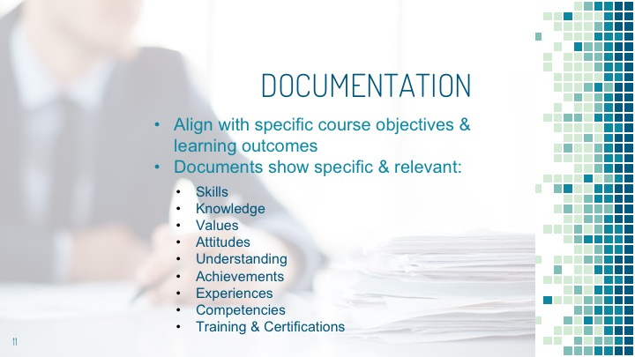
Step 3: Rubric Criteria Categories
We are now going to explore the rubric criteria.  The Assessment Ratings Criteria are:  - Sources of Learning  - Demonstration of Learning  - Evidence of Learning  - Mastering Knowledge and Skills  - Reflection on Learning  - Presentation  Let’s look at each category more in-depth… | Slide 14  Slide 15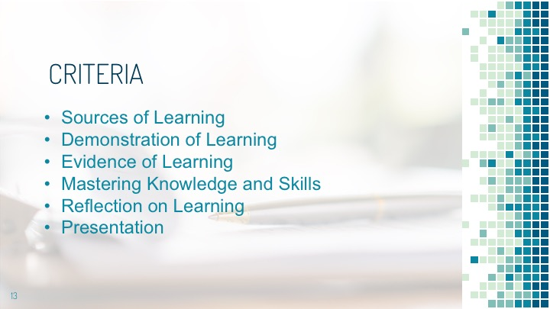
Sources of Learning  The narrative would:  - Document learning experiences  - Relate the learning experiences to the stated course learning outcomes  - Examine and show how prior learning meets/fulfills the stated course outcomes  - Document and describe learning experiences  - Align past learning with the course learning outcomes | Slide 16  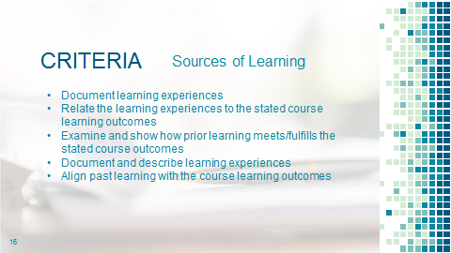
Demonstration of Learning  Appropriate documents and artifacts which support the course learning outcomes and are appropriate to the field of study. Examples might be:  - Training certificates - Training records - Transcripts - Work samples - Business plans - Publications - Performance reviews - Photographs/videos/ multimedia - PowerPoint presentations - Official documents of learning experiences | Slide 17  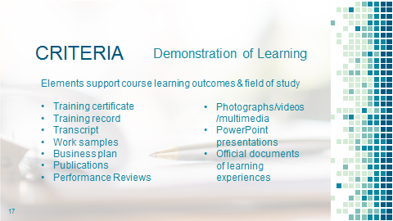
Evidence of Learning  Institutional PLA processes may vary. If you work directly with students, you can assist them in the creation of a more robust portfolio that provides better evidence of learning by introducing them to an appropriate academic framework. For example, Kolb’s Learning Theory examines experiential learning and  may assist students in relating their experience and incorporating detailed evidence into the narrative. | Slide 18  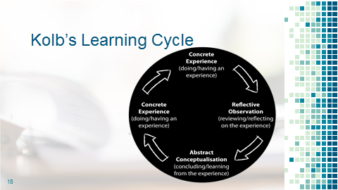
Mastering Knowledge and Skills  - Concrete, specific experiences of good or optimal length (to ensure learning took place)  - The ability to apply knowledge and skills in practice for a sufficient period  - Application of their knowledge to a different learning and problem solution | Slide 19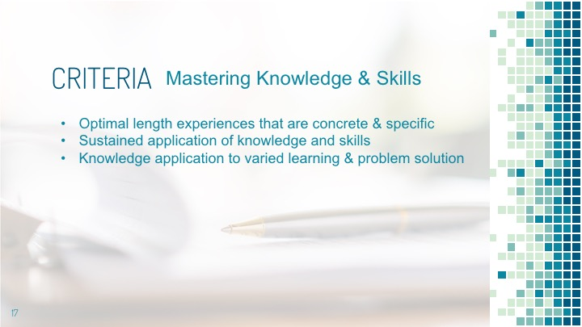
Reflection on Learning  - Begin to self-evaluate utilizing critical reflection: What produced this personal growth and expertise?  - Able to implement strategies and recognize knowledge gained by the concrete experience: How did self-reflection help the student better understand their learning? Did student demonstrate growth? | Slide 20  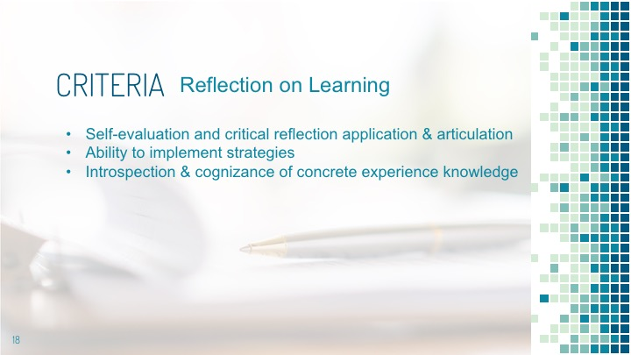
Presentation  - All required elements are included  - Clear and well organized  - Quality of all documentation  - Attention to grammar and spelling | Slide 21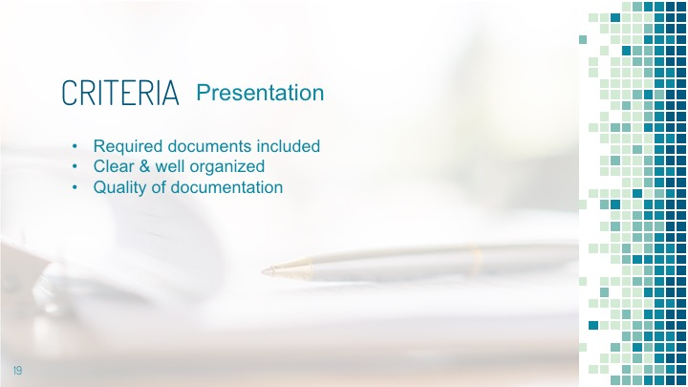
Step 4: Ratings and Scoring
Expectation Ratings are between 0-3  - 0 - Does not meet  - 1 - Partially meets  - 2 - Meets  - 3 – Exceeds | Slide 22  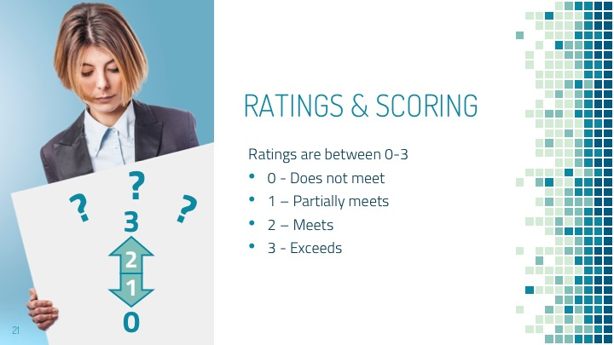
Scoring can run between 0-18  - 12 is a recommended successful score,  - There must be at least a score of 1 in each of the six assessment criteria | Slide 23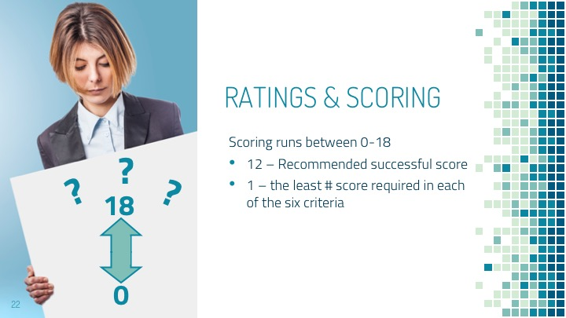
Step 5: Transition/Activity End
Now that we are clear about the criteria and the scoring expectations, we must investigate the question of what does an exemplary rating such as #3 - Exceeds expectations look like….and what do the #0-2 ratings look like?  Certainly, there will be some gray areas and subjectivity, but let’s investigate what may fall into each of these ratings as we move to the next learning activity. | None/Blank

Learning Activity 3: The Rubric in Application I

Format: Entire participant group
Time: 40 minutes
Materials needed: Participant Manual, rubric key, blank rubric copies for grading the portfolios, PPT presentation. Course learning outcomes, graded rubric copies for distribution to group once they have evaluated the portfolio/s.
Portfolio Components used: Two Portfolios (#’s 1- satisfactory and 2 - unsatisfactory), graded rubric/s, course learning outcomes
PowerPoint: Learning Activity 3 – slides 24-31

Overview:
- Compare 2 different sample portfolios and determine whether they meet criteria of rubric
- Provide rationale for choices

Learning Objectives
Upon completion the Participant will:
- Apply the rubric to two portfolios
- Compare two portfolios
- Examine and analyze components of each portfolio
- Score the portfolios
- Discuss each portfolio's quality and completeness
- Justify their ratings

SCRIPT | SLIDE
Step 1: Introduction of the Learning Activity
Note: Pass out two blank rubric copies to each participant. Reserve the graded rubric copies until the group/s have evaluated and graded the portfolio. Distribute a copy to each group.  Introduce the learning activity  Now that we are familiar with the rubric criteria and scoring, let’s compare two portfolios to determine if and why they meet all criteria.  Our goal is two-fold:  First, we will compare two portfolios as a group to determine whether the applicant has fully satisfied each criteria with their submission.  Second, we will look for evidence that indicates how well they satisfied it and assign ratings to each criteria. Keep in mind the stated course learning outcomes as we evaluate and compare these two portfolios. | Slide 24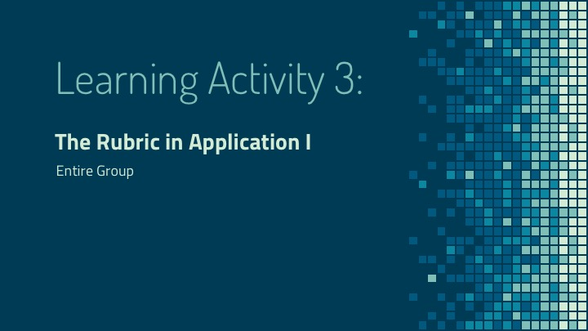 Slide 25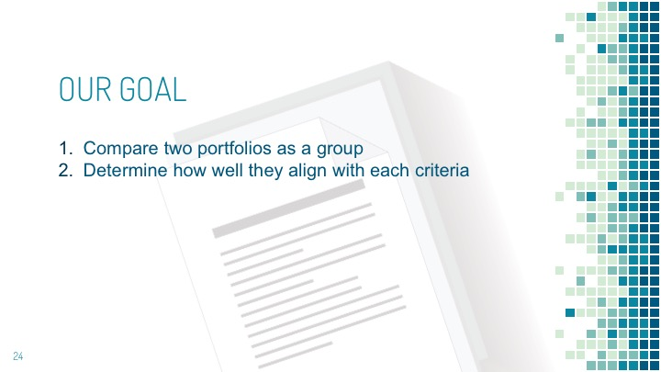
Step 2: Locating the Sample Portfolios
Direct the participants to find Learning Activity #3.  Keep the assessment rubric out and go to Portfolio Examples book.  Review the Learning Outcomes for the portfolios.  Have the portfolios in front of you so you may view and compare them. | Blank/None
Step 3: Determining Completeness
We will work on this activity as a group.  Begin by reviewing the course learning outcomes for each of the two portfolios and then the rubric. Refer to each category and criteria  The first thing we need to determine is whether both portfolios are complete. Does each of the portfolios have all required documentation?  If not, what is or may be missing?  Note that each portfolio may be organized differently and have varying artifacts and documents. You will need to distinguish between these elements and organize them in a way that makes sense to you as you evaluate them | Slide 26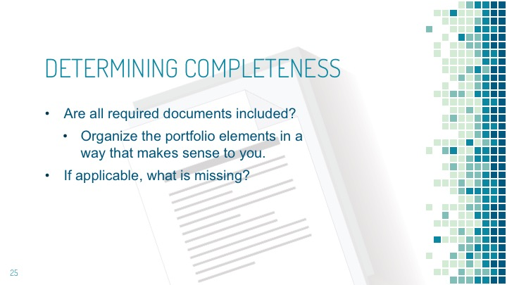
Step 4: Fulfillment of Criteria
Does each portfolio’s set of documentation apply to the course learning outcomes and fulfill the criteria of the rubric? How should it be scored?  Look at each document. How well do they meet the criteria and what scores would you choose? | Slide 27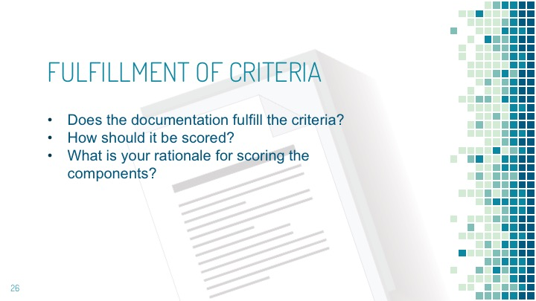
Step 5: Individual Rationales for Scoring
Why would you score it as a 0, 1, 2, or 3?  What is your rationale? | Blank/None
Step 6: Comparing Your Individual Rating to the Group’s Score
As a group find agreement on scoring  Let’s discuss ratings for documents and as a group assign scores for them  Reflection: Go through each document and rate them as a group. Take note of the final results.  Now we will compare our individual scoring to the group rating.  After our discussion, would you change your appraisal of either portfolio? | Slide 28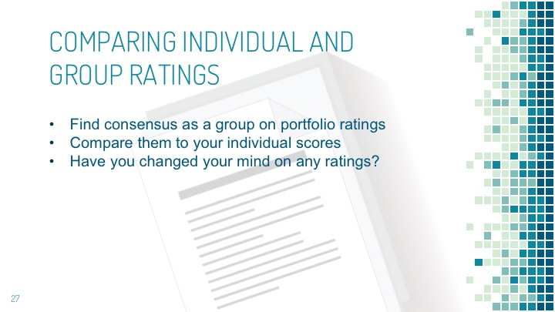
Step 7: Comparing Individual & Group Scores to the Original Assessors Scores
As an assessor you will have to weigh your scoring decisions carefully. Reviewing how an original assessor rated a portfolio can be helpful in developing your rating skills.  Pass out Graded Rubrics.  Take a look at the original assessor’s scores again and compare them to both the group’s score and your individual initial score.  Discuss how the group and individuals compare to the original assessment scores.  Review the original assessor’s rationale for scoring. Do you agree with their scores and rationale? Why or why not?  Do any of the original assessor’s rationales change your thoughts on the scores we chose as a group or personally? Why? | Slide 29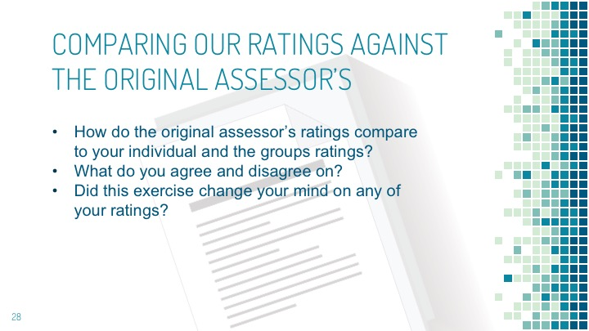
Step 8: Borderline and Incomplete Portfolios
Sometimes a portfolio will come to you with poorly composed or gathered components or missing important elements.  Discuss borderline ratings and incomplete portfolios/those needing more work  If you find that a portfolio’s contents do not present clear evidence of learning, or that important pieces are missing, how should you proceed?  Does your institution have any policies or procedures in place to request the applicant provide a more robust and complete portfolio?  How would you write your request for these?  Discuss how different institutions accomplish this. | Slide 30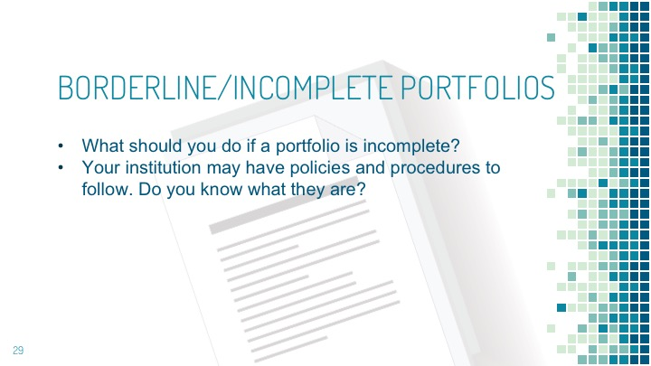
Step 9: Portfolios in Need of Changes/Additions or Resubmission
How to advise students or communicate adequately what needs to be added/changed/improved.  There will be times that submitted portfolios do not meet the learning outcomes for a particular course and it is understandable that they would not pass.  However, portfolios that need minor improvements, such as more documentation of learning or inclusion of a required form, may sometimes be resubmitted by the applicants. (Please check to see your institution’s policies as they may vary.)  While you may or may not have direct communication with applicants about their portfolios, providing clear and concise written rationales, explanations and directions for re-submitting a portfolio will assist them in making sure that their second try will be more successful. It is critical assessors understand their institution’s policy on resubmission as it may vary between institutions. | Slide 31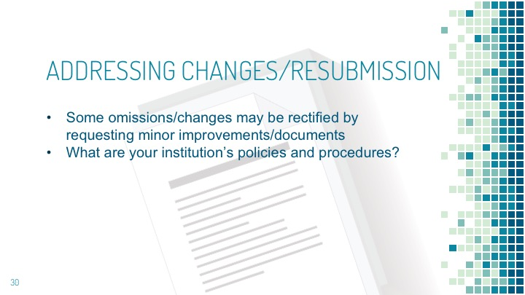
Step 10: Transition/Activity End
In this activity we compared two portfolios, examined for completeness, scored, and justified our rationales.  Does anyone have any questions before we move to the next learning activity?  Answer any questions then move on to Learning Activity #4. | Blank/None

Learning Activity 4: The Rubric in Application II
Format: Entire Group (May want split into smaller groups if you have a larger group)
Time: 40 minutes
Materials needed: Participant Manual, course learning outcomes, rubric key, blank rubric copies for grading the portfolios, graded rubric copies for distribution to group once they have evaluated the portfolio/s.

Portfolio Components Used: #3
PowerPoint: Learning Activity 4 – Slides 32-40

Overview:
- Review 1 sample portfolio & whether it meets rubric criteria

Learning Objectives
Upon completion the Participant will:
- Apply the rubric to a portfolio
- Distinguish between the documents and artifacts
- Examine and analyze components of each portfolio
- Score the portfolio
- Discuss the portfolio's quality and completeness
- Justify the ratings they assigned to each component

SCRIPT | SLIDE
Step 1: Divide Up into Smaller Groups
Note: Pass out two blank rubric copies to each participant. Reserve the graded rubric copies until the group/s have evaluated and graded the portfolio. Distribute a copy to each group.  As a facilitator, and for this activity, you may want to split into small groups of 6-8 depending on the number of participants. | Slide 32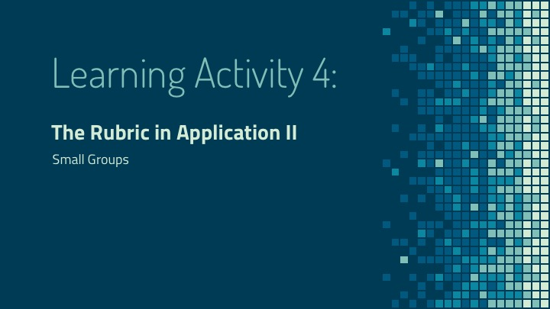
Step 2: Introduce the Activity
In this activity you will assess one portfolio.  Go to Learning Activity #4 in your manual.  Locate portfolio #3 and have it in front of you so that you may review and compare its contents. | Slide 33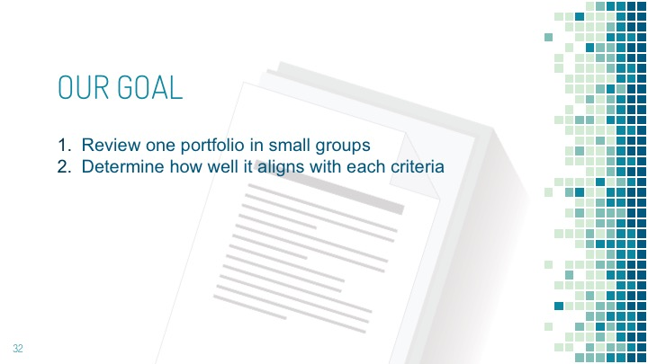
Step 3: Identify the Portfolio’s Components/Artifacts
This particular portfolio has the following elements:  - Cover page  - Preface  - Honesty Statement  - Applicant Chronological Record  - Goals  - Assessment request  - Learning statement  - Supporting document  - Job Description  - Training Manual sample  - Certificate of completion  - Letter from Employers/Peers  - Training Evaluation/Performance Reviews  - Certificates of Attendance/Completion  - Photos of Awards  - News Article  - Award nomination form and letters  - Photo of applicant co-presenting  - Customer, Employer, New Hire, and Club surveys | Slide 34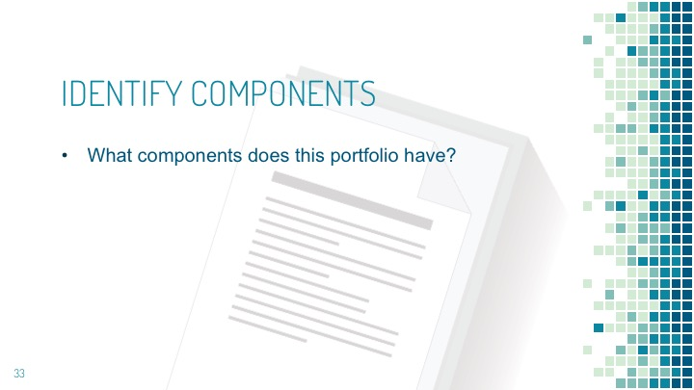
Step 4: Identify Relevant Components
You will need to identify the components that will need to be examined and assessed.  Remember you may receive portfolios that contain documents/artifacts that are not needed. | Slide 35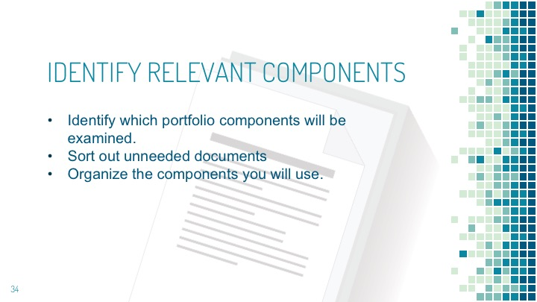
Step 5: Portfolio Completeness
In reviewing the components, ask: Does the portfolio look complete? Is there anything missing? Discuss this among your group. | Slide 36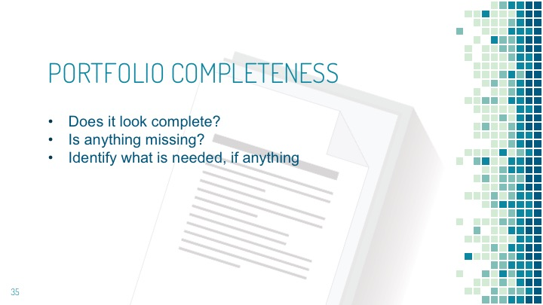
Step 6: Components as they Align to Criteria
Now review each component in your group and discuss where each component fits within the criteria and how well it aligns with the learning outcomes. | Slide 37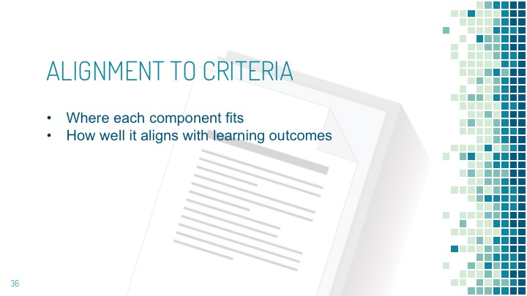
Step 7: Review and Score Portfolio
Now review and score the portfolio  Ask yourselves: Do the documents and artifacts provide “clear” evidence that the applicant has “mastered” course learning outcomes and competencies?  For each component, how well does it align with the Rubric expectations? | Slide 38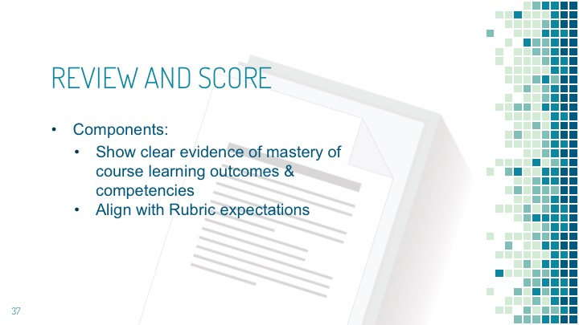
Step 8: Discuss Differences and Final Scoring
As a group, discuss any differences in final scoring and why you came to different conclusions. | Blank/None
Step 9: Sharing Small Groups Findings
Let’s share our results. The group (or groups) will present their findings and we will compare and discuss our methodology, conclusions and rationales for scoring as we did.  Facilitator guides the discussion as each group presents their final scores.  Would your group change any scores? If so, why?  Address any questions/comments | Blank/None
Step 10: Borderline Ratings/Incomplete Portfolios
Discuss borderline ratings and incomplete portfolios/ones needing more work.  In the case of sending the portfolio back to a student if it is incomplete/needs more work, assessors must provide reasons and rationales.  They need to adequately communicate what is needed, such as: Additional elements, more depth, application in practice, evidence, better writing skills. Note that different institutions may have different re-submission criteria, as it varies from institution to institution.  Now, think about and provide rationale/s as to why you scored each criteria as you did.  Clear rationales provide the reasoning and logic behind the scores you choose. This will help students/others who view your assessment ratings. | Slide 39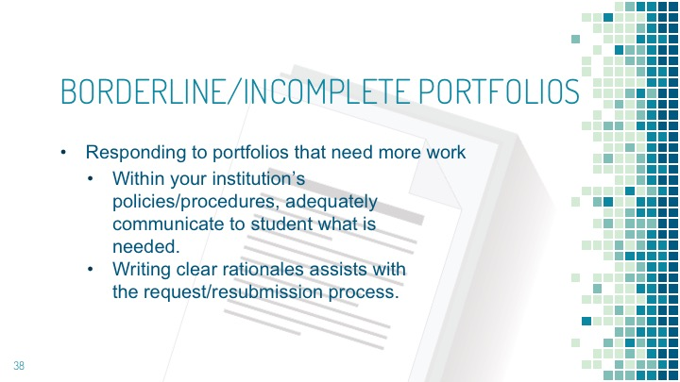
Step 11: Reviewing the Original Assessors Scores
Now take a look at the original assessor’s scores  Pass out the Graded Rubrics  Review their rationale for scoring. Do you agree with their ratings and rationale? Why?  Do any of their rationales change your thoughts on the ratings you chose? Why? | Slide 40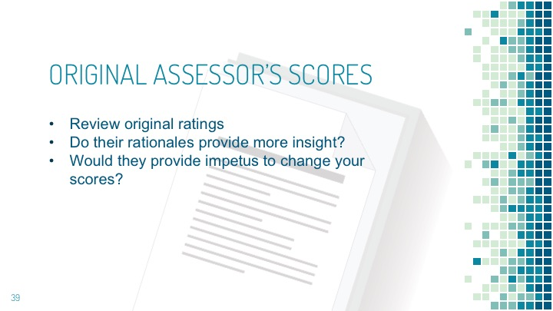
Step 12: Transition/Activity End
In this activity we honed our skills in identifying needed portfolio components, evaluated a portfolio for completeness, scored it and justified our ratings.  Are there any questions?  Wait for and answer any questions.  If not, let’s move on to the next activity. | Blank/None

Learning Activities 5: The Rubric in Application III
Format: In Pairs, as reviewers
Time: 35 minutes
Materials needed: Participant Manual, rubric key, blank rubric copies for grading the portfolios, course learning outcomes, graded rubric copies for distribution to group once they have evaluated the portfolio/s.

Portfolio Components Used: # 4 – good
PowerPoint: Learning Activity 5 – Slides 41-48

Overview:
Review 1 sample portfolio & whether it meets rubric criteria

Learning Objectives
Upon completion the Participant will:
- Demonstrate their proficiency
- Practice interpreting sample portfolios
- Examine and inspect the portfolio
- Appraise the portfolio
- Distinguish between the documents and artifacts
- Examine and analyze components of each portfolio
- Score the portfolio
- Discuss the portfolio's quality and completeness
- Justify the ratings they assigned to each component

SCRIPT | SLIDE
Step 1: Divide into Pairs
Note: Pass out two blank rubric copies to each participant. Reserve the graded rubric copies until the group/s have evaluated and graded the portfolio. Distribute a copy to each group.  To gain experience and confidence, the learning activities provided an opportunity to evaluate portfolios in both a large and small group. Now that you are more experienced, let’s divide our small groups further into pairs. This will be our last portfolio to evaluate together.  Divide the groups into pairs. If one person remains, create one group of three. | Slide 41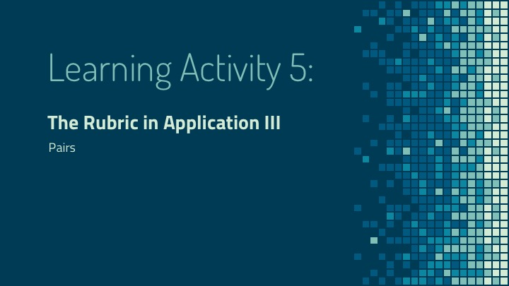
Step 2: Introduce Learning Activity
Locate learning activity #5 in your manual and have portfolio #4 in front of you so that you may review and compare its contents. | Slide 42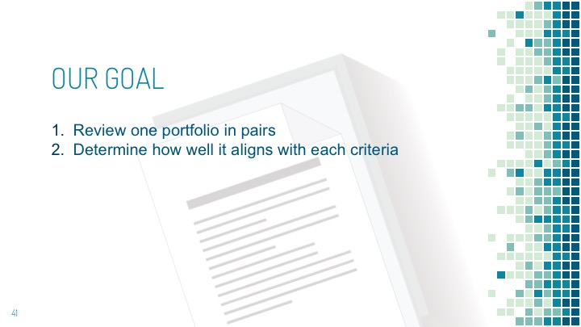
Step 3: Identify Components
Ask each pair to identify the portfolio’s components  As with the last activity, identify its components.  Components are:  - Cover page  - Table of Contents  - Course info  - Autobiography  - Resume  - Prior Learning narrative  - Reference letters/Work experience statements  - Prior University degree transcript (blank) | Slide 43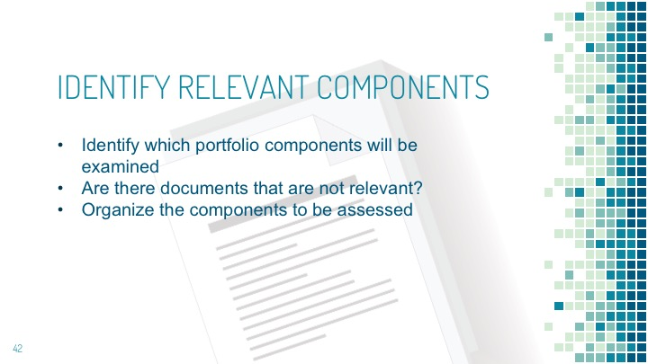
Circulate the room to assist, answer questions as they come up and note those that the entire group should be aware of. | Blank/None
Pairs review each component.  As with the prior portfolio, Identify the components that will need to be examined and assessed. | Blank/None
Instruct the groups to make a list of the components in the provided space in their participant’s manuals.  In the space provided in your participant’s manuals, list the components of the portfolio.  Next, organize them in a way that makes sense to you as you review them. | Blank/None
Step 4: Portfolio Completeness
Ask yourselves: Does the portfolio look complete?  Is there anything missing?  If yes, what?  Make note of the missing components.  Discuss with your partner what may be missing or incomplete and how to address the issues.  The group should know from the previous activity what to do in case of an incomplete portfolio (e.g., ask for resubmission/missing components as per their institutions protocol). | Slide 44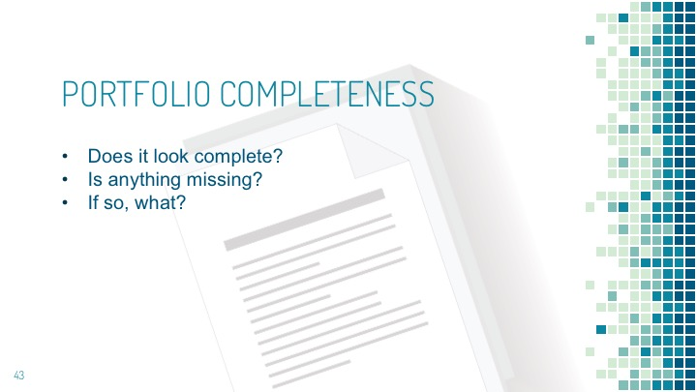
Step 5: Components as they Align to Criteria
Pairs discuss where each component fits within the rubric’s criteria.  With your partner, review each component and discuss where each component fits within six rubric criteria and how well it aligns with the learning outcomes. | Slide 45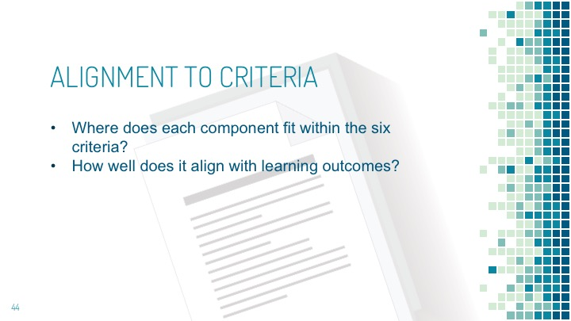
Step 6: Review and Score Portfolio
Pairs review and score the portfolio.  Review the documents and artifacts. Do they provide “clear” evidence that the applicant has “mastered” course learning outcomes and competencies?  Scoring the portfolio  For each component, how well does it align with the Rubric expectations?  Decide on your final scoring. | Slide 46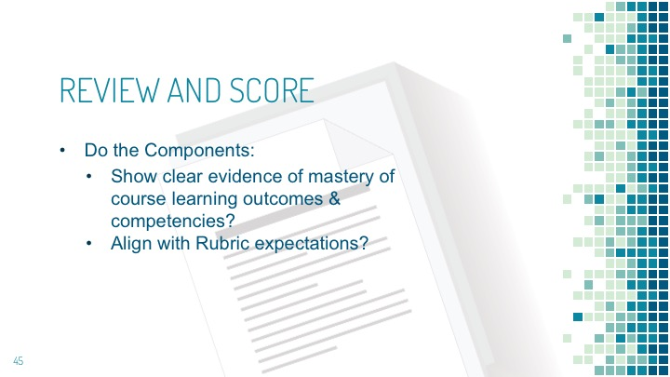
Step 7: Scoring Rationales
Each group will present their score and rationale.  Now, each pair will present their final score and provide rationale as to why they scored each criterion as they did. | Blank/None
Step 8: Group Discussion
The entire group discusses any differences in final scoring and rationales.  Now let’s discuss differences in your scoring.  Take time for the group to discuss scoring and rationales.  After our discussion, does anyone think that they should change any of their scores? If so, why? | Blank/None
Step 9: Borderline Ratings/Incomplete Portfolios
Did any of you determine the portfolio had borderline scoring? If so why?  Wait for answers  Do you know your institution’s procedure for requesting more artifacts/documents or asking for a resubmission? If not, make sure to find that out so you know what to do and can share that information with assessors at your institution. | Slide 47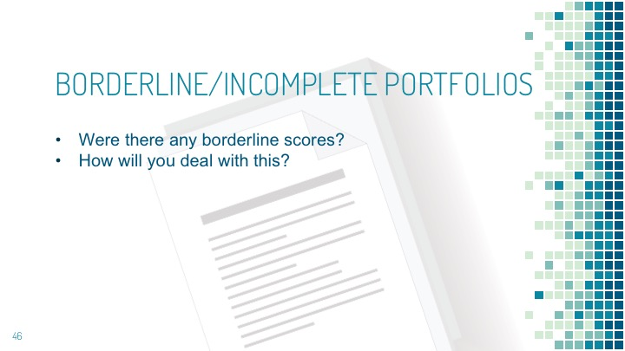
Step 10: Reviewing the Original Assessors Scores
Now take a look at the original assessor’s scores  Pass out the scored Rubrics  Review their rationale for scoring. Do you agree with their ratings and rationale? Why?  Do any of their rationales change your thoughts on the ratings your chose? Why? | Slide 48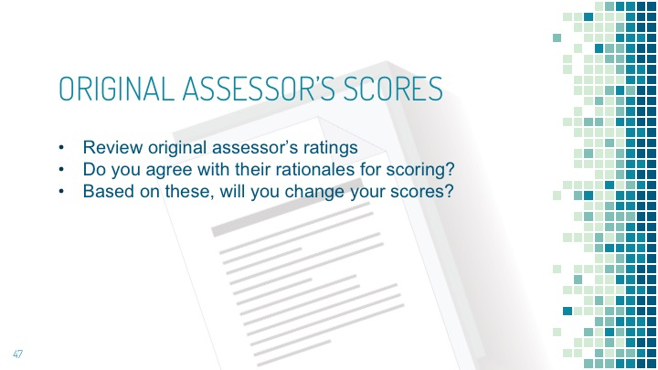
Step 12: Transition/Activity End
You’ve done an excellent job! You have gained more experience and autonomy in evaluating and assessing a portfolio.  We will now move on to materials telling you how to prepare as a facilitator on your campus.  Recap: up until this point, we have been training you to use the rubric to assess portfolios. Now, you will learn how to facilitate a training session on your campus. | Blank/None

Optional Learning Activity 6: Facilitating a Workshop
Activity 6 gives you step-by-step instructions to hold a training session on your campus. It is located here, late in the training session, because it was necessary to first learn to assess a portfolio using the rubric. This is merely a framework for you to use as a reference until you get comfortable facilitating a workshop.
Format: In pairs, one as facilitator the other as a participant
Time: 60 minutes
Materials needed: Participant Manual, Rubric, Facilitator Manual
for distribution
Portfolio Components Used: #4 - good (reusing)
PowerPoint: part 6 – Slides 49-70

Overview:
- Use role playing to assist participants in gaining experience facilitating a workshop.

Learning Objectives
Upon completion the Participants in the role of Facilitator will:
- Participants will show understanding and demonstrate their proficiency in presenting, use of the facilitator's manual, and finding related materials.
- Lead the participant in applying the rubric to a portfolio
- Provide guidance to participant in distinguishing between the documents and artifacts
- Show how to score components of each portfolio
- Discuss how to gauge a portfolio's quality and completeness
- Demonstrate how to score the portfolio and let the participant practice
- Explain how the participants should justify the ratings they assigned to each component

SCRIPT | SLIDE
Step 1: Introduction
Note: Have the Facilitator Manuals ready to be distributed to participants. Pass out two blank rubric copies to each participant.  The training moves from rubric centered assessment of portfolios to participants practicing in pairs as facilitators  Introduce learning activity  Your role so far has been as participant. You will now practice being the facilitator, so you may become more comfortable leading a workshop at your institution  This is a role-playing activity. As pairs, each of you will take turns introducing and presenting a learning activity. | Slide 49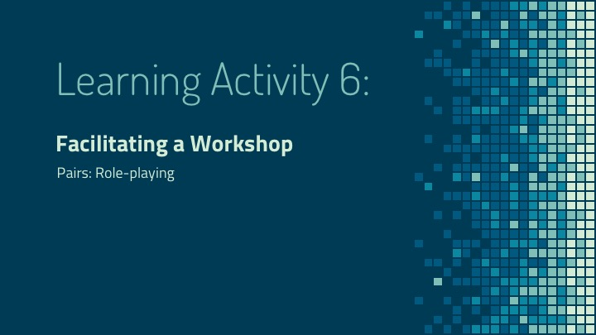  Slide 50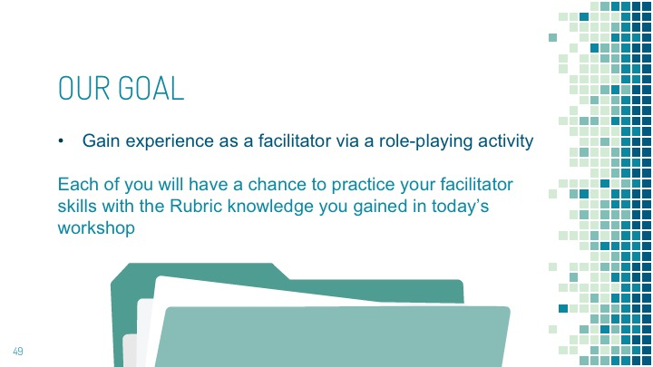
Step 2: Distribute Facilitator’s Manuals and Familiarize Participants with it.
Hand out Facilitator manuals.  I am passing out the Facilitator manual that I’ve used to lead this workshop. | Slide 51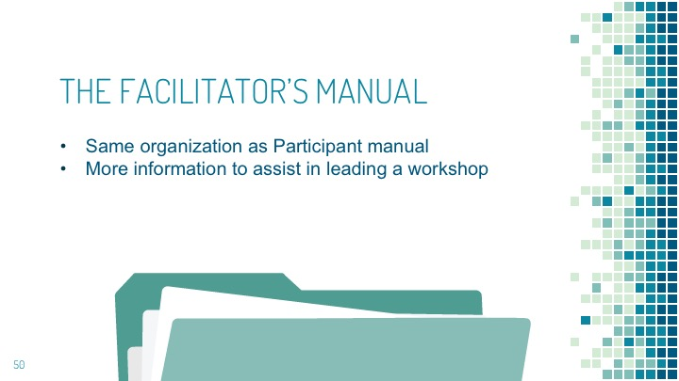
Describe how the Facilitator’s Manual is organized and how to use it.  The facilitator’s manual is organized in the same manner as the participant’s manual, but it contains more information so that you can effectively lead a workshop. | None/Blank
Show slide that has the Facilitator Guide Key image.  This is the Key that describes how the facilitator’s manual is laid out.  Descriptions for each Key component are below. | Slide 52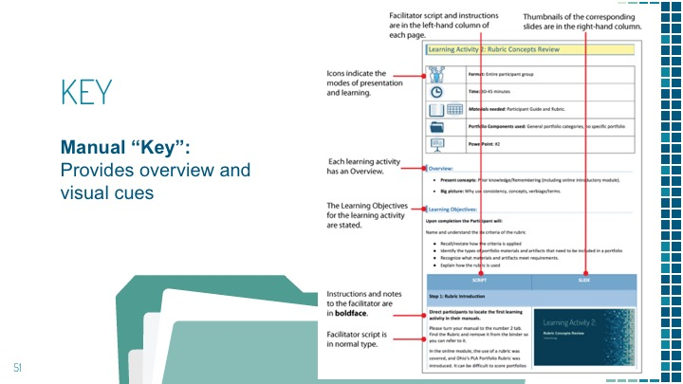
Icons  The facilitator guide contains icons that indicate the learning activity mode. At a glance you will know what methods will be used. | Slide 53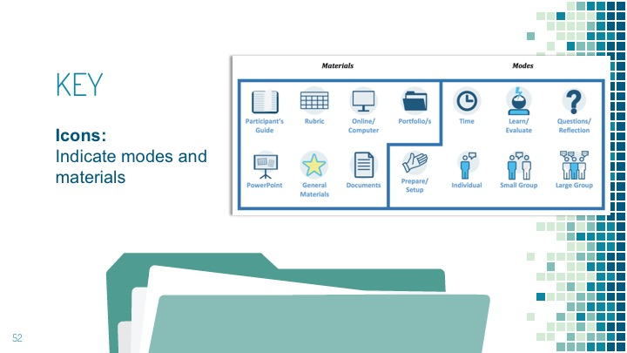
Learning Activity  The learning activity will be numbered and written in the heading. | Slide 54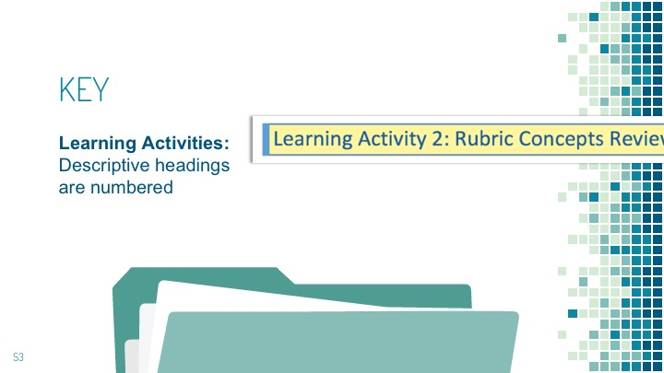
Format  They indicate how a learning activity is formatted, and whether the entire group or smaller groups will participate. | Slide 55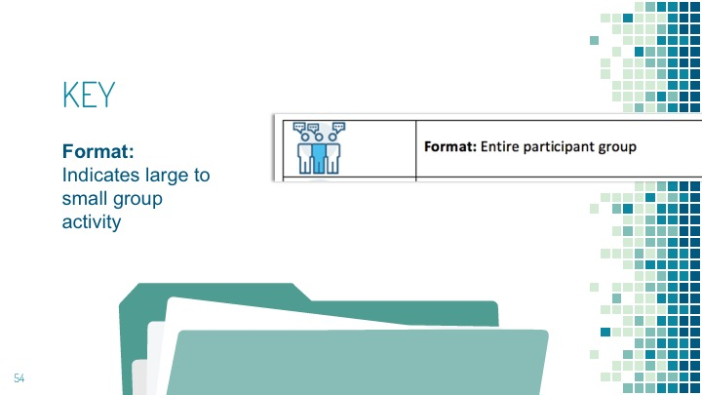
Time  Next the estimated time you will need to complete the learning activity is noted. | Slide 56  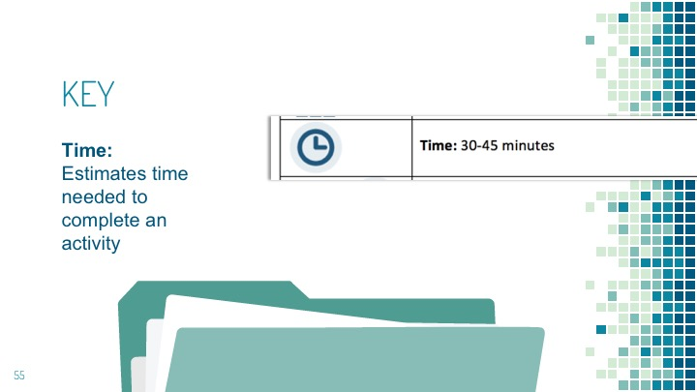
Materials needed  Any materials that will be needed are also noted. This will allow you to locate and retrieve any additional content and know which associated PowerPoint presentation will be used. | Slide 57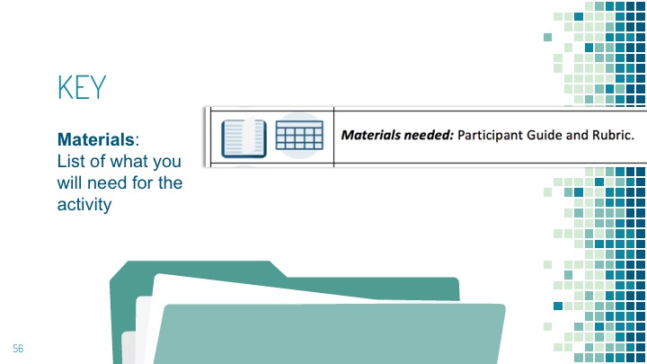
Portfolio components used  Following that, the name of the sample portfolio component/s is listed. | Slide 58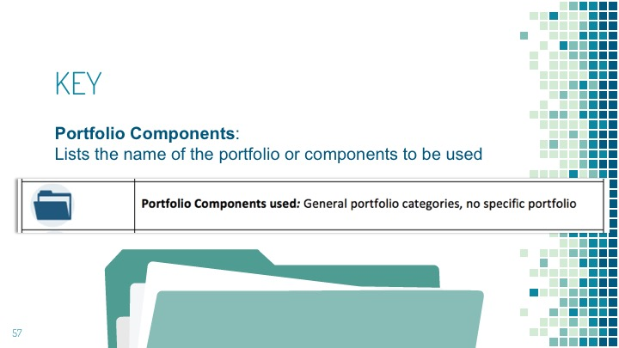
PowerPoint  Indicates the PowerPoint presentation that will be used. | Slide 59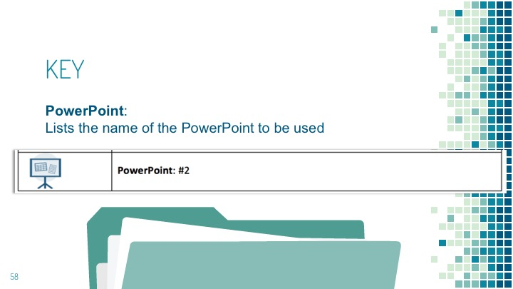
Overview  The Overview provides a short list of what will be covered. | Slide 60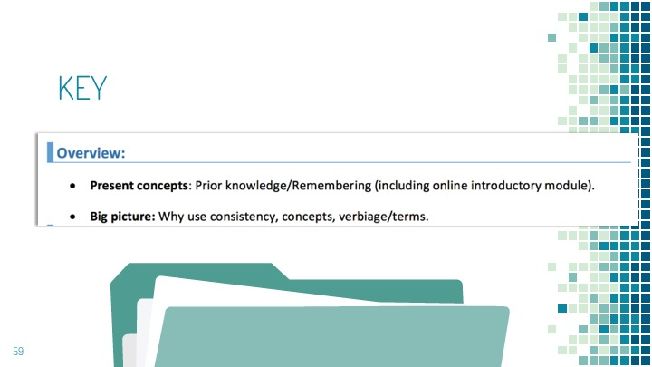
Learning Objectives  Lastly the learning outcomes for that activity are listed. | Slide 61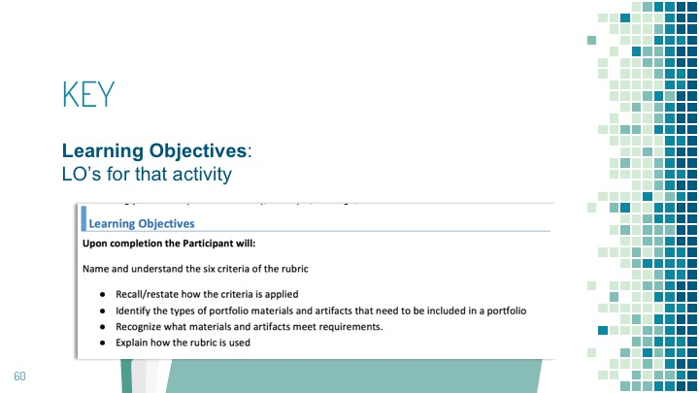
Narration, Instructions and Slides  In the table below, it you will see two columns, Script and Slide. | Slide 62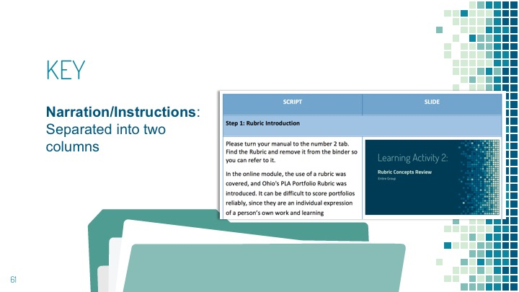
Script  The Script cells contain the text that you will speak in normal type and any instructions will be in boldface. | Slide 63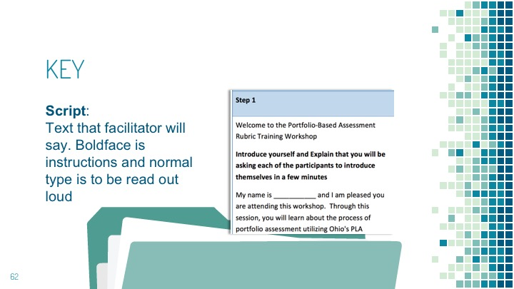
Slide  The column to the right will contain the slide number, a short description and a thumbnail image of the slide that should be simultaneously displayed as you read the script for that portion of the activity. | Slide 64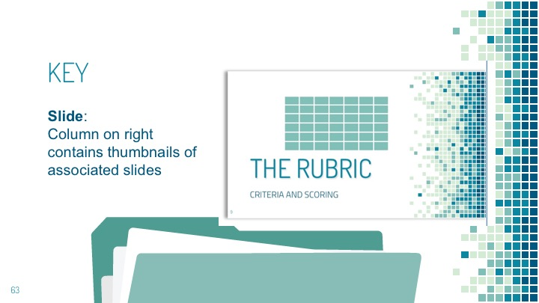
Note The pattern of organization  Each learning activity is organized in the same consistent manner. Take a quick look through the facilitator’s manual to become familiar with it. | Slide 65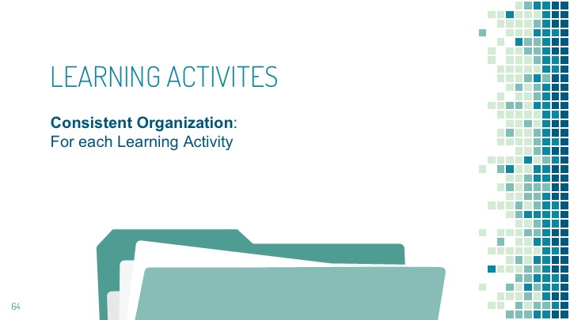
Questions:  Does anyone have questions on the manual before we begin this activity? | Slide 66
Step 3: Beginning the Role-Playing Activity
Explain how the learning activity will be conducted and the roles of each participant.  As you work in pairs, each of you will have an opportunity to practice leading a short learning activity. There are two activities, A and B. Each of you will take turns as a Facilitator and participant. Each activity should take about 10-15 minutes.  As facilitator, have the participant follow along.  Use learning activity #5, (the learning activity you completed in pairs, prior to this one).  You will guide the participant (your partner) through the steps of evaluating a portfolio using the rubric and Learning Activity #5. The Portfolio Evaluation List may be used as reference if needed. | Slide 67 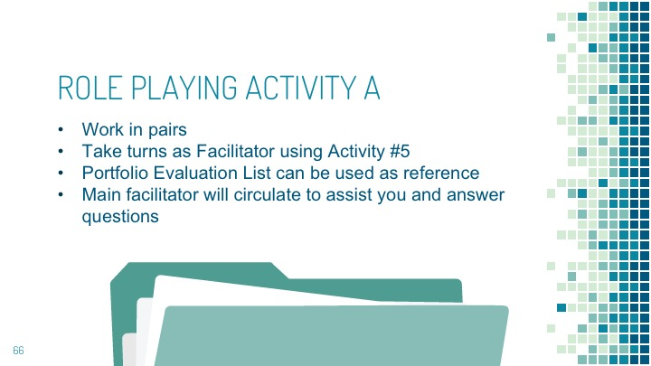
Each pair decides who will go first.  Chose which of you will act as facilitator first. | Blank/None
Step 4: Role-Playing Activity A
Please make sure each participant has their respective manuals open to the correct activity.  Use the Portfolio Evaluation list to assist you as you facilitate or participate in this activity if needed.  Please go ahead and begin this activity.  As the main workshop Facilitator, I will circulate to assist and answer questions as they arise.  Share and address any relevant question with the entire group. | Blank/None
Step 5: Wrapping up the Role-Playing Activity A
Wrapping up Activity A:  So, how did it go? Let’s take this time to review how this activity went.  Facilitators, tell me how your experience went.  Did the notes and script in the manual assist you in presenting the portfolio assessment activity?  Do you have any questions or comments?  Address any questions or comments  Did this exercise help you feel more confident in facilitating in a workshop at your own institution?  How might we improve this experience?  For participants:  How did your facilitator do?  Did they present the activity well? Did you think that your partner was able to utilize the manual resources confidently?  What might help improve the experience? | Slide 68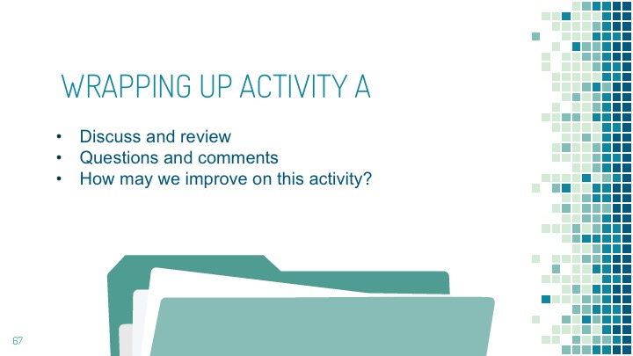
Step 6: Role-Playing Activity B
Directions:  Please make sure each participant has their respective manuals open to the correct activity.  Use the Portfolio Evaluation list to assist you as you facilitate or participate in this activity, if needed.  Please go ahead and begin this activity.  As before, I will circulate to assist and answer questions as they arise.  Any questions that are relevant will be shared with the entire group. | Slide 69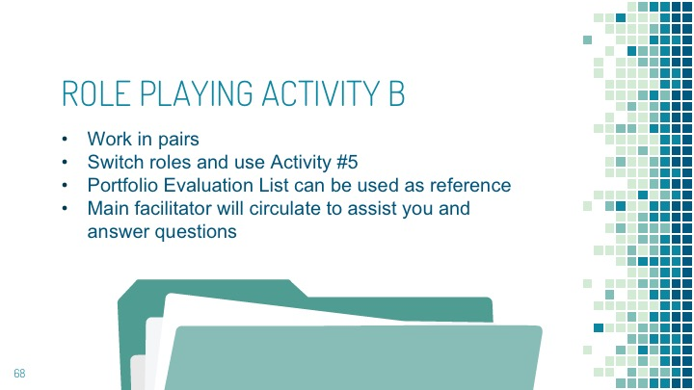
Step 7: Wrapping up the Role-Playing Activity B
So, how did it go? Let’s take this time to review how this activity went.  Facilitators, tell me how your experience went.  Did the notes and script in the manual assist you in presenting the portfolio assessment activity? Do you have any questions or comments? Address any questions or comments. Did this exercise help you feel more confident in facilitating in a workshop at your own institution?  Participants, how did your facilitator do? Did they present the activity well? Did you think that your partner was able to utilize the manual resources confidently? What might help improve the experience? | Slide 70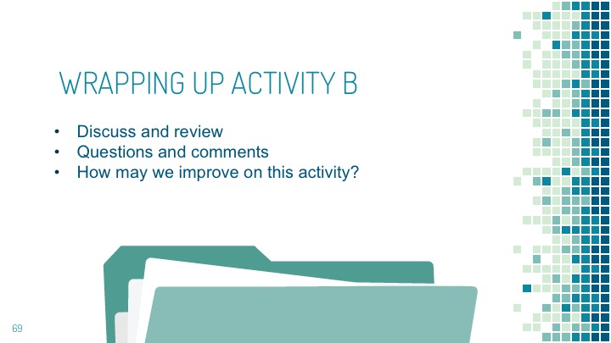

Learning Activity 7: Workshop Wrap Up
Format: As a Group
Time: 10 minutes
Materials needed: Participant Manual.
Portfolio Components Used: None
PowerPoint: Learning Activity 7 – Slides 71-73
Advise the attendees where links for more information and where the files for the manuals will be located to that they may reproduce the materials for their institution. Also, refer them to the Appendix.

Overview:
- Quick review of what was covered.
- Time to answer questions and to provide additional information on how to use the manual to train people at their institution.

SCRIPT | SLIDE
Step 1: Final Review and Wrap-Up Activity
Congratulations! You have completed the training and we will now quickly review what we’ve learned and provide answers to any final questions before moving on to the exit quiz. Thanks for all your hard work and input. | Slide 71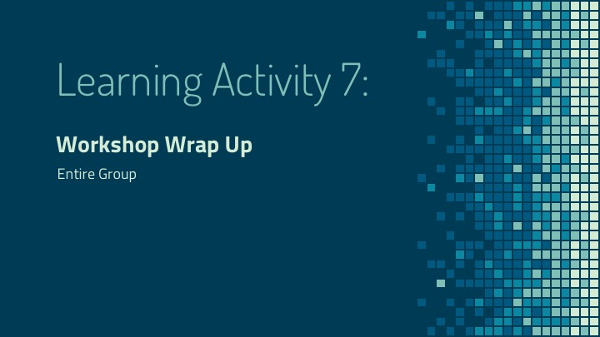
Step 2: Review of Learning/Main Points
In this workshop we have accomplished the following. You’ve:  - Explained a rubric and its use  - Recalled and understood the components and structure of the rubric.  - Identified the characteristics of an effective portfolio  - Discussed and employed the rubric rating and scoring system  - Interpreted the individual rating components and associated rating scale  - Practiced applying the rubric grid on a sample portfolio  - Examined and appraised both good and bad sample portfolios using the rubric  - Evaluated and justified your review and scoring of sample portfolios | Slide 72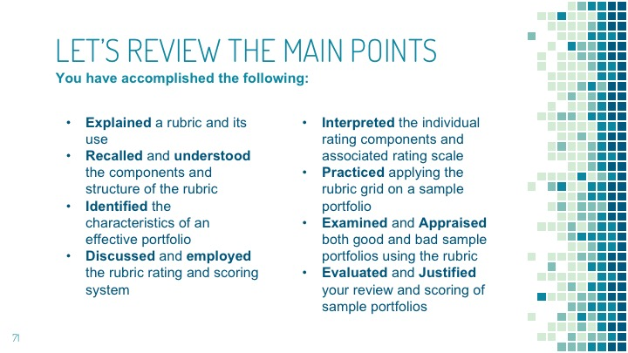
Step 3: Final Questions
Please ask remaining questions you may have about the process of evaluation/scoring or facilitating a workshop.  Answer any remaining questions. | Slide 73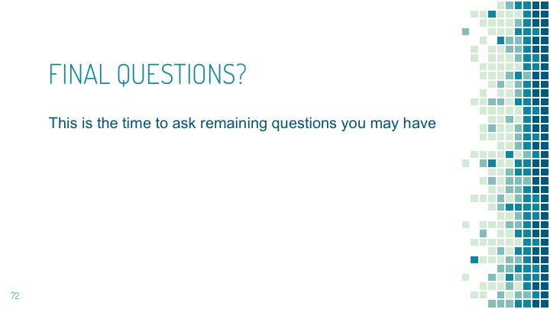
Step 4: Links to More Information
Direct the attendees to the Ohio Department of Higher Education website for more information,  manuals and additional resources. https://www.ohiohighered.org/PLA-resources  Also, refer them to the Appendix. | Blank/None
Step 5: Transition/Activity End
Move on to the final evaluation.  Proceed to the final portion of the  workshop. | Blank/None

Learning Activity 8: Workshop Evaluation and Post Test
***Optional opportunity for individual assessment of a portfolio as time allows.
Format: Individually
Time: Post Test and Evaluation to take 10 minutes. If you decide to go forward with an individual assessment, you will need to allot 45 minutes for this section.
Materials needed: Computer, Participant Manual, Rubric, Portfolio evaluation list.
Portfolio Components Used: #5 - excellent
PowerPoint: Final Activity 8 – Slides 74-77

Overview:
- To assess the knowledge and skills of participants
- Answer questions on the Rubric and a Sample Portfolio

Learning Objectives
Upon completion the Participant will:
- Demonstrate their knowledge of the Rubric.
- Provide an evaluation and scoring of a sample portfolio.
- Recognize a portfolio that is incomplete, or which has elements which need improvement.

SCRIPT | SLIDE
Step 1: Introduction to the Final Assessment/Post-Test
You are almost finished. We will take the online assessment to test the knowledge and skills you developed in this workshop.  There are three parts to the final assessment.  The first part is a workshop evaluation. The second part will test your knowledge of the rubric and the third part will appraise your ability to evaluate a sample portfolio. | Slide 74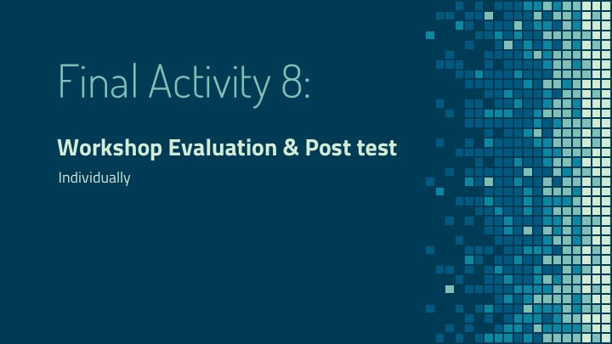  Slide 75
Step 2: Completing the Online Assessment
Direct each participant to follow the link you provide to open the quiz landing page.  Let me know if you have any questions or need assistance finding or beginning the quiz. | Slide 76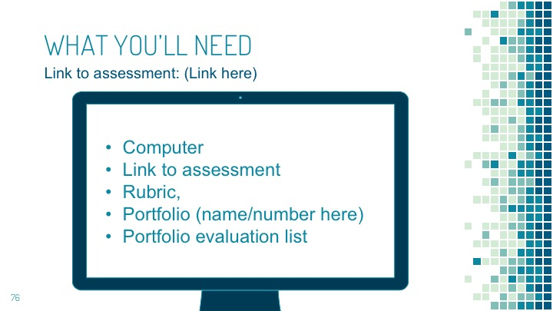
Step 3: Assessment Directions
Put all materials away.  Open the final quiz.  First, Complete part One (1), the workshop feedback evaluation. Next, take part two (2) the Rubric quiz. When you have completed it, open your manual and remove portfolio #5 along with the rubric to assist in the part three (3) the portfolio evaluation. | Blank/None
Completion of the assessment.  Once you have completed the quiz feel free to ask me any parting questions. | Blank/None
Taking both manuals home  Please remember to take both manuals with you. | Blank/None
Closing Comments:  Thank you for your participation today, remember that the manuals and associated materials can be downloaded at_______. (Facilitator to advise.)” | Slide 77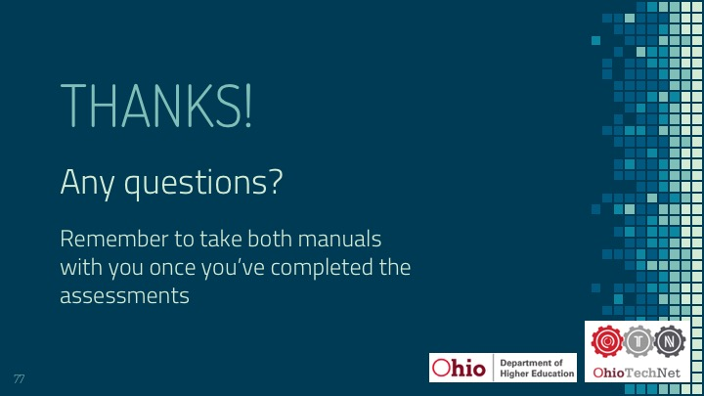

═══════════════════════════════════════════════════════════
- Finish -
═══════════════════════════════════════════════════════════

Appendix

Portfolio Evaluation List

Portfolio Elements
Identify the components
- Is the portfolio complete?
- Are important parts missing?
  - What parts need to be included?
- Are the portfolio components robust/of high enough quality to continue assessment?
- If the quality is lacking, what specific changes need to occur?
- If incomplete or lacking important elements, how do you adequately communicate to a student/applicant what is needed (additional elements, more depth, application in practice, evidence, better writing skills)?
- What are your institution’s policies and procedures:
  - For responding to the applicant?
  - Which entities/departments need to be notified?
  - Do you need to discuss your decision with other entities/departments?

Scoring
- Do the documents and artifacts provide clear evidence that the applicant has mastered course learning outcomes and competencies?
- How well does each component align with the Rubric expectations? (0-3, Does Not Meet Expectations, to Exceeds Expectations)
- What is your justification/rationale for selecting the scores you chose?
  - This provides feedback to the student and other institutional entities.

Post Scoring – Next Steps
- Does your institution have any additional policies/procedures concerning the final assessment (pass/fail) of a portfolio?
- Do other post-secondary faculty and administrators need to review and give final approval?
- Returning assessed portfolios (passed/failed)
  - What are your institution’s policies and procedures?
- Which entities/departments need to receive a copy of the scored portfolio?
  - Do you or another entity send the scored portfolio to the applicant?
- Other policies/procedures unique to your institution

Glossary
Analysis | The separating of documents and artifacts into elements and detailed examination of those elements such as certificates, news clippings, PowerPoints, videos, etc. that may be included in any portfolio.
Application | Applying supporting documentation to the learning outcomes to show significant and essential learning that a participant has achieved.
Artifacts | Any feature that is not naturally present but is a product of an extrinsic agent, method or the like. Example for PLA: videos, .PPTs, artwork, blueprints, scripts, certificates, etc.
Competencies | A measurable pattern of skills or knowledge, abilities, behaviors and other characteristics that lead to the accomplishment of an outcome.
Comprehension | The action of capability of understanding something.
Criteria | The principle or standard by which something may be judged.
Evaluation | The making of a judgement or assessment about the portfolio.
Expectations | The supposition that something will occur.
Facilitator Manual | The guide that person/s leading workshops will use to assist them in efficiently and effectively reaching the learning objectives.
Knowledge | Acquaintance with facts, truths or principles, as from study or investigation.
Learning outcomes | Statements that describe significant and essential learning that participants will achieve, and which they can reliably demonstrate at the end of the workshop.
Participant Manual | The guide that person/s participating in the workshops will use to assist them in efficiently and effectively reaching the learning objectives.
PLA | Prior Learning Assessment (PLA)-Process of earning credits for college level learning acquired through work, community service and service in the military.
Portfolio | A compilation of documents and artifacts assembled for the purpose of evaluating their quality as applied to the Ohio PLA Rubric.
Presentation | The manner in which portfolio contents are displayed and organized.
Ratings | The 0-3 rankings of the Ohio Rubric, based on the standards of the criteria.
Synthesis | The end result of the process of combining separate ideas, knowledge, and skills to form meaningful learning and the application of it to new and different problems.

Graded Rubrics (with learning outcomes and grading rationales)

Portfolio 1
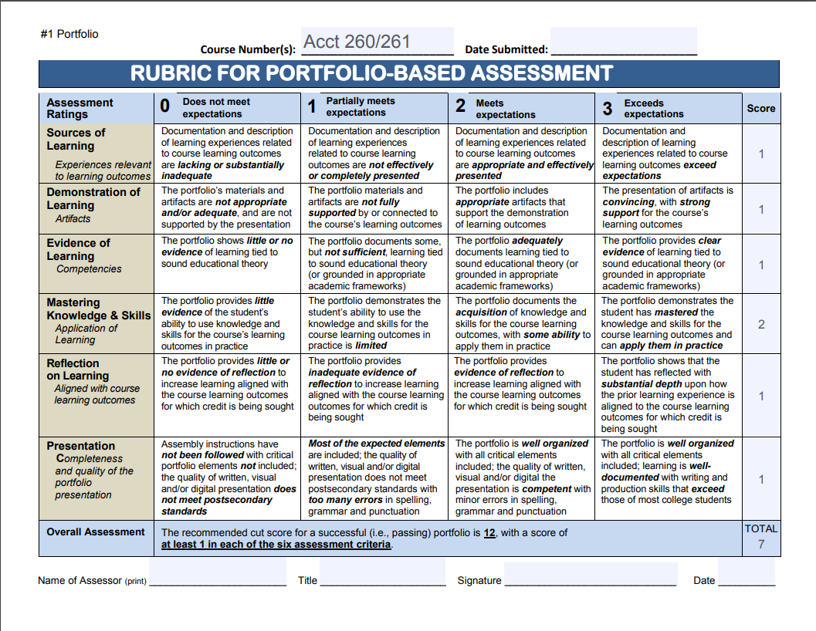
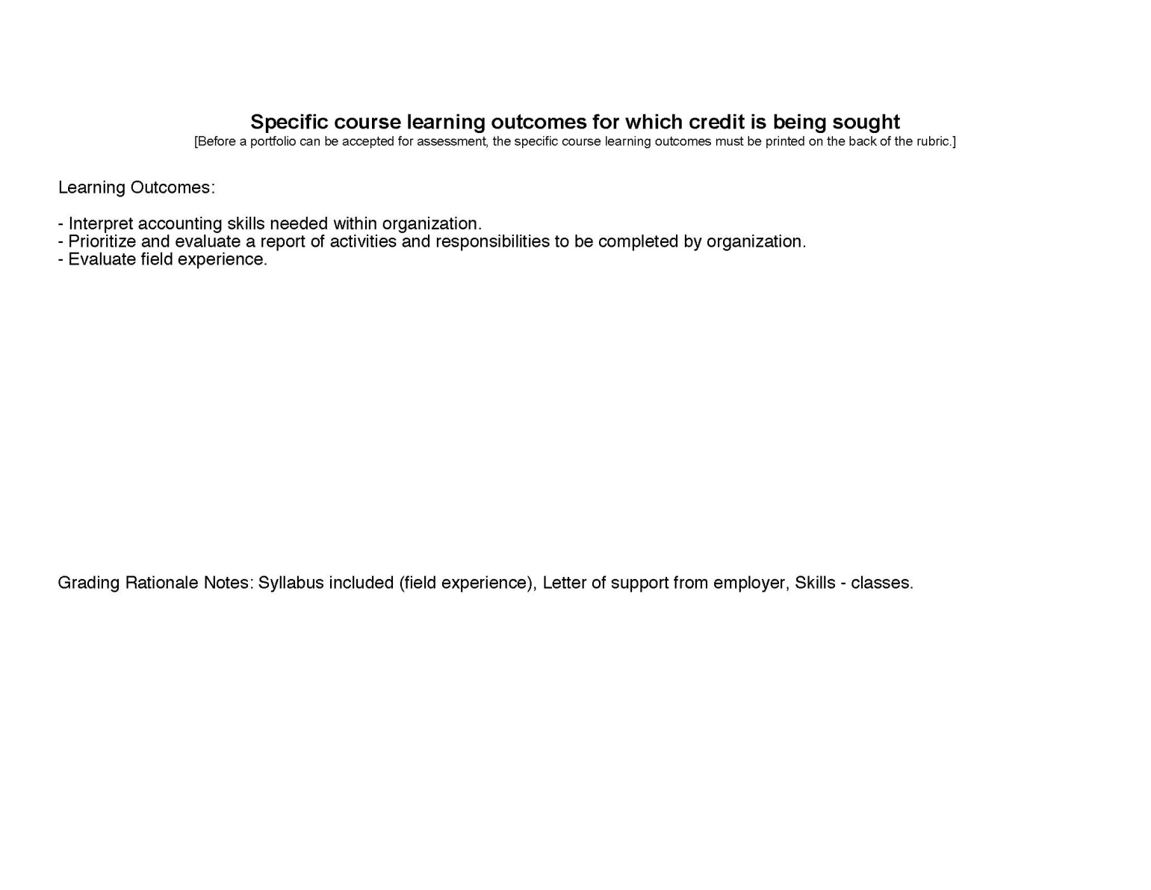

Portfolio 2
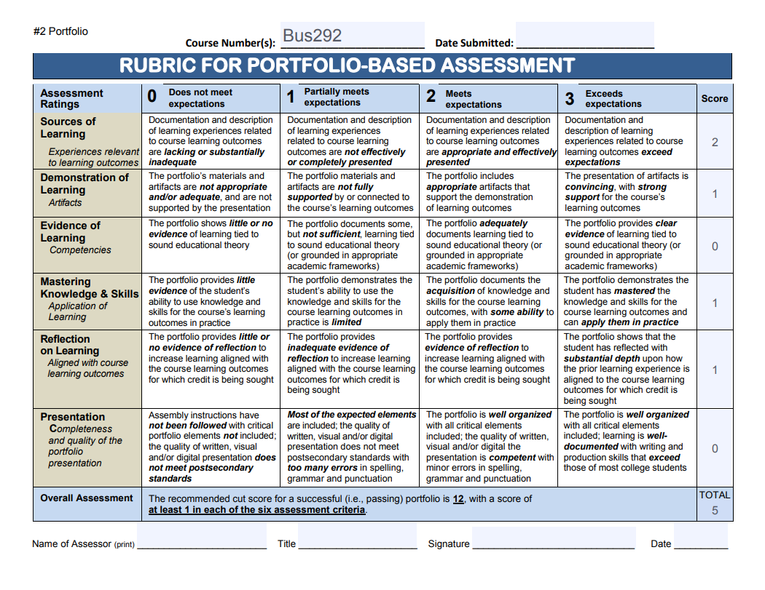
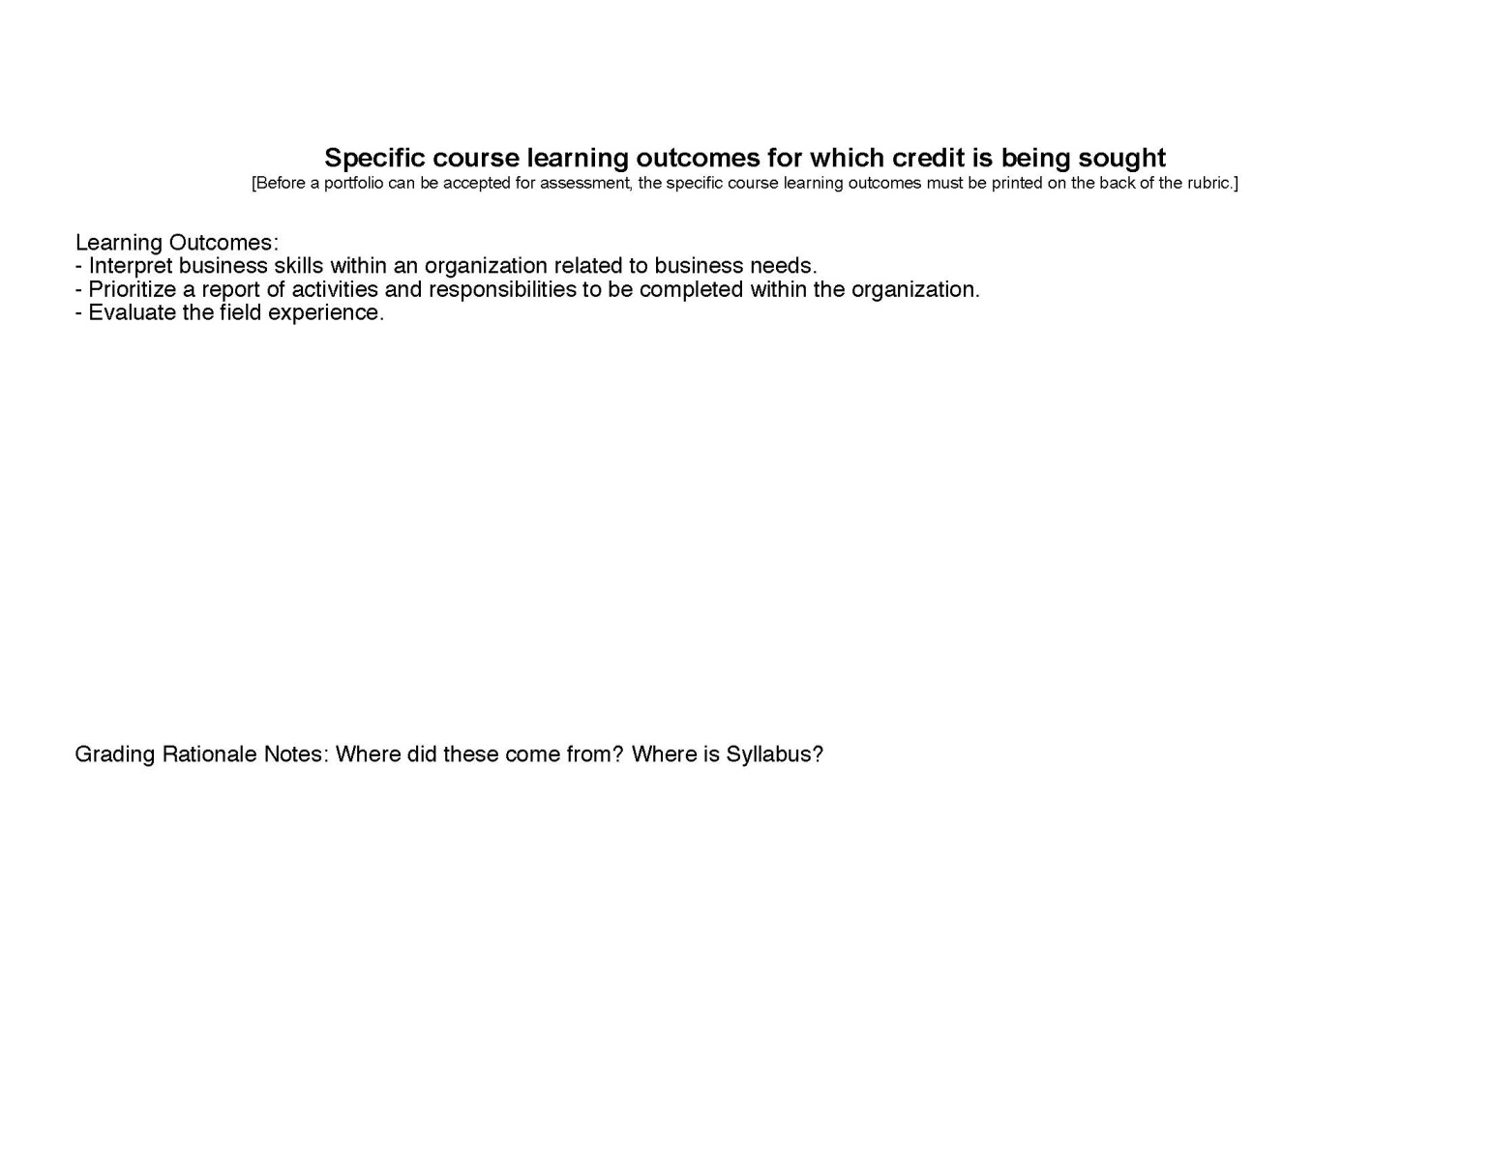

Portfolio 3
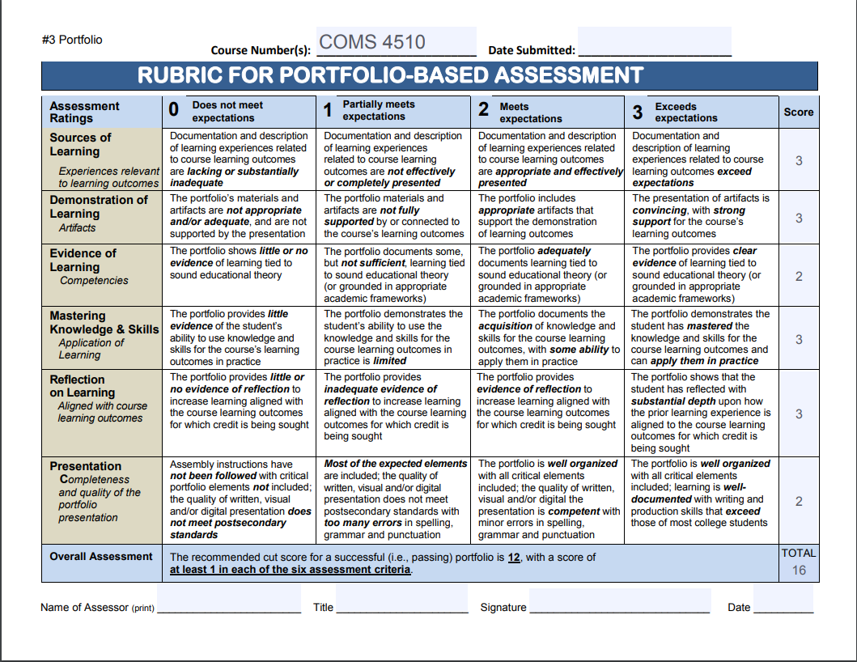
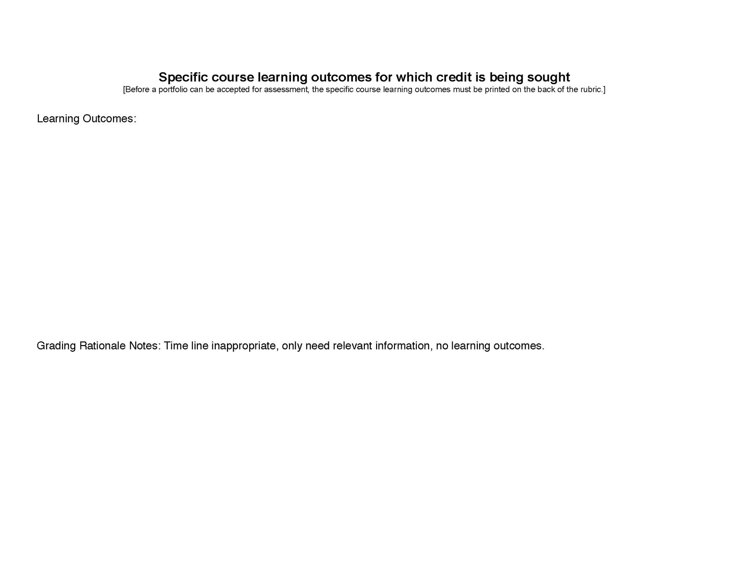

Portfolio 4
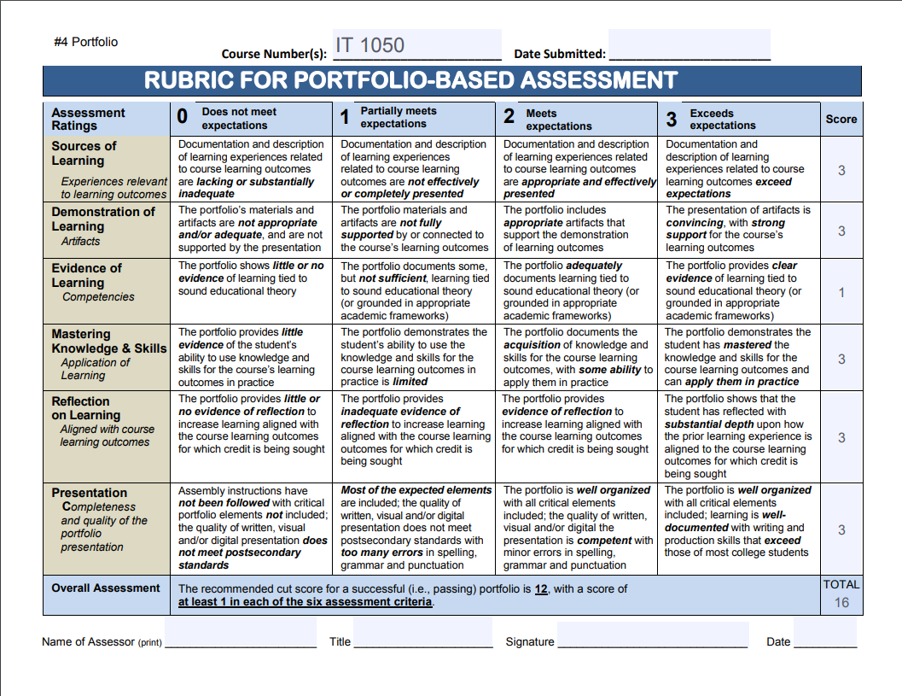
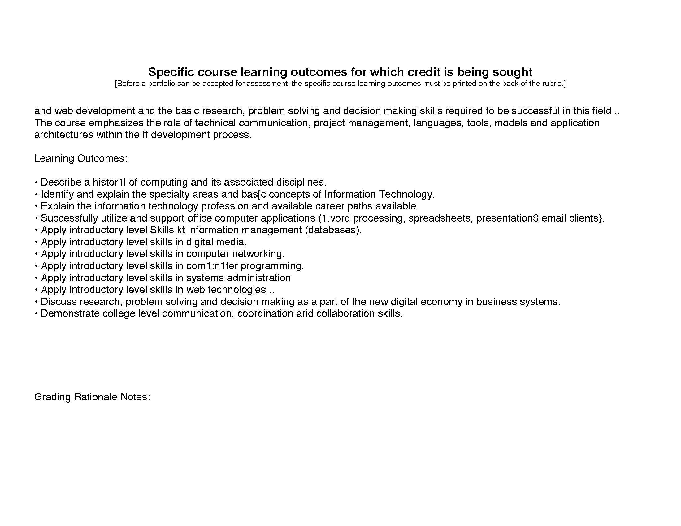

Portfolio 5
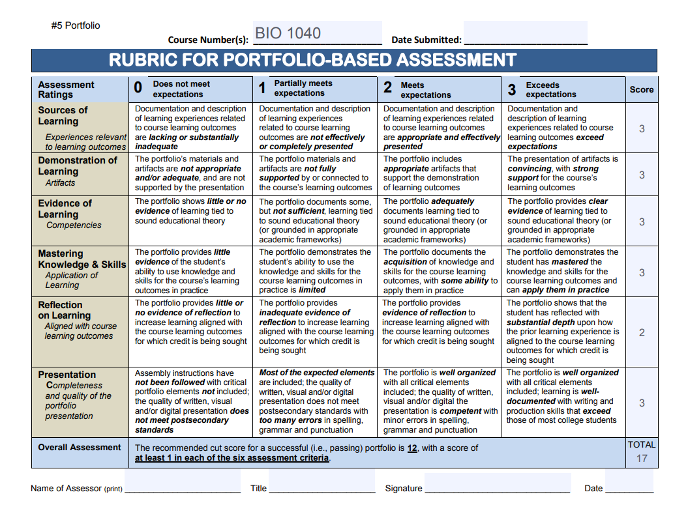
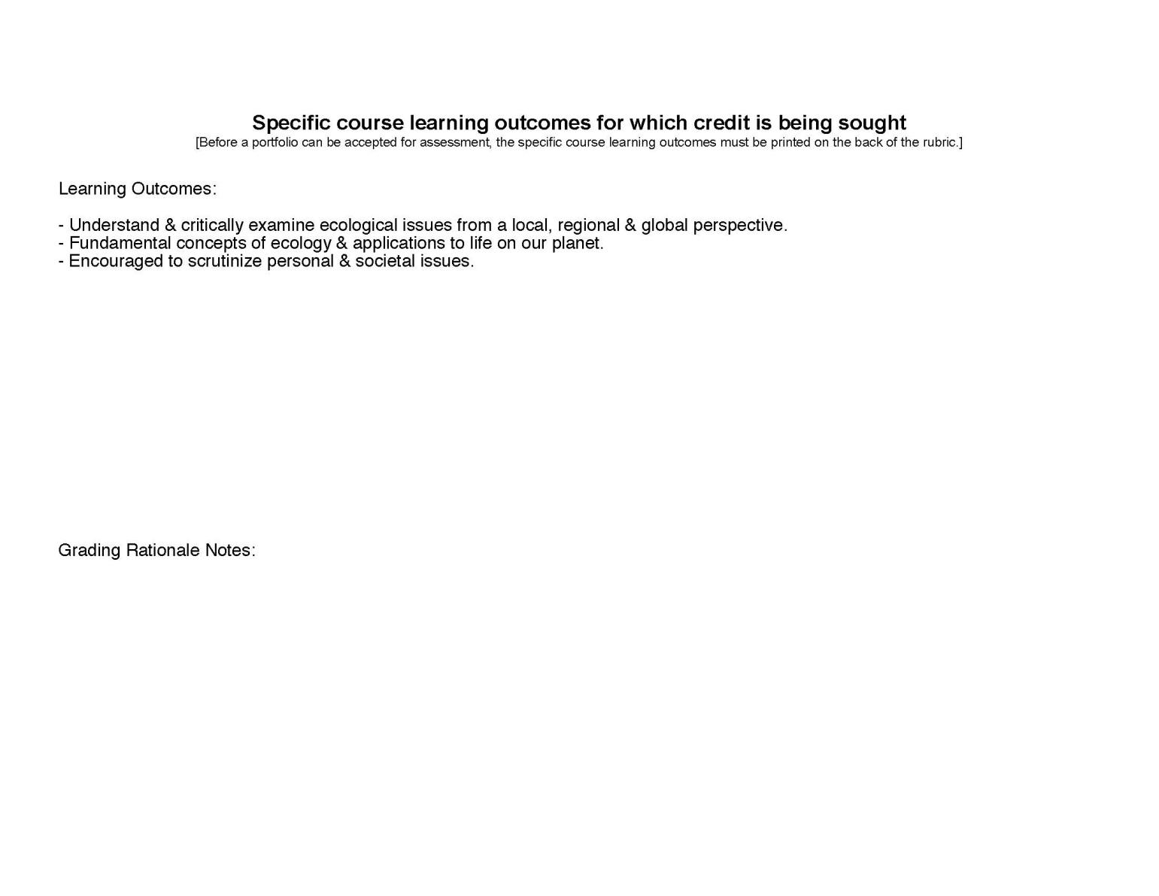

Rubric

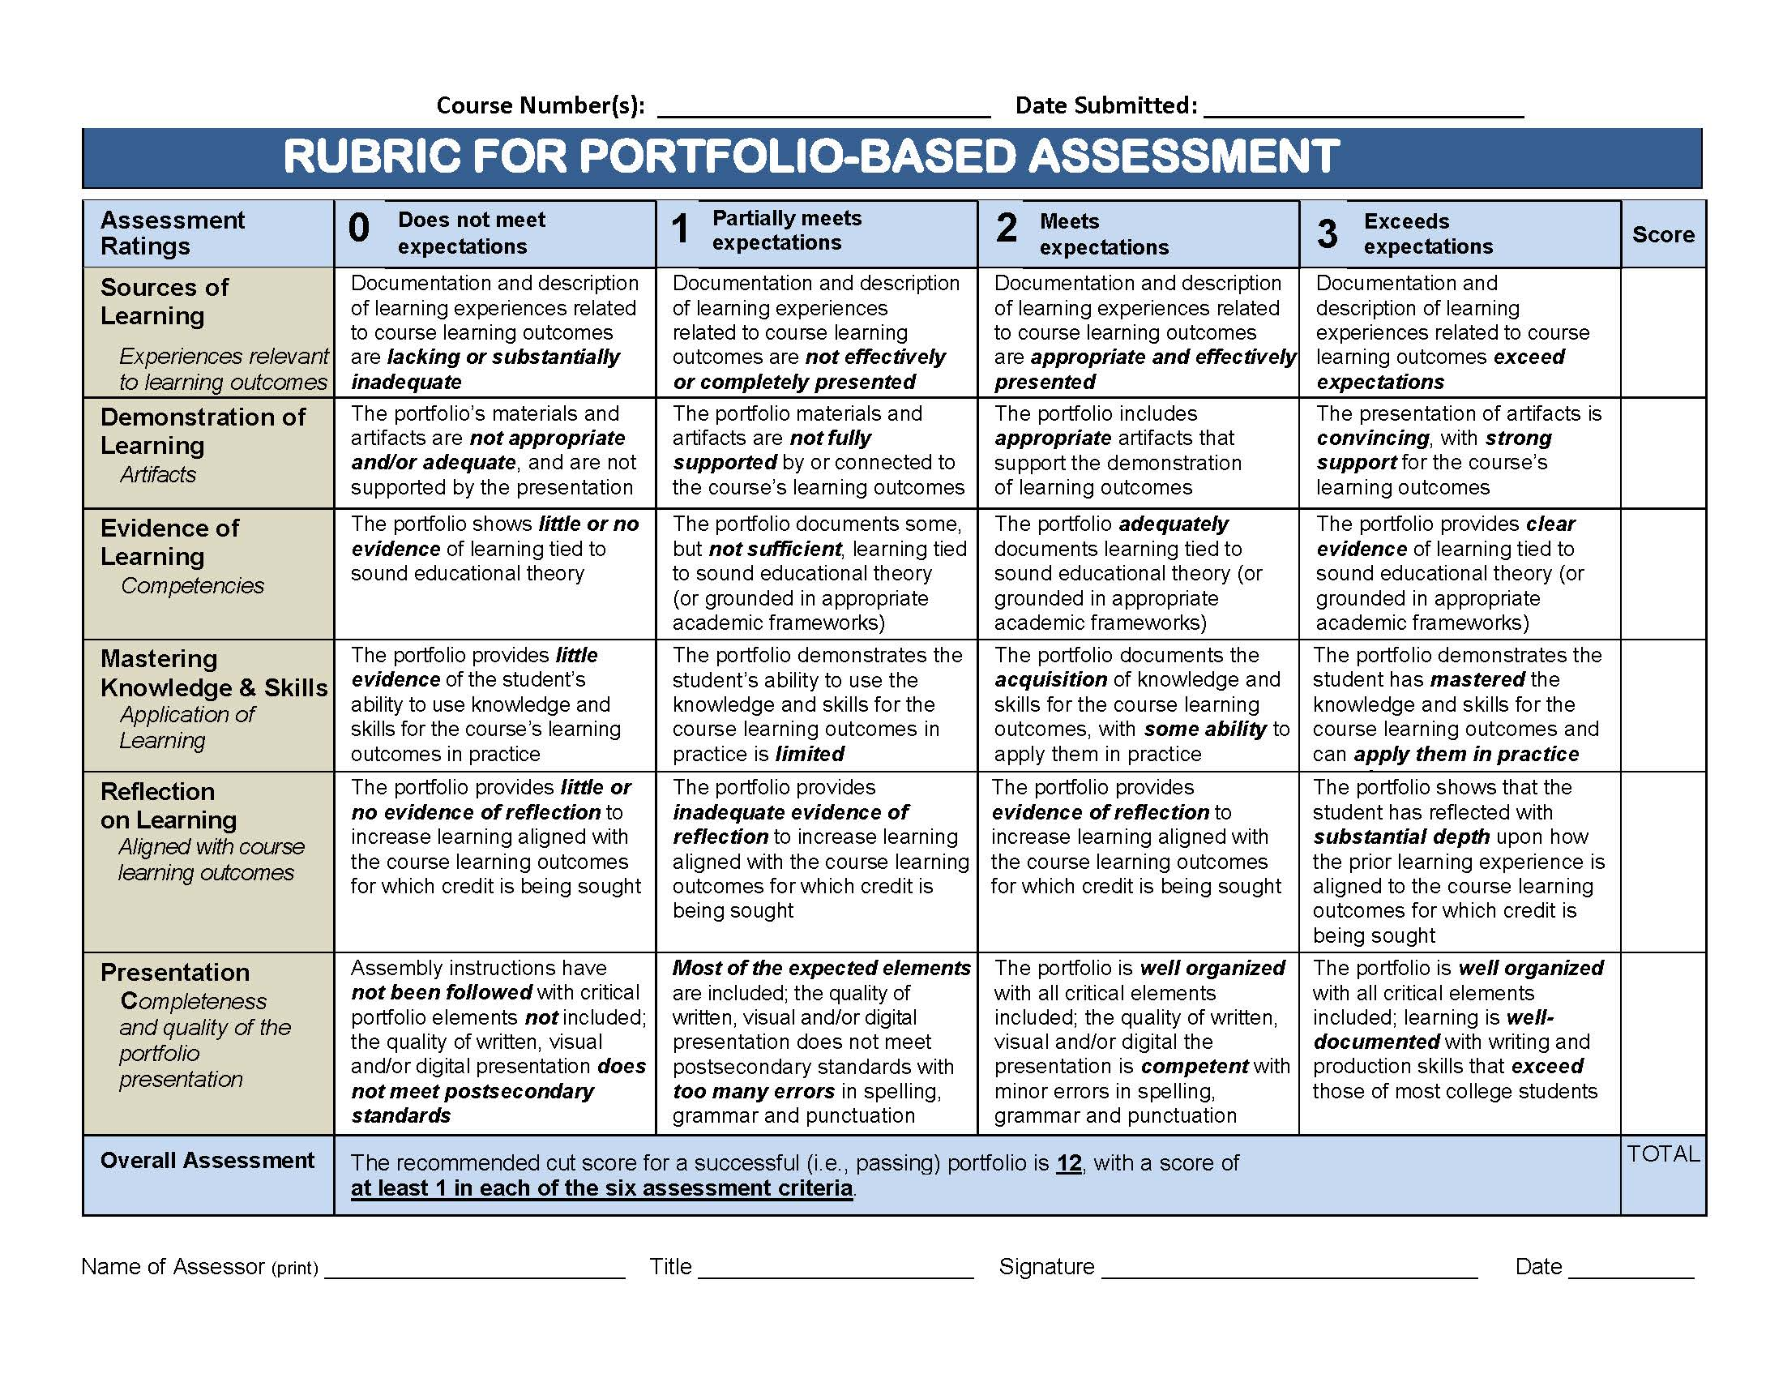
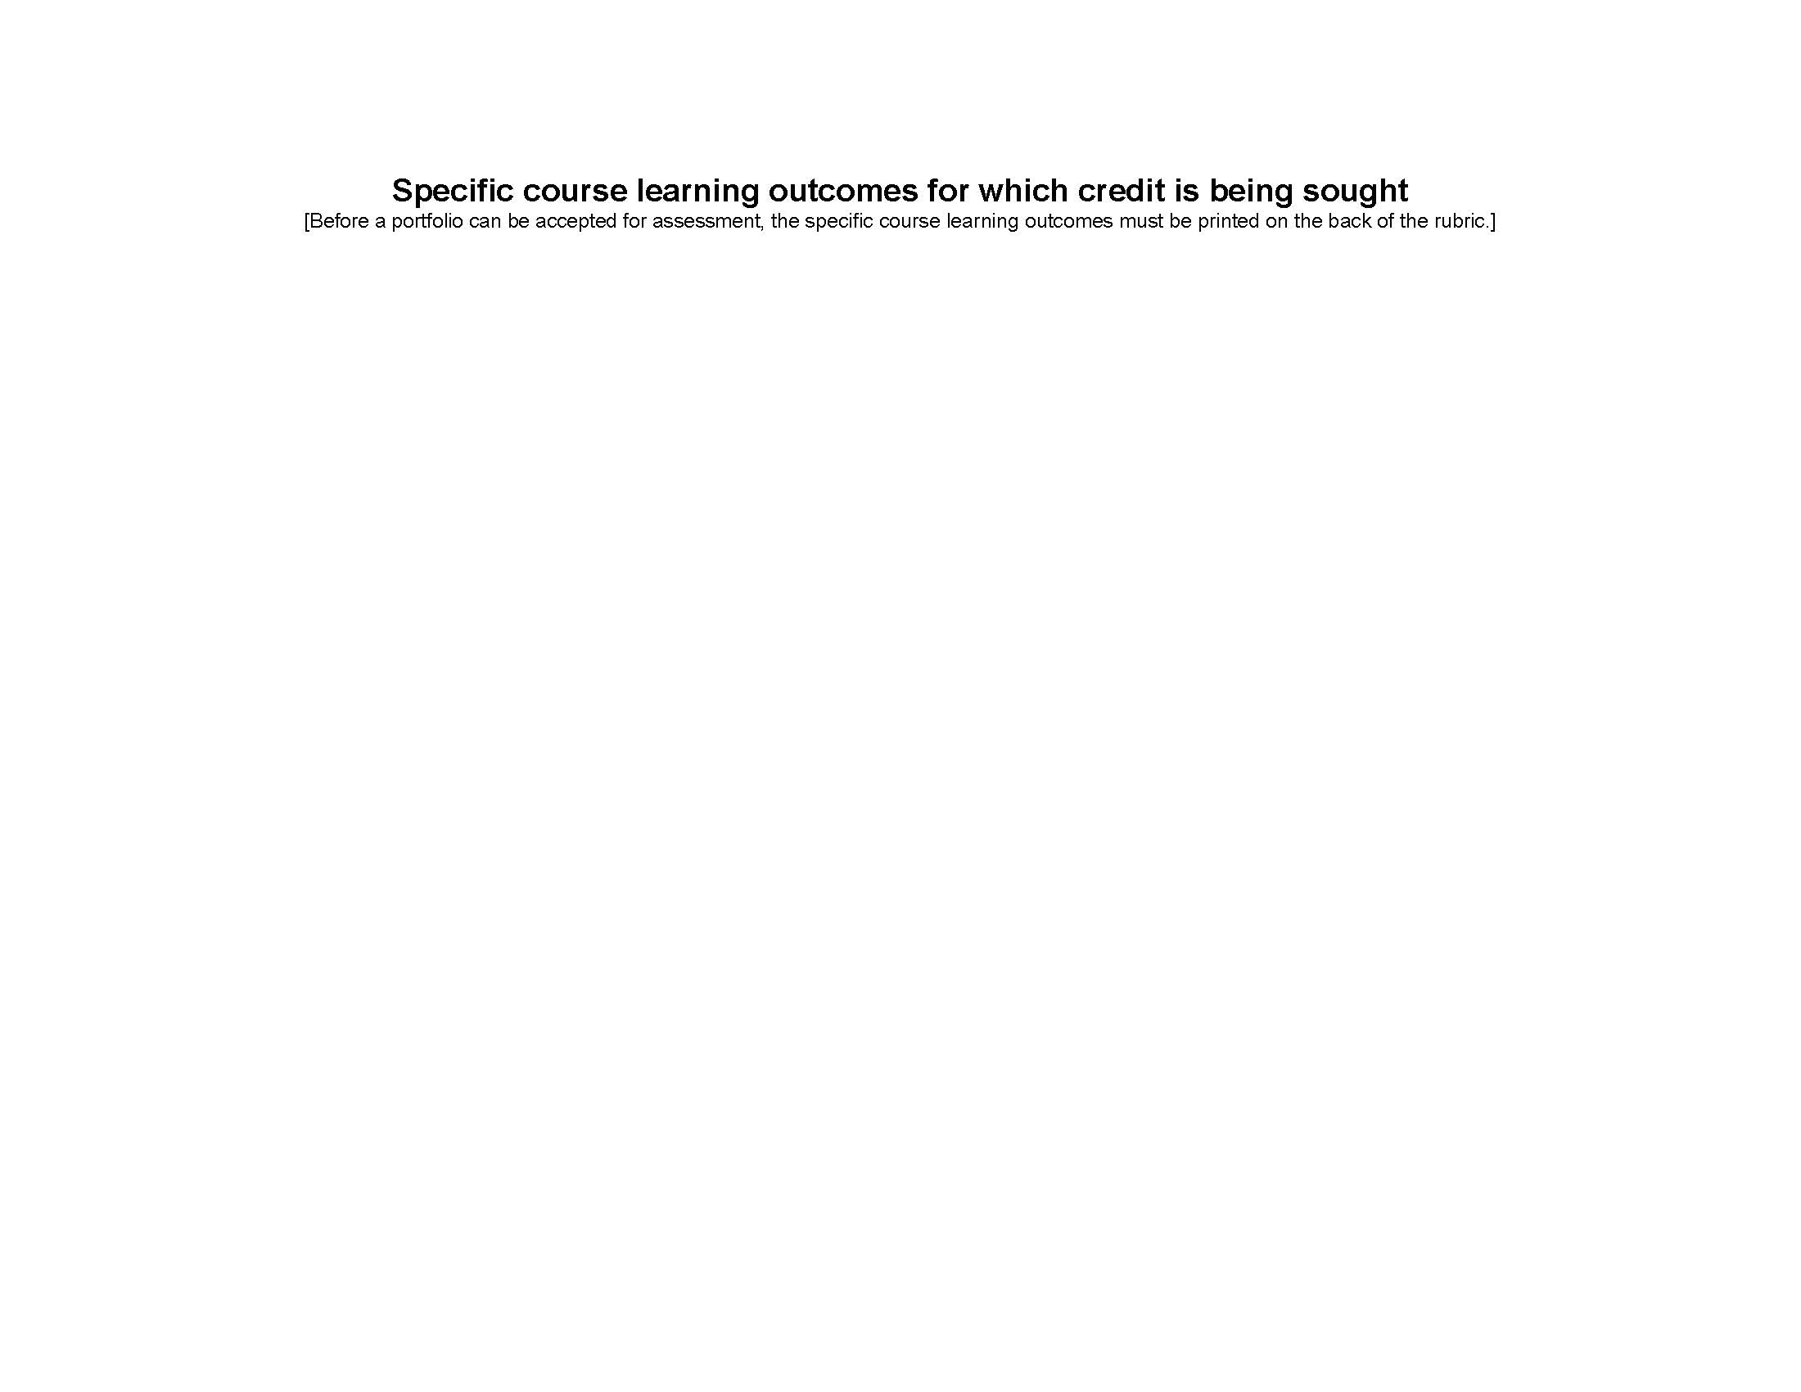

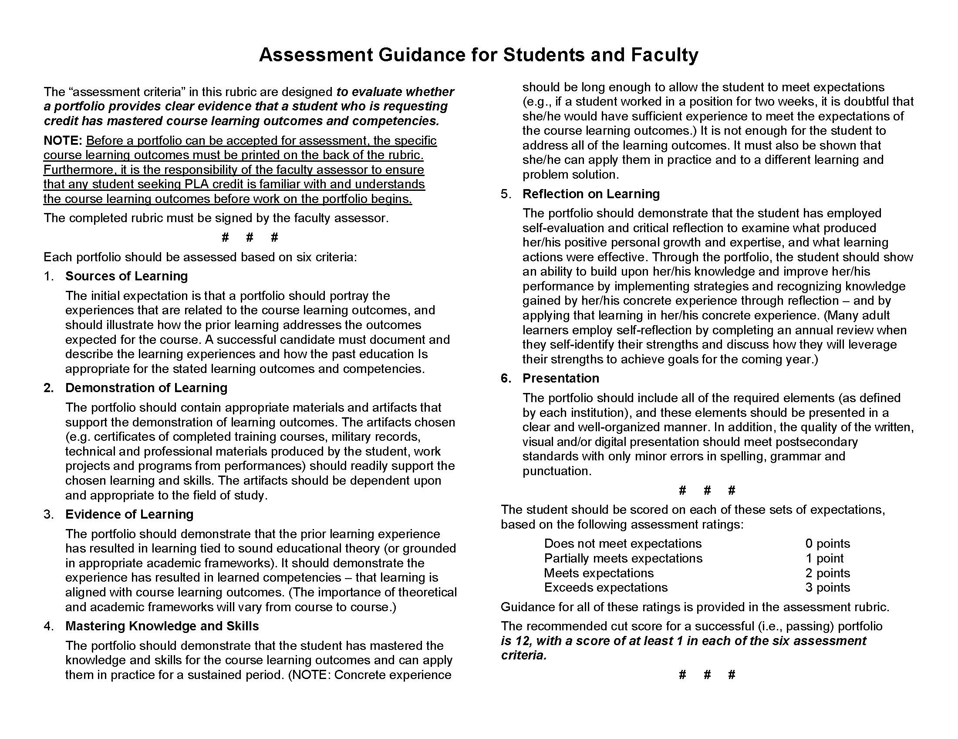

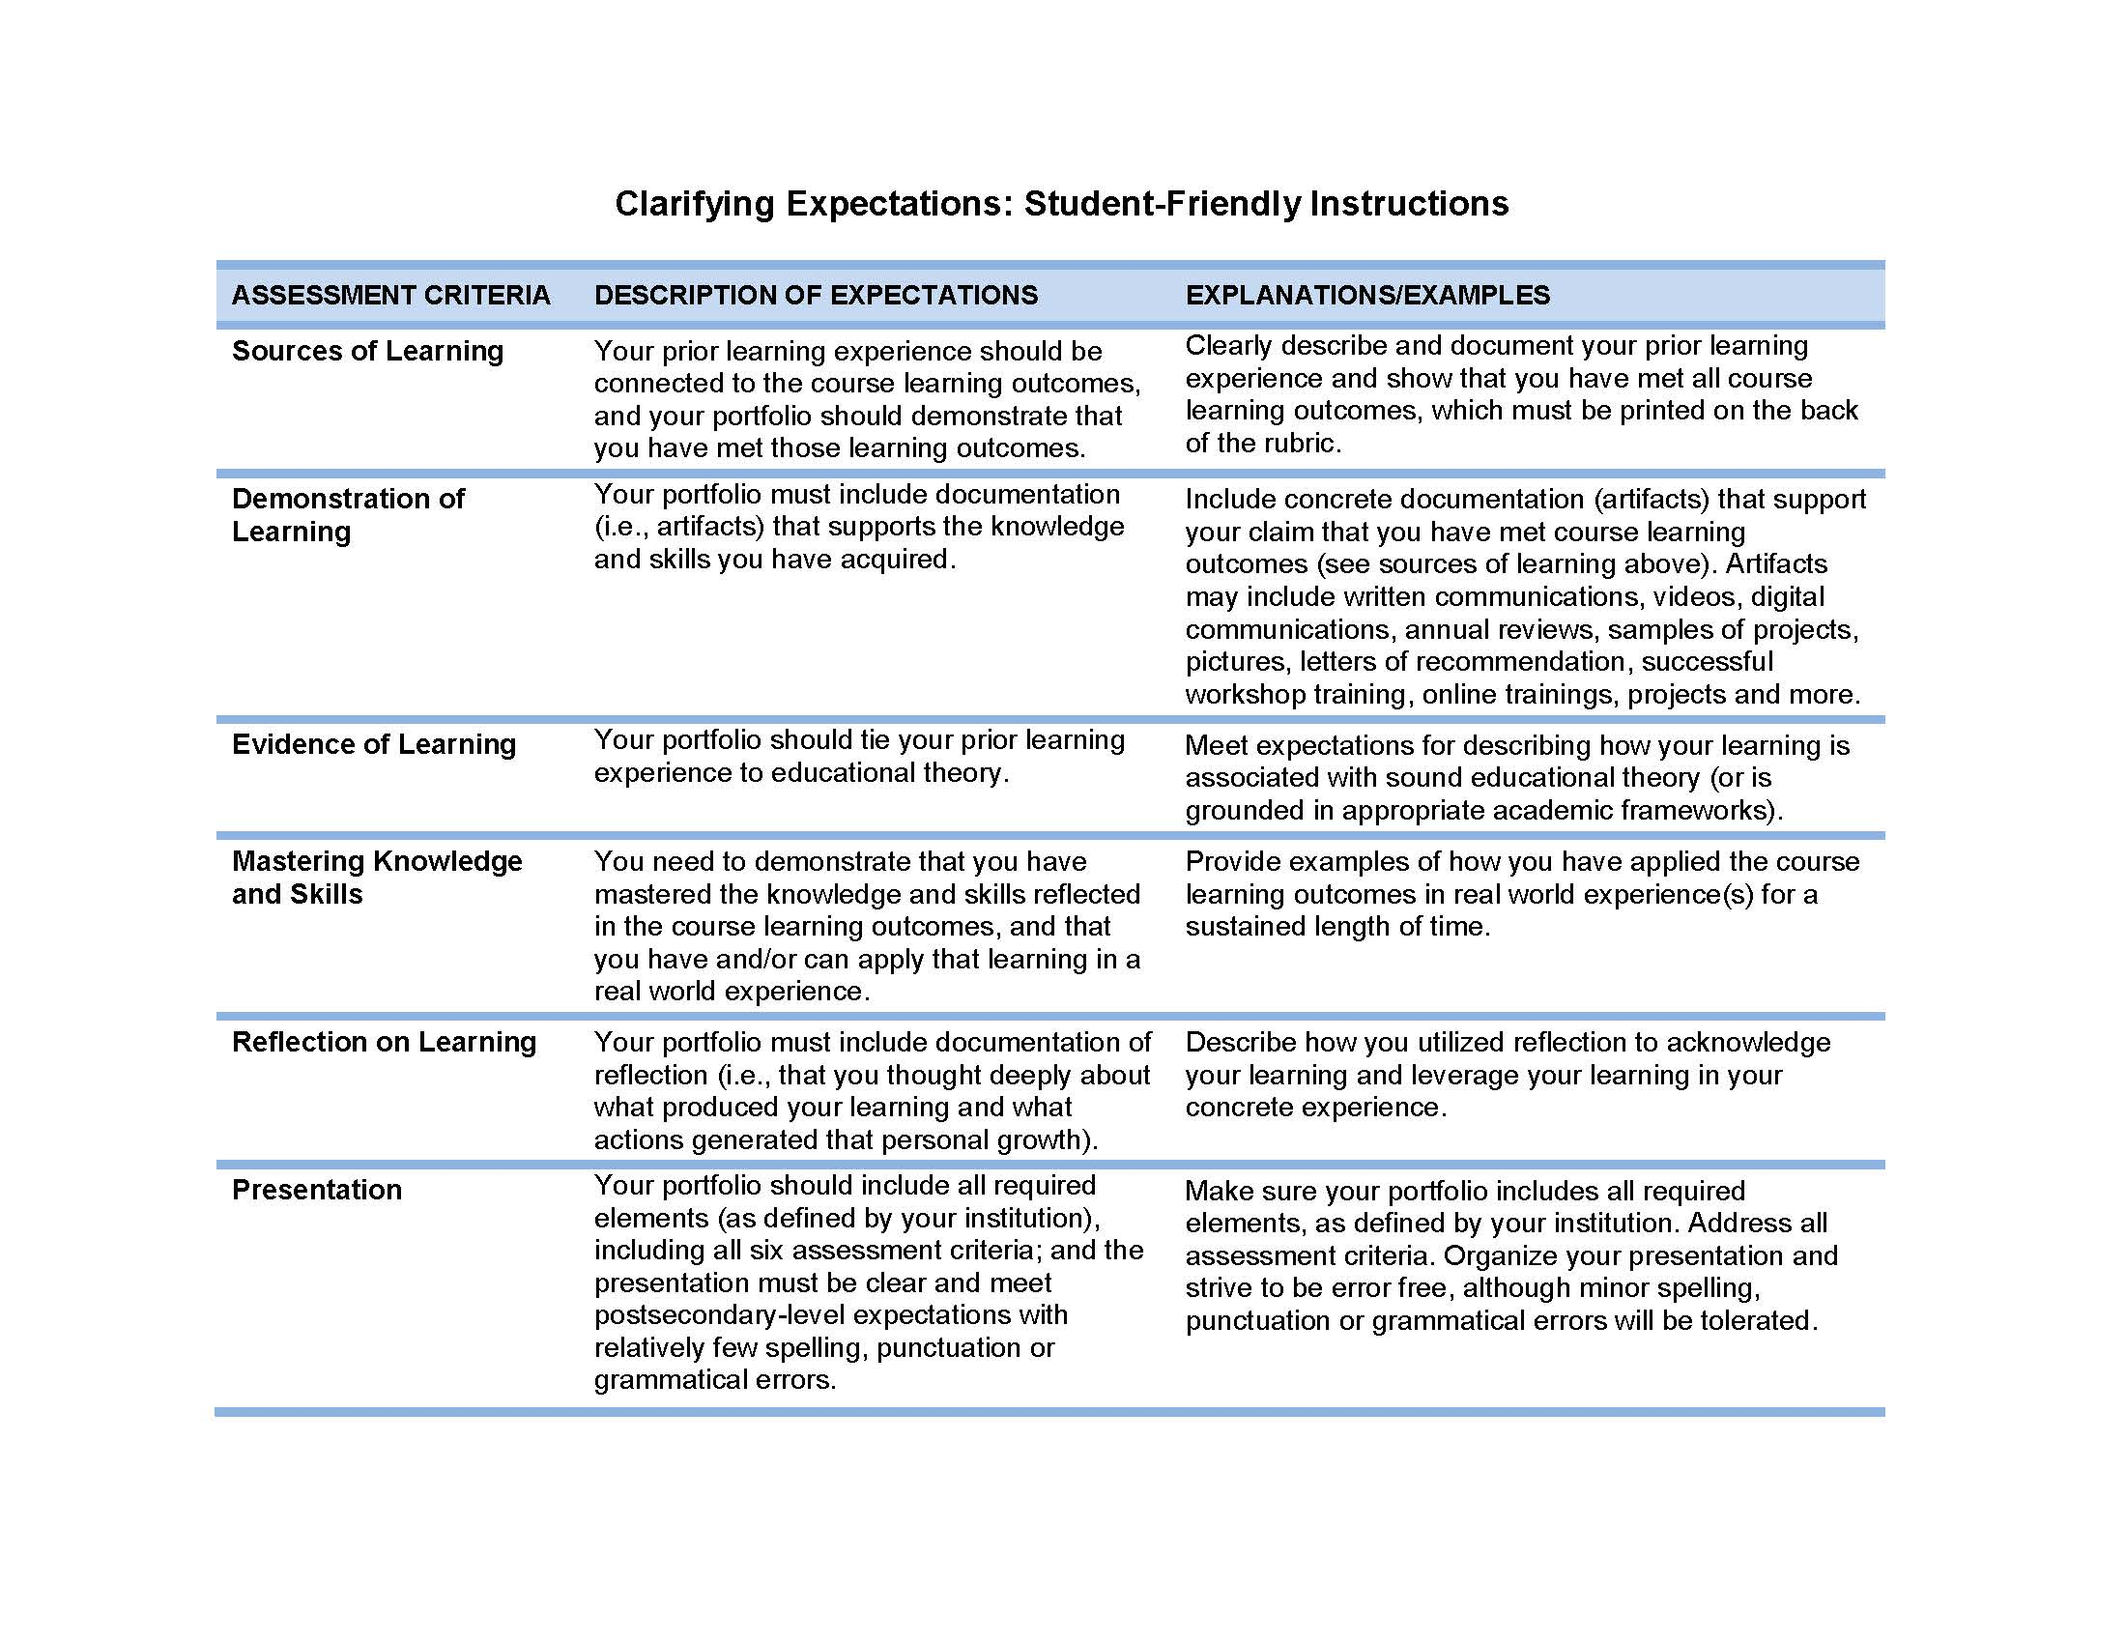

Rubric Key

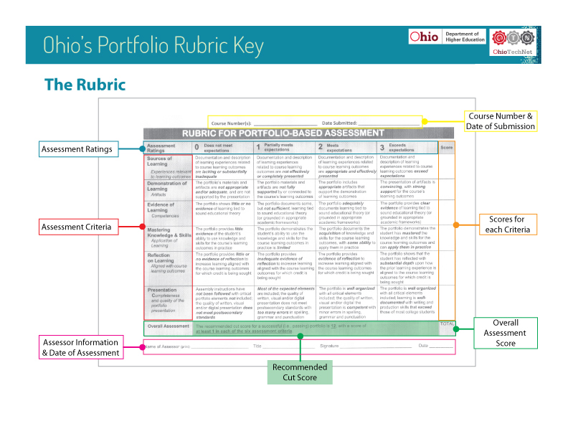
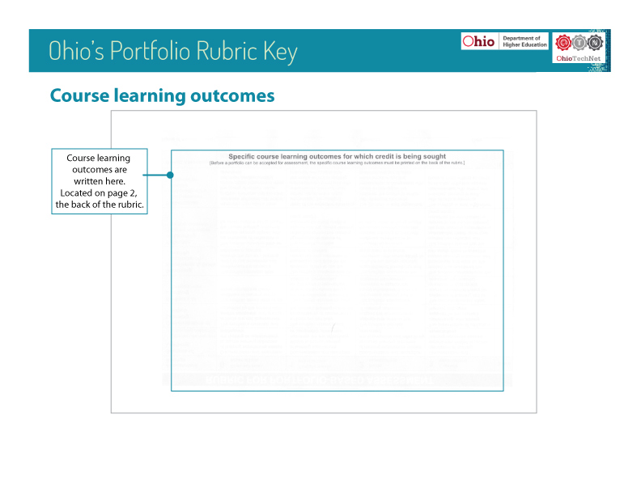
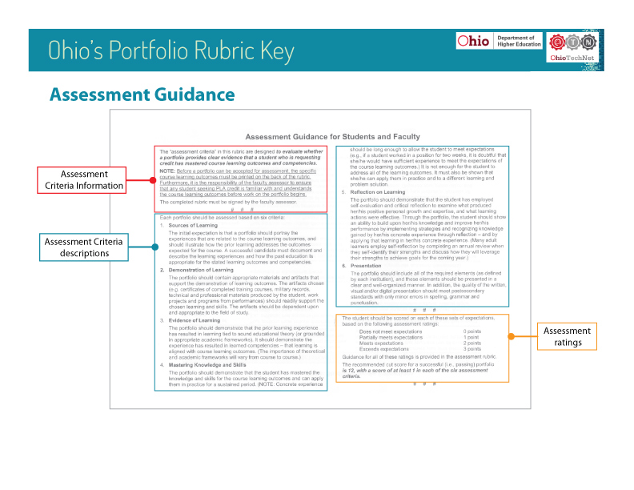

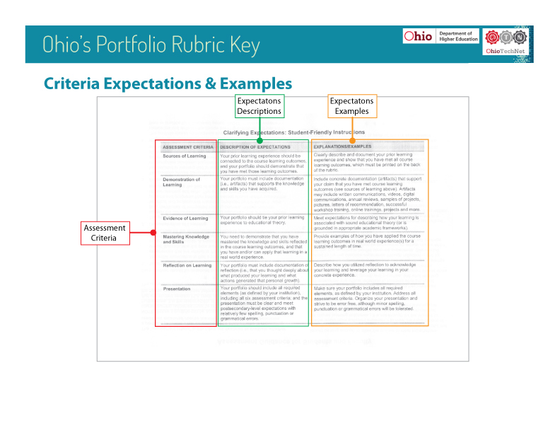

Frequently Asked Questions

PLA Rubric & Assessor FAQ’s

Rubric FAQs
Rubric FAQs:

The Rubric

What is the Rubric?
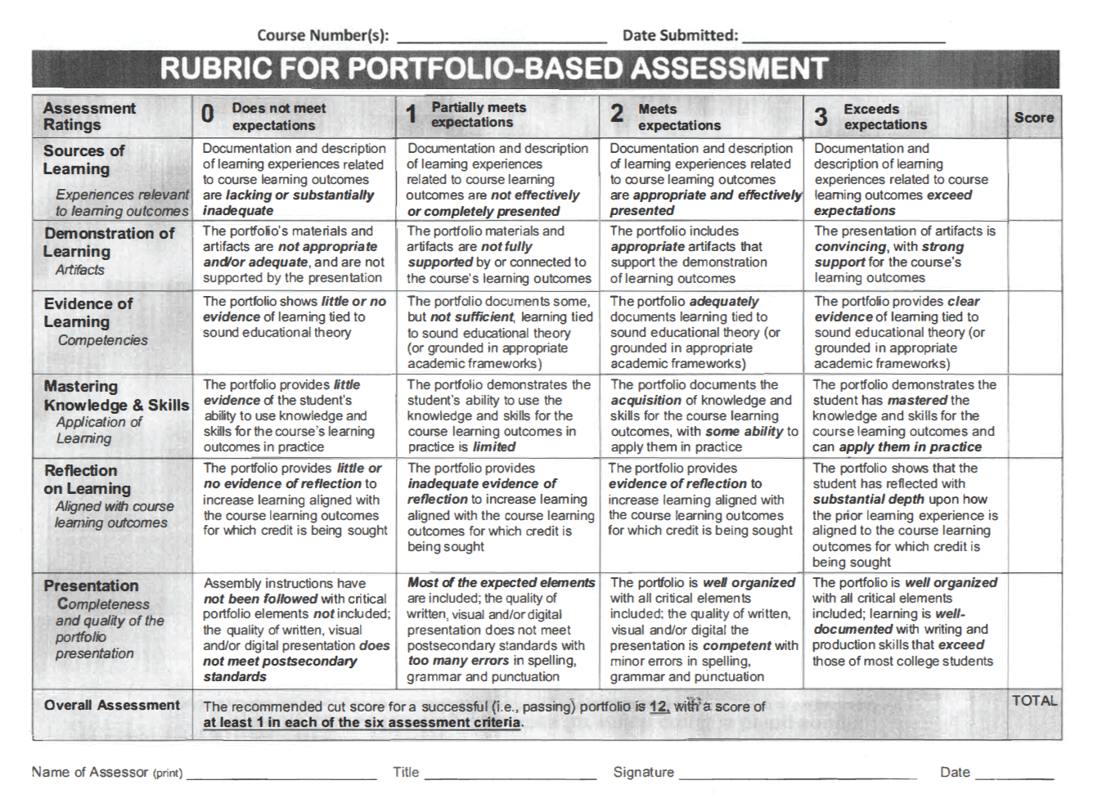
It is a scoring guide that Ohio assessors will use to evaluate portfolio learning assessments. The Rubric divides competencies and objectives into specific aspects. Portfolio components and artifacts will be compared against the rubric to see if they meet criteria.

What are the Rubric’s components?
The Rubric is a table with rows and columns.
The first column on the left includes the six Assessment Criteria:
- Sources of Learning
- Demonstration of Learning
- Evidence of Learning
- Mastering Knowledge & Skills
- Reflection on Learning
- Presentation
Assessment Criteria are requirements for documents and artifacts as they apply to the course learning outcomes.
The top row contains the Assessment Ratings. They indicate the levels of alignment to the course learning outcomes. The Ratings are arranged on a scale of values, from lowest (0) to highest (3) levels. These ratings are applied to a portfolio’s contents. A portfolio must provide clear evidence that the requesting student has mastered course learning outcomes and competencies.

Why should we use the Rubric?
The new Ohio Portfolio Rubric plays an important role in preserving high standards and maintaining consistency. It is crafted to help ensure:
- Student-centered, faculty-driven practices
- Consistency in assessment of portfolios
- Maintenance of academic integrity within, across, and among institutions
- Improved portability of credit earned by students

Using the rubric will assist assessors in their job of reviewing and rating portfolios. It is, in essence, a template on which expectations for a passing portfolio are placed. It will make your job as assessor easier by providing a consistent and concrete framework from which to work. The Portfolio Learning Assessment (PLA) Rubric will also provide clarity for assessors and the students who apply for course credit.

Portfolios

What should be in a portfolio?
Each portfolio will be unique and should align with the specific course learning outcomes for which credit is being sought. It should contain a student’s best evidence of mastery of course learning outcomes and competencies. Multiple types of documents can act as evidence. Examples include:
- Autobiographies
- Business plans
- Job performance reports
- Multimedia (e.g., photos, videos, PowerPoint presentations, etc., as appropriate)
- News articles
- Official documents of learning experiences
- Official signed awards/award nomination forms and letters
- Prior learning narrative/reflection
- Publications
- Resumes
- Signed reference letters and work experience statements
- Training certificates/records on official company/institution letterhead signed by appropriate HR/Training personnel
- Transcripts
- Training dates & completion records
- Work samples
- Each of these documents or artifacts should be complete, well written, and free of spelling and grammatical errors.
In sum, each portfolio artifact must be of quality and reflect the stated course learning outcomes (printed on the back of the rubric) for which a student is applying.

The Workshop

Why do we need the workshop?
The overall goal of the pre-training and workshop is to prepare participants to:
- Effectively evaluate portfolios by implementing the rubric
- Be able to train/educate other potential portfolio evaluators.

Do I need to do anything before the workshop?
You will need to complete the Online Module.

Where is the workshop and where should I park?
You should receive instructions as to the location and parking from the hosting institution/facilitator.

What should I bring?
It is suggested that you bring a pen/pencil. The Participant’s Manual has a notes area, but you may want to bring a notepad. Availability of beverages, snacks, and a catered lunch will vary. Please check with your workshop’s facilitator before arriving.

What tools will be used?
The facilitator will present information using a PowerPoint. Manuals will be passed out and computers will be used for the pre and post-test segments.

How long will it take?
The workshop will take approximately six (6) hours including breaks.

What is covered?
We will cover:
The Rubric: Gain knowledge and understanding of the rubric and its application in assessing portfolios.
- Structure and components of the rubric
- How it is used theoretically and in practice
- What components a complete portfolio should have
- How to assess and score a portfolio
- How to provide rationales for your scoring
- How to lead workshops at your institution

Assessor FAQ’s
Assessor FAQs:

Frequently Asked Questions
What’s a PLA portfolio?
It is a written presentation that a petitioner assembles and submits in anticipation of earning course credit for their learning. Components of the portfolio include a written narrative as well as a supporting collection of evidence that meets the requirements of a course’s learning outcomes.

How long do I have to complete the course evaluation process?
Please check with your advisor to determine your institutions requirements. Generally, no more than two weeks from the first submission if there aren’t any issues or rewrites.

How many portfolios may a student submit?
As many as he or she would like but only portfolio at a time. Your institution may have a limit on the number of credits that may be earned through PLA. Please check with your PLA advisor.

How will I be compensated for the evaluation of a portfolio?
Each school in Ohio has a unique compensation structure. Please contact your school’s PLA advisor for details.

Can any faculty evaluate a portfolio?
Faculty who are interested in becoming a faculty assessor will need to consult with their dean and PLA advisor about this opportunity. To determine credit awards and competence levels, you must be the subject matter and academic expert.

Who works with the students to determine if the portfolio process is the right path toward earning credit?
Advisors and faculty define the level of experience that could reasonably provide adequate prior learning

How much contact is there between assessors and students?
The amount of contact would depend on the need for additional information or a rewrite. Ideally, limited contact is desired since increasing the amount of communication between you and the student could potentially increase personal influence on the assessment process.

Who determines the ratings for each component?
The assessor will use the provided PLA Portfolio rubric to assist in the evaluation process. The student must earn no less than a score of 12 to earn PLA credit.

Who determines how the evaluation instrument is implemented? Does a student have to score a certain number in every component of the evaluation?
The assessors define the scoring needed to get an overall rating. For instance, some assessors might state that a lower score in one component might be offset by a higher rating in another component. Another assessor might state that the rating for each component must be at a certain number in order to get an overall satisfactory score.

What happens if a student does not receive the minimum passing score?
Please direct inquiries to the PLA advisor for next steps.

How can we be sure the experiences are authentic and valid?
Students document these experiences. Documentation can include certificates, training materials, annual reports or supervisor evaluations, work products, photographic or video evidence, as well as testimonials. These experiences are important as both justifying entry to PLA and also as basis for learning. However, the evaluation focuses primarily on learning, not the experiences themselves.

How can we be sure the evidence of learning in the submission is the work of the student?
Where there is a question of validity of learning, the assessment rubric should provide clear expectations that the evidence of learning be closely aligned with experiences and learning outcomes. For instance, the assessor can describe that evidence of learning must include examples and case studies obtained from experience.

How do I transcribe a course to my college when I complete a portfolio evaluation?
You will discuss the process with the advisor to complete the process.

Licensing Statement and DOL Disclaimer

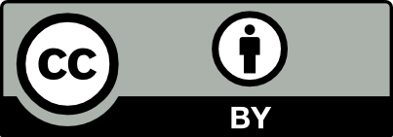
This workforce solution was funded by a grant awarded by the U.S Department of Labor’s Employment and Training Administration. The solution was created by the grantee and does not necessarily reflect the official position of the U.S Department of Labor. The Department of Labor makes no guarantees, warranties, or assurances of any kind, express or implied, with respect to such information, including any information on linked sites and including, but not limited to, accuracy of the information or its completeness, timeliness, usefulness, adequacy, continued availability, or ownership.
This work is licensed under the Creative Commons Attribution 4.0 International License. It is attributed to Ohio TechNet. To view a copy of this license, visit http://creativecommons.org/licenses/by/4.0/.

