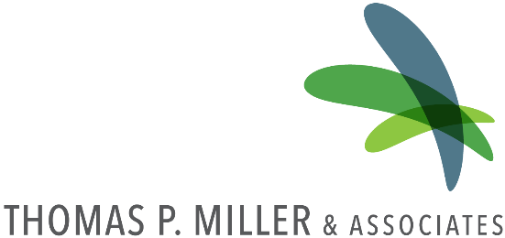
PATH Employer Market Research Study Site Visit
2018
This program is funded in part/in whole by the U.S. Department of Labor –
Employment and Training Administration. This work is licensed under a Creative
Commons Attribution-NonCommercial-NoDerivatives 4.0 International License.

PATH Employer Market Research Study

Purpose and Background
The purpose of this site visit is to measure awareness of programs developed under a Department of Labor grant Northampton Community College, Luzerne County Community College, and Lehigh Carbon Community College received to launch the Pennsylvania’s Advanced Training and Hire (PATH) initiative. During the site visit, TPMA will also seek to understand skill and training provider needs to determine the relevance of these programs in meeting employer needs.

Next Steps
Following the site visit, TPMA will analyze site visit data and generate a report outlining findings from the surveys and focus groups. The report will document PATH program awareness across a sample of employers as well as highlight training provider needs, skill needs, and company demographics to determine the relevance of these programs in meeting employer needs.

Employer Focus Group Guide

February 2018

Purpose and Background
- Purpose of the focus group discussion (e.g., gather information on employer needs to determine relevance and awareness of PATH programs) and highlight confidentiality of discussion (e.g., information will only be reported in the aggregate)
  - Introduction to PATH, if needed (i.e., partnership between Lehigh Carbon Community College, Luzerne County Community College, and Northampton Community College that seeks to to provide career pathways in Healthcare, Advanced Manufacturing, and Logistics & Transportation. Individuals that complete these programs will be able to earn stackable, portable, industry-credentials that will prepare them for employment in these industries)

Introductions
- Please state your name and the company that you are representing.
- What is your level of familiarity with the PATH programs offered at Lehigh Carbon, Luzerne, and Northampton?

Discussion Questions

PATH Awareness
- Have you or your company worked with one of the PATH colleges before?
  - If yes, in what ways (e.g., curriculum review, company tours, participation in campus events, hiring students, and internships)?
  - If not, have you worked with other educational institutions or training providers in the past or currently? In what ways?

Skill and Training Needs
- Please describe any challenges you face in finding employees with the appropriate education, certifications/training, technical skills, or soft skills.
- Based on the needs of your company, what would you say are your top 3 technical/hard skill needs?
  - What are your top soft skill needs?
- How could an educational institution best meet your training needs? In other words, what types of program offerings, courses, and course structures (course duration, days, location, costs, etc.) would help address the challenges you stated above?

Recommendations
- How do you typically become connected with educational institutions and training providers in the region (e.g., company contacts college or college contacts company)? Do you find this approach effective? If not, what suggestions do you have to improve this approach?
- What recommendations would you have for colleges trying to increase awareness of programs amongst employers? What strategies would be most effective in ensuring the programs are relevant to your needs?

Summary and Report Out

Site Visit Itinerary

Day 1
Group | Time

Day 2
Group | Time

