[CC BY Logo
](http://creativecommons.org/licenses/by/4.0)

"Microburst Learning Certification Letter for NJHPC NJPREP Files" by Microburst Learning, NJPREP, TAACCCT Grant - NJHPC NJPREP is licensed under [CC BY 4.0](http://creativecommons.org/licenses/by/4.0)

<a>"Microburst Learning Certification Letter for NJHPC NJPREP Files"</a> by <a>Microburst Learning</a>, <a>NJPREP</a>, <a>TAACCCT Grant - NJHPC NJPREP</a> is licensed under <a href="http://creativecommons.org/licenses/by/4.0" target="_blank">CC BY 4.0</a>

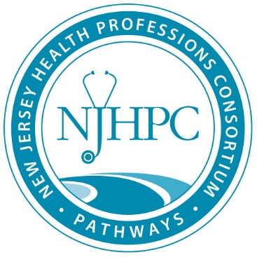

The New Jersey Health Professions Consortium - New Jersey Health Professions Pathways to Regional Excellence Project (NJ-PREP)

Microburst Learning process for evaluation of course outlines and course content to ensure ADA compliance standards for TAACCCT materials

To: Bergen Community College

Prepared By: Sarah Hartzell, Microburst Learning

Date: July 2, 2018

Subject: Bergen Community College Review Process

Bergen Community College (MCC) partnered with Microburst Learning (MBL) to evaluate course outlines and course content ensure that the outlines and content met ADA compliance standards and standards.

MBL used the following process to perform these reviews.

**Initial Review**

MBL developed a custom rubric that analyzed each file on a number of standards, including, SkillsCommons’ 508 Checklist, and compliance standards from the Skills Commons Accessibility Checkpoints Guide. MBL representatives also attended a Storyline conference on accessibility and a U.S. DOL workshop on accessibility and included those findings in the rubric. Additionally, MBL included a number of AIM/CAST Compliance standards on the rubric, including:

* Text accessible via NVDA screen reader
* Keyboard support for all areas on a slide, if an interaction is a drag and drop or hot spot type interaction, an alternative keyboard supported interaction is provided
* Flicker reduction (no flashing or blinking objects or other elements with a frequency greater than 2 Hz and lower than 55 Hz)
* Text equivalents are provided for all non-decorative non-text elements
* Object’s or image’s type, state, and description is passed to the accessibility interface
* Color coding is not used as the only means of conveying information indicating an action, prompting a response or distinguishing a visual element
* Color contrast approved ratio for background and foreground colors is 4.5:1 or greater
* Contains Clear and Consistent Navigation
* Attachments and lessons are in Word vs pdf and have contrast between headings, text, and backgrounds
* Hyperlinks are active and clearly identified
* Page numbers listed in online material match printed text
* Table Markup includes identifiers (rows and columns that is compatible with assistive technology or rendered in an application such as a browser that offers this functionality)
* Audio/video content is shown in a media player that supports closed captioning
* Closed Captioning in videos (and/or  transcripts as requested)
* Control of volume for the video and narration on the slide
* Video and audio with no music in the background
* Video controller where the user can play, pause and go to a direct location in the video
* Narration of text on screen

MBL reviewers used a custom rubric to review each document as well as the 508 Checklist to ensure aforementioned standards are met.

**Additional Information**

For additional information regarding Microburst Learning’s review process and custom rubric, please call 803-719-5073.

This workforce product was funded by a $15,000,000 grant awarded by the U.S. Department of Labor’s Employment and Training Administration. The product was created by the grantee and does not necessarily reflect the official position of the U.S. Department of Labor. The U.S. Department of Labor makes no guarantees, warranties, or assurances of any kind, express or implied, with respect to such information, including any information on linked sites and including, but not limited to, accuracy of the information or its completeness, timeliness, usefulness, adequacy, continued availability, or ownership.