Employer Meet and Greet Networking Layout
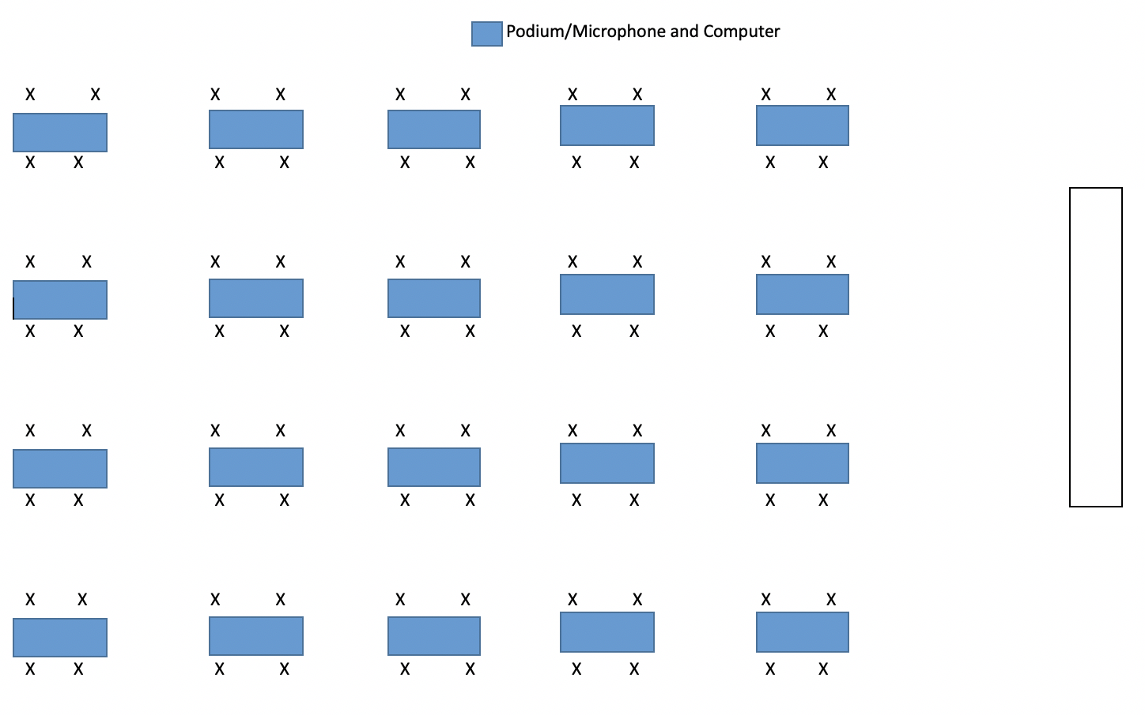

This workforce product was funded by a $15,000,000 grant awarded by the U.S. Department of Labor’s Employment and Training Administration. The product was created by the grantee and does not necessarily reflect the official position of the U.S. Department of Labor. The U.S. Department of Labor makes no guarantees, warranties, or assurances of any kind, express or implied, with respect to such information, including any information on linked sites and including, but not limited to, accuracy of the information or its completeness, timeliness, usefulness, adequacy, continued availability, or ownership.

"County College of Morris TAACCCT Grant Documents" by TAACCCT Grant Employees at County College of Morris, NJPREP, TAACCCT Grant and County College of Morris is licensed under CC BY 4.0

<a>"County College of Morris TAACCCT Grant Documents"</a> by <a>TAACCCT Grant Employees at County College of Morris</a>, <a>NJPREP</a>, <a>TAACCCT Grant and County College of Morris</a> is licensed under <a href="http://creativecommons.org/licenses/by/4.0" target="_blank">CC BY 4.0</a>

