Title: ______ELT 2613 Hybrid Programable Logic
Name of Instructor: ___Jimmy Whitehead______________________
“This workforce solution was funded by a grant awarded by the U.S. Department of Labor’s Employment and Training Administration. The solution was created by the grantee and does not necessarily reflect the official position of the U.S. DOL. The DOL makes no guarantees, warranties, or assurances of any kind, express or implied, with respect to such information, including any information on linked sites and including but not limited to, accuracy of the information or its completeness, timeliness, usefulness, adequacy, continued availability, or ownership. This solution is copyrighted by the institution that created it. Internal use by an organization and/or personal use by an individual for non-commercial purposes is permissible. All other uses require the prior authorization of the copyright owner.”
This work is licensed under a Creative Commons Attribution 3.0 United States License.

Form 2-COURSE
Content: Policies, Course Outlines, Content, Resources, Assessments
Course Title: ELT 2613 Programmable Logic Controllers___________________________
Name of Instructor: __Jimmy Whitehead_______________________________
Course Description:
Use of programmable logic controllers (Places) in modern industrial settings. Also,
the operating principles of PLCs and practice in the programming, installation, and maintenance of PLCs (3 sch: 2-hr lecture, 2-hr lab.)

Section I. Syllabus: (Include the full Syllabus for the course. See outline below.)
- Policies:

  - ADA: Northeast Mississippi Community College provides adaptations and modifications to the
Learning environment for eligible impaired and/or disabled students. All students with a
disability, including distance learning students, are strongly encouraged to contact the
ADA/Section 504 Compliance Officer:
Insert Contact Here
to discuss their disability and the appropriate accommodations. Students must self identify in order to receive accommodations.
NEMCC Disability Applications may be obtained from the Counseling Center in Waller
Hall, or online from the College’s website at www.nemcc.edu

  - Honesty Policy:
Academic honesty is a fundamental attribute of higher learning. Students who violate the principle of honesty deny themselves an opportunity to master the skills that they are credited to possess, cheat their classmates of deserved recognition, and demean the college and its degrees. It is a matter of great concern that all members of the college community strive for high standards of personal integrity.
Evaluation of each student’s level of knowledge and understanding is a vital part of the teaching process, and requires tangible measures such as reports, examinations, and homework. Any act that interferes with the process of evaluation by misrepresenting the relationship between the work being evaluated and the student’s actual state of knowledge is an act of academic dishonesty. These acts of dishonesty include but are not limited to: fraud, cheating, plagiarism, forgery, and facilitating dishonesty. (Definitions and discipline procedures may be found in Northeast Procedures Manual).

  - Attendance Policy:
Northeast Mississippi Community College is a member of the Mississippi Virtual Community College (MSVCC). This allows students to take online courses that are taught by Northeast instructors (provided courses), as well as courses that are taught by instructors from the other community colleges (hosted colleges). Each college will have its own absence policy. At the beginning of the course, the instructor must communicate with the student by documented class policies his/her expectations regarding the format and frequency of class participation.
Absence policy for online courses provided by Northeast instructors: Online instruction differs fundamentally from traditional classroom instruction in that the student may access the online resources at times that are convenient to the student’s personal schedule within a range of times defined by the instructor. However, consistent attendance is required to successfully complete an online course. A student participating in a provided online course will be allowed two (2) absences. Upon the third absence, the student will be cut by the instructor and will receive an F for the course unless a proper Withdrawal form is completed during the approved withdrawal period.
Attendance will be monitored by timely submission of assignments, including test, homework, projects, discussion boards, etc. A student is expected to complete all assignments by the appropriate due date. Failure to complete such assignments by the due date will be cut from the course barring any extenuating circumstance. It is understandable that extenuating circumstances occur, such as an extreme illness, death in the immediate family, legal matters, or military duty. It is the student’s responsibility to provide appropriate documentation in a timely manner (prior to the due date if all possible) to substantiate such circumstances. At which time the instructor will determine if an extension is warranted. Students and instructors of online courses will adhere to the academic calendar and the process of appeal.

  - Drop Policy: See student Handbook

  - Make up Policy: See student Handbook

  - Materials use Policy: See student Handbook

  - Code of conduct/accountability Policy: See student Handbook

  - Student Rights/Responsibilities Policy: See student Handbook

  - Communication with instructor Policy: See student Handbook

- Grading Scale/System and Calendar:
- Date | Materials | Assignments | Points
Student Orientation |  | Fill out all paper work | 100
Module 1 |  | End of chapter 1 Questions  Journal on Module 1 | 100  100
 |  | Chapter 1 Quiz | 100
 |  | Two hour Lab at College | 100
Module 2 |  | Answer review questions at the end of chapter 2 | 100  100
 |  | Journal on Module 2 | 100
 |  | Two hour Lab at College | 100
Module 3 |  | Journal on Module 3 | 100
 |  | Chapter 2 Quiz | 100
 |  | Two hour Lab at College | 100
Module 4 |  | Journal on Module 4 | 100
 |  | Chapter 3 Quiz | 100
 |  | Two hour Lab at College | 100
Module 5 |  | Answer review questions at the end of chapter 5 | 100
 |  | Journal on Module 5 | 100
 |  | Two hour Lab at College | 100
Module 6 |  | Journal on Module 6 | 100
 |  | Chapter 5 Quiz | 100
 |  | Two hour Lab at College | 100
Midterm |  | Proctored Test  Performance Test | 100  100
Module 7 |  | Answer review questions at the end of chapter 6 | 100
 |  | Journal on Module 7 | 100
 |  | Two hour Lab at College | 100
Module 8 |  | Journal on Module 8 | 100
 |  | Chapter 6 Quiz | 100
 |  | Two hour Lab at College | 100
Module 9 |  | Answer review questions at the end of chapter 7 | 100
 |  | Journal on Module 9 | 100
 |  | Two hour Lab at College | 100
Module 10 |  | Answer review questions at the end of chapter 8 | 100
 |  | Journal on Module 10 | 100
 |  | Chapter 7 & 8 Quiz  Two hour Lab at College | 100  100
Module 11 |  | Answer review questions at the end of chapter 13 | 100
 |  | Journal on Module 11 | 100
 |  | Two hour Lab at College | 100
Module 12 |  | Journal on Module 12 | 100
 |  | Chapter 13 Quiz | 100
 |  | Two hour Lab at College | 100
Final |  | Proctored Test | 100
 |  | Performance Test | 100

Evaluation Rubric
Weekly Assignments | 30%
Midterm | 20%
Lab work | 30%
Final Exam | 20%

Continued below…..

Section II. Content:
- Student Orientation:

Student Orientation
Required Student Orientation
To complete the student orientation assignment and receive credit for attending the first week of class, please complete the items below:
- This class is a Hybrid class each student will be required to attend some instruction at their respective college. The time and dates will be posted by instructor.
- The book used for this class is Programmable Logic Controllers By Frank D. Petruzella 4th edition ISB 978-0-07-351088-0.
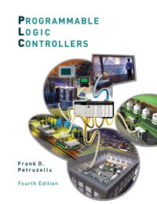

- Module 1 (with study materials, graded assignments):

Module1
Module 1 PLC Principles / Safety
1. Read Chapter 1
2. Answer review questions at end of chapter
3. Journal on Module 1
What did you learn about PLCs? Short answers
5. Chapter 1 Quiz
6. Two hour Lab at College

- Module 2 (with study materials, graded assignments):

Module 2
Module 2 PLC Hardware Components Part 1
1. Read Chapter 2
2. Answer review questions at the end of chapter
3. Journal on Module 2
Short statements on Chapter 2 and Lab project
5. Two hour Lab at College

- Module 3 (with study materials, graded assignments):

Module 3
Module 3 PLC Hardware Components Part 2
1. Continue to read Chapter 2
2. Journal on Module 3
What did you learn form module 3 Lab projects
4. Chapter 2 Quiz
5. Two hour Lab at College

- Module 4 (with study materials, graded assignments):

Module 4
Module 4 PLC numbering systems
1. Read Chapter 3
2. Journal on Module 4
Short statements on what you have learned on numbering systems.
4. Chapter 3 Quiz
5. Two hour Lab at College

- Module 5 (with study materials, graded assignments):

Module 5
Module 5 Basic PLC Programming Part 1
1. Read Chapter 5
2. Answer review questions at the end of chapter
3. Journal on Module 5
Short statements about what you learned from Chapter 5.
4. Two hour Lab at College

- Midterm Exam:
Hands on Skills Check Off ELT 2613 PLC
- Identify types of PLC hardware.
- PLC system from Logix 5-5000 platform.
- Processor, I/O modules, and Analog cards.
Examples:

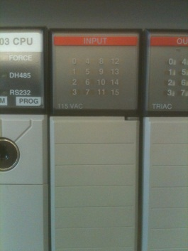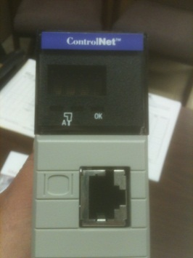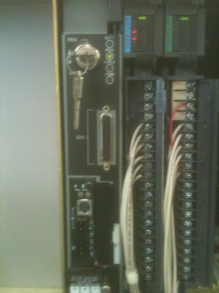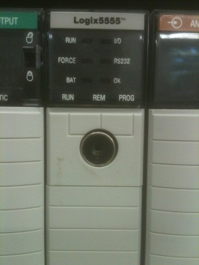

- Module 7 (with study materials, graded assignments):

Module 7
Module 7 Fundamental PLC wiring and Logic Programs Part 1
1. Read Chapter 6
2. Answer review questions at the end of chapter
3. Journal on Module 7
Short statements on what you have learned from chapter 6.
5. Two hour Lab at College

- Module 8 (with study materials, graded assignments):

Module 8
Module 8 Fundamental PLC wiring and Logic Programs Part 2
1. Continue to read chapter 6
2. Journal on Module 8
Short statements on Lab projects in module 8.
4. Chapter 6 Quiz
5. Two hour Lab at College

- Module 9 (with study materials, graded assignments):

Module 9
Module 9 Programming Counters/Timers Part 1
1. Read chapter 7
2. Answer review questions at the end of chapter
3. Journal on Module 9
Short statements what you learned on Chapter 7.
5. Two hour Lab at College

- Module 10 (with study materials, graded assignments):

Module 10
Module 10 Programming Counters/Timers Part 2
1. Read Chapter 8
2. Answer review questions at the end of chapter
3. Journal on Module 10
Short statements on what you have learned on Chapter 8.
5. Chapter 7 & 8 Quiz
6. Two hour Lab at College

12. Module 11 (with study materials, graded assignments):

Module 11
Module 11 Troubleshooting PLC Processors, Input/Output Part 1
1. Read Chapter 13
2. Answer review questions at the end of chapter
3. Journal on Module 11
Short statement on what you have learned from your readings.
5. Two hour Lab at College

13. Module 12 (with study materials, graded assignments):

Module 12
Module 12 Troubleshooting PLC Processors, Input/output Part 2
- Continue to read Chapter 13
- Journal on Module 12
- Short statements on module 12 Lab.
- Chapter 13 Quiz
- Two hour Lab at College

Final Exam Hands on Skills Check Off ELT 2613 PLC

1. Program a XIC, XIO, TON, TOF, CTU, CTD, latch, and unlatch instruction.
a. Program using any platform from Logix 5-5000.
b. Demonstrate each instruction in a complete program.
c. Down load and run program.

Section III. Labs, Discussions, other: (Include any Lab exercises, discussions, or other items.)
Labs are in each Module.

