These instructions are for loading the SCORM packages into a Blackboard LMS. If you are using a different learning management system, please refer to the proper procedure for your LMS.
NOTE: When uploading SCORM packages, keep the package in the zipped format.
- In blackboard, go to the folder where you wish to add the package and select Add – Content Package.
- Browse computer for the SCORM Zip Package.
- Click “Submit”
- Enter settings as shown below: (for #6, you can allow unlimited attempts.)
Figure 1 SCORM Availability Settings
- Select “‘SCORM Completion”

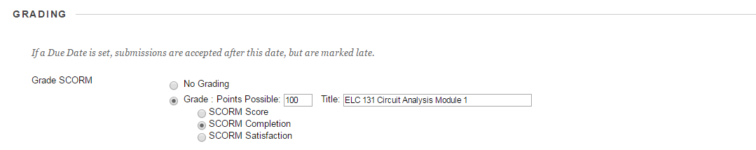
Figure 2 SCORM Grading Settings
- Select ‘When SCORM is completed display score in Grade center’ option.

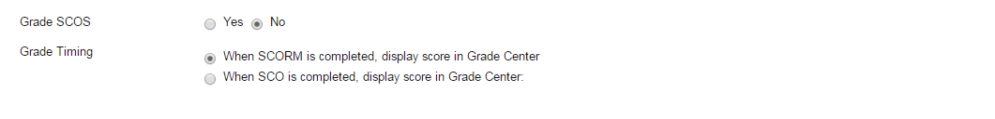
Figure 3 SCORM Completion Settings

- Submit and test the module. If the content works as expected, you are finished. Steps 1-7 will work for the majority of the content. However, if you are uploading a zip file that is not a “module,” and the animation or lab does not work, continue to step 8.

(NOTE: ONLY follow step 8 for animations or virtual labs that DO NOT WORK after steps 1-7.)
- Please click on File option at the left hand bottom corner as shown below.

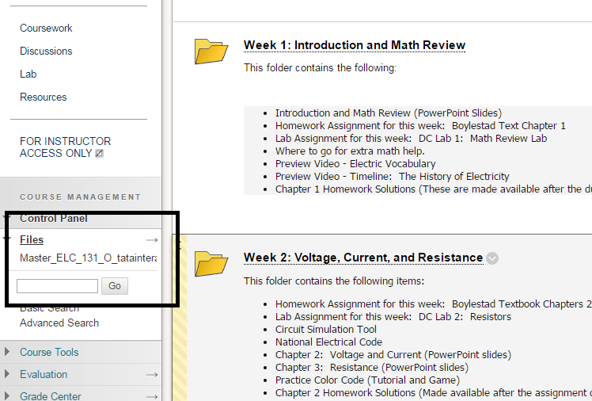
Figure 4 Blackboard Control Panel Location

- Click on name of your blackboard shell. The name of our shell was “Master_ELC131_O_tatainteractive” link.

- After clicking, on right hand side and create a folder and give a descriptive name. We named our folder “Nugget 1.”

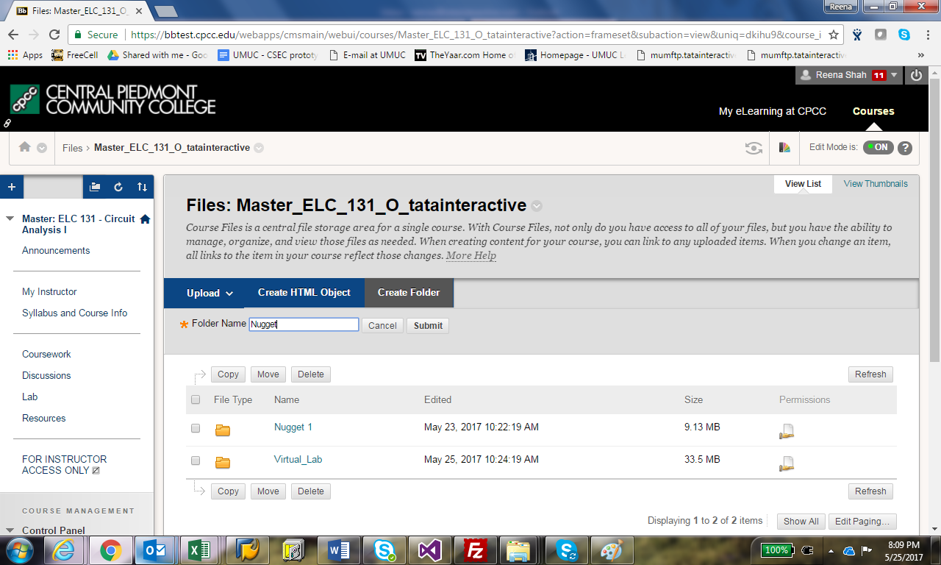
Figure 5 Folder Creation in Blackboard
- Once the folder is created, select the folder and upload the zip package provided.
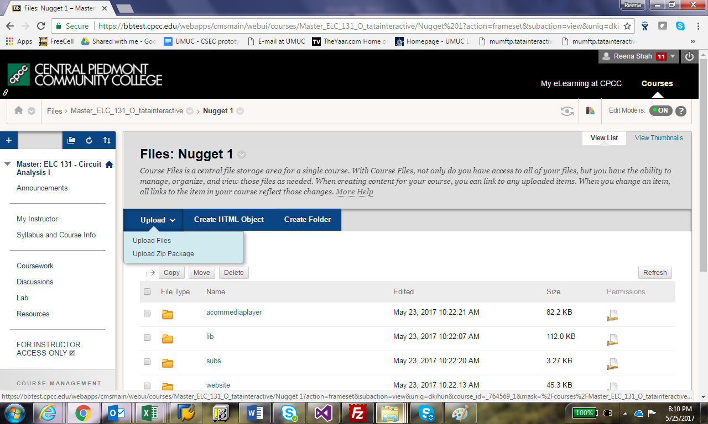
Figure 6 Upload Zip Folder to New Folder
- Once uploaded, go to the folder where the content will be placed in the shell.

- Click on Create Item.

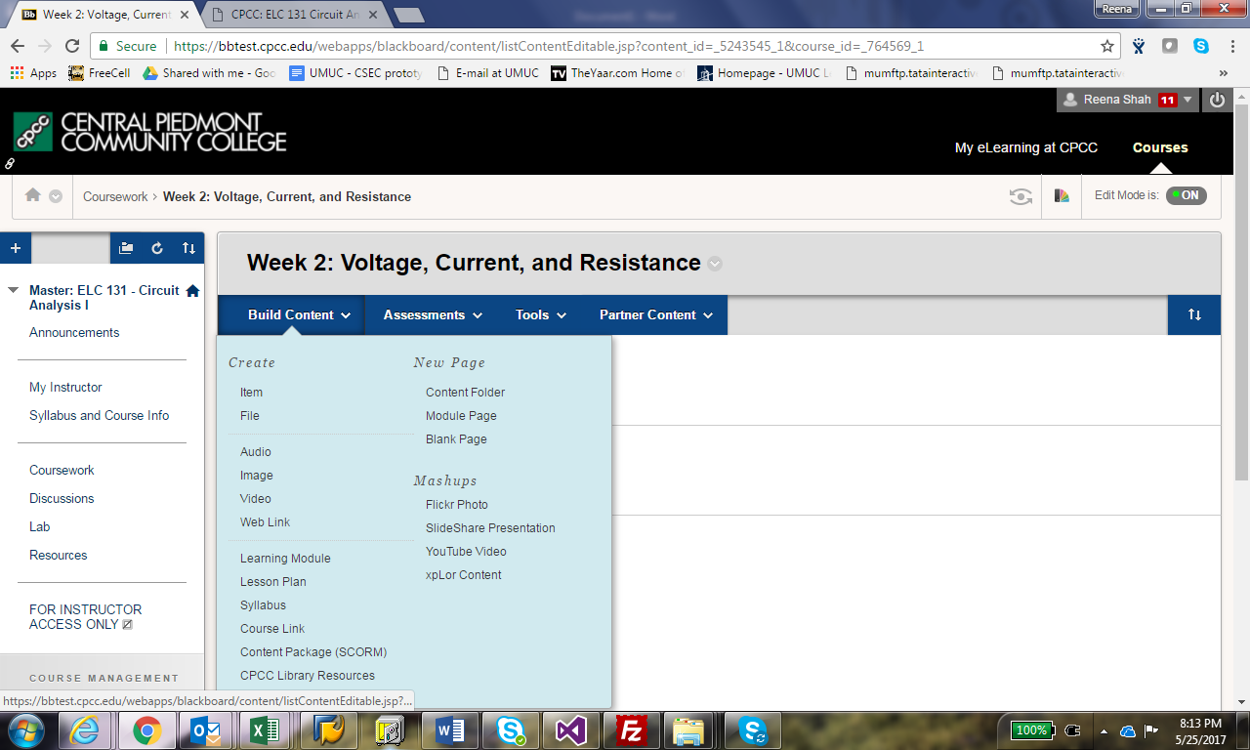
Figure 7 Item Creation Menu

- Create a name for your content item in the name and description area.

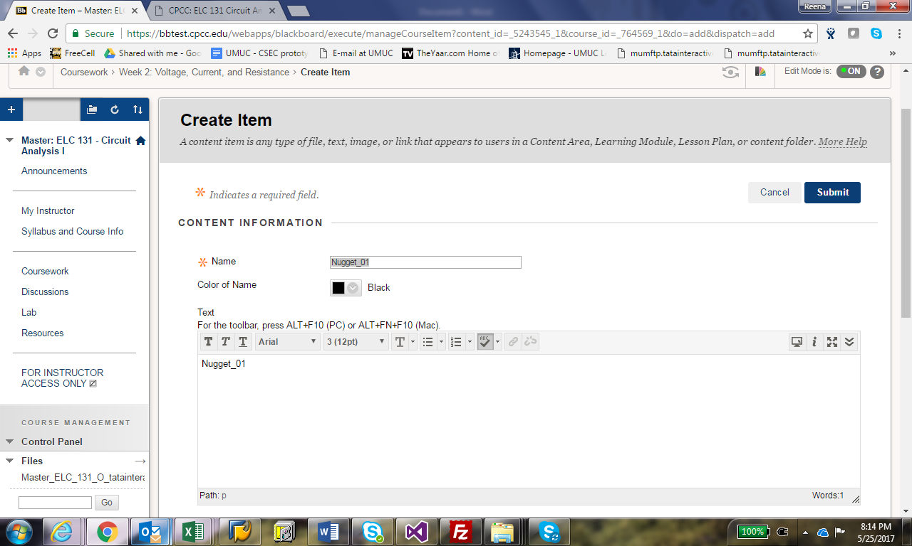
Figure 8 Create Item Dialog Box
- Scrolling below, click on Browse course and choose the folder where you placed the zip package.

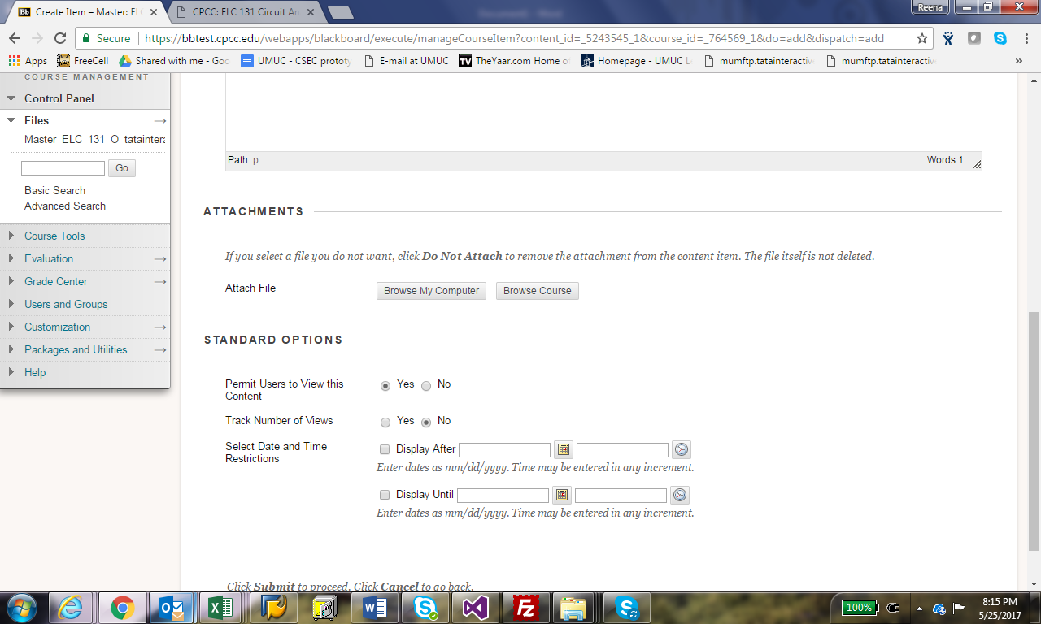
Figure 9 Browse to Course Folder
- Within the folder, you will see an Index.html file. This is to be selected by clicking on the check box on the left side of the file.

- Once selected, click submit and test the content.

