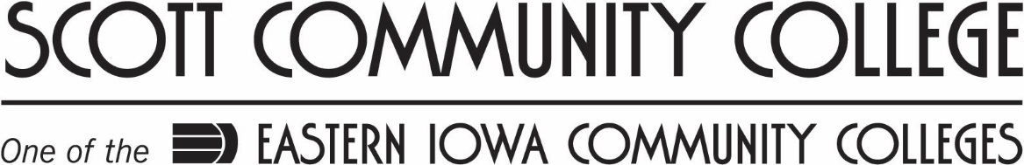

Windows Workstation Operating Systems

Spring 2017 Syllabus

Course number | NET-303-DEC01
Section number | 177128
Building and room number | www.iocconline.com

Instructor Information

Name | K. Raine Morford
College email | kmorford@eicc.edu
Office hours or times available | Email
College voice mail number | (563) 441-4390

Course Information
This course prepares the student for supporting and using Windows Operating System Platform in a business setting. Topics of this course include installation, administration of resources, troubleshooting, networking, optimization and security.

Grading Policies
Points will be awarded for all homework assignments, classroom labs, one required presentation, class participation, mid-term and final exams. Convert numeric scores to final grades using the following scale. (Divide the total points earned by the total points possible.)

90 – 100 A
80 – 89 B
70 – 79 C
60 – 69 D
Below 60 F

Homework:
Homework assignments due dates are listed under due dates on the left side. All Assignments are to be turned into the Dropbox. No late assignments will be accepted. The ONLY exception will be if the student makes arrangements with the instructor PRIOR to the date the assignments are due! In order to prepare grades in a timely manner, no makeup labs or late homework assignments will be accepted after the end of class.

Attendance:
This is an online class, you will be required to log in and post to discussions. You should log in at least 3 times a week to check for announcements. You should plan on spending at least 8 hours a week on class work.

Student Information

Required text | MCSA Microsoft Windows 10 Study Guide: Exam 70-697 William Panek  ISBN: 978-1-119-25230-6
College web site | http://eicc.edu
Midterm date | 3/10
Final date | 5/16
Advising day | 4/4
Days college is closed | 2/17, Spring Break 3/13-3/17

Class Information
All class information can be found under course home links.

College Information

Academic Calendar: with dates pertaining to the class schedule, go to
https://eicconnect.eicc.edu/academicinformation/acadcalendars/Pages/default.aspx
To Access E-Bridge: to check Grades, Class Schedule, Financial Aid, and Register for Classes:
Go to www.eicc.edu Chose EICC connect and log in. Then chose eBridge, Students, Academic Profile
FERPA information: Scott Community College, in full compliance with the Family Educational Rights and Privacy Act of 1974, shall make educational records available to students upon request. Likewise, in accordance with the law, individually identifiable educational records will not be released to other than authorized individuals without written consent of the student. Students have the right to file complaints with the Family Educational Rights and Privacy Act (FERPA) Office concerning alleged failures by the institution to comply with the act. For more information go to http://www.eicc.edu choose EICC Connect, sign in, choose Student Services, Student Resources, Student Files, then FERPA
ADA information: Anyone who feels they may need an academic accommodation based on the impact of a documented disability should contact the learning specialist on the Belmont campus at 536-441-4027 to arrange an appointment as soon as possible. At the appointment, course format, individual needs, and potential accommodations will be discussed. This service is FREE and confidential.
Military information: Eastern Iowa Community Colleges seeks to provide a learning environment that is welcoming to all students. Any active or reserve military who would like to discuss transitioning from the military into the academic environment, please contact Rebecca Geiken. She is available to assist all veterans and their families in accessing programs and services within the college and community to enhance the educational experience. We have a Student Veteran’s Organization and a Veteran Center in room 1019 on the Belmont campus. Rebecca Geiken, Military and Veteran Student Affairs Facilitator, rgeiken@eicc.edu or by phone at 563-441-4060.

This workforce solution is funded by the IHUM Consortium which is 100% financed through a $15,000,000 grant from the U.S. Department of Labor’s Employment & Training Administration.
The product was created by the grantee and does not necessarily reflect the official position of the U.S. Department of Labor. The Department of Labor makes no guarantees, warranties, or assurances of any kind, express or implied, with respect to such information, including any information on linked sites and including, but not limited to, accuracy of the information or its completeness, timeliness, usefulness, adequacy, continued availability, or ownership. This work is licensed under the Creative Commons Attribution 4.0 International License. To view a copy of this license, visit http://creativecommons.org/licenses/by/4.0/.

