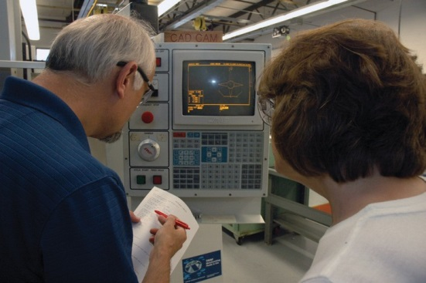
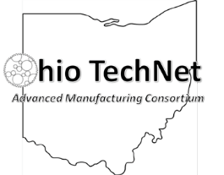

Ramp Up Your Career!
Position yourself with short-term training and degrees that can lead to new or expanded career opportunities.

Over the next decade nearly 3.5 million manufacturing jobs will likely be needed in these areas:
- CNC/CAMM
- Automation
- Micro-electrical systems and sensors
- Digital fabrication
- Industrial maintenance
- Occupational Safety
- Welding

Learn about short-term training that can be done in as little as eight months, includes paid internships with employers who need skilled workers and can lead to an associate or bachelor’s degree. Financial aid may be available for those who qualify.

Ramp Up Your Career postcard.indd 1 11/10/15 3:42 PM

Lorain County Community College and the Lorain County JVS can help you prepare for a new career or upgrade your current one in these areas: CNC/CAMM, automation, micro-electrical systems and sensors, digital fabrication, occupational safety industrial maintenance and welding.
“There are jobs waiting in these industries for people with the training they can get from LCCC. These programs prepare students to enter the workforce and employers are eager to hire them.” – Johnny Vanderford, LCCC SMART Center project engineer and professor in the LCCC Mechatronics program.
Ramp Up Your Career
www.lorainccc.edu/rampup

Learn more about training in these areas at LCCC or LCJVS at one of these information sessions:

OhioMeansJobs-Lorain County • 42495 North Ridge Rd., Elyria, OH 44035
- Thursday, December 3 at 9 a.m.

Lorain County JVS Adult Education Center, Conference Room B 15181 State Route 58 South, Oberlin, OH 44074
- Wednesday, December 9 at 6 p.m.
- Tuesday, January 5 at 6 p.m.

Lorain County Community College - Spitzer Conference Center, Room 210 1005 North Abbe Rd., Elyria, OH 44035
- Wednesday, November 18 at 6 p.m.
- Tuesday, December 1 at 9 a.m.

To register for an information session, visit www.lorainccc.edu/rampup
If you have questions, please call (440) 366-4325.

1005 North Abbe Road, Elyria, OH 44035-1691
www.lorainccc.edu/rampup
NON-PROFIT ORGANIZATION US POSTAGE PAID
PERMIT NO. 1742

Ramp Up Your Career postcard.indd 2

This workforce solution was funded by a grant awarded by the U.S Department of Labor’s Employment and Training Administration. The solution was created by the grantee and does not necessarily reflect the official position of the U.S Department of Labor. The Department of Labor makes no guarantees, warranties, or assurances of any kind, express or implied, with respect to such information, including any information on linked sites and including, but not limited to, accuracy of the information or its completeness, timeliness, usefulness, adequacy, continued availability, or ownership.
This work is licensed under the Creative Commons Attribution 4.0 International License. It is attributed to Ohio TechNet. To view a copy of this license, visit http://creativecommons.org/licenses/by/4.0/.
11/10/15 3:43 PM

