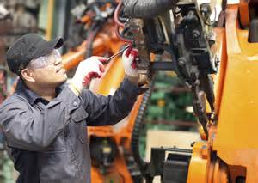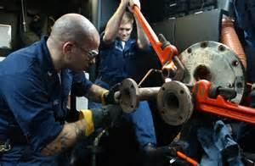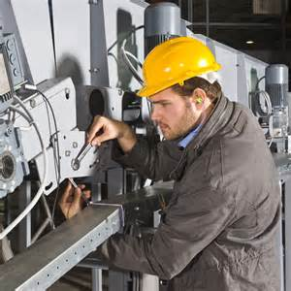

**Want to learn more…attend**

**an Information Session!**

**Wednesday, June 7, 2017 | 10 a.m.**

**Lorain County Community College**

**Patsie C. Campana Building**

**1005 North Abbe Road**

**Room: PC 101**

**Elyria, Ohio 44035**

**Thursday, June 15, 2017 | 10 a.m.**

**OhioMeansJobs-Lorain County**

**42495 North Ridge Road**

**Elyria, Ohio 44035**

**Tuesday, June 20, 2017 | 10 a.m.**

**Lorain County JVS-Adult Career Center**

**15181 State Route 58**

**Room: Lecture Room A**

**Oberlin, Ohio 44074**

**Thursday, June 29, 2017 | 10 a.m.**

**OhioMeansJobs-Lorain County**

**42495 North Ridge Road**

**Elyria, Ohio 44035**

**Reserve your seat today!**

**www.lorainccc.edu/ramp**

To speak with an advisor, call

Chrissy Cooney

440.366.4325

ccooney1@lorainccc.edu

**Maintenance Technician**

**Short-Term Technical Certificate**

**Program offered at Lorain County JVS**

**Program Overview**

**The Maintenance Technician Certificate** trains individuals to repair, troubleshoot, and maintain automated equipment commonly used in industry.

Within this field, there are a wide range of functions related to the control and maintenance of production, distribution and/or manufacturing conducted by automated processes. Individuals working in companies may develop and test industrial process control systems, conduct the installation and operation of such systems. They may calibrate operating systems and components and troubleshoot for improvement and functionality of theses systems. Others work with programmable logic controllers involving work with special-purpose computers to synchronize all of the technologies used for a manufacturing process.

Mass production is the basis for most every business, from car companies to computer giants. The automation industry is one of the fastest growing areas of our national and international high-technology economy. It combines the fields of electronics, electrical, and mechanics and includes the interaction and control of motors, computers, pneumatics, hydraulics and other processes used in manufacturing.

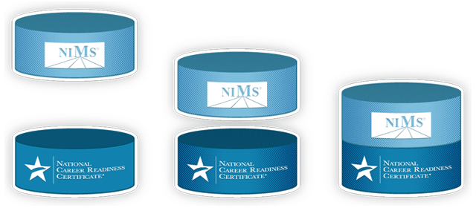

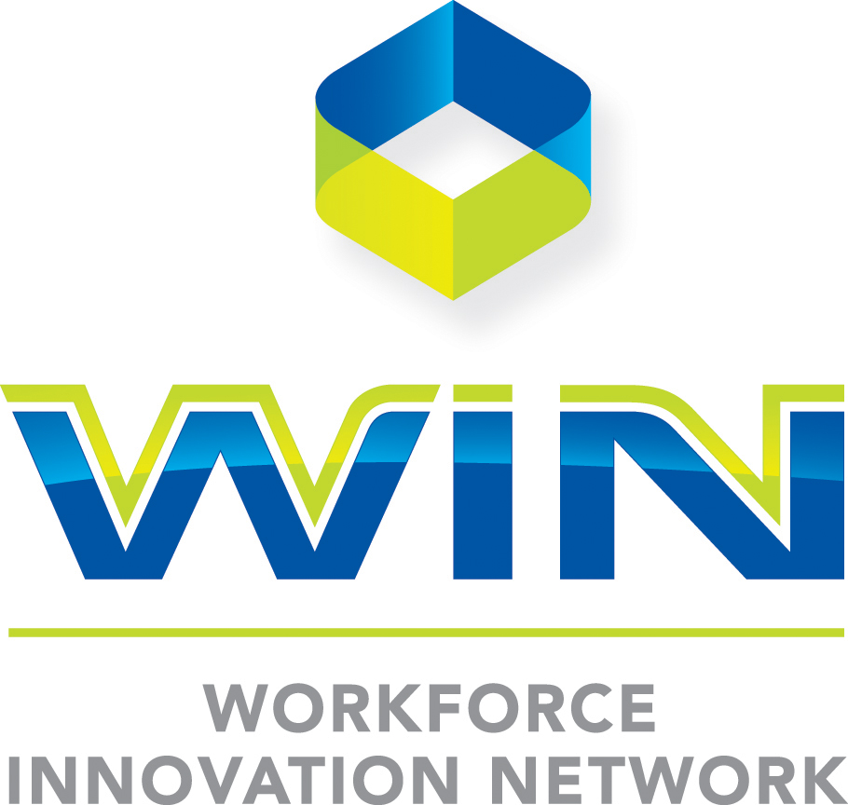

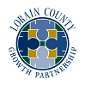



*Powered by Lorain County JVS and Lorain County Community College*

This workforce solution was funded by a grant awarded by the U.S Department of Labor’s Employment and Training Administration. The solution was created by the grantee and does not necessarily reflect the official position of the U.S Department of Labor. The Department of Labor makes no guarantees, warranties, or assurances of any kind, express or implied, with respect to such information, including any information on linked sites and including, but not limited to, accuracy of the information or its completeness, timeliness, usefulness, adequacy, continued availability, or ownership.

https://i.creativecommons.org/l/by/3.0/88x31.png This work is licensed under the Creative Commons Attribution 4.0 International License. It is attributed to Ohio TechNet. To view a copy of this license, visit <http://creativecommons.org/licenses/by/4.0/>.