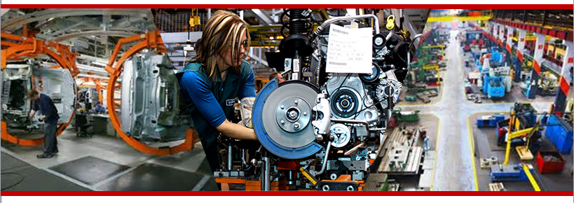

Foundations for

Manufacturing Careers

**Jump start your Career in Manufacturing!**

**FREE TRAINING**

**Call today!**

**440.366.4367**

***Program Benefits:***

* **Ability to earn industry-recognized credentials that are portable**
* **FREE Fast-Track Training**
* **Carousel starting points allow for on-going registration throughout the program with each module**
* **Attend 2 days a week Tuesdays and Thursdays from 6 – 8:15 p.m. - for each 5 week module**
* **Training connects students to employers**
* **Dedicated Academic Advisor to work with you every step of the way!**

**Program Overview:**

Employers in our area need entry-level workers who can grow with them in the advanced manufacturing field! The Foundations for Manufacturing Careers Program combined with the Manufacturing Skill Standards Council (MSSC) training and assessments help individuals develop abilities in problem-solving, decision-making, gathering and analyzing information and teamwork as well as technical skills.

**Program Highlights:**

* Certified Production Technician (CPT) through Manufacturing Skills Standards Council (MSSC)
* OSHA-10 Certification
* National Career Readiness Certificate (NCRC)

**Program Content:**

MSSC Four Modules & Assessment Opportunities:

***Carousel starting points allow for on-going registration throughout the program at each module!***

| **Module 1:**  Safety | November 7, 2017 – December 7, 2017 | 6:00 p.m. – 8:15 p.m. |
| --- | --- | --- |
| **Module 2:**  Manufacturing Processes and Production | December 12, 2017 – January 18, 2018  Break  Dec. 25 – Jan. 1 | 6:00 p.m. – 8:15 p.m. |
| **Module 3:**  MSSC Quality Practices and Measurement | January 23, 2018 – February 22, 2018 | 6:00 p.m. – 8:15 p.m. |
| **Module 4:**  Maintenance Awareness | February 27, 2018 – March 29, 2018 | 6:00 p.m. – 8:15 p.m. |

**Program Qualifications:**

* High School Diploma or GED

**INDUSTRY**

**PARTNERS**

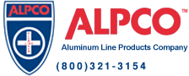

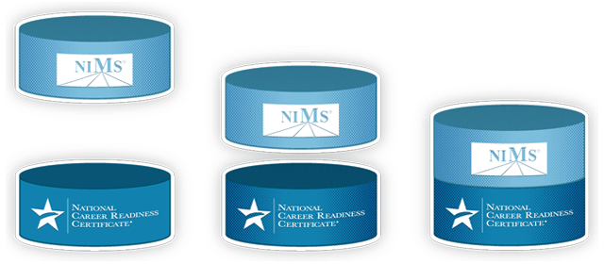

Autocam Logo



**For more information contact:**

**Workforce and Business Solutions**

**440.366.4367**

**tjenkins@lorainccc.edu**

**Earnings/Occupations**

Employer demand in Ohio for entry-level related workers has nearly doubled since the end of 2014 and is expected to have a seven percent growth rate through 2022 with nearly 8,000 annual job openings.



C:\Users\ckushner\AppData\Local\Microsoft\Windows\Temporary Internet Files\Content.Word\MSSC logo.tif

This workforce solution was funded by a grant awarded by the U.S Department of Labor’s Employment and Training Administration. The solution was created by the grantee and does not necessarily reflect the official position of the U.S Department of Labor. The Department of Labor makes no guarantees, warranties, or assurances of any kind, express or implied, with respect to such information, including any information on linked sites and including, but not limited to, accuracy of the information or its completeness, timeliness, usefulness, adequacy, continued availability, or ownership.

https://i.creativecommons.org/l/by/3.0/88x31.png This work is licensed under the Creative Commons Attribution 4.0 International License. It is attributed to Ohio TechNet. To view a copy of this license, visit [http://creativecommons.org/licenses/by/4.0/.](http://creativecommons.org/licenses/by/4.0/)