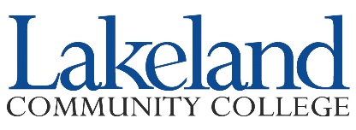

Faculty Challenge Grant
Non Destructive Testing (NDT) Lecture Pre Test

The objective of this evaluation is to assess your understanding of NDT prior to the lecture. Your feedback is very valuable and beneficial for the future development of Industrial Welding Curriculum. Thank you in advance for your time.

A note on privacy:
This survey is anonymous. The record kept of your survey responses does not contain any identifying information about you.

Q1. Have you heard the NDT guest lecturer previously ______ YES ______ NO

Q2. Please indicate your level of agreement with the statements below:
 | Strongly Agree | Agree | Neutral | Disagree | Strongly Disagree
A lecture on NDT content is relevant to my class.
I am familiar with NDT
I have a general understanding of the purpose of NDT.
I have a general understanding of the value of NDT.

Funding provided by the Lakeland Foundation
This workforce product was funded by a grant awarded by the U.S. Department of Labor’s Employment and Training Administration. The product was created by the grantee and does not necessarily reflect the official position of the U.S. Department of Labor. The U.S. Department of Labor makes no guarantees, warranties, or assurances of any kind, express or implied, with respect to such information, including any information on linked sites and including, but not limited to, accuracy of the information or its completeness, timeliness, usefulness, adequacy, continued availability, or ownership.
The course and services are available without regard to a participant’s race, color, religion, ancestry, age, handicap, sex, marital status or national origin. The number for TDD/TYY or relay services is 440-525-7006.

This work is licensed under the Creative Commons Attribution 4.0 International License. It is attributed to Ohio TechNet. To view a copy of this license, visit http://creativecommons.org/licenses/by/4.0/

