Accelerated MIG-Welding
Program at Cincinnati State

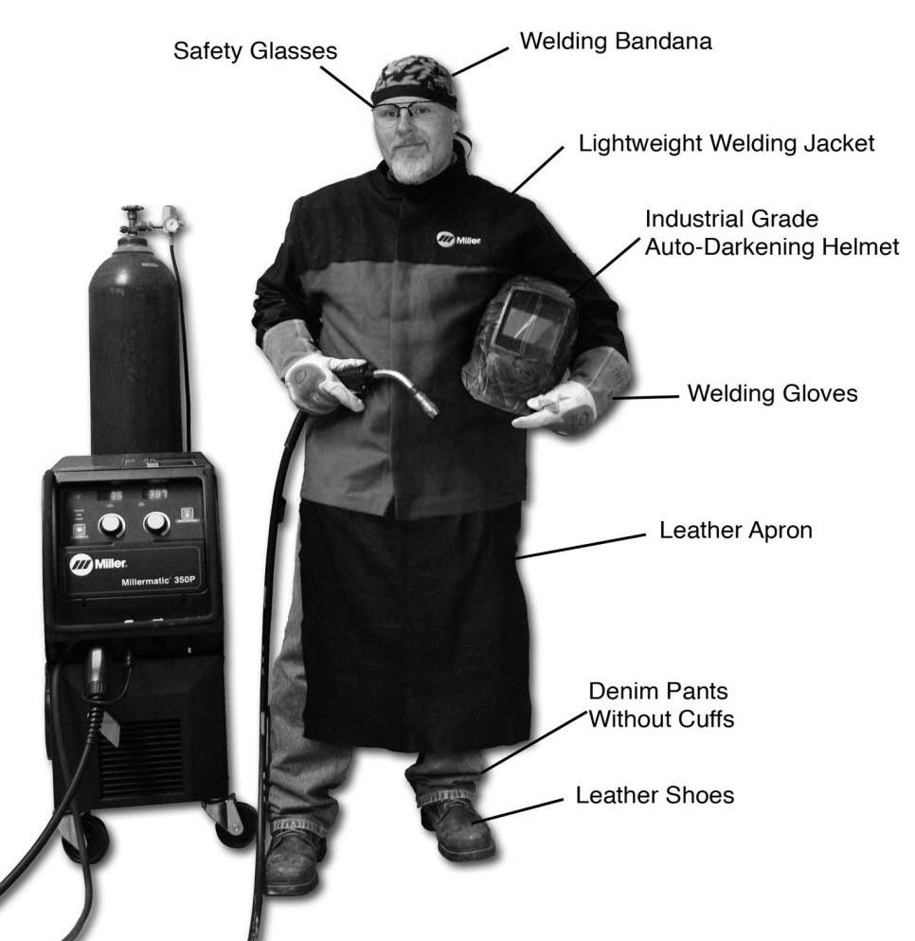
COMPLETE A HANDS-ON TRAINING PROGRAM IN JUST 15 WEEKS!

COURSES INCLUDE:
• Blueprint Reading
• Fundamentals of
Welding
• Gas Metal Arc Welding
(GMAW)

EVENING CLASSES:
Monday – Thursday
6:00pm – 10:20pm

Total In-State Cost:
$2,636.65 per student (Includes all equipment & supplies)
Classes start January 9th and are held at the new welding facility at the Clifton Campus

Contact Danielle Fuller @ 513-569-4136 at Cincinnati State’s Pathway to
Employment Center (PTEC) for more information or to register now.

This workforce solution was funded by a grant awarded by the U.S Department of Labor’s Employment and Training Administration. The solution was created by the grantee and does not necessarily reflect the official position of the U.S Department of Labor. The Department of Labor makes no guarantees, warranties, or assurances of any kind, express or implied, with respect to such information, including any information on linked sites and including, but not limited to, accuracy of the information or its completeness, timeliness, usefulness, adequacy, continued availability, or ownership
This work is licensed under the Creative Commons Attribution 4.0 International License. It is attributed to Ohio TechNet. To view a copy of this license, visit Creative Commons.

