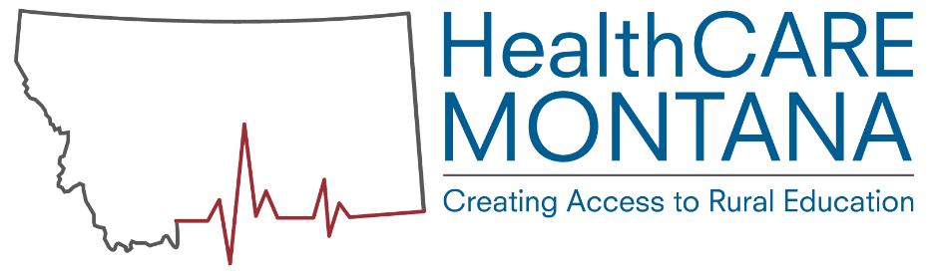

Taking the Next Step:
Is apprenticeship right for my facility?

What is healthcare apprenticeship?
Apprenticeship is a time-tested, “earn while you learn” strategy with a combination of on-the-job training, related instruction online or in a classroom, mentorship, and incremental wage increases. Employers work with the Registered
Apprenticeship Program to identify competencies, timelines, and related coursework.

The healthcare industry will need to add roughly 1,300 jobs every year for the next decade to meet the needs of Montana’s population. Healthcare apprenticeships are an adapted training model for Montanans to receive necessary medical care by having trained and highly skilled professionals in our communities.

Apprenticeship Occupations in Healthcare:

- Certified Nurse Aide (CNA)
- Specialty Training for CNAs: Dementia, Rehabilitation
- Pharmacy Technician
- Medication Aide II
- Administrator (Long Term or Assisted Living)
- Computed Tomography Tech
- Medical Coding & Billing
- Surgical Tech
- Health Informatics
- Medical Claims
- Medical Scribe
- Phlebotomist
- Licensed Practical Nurse
- Medical Assistant
- Community Health Worker – In Development
- Behavioral Health Tech – In Development

How do apprenticeships differ from clinical rotations and internships?

On the job training is already a major part of many degree and technical programs. However, the type of on the job training often occurs on a spectrum with different roles and responsibilities for students, employers, and faculty members. The following side-by-side comparison aims to differentiate by types of on-the-job training programs.

Apprenticeships | Clinical Rotations | Internships
Paid | Unpaid | Typically unpaid
Related to coursework | Related to coursework | Varies
Employer-specific competencies | No employer-specific competencies | Varies
Employer evaluates competencies | Faculty evaluate competencies | Employer evaluates competencies
Employer investment in the individual | Less employer investment | Varies
Trains permanent employees | Provides familiarity with work environment | Provides work experience
Employment anticipated with training facility upon graduation | Employment not anticipated for all students with facility upon graduation | Varies
Is apprenticeship the right training model for my organization? The following criteria may help confirm whether apprenticeship is the right training model:
- Apprentices are paid from the first day they start working. They receive incremental wage increases at key intervals. Starting at a lower wage can help offset training costs.

- Facility culture and recruitment strategy favors employee retention and internal promotion.
- Apprenticeship is an investment in the future workforce. Time and effort in training employees now produces workforce development results in the long run.
- Facilities can develop customized skill sets that can be built into apprenticeship training models (e.g. soft skills, quality improvement, retail and/or customer service skills).
- Fully trained and credentialed workers are able to serve as mentors or supervisors.
- Apprenticeship candidates are identified by facilities by either recruitment or internal promotion. A probation period allows both parties to evaluate cohesion.
What are the next steps?
- Contact your closest Department of Labor and Industry (DLI) healthcare apprenticeship representative.
- Select the occupation(s) for workforce development.
- Work with DLI representatives to identify educational component through distance, campus, or in-house training.
- Recruit or identify internal candidates for apprenticeship(s).
- Consult with local Job Service Office for incentive funding opportunities.
- Identify internal skilled workers who will serve as apprenticeship mentor(s) and supervisor(s).
- Meet with DLI representatives to register apprentice.
- Apprentice starts working.
- Apprentice enrolls in related education program, including any prerequisite requirements, or facility hosts in-house education.
- DLI representatives conduct periodic monitoring.
- Apprentice completes program when all curriculum and competency requirements are met.
- Fully skilled worker continues working with apprenticeship sponsor or seeks external employment.
For More Information:
Visit our websites: apprenticeship.mt.gov and healthcaremt.org.
Check out our press coverage:
- Recognition in Governing Magazine: https://goo.gl/vgybfE
- Allegiance Medical Claims Apprenticeship program in collaboration with Missoula College: https://goo.gl/aw7ahd
- Whitehall offers apprenticeship programs for brain injury care: https://goo.gl/RVYH8y
- Coverage of the LPN program in Wolf Point: https://goo.gl/uXYrtF
- Guest Editorial from former Deputy Commissioner of Higher Education John Cech: https://goo.gl/vcvwY
Contact the Montana Department of Labor and Industry Registered Apprenticeship Program:
Valerie Piet, 406-490-7888, vpiet@mt.gov
Madeline Boehm, 406-686-2945, mboehm@mt.gov
Bo Bruinsma, 605-751-9037
Or 406-444-4100

