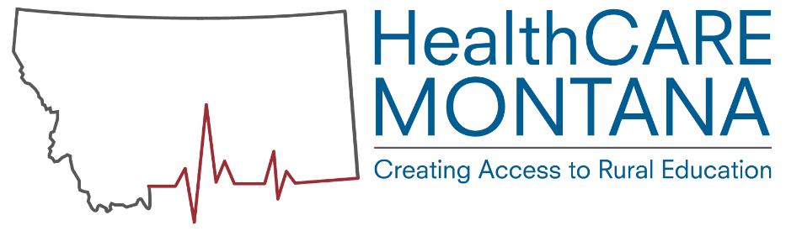
Pharmacy Technician Apprenticeship Education Options

This document is meant to serve as a resource outlining educational options to supplement on-the-job training through a registered apprenticeship. Montana Department of Labor & Industry does not claim endorsement for any program.

Montana Community Colleges, Classroom Based:

- Flathead Valley Community College
Certificate Program. 17 credits.
Applications due by May 20th
Program begins Fall Semester. 6-10 students admitted.
Estimated cost $2000 in-district, $2700 out-of-district for tuition and fees.
Requires competency in math and writing through placement testing into M 120 and WRIT 101.
http://www.fvcc.edu/programs/health-care/pharmacy-technology-certificate/

- Miles Community College
Certificate Program. 33 Credits.
Estimated in-district cost $1950 for tuition and fees, $550 for books and supplies.
Requires college level competency in math and writing through COMPASS testing.
https://www.milescc.edu/DegreesPrograms/Nursing/PharmacyTech/

Montana Community College, Distance Education:

- Great Falls College
Certificate Program. 28 credits.
Applications due October 30th.
Program begins Spring semester. 23 students per class.
Offered online except for clinical rotation.
Estimated total cost $3280 for tuition and fees, $1,148 for books and supplies.
Requires college level competency in math through placement testing into M 090 or completion of M 065.
http://catalog.gfcmsu.edu/academic-programs/pharmacy-technician/

- Missoula College
ASHP-Accredited Program
Certificate of Applied Science. 30 Credits.
Program begins in the Fall. Admits up to 12 students per class.
Applications due by April 1st.
Estimated cost $3500 for tuition and fees, $1400 for books and supplies.
Requires college level competency in math, writing and computers.
http://mc.umt.edu/academics/health/pharmtech/
Distance education course sharing options between Missoula College and City College MSU Billings are anticipated 2016/2017.

Other Distance Education Options:

- Mineral Area College
Self-directed through free, publically available materials.
Noncredit bearing, students are not enrolled in a course or program.
https://www.skillscommons.org/handle/taaccct/2005

The following distance education options offer self-paced, online course work and exam preparation. These courses are non-credit bearing and do not offer certificates or degrees. These courses are accredited through Distance Education Accrediting Commission. Course costs vary; but are around $600-$800 with upfront payment; $800-$1000 with graduated payments. Penn Foster Career School is VA benefit eligible.
- Penn Foster Career School: http://www.pennfoster.edu/programs-and-degrees/medical-and-health-careers/pharmacy-technician-career-diploma
- US Career Institute: http://www.uscareerinstitute.edu/certificates/health-care-programs/pharmacy-technician/
- Ashworth College: https://www.ashworthcollege.edu/career-diplomas/pharmacy-technician/
- Blackstone Career Institute: http://blackstone.edu/pharmacy-technician/
- Allied Health Schools Career Training: http://alliedhealthcareertraining.enrollware.com/schedule

Sponsors and apprentices can also opt to utilize textbook-based curriculum options.

For More Information:
Visit our websites: apprenticeship.mt.gov and healthcaremt.org.
Contact the Montana Department of Labor and Industry Registered Apprenticeship Program:
Valerie Piet vpiet@mt.gov 406-490-8788
Madeline Boehm mboehm2@mt.gov 406-431-8708
Brittney Keller bkeller@mt.gov 406-686-2939
Bo Bruinsma bbruinsma@mt.gov 605-751-9037

