CBE Programs Dashboard
The CBE Dashboard is designed to provide current and historical enrollment, course completion, and credential completion data related to Sinclair’s competency-based education (CBE) course sections. The dashboard provides an CBE academic coach/advisor with instant access to real-time data on CBE students. The sections are screen captured below and include: Enrollment, Enrollment Tracking, Retention, Course Completion, Credential Completion and Student Characteristics. The CBE Caseload report provides critial information regarding individual student progress in CBE courses.
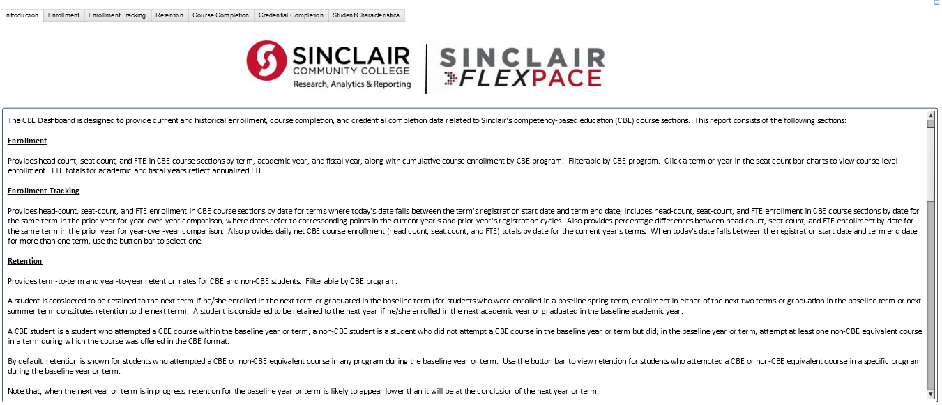
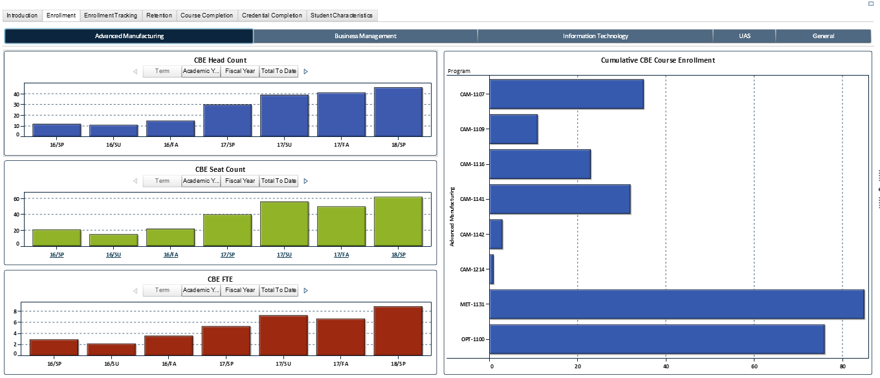
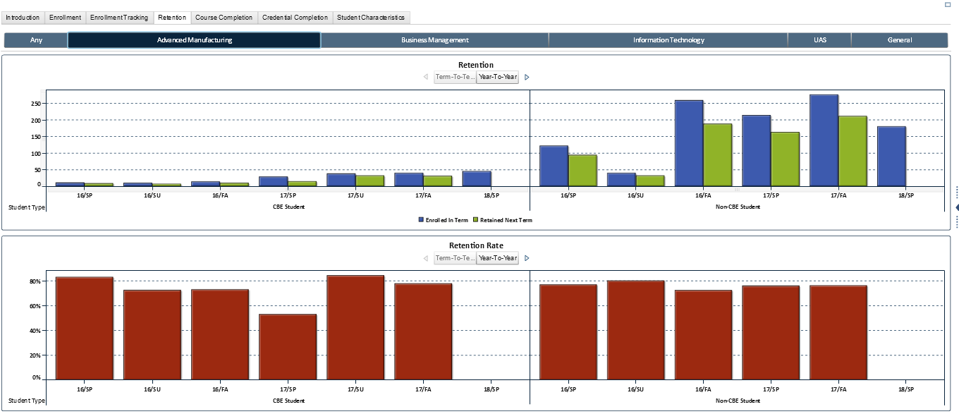
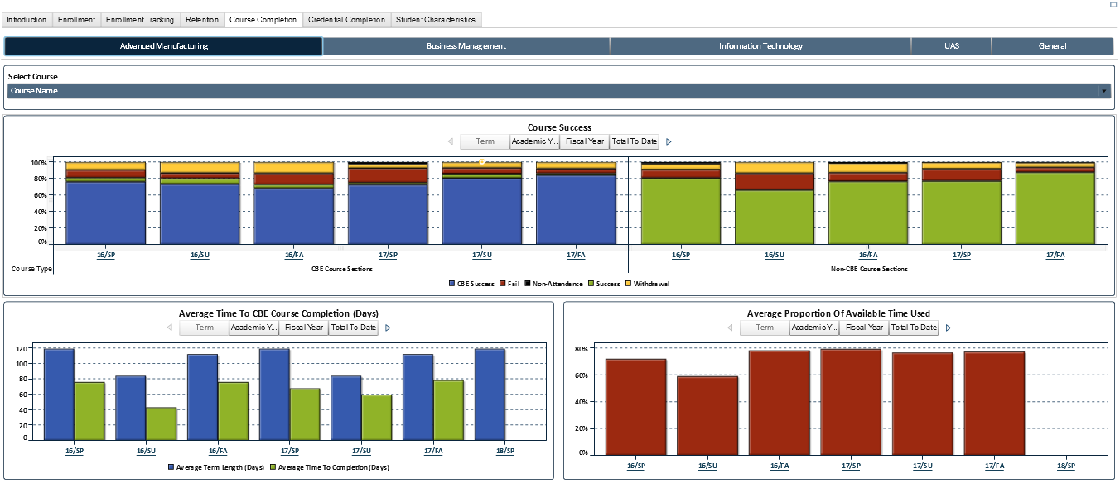
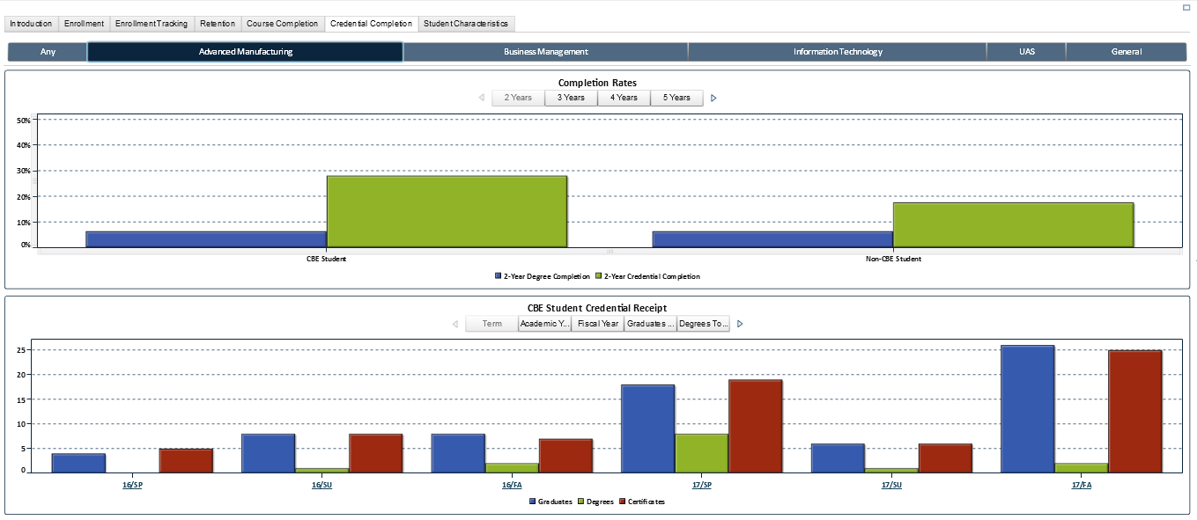

CBE Academic Coaching Tool
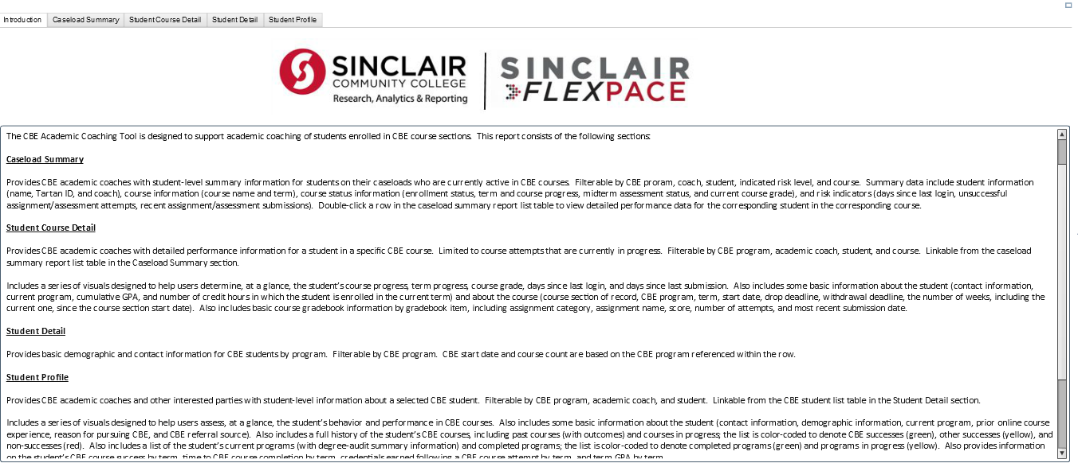
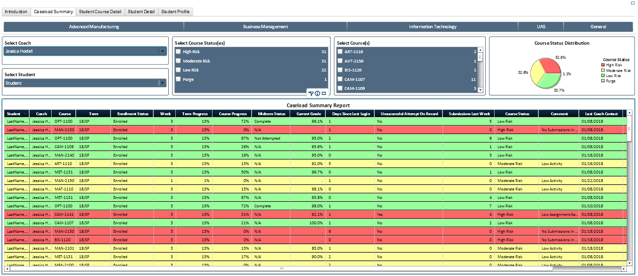
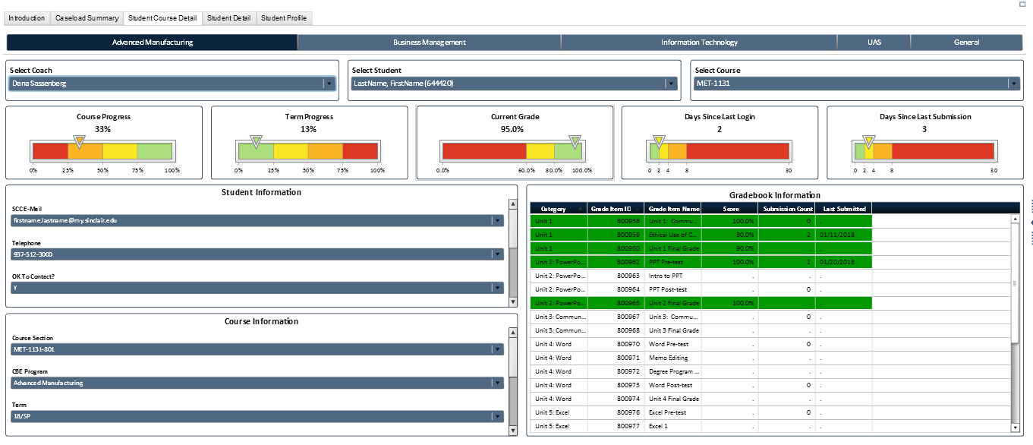

This workforce product was funded by a grant awarded by the U.S. Department of Labor’s Employment & Training Administration. The product was created by the grantee and does not necessarily reflect the official position of the U.S. Department of Labor. The U.S. Department of Labor makes no guarantees, warranties, or assurances of any kind, express or implied, with respect to the information, including any information on linked sites and including, but not limited to, accuracy of the information or its completeness, timeliness, usefulness, adequacy, continued availability, or ownership.
This work is licensed under the Creative Commons Attribution 4.0 International License. It is attributed to Ohio TechNet. To view a copy of this license, visit http://creativecommons.org/licenses/by/4.0/.

