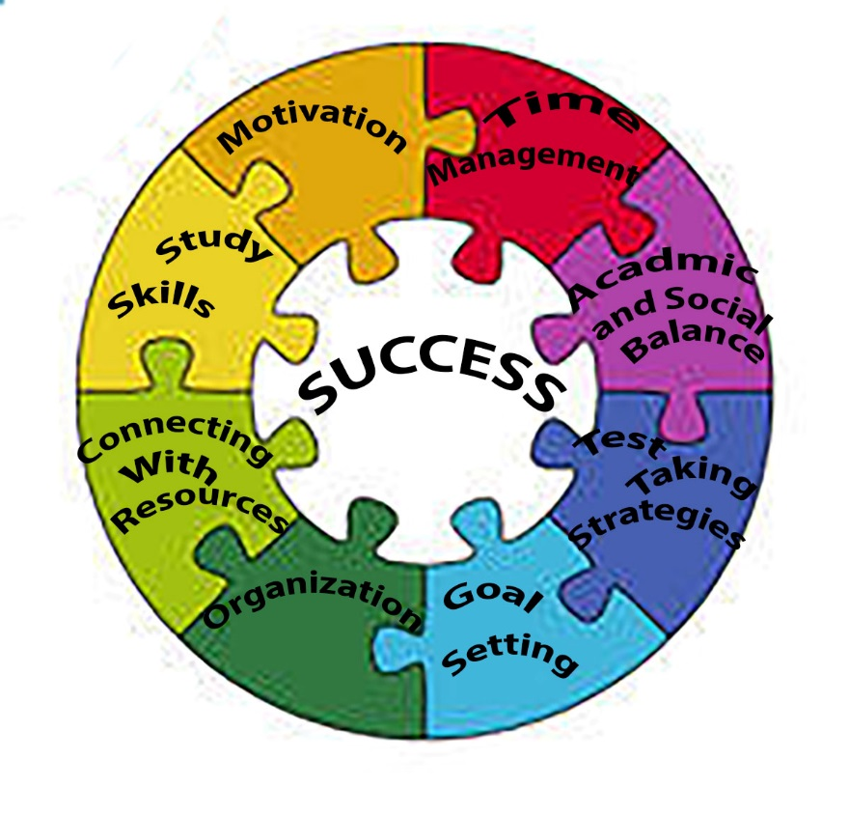

**This workforce product is 100% funded by a $14.9 million grant Award from the U.S. Department of Labor and is licensed under a Creative Commons Attribution-NoDerivatives 4.0 International License. More  information can be found at the following link http://www.healthcaremontana.org/disclaimer.**

Non-Traditional Student Peer Mentoring

Faculty, staff, and fellow students realize that returning to school as a non-traditional student can be an exciting, daunting, and stressful experience, especially if that student is a first generation college student, the first in their family to go to college. First generation college students often lack the support of families and employers. Relating to fellow students when they do not feel connected may be difficult. When a student finds themselves struggling receiving assistance from someone of the same age group helps create bridges for learning. A peer mentor can relate to a student on an entirely different level than an educator. The concept behind a peer mentor is to add confidence, install self-reliance, fill in the missing academic pieces, and create a connection to the institution for each student served, according to LaFountaine (2007). Confidence, in schoolwork, when returning after many years may be slow in coming, and focusing on academics amongst family, community, work, and financial constraints sometimes may seem impossible. Even simple things that experienced students take for granted can be challenging for a new student, such as finding classrooms and offices on campus, understanding school policies when registering for classes, and learning the special language of the college such as syllabus, office hours, and prerequisites. Many students are balancing families, careers, community, and school. Peer mentoring is an excellent way to enhance comfort and growth for student, and assist them in success. The Non-Traditional Student Peer Mentoring Program is a structured year-long opportunity for the experienced students to serve as guides for new students to help them access the knowledge and resources at the college. Moreover, new students will continue to seek the advice of experienced students regarding decisions about classes, majors, academic difficulties, and personal problems.

The power of peers helping peers and influencing positive adaption and learning in college, is well-documented (Whitman 1988). The use of peer mentors is a valuable way to help other students learn and an effective use of resources that benefits students, the mentors themselves, the faculty and student support services associated with the learning communities, and the institution as a whole.

Who is a Non-Traditional Student?

According to the Center for Postsecondary and Economic Success (2015), (<http://www.clasp.org/resources-and-publications/publication-1/CPES-Nontraditional-students-pdf.pdf>) yesterday’s non-traditional student is today’s traditional student. Examples of these students are:

1. Adults Age 25 or Older
2. Independent Students
3. 24 years and older

* Married
* Responsible for legal dependents other than a spouse
* Orphans or wards of the court (are were wards of court until age 18)
* Veterans of the U.S. Armed Forces
* Homeless or risk of being homeless

1. Enrolled Part-Time
2. Minority Students
3. Low-income
4. Employed Part-time
5. Employed Full-time
6. Parents
7. Single Parents
8. First-Generation College students

Mission and Goals of Non-Traditional Student Peer Mentoring Program

Provide a student ready campus-based community dedicated to the academic and professional development of non-traditional students fostering academic, social and emotional support with the goal of,

1. Contributing to a positive atmosphere toward success in academics,
2. Provide an opportunity for students to access interpersonal connections and supportive resources,
3. Provide a system for advice, information, and opportunity for students

What is a Student Peer Mentoring Program?

When a non-traditional student steps on campus for the first time, he or she can be overwhelmed at how much there is to learn and do. This is compounded by the fact that he or she may not feel connected to fellow students. Peer mentoring pairs a current non-traditional student with a new or returning non-traditional student for the purpose of providing one-on-one assistance during their transition to the academic environment. The mentor takes non-traditional students by the hand and helps them recognize where they are going, how to get there and who can help them along the way. Peer mentors draw from their own experience to offer encouragement and support to their mentees and provide a connection to our college or university and offer insight, knowledge, perspective and encouragement to their mentees. A mentor can impact the mentee’s level of self-confidence, chances for academic success, and possible whether or not a student stays in school. Being a mentor can make a huge impact on another student’s life.

Benefits of Non-Traditional Student Peer Mentoring Program



Benefits of being a peer mentor is that it provides satisfaction of helping someone discover their potential success in college and possibly in life, through sharing experiences and wisdom that has assisted them in their success. It helps them realize how much they have learned and gained, providing a sense of accomplishment. Mentoring enhances skills in coaching, listening and role modeling. It also provides an opportunity to practice and develop a more personal style of leadership. All great qualities to have gained before entering the workforce after graduation.

Peter Collier (2015), identified that one of the single most important factors associated with high retention and graduation rates for low-income, first-generation college students was their ability to find support in navigating college and locating important resources (pp. 70-72). Collier shares that finding a peer mentor not only helps students to succeed academically but also with career planning and the development of life management skills such as dealing with personal and family problems. Peer mentoring continues to benefit a student as it increases the chances of degree completion. It also promotes college success by:

1. Increasing engagement in students own learning
2. Building campus connections
3. Providing social support
4. Increasing knowledge of available services on campus and community
5. Facilitating mastery of the college student role
6. Improving decision making

(Collier, 2015, pp. 72-77)

The mentee’s greatest benefit comes through interacting with a student who is a resource and role model. They have someone who, through experience, will listen and respond to problems and concerns. They also have a resource who can offer useful guidance on academic achievement goals, while balancing family, work, community and school.

Being a Successful Mentor

A mentor is a student who is knowledgeable and experienced to guide and thus improve students understanding and learning (Minor, 2007). He/she is a trusted ally and advocate, and one who is a

caring role model. An effective mentor is respectful, reliable, patient, trustworthy, and a very good listener and communicator. It is a person who when a student is confronted with an academic or personal problem they have someone with whom to seek out advice, guidance and encouragement. The mentor is familiar with their campus and understands the resources adult students need to find success. An activity suggestion to assist in developing a positive relationship and assist the mentee toward success can be:

* Having knowledge and sharing with the mentee about academic programs, support resources, and engagement opportunities.
* Contacting the mentee to facilitate regular meetings to discuss their experience academically and socially.
* Hosting study groups with the mentee, at agreed upon time and place that fits both the mentor and mentee’s schedules.
* Arranging for the mentee to participate in campus social activities, which engages them in a wider group of their peers.
* Helping the mentee with planning and implementation class schedule, a study plan for homework, and providing ideas of how to balance school and home needs and schedules.

A Non-Traditional Student Peer mentor should be in regular communication with the mentee. There needs to be regular communication which can be for a formal reason or just to check in. Try using a conversation starter. The following are some ideas to start up conversations and possible the first meeting with a mentee:

* Start by sending an email, text or call, and introduce yourself as their Non-Traditional Student Peer Mentor, provide three relevant details about yourself you want them to know ( major, year, hometown) explain your role, list upcoming important dates, suggest some times/ dates to meet, suggest a neutral location to meet initially.
* Offer to get coffee and talk about your college experience and ask them questions to learn about who they are and their needs. Share personal lives of family, jobs, interest, hobbies, or what they like to do for fun. Ask and share about the classes each are taking, how they are going, share on major or intended major.

**Skills for Effective Mentors**

* **Be a good listener**
* Ask open ended questions. In other words questions that elicit a YES or NO answer are less helpful than questions that elicit more information about the situation such as “What, When, How, Who” questions. Be mindful that “why” questions may seem like they would convey concern and a desire for more information but they can also come off as judgmental

and cause a mentee to shut down. For example in response to a mentee saying the he or she is really disappointed with the grade they got on their last exam, and that they wish they had studied more asking “Well, why didn’t you go to all the study sessions?” may cause your mentee to feel judged.

* **Attend and respond to both occurrences and emotional reactions to occurrences**. When a mentee comes wanting to be heard about a social or academic issue listen and carefully respond both to the occurrence that is effecting them and the emotions that they are experiencing as a result.
  + Example scenario – Mentee says, “My Alpha seminar Professor emailed me this morning saying we needed to meet within the next couple of days I am really panicking”
    - The occurrence in the case is the eminent request for meeting from the professor.
    - The emotional reaction is the panicking.
    - It is important to attend to both.
* **When appropriate let your mentee solve the problem**. Offer encouragement and support by asking open-ended clarifying questions, but ultimately let your mentee come up with a solution to the problem**.** 
  + It may seem easier or more rewarding to offer advice or give suggestions of what you would do if you were in their situation but that is not as helpful as it may seem.
  + You do not know the whole situation, and it is better to refer the mentee to someone with the professional training to guide them through some issues.
  + Usually the mentee will have an idea of the steps he/she needs to take to begin solving their dilemma, by asking open ended questions you will help your mentee clarify the next steps to approaching their situation.
* **Refer to/use your resources.** In order to be a successful mentor, it is best to develop a diversity of academic and social skills. In many cases a mentor will deal with issues in the realm of academic as well as social. It is paramount to remember in these situations that a mentor is neither a counselor nor a trained academic resource; however you do have access to these individuals.
  + Know your limits sometimes the best way to help is by referring a mentee to someone with the specific expertise to help.
  + Most colleges have a diverse pool of programs, departments and professionals ready and willing to assist students with their academic and social challenges. The mentor should have a list and familiarize themselves with the resources, service provided, personnel and contact information, and the hours of service.
* **Help Mentee Establish Effective Study Habits:**
* “Adult learners beginning their post-secondary education are to likely have a gap in their academic development process (Kenner & Weinerman, 2013). Therefore it is important that Non-Traditional Students especially those who have taken a break

from the academic environment are intentional about establishing effective study habits and early on in their academic career.

* As a mentor you are in the position to support your mentee in two ways;
  + First by adopting and modeling intentional study habits and
  + Second by noticing when they are struggling and educating them about the resources that exist on campus, such as academic resource center, TRIO Student Support Services, their Professors, and their advisor for them to overcome this barrier.
* Having and communicating the knowledge and tools to understand your own study time needs and to teach a mentee through the process of learning their study time needs.
* Teaching a mentee how to schedule and lead productive study sessions.
* **Understanding Personal Study Time Needs:**
  + One of the greatest challenges students face when acclimating to the college environment is determining how much time to spend studying. How much time should you spend studying each week? Though there are several recommendations; the best rule is to be flexible. Start with as many hours as you have courses. If that number proves to be too few, then add more study hours to your schedule. When you take stock of how much time it takes you to complete each weeks assignments you will have a better sense of how much time to spend studying. That said, be willing to make adjustments some instructors give last minutes assignments. Take a look at the example study hour’s schedule below.



Deem, James (1993) Study Skills in Practice .Houghton Mifflin Company (Boston MA).

Pp 17-18

* + Prior to meeting with the mentee for the first study session take the time to write out your own weekly study hour’s schedule estimating the number of hours needed to devote to completing assignments for the week. As the week progresses, make note of where to make adjustments in the log. When you meet with the mentee for a study session, suggest that that the two of you take the first 15 minutes to write out the number of hours you will each need to spend on assignments from now until the next time you meet (Deem, James (1993) Study Skills in Practice .Houghton Mifflin Company (Boston MA). Pp 17-18).
* **Adopting and Modeling Intentional Time Management Practices**
  + One way to effectively manage one’s time is to set up a seven-day schedule that includes your class sessions, work hours, commute times, meals, required weekly activities, mandatory social and family activities, scheduled exercise, and sleep time.
  + Make sure the college’s calendar for holidays, special events, and important dates such as exams. Included is an example of one format you can use to chart your weekly activities.
  + As preparation for the semester and to guide a discussion with the mentee, practice filling out a weekly schedule chart and share this with the mentee, along with providing them with a chart.
  + Request to meet with the mentee at least weekly and pick a regular time that will fit with both schedules (Deem, James (1993) Study Skills in Practice .Houghton Mifflin Company (Boston MA). Pp 24-25).
  + When meeting with your mentee, ask them bring their seven-day schedule, bring your seven day schedule as well, and review them together for what is working and what might need to be changed if the time allotted is not being met.
  + As an example to start with setting up a schedule, the following questions should be discussed
    - Based on a seven day schedule, what is the dates and times of mandatory commitments (classes, family events, etc.)?
    - How much sleep do I need a night?
    - What is the best time for me to study (morning, afternoon, evening, night)?
    - What is the most productive length of time to study for me to stay focused?
    - How often do I need to take a break?
    - What is your best environment for reading?
    - Can you set up this environment for reading?

Ethical Considerations for the Peer Mentor

As a student serves in the role as a peer mentor it is important to always practice ethical behaviors. Mentors are selected for the position based on their combined academic, leadership and interpersonal strengths. Those same interpersonal strengths that make one a well-qualified candidate for this position also can open one up to some challenging interpersonal situations with your mentee.

**Ethical Standards**

1. Peer mentors will respect the individual dignity and autonomy of their mentees and fellow mentors.
2. Peer mentors will not act beyond the scope of their qualifications. In the event of a situation that requires higher level professional expertise they will refer their mentee to the appropriate professional.
3. Peer mentors will assume the responsibility that if a conflict arises between themselves and their mentee and they are no longer objective, they will seek professional assistance sand/or resources to resolve the conflict.
4. Peer mentors will abstain from becoming romantically or intimately involved with their mentees. Peer mentors will act appropriately when working with people for whom they feel attraction.
5. Peer mentors will remember that they are role models obligated to maintain congruence between what they say to their mentees and the way they present themselves in other public facets of their lives.

Importance of Trust between the Peer Mentor and Mentee

When the mentee shares something personal with the mentor a bond of trust is formed, in some cases it is the responsibility of the mentor to uphold that bond by listening attentively to what the mentee is telling.

In other cases it is the responsibility to uphold that bond of trust by listening carefully to you mentee, asking open-ended clarifying questions, and encouraging the mentee to seek the appropriate professional help. As someone the mentee has chosen to trust with their personal information it is the mentor’s responsibility to direct them to professionals who have the skills to help them. If there is a situation of potential harm to the mentee or other, it is the mentor’s responsibility to report this right away.

Common Issues for Non-Traditional Students

Many new students have adjustment issues when they transition from the home to the college environment. However, there are some ways in which Non-traditional students, because of their age, life experience, and responsibilities bear a unique set of challenges when transitioning to the college setting.

Below are some of the issues you may encounter. When assisting students with these issues be sure to talk with a member of the Non-Traditional Student Advisory Council if you need assistance locating a resource.

**Personal Challenges:**

* Balancing multiple responsibilities: “Older Students, (those more than 25 years) generally have at least four non-traditional factors: financial independence, full-time employment, dependents, and part-time enrollment. Therefore many older students fall into Horn’s highly non-traditional category, placing them…at risk for not completing their degree (Kenner & Weinerman,2013)

**Academic Challenges:**

* A gap in the academic development process: “Adult learners beginning their post-secondary education are likely have a gap in their academic development process... depending on how long it has been between the time they graduated from high school or earned their GED and their first day of college or university.
* A self-directed learning style: “That [leads them to] take responsibility for their own actions and resist having information arbitrarily imposed on them.
* Deeply engrained procedural or practical knowledge: “They [Non-Traditional Students] have increased development of practical knowledge that is useful in one’s everyday life. However collegiate level coursework requires adult learners to explore different ways of examining and incorporating information [this transition from using predominantly practical knowledge to applying collegial thinking can be jarring and flustering for non-traditional students for whom, knowledge learned in the work place is a part of their psyche].

**Interpersonal Challenges:**

* **Social isolation:** “One of the challenges for Non-Traditional Students is a high attrition rate. Studies indicate that one component leading to this high attrition rate is the lack of successful integration of Non-Traditional Students into the university environment.

Common Issues a Peer Mentor Will Assist Mentee

A good mentor has the ability to assist a mentee with a variety of issues, and in the event that the mentor is not able to, there will be someone with professional training available to do so. Just always refer the student or yourself for advice the college resources. Some of the main issues or questions that a mentee may ask are:

**Personal:**

* Career questions.
* Questions about picking the right major, and where to declare a major.
* Questions on where to go to find work study, internships and summer jobs.
* Admission of personal, or emotional struggle (possible related to the stress of balancing academic, family, and work obligations) which may also warrant referring of the mentee to the campus advising and/or counseling services. The mentor should share with the mentee what worked best for them regarding these issues.

**Academic Challenges:**

* Managing and prioritizing study time.
* Goal setting for study sessions, set priorities for major goals that will be accomplished within study sessions for the next week, month, next few weeks.
* Getting additional subject tutoring from the academic resource center to improve performance in a class.
* Getting guidance from the academic resource center on how to approach faculty about grading policies and procedures.
* Getting accommodations for test takers with disabilities.

**Interpersonal Challenges:**

* Getting to know their faculty.
* College activities and how to get to know other students.

Possible Challenges Encountered as a Peer Mentor

There is no single method to address the challenges faced as mentor in a non-traditional peer mentoring program. The mentor should document and discuss all challenges with the program advisory for support and advice. Some of the topics of challenge could be:

**Motivating and Encouraging:**

* Getting a mentee excited about attending school/class.
* The mentee not wanting to show-up for scheduled meetings or appointments.
* The mentee displaying an apathetic attitude towards check-ins or meetings.
* The mentee not arriving prepared for meetings, appointments, classes or study groups.
* The mentee not knowing how to study and therefore needing to be directed to the academic resource center for a refresher on study skills.

**Role Perceptions:**

* Being viewed as an extension of the administration.
* Not being viewed as a peer.
* Being expected to solve your mentee’s problems.

**Time Issues:**

* Scheduling meetings that works for both mentor and mentees schedules.
* Having consistent scheduled contact with mentee.

**Personal issues:**

* Finding the balance between responding to mentee showing you are listening and giving advice that reflect a personal or moral view point.
* Limiting involvement with home and sometimes relationship issues.
* Dealing with confrontation issues tactfully.

**References:**

Collier, P.J. *Developing Effective Student Peer Mentoring Program, A Practitioner’s Guide to Program Design, Delivery, Evaluation, and Training*. October 2015. Stylus Publishing

Deem, James (1993) *Study Skills in Practice*. Houghton Mifflin Company (Boston MA). Pp 17-25.

Kenner, Cari., Weinerman, Jason. (2011) *Adult Learning Theory: Applications to Non-Traditional College Students.* Journal of College Reading and Learning, 41(2). Pp. 87-96.

Minor, Frankie, (2007) *Building Effective Peer Mentor Programs, Learning Communities and Educational Reform*. Washington Center, Pp.1-13.

University of Vermont and PACER Center, (2008) *Listening and Asking Clarifying Questions*. PowerPoint presentation. https://www.google.com/#q=University+of+Vermont+and+the+PACER+Center+Listenign+and+asking+Clarify+questions.

Whitman, N. 1988. *Peer Teaching: To Teach is to Learn Twice.* ASHE-ERIC. Higher Education Reports. Washington, DC: ERIC Clearinghouse on Higher Education.