WORK SKILLS PROGRAMS

ENGINEERING
TECHNICIAN PROGRAM

Advance your skills. Get hired fast.

75% | Hands-on | 92% Retention rate
95% | of graduates are employed or get further education within a couple months of graduation.

ViaSat, HME, SMAC, and TE Connectivity… these are all companies that have hired our graduates.
Our 600-hour program is designed around the changing skills and training demanded by area manufacturers. Students learn how to use the equipment, as well as how to repair, troubleshoot, and install systems. This course integrates theory and application in the following areas:

Mechanical Electrical Electronics Fluid Power
Robotics Automation Computer Software Blue Technologies

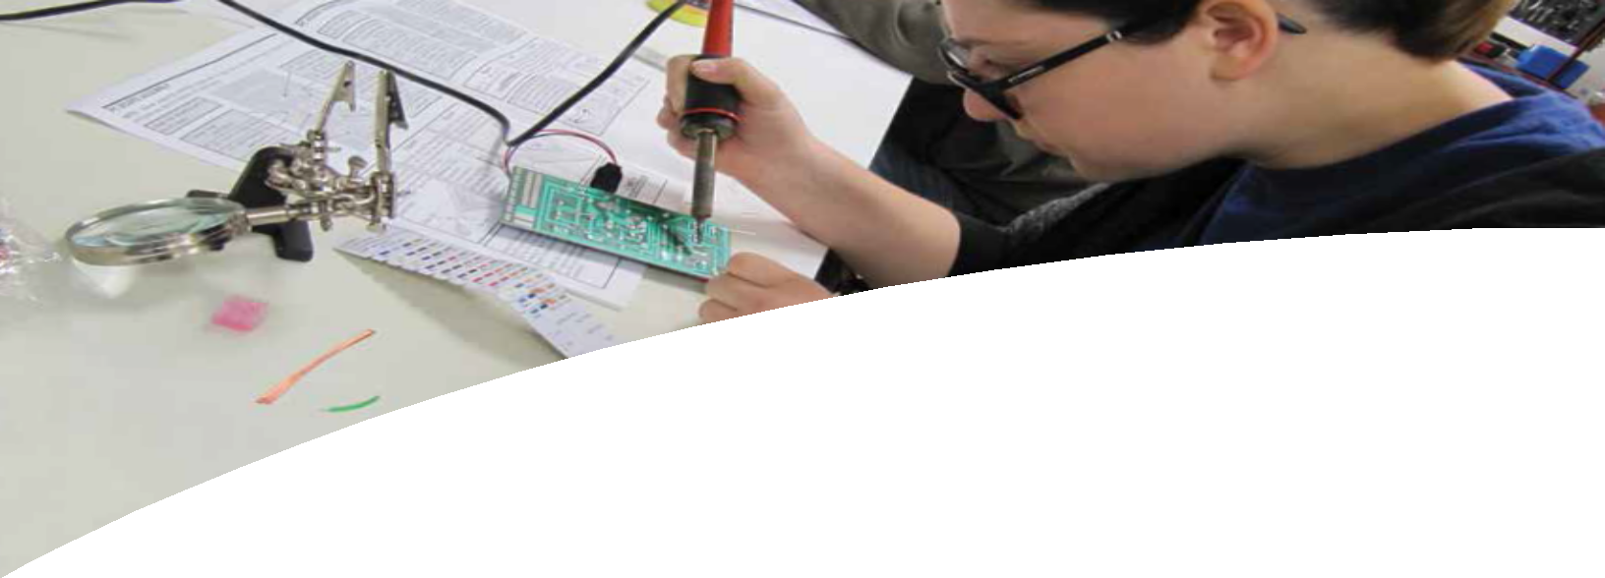
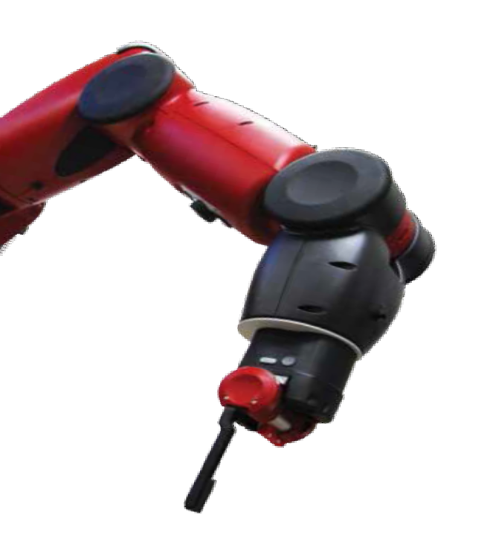
GI Bill® and WIOA funding approved.
Financial support may be available for those who qualify.

For more information or to schedule a tour 760.757.2121, x6346
tci@miracosta.edu

Disclaimer and License information
This workforce solution was funded by a grant awarded by the U.S. Department of Labor’s Employment and Training Administration. The solution was created by the grantee and does not necessarily reflect the official position of the U.S. Department of Labor. The Department of Labor makes no guarantees, warranties, or assurances of any kind, express or implied, with respect to such information, including any information on linked sites and including, but not limited to, accuracy of the information or its completeness, timeliness, usefulness, adequacy, continued availability, or ownership.
This work is licensed under the Creative Commons Attribution 4.0 International License. To view a copy of this license, visit http://creativecommons.org/licenses/by/4.0/.

tci.iracosta.edu

Technology Career Institute 2075 Las Palmas Drive
Carlsbad • CA

