Unit 5 – Electrical Safety

LEARNING OBJECTIVES:
- Describe the basic structure of the atom.
- Explain the characteristics of insulators, conductors and resistive devices.
- Describe how an atom becomes an ion.
- Explain the process of current flow.
- List the six sources of electricity and explain how they produce electrical pressure.
- List the requirements of an electrical circuit.
- Define voltage and give the letter for its unit of measure.
- Define current and give the letter for its unit of measure.
- Define resistance and give the symbol and letter for its unit of measure.
- Explain the difference between an open and a closed circuit.
- Define the terms series, parallel, and combination circuits with regard to physical and electrical description.
- State the difference between direct current and alternating current.
- Describe the relationships of current, voltage and resistance.
- Use Ohm’s law equations to solve for electrical circuit values.
- Define grounding and list practical applications in electrical circuitry.
- Describe the operation of circuit protection devices.
- List the factors that contribute to the severity of an electrical shock.
- Identify the effects to the body when exposed to different current levels.
- Describe how fires and explosions occur resulting from electricity.
- Describe the operation of circuit protection devices and their primary function.
- List and explain the ratings for wires and their insulation.
- Explain how the grounding connections of three-prong plugs prevent shock hazards.
- List the various safety procedures recommended when working with electricity.
- Identify the responsibilities of qualified and unqualified workers.
- List and explain in sequential order the first –aid steps in response to electrical shocks.
- Describe static electricity hazards and steps that should be taken to minimize its effects.

ALLOTTED LEARNING TIME:
7 days

Objective
Every production technician is expected to know how to recognize electrical hazards; therefore, this unit will focus on the safety issues and requirements that pertain to electrical safety. We will also discuss safety issues and requirements that pertain to hand and power tools. Every production technician is also expected to know the value of the safe use of tools, how to inspect tools prior to use, and what the technician should do if he or she suspects that a tool is unsafe for use. Together, this knowledge of electrical and tool safety will save lives, decrease lost work-hours, and save the company money.

In this unit, we will discuss how to work safely with electricity, how to recognize specific electrical hazards, and how to be protected from those hazards. Additionally, we will discuss how to use and maintain the various tools that are commonly used in the manufacturing industry. Recognizing the proper use of tools is every production technician’s responsibility. To do this you must know the parameters for specific tools and what is considered safe and unsafe.

- What is Electricity?
Electricity is the energy made available by the flow of electrons through a conductor. It is a secondary energy source, which means that we get it from the conversion of other sources of energy like coal, natural gas, oil, and nuclear power.
Electricity affects our lives in many ways. It is the driving force that provides most of
the power used in the industrialized world. Electricity lights our homes, heats and
cools the inside of buildings, cooks and preserves food, drives electrical motors, and
provides the ignition for vehicles that use internal combustion engines. It is also the
power source for cell phones and other smart devices, and causes circuitry inside
computing devices to operate the way they do.
Despite its importance in our daily lives, most people rarely stop to think about what life would be like without electricity. Like air and water, there is a tendency to take electricity for granted, and therefore people often fail to recognize potential danger signs. However, to understand the hazards associated with working around electricity, it is important to know, first, how electricity works.

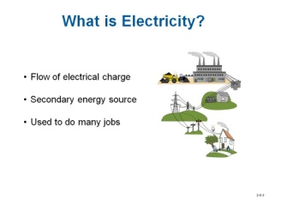

1.1 Structure of the Atom

To understand what electricity is, different ways in which it is produced, and how it is put to work, it is necessary to review the basic structure of atoms. Atoms are comprised of electrons, protons, and neutrons. Figure 1 shows an atom. The proton has a positive charge, the electron has a negative charge, and the neutron is neutral which means it has no charge. At the center of the atom, the protons and neutrons combine to form a nucleus. The electrons travel around the nucleus in an orbit, similar to the way in which planets go around the sun.
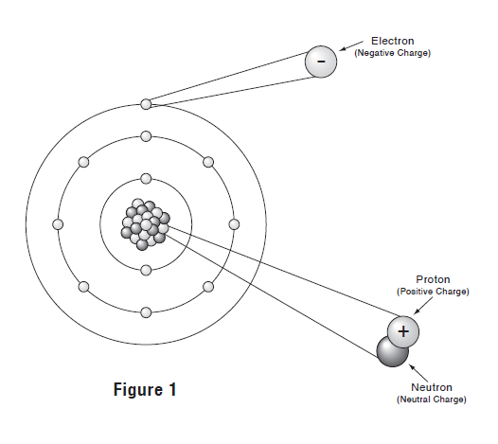
There are more than 100 different atoms. How they differ is the number of protons and electrons they have, and the way in which the orbital electrons are arranged around the nucleus. Each type of atom makes up a specific type of substance, or element, such as copper, silver, and gold.
The electrons that move around the nucleus are aligned in a structured manner in what are known as orbital shells. Depending on the type of atom, the number of shells can range from 1 to 8. The outermost shell has anywhere from one to eight electrons. The electrons in the outer shell are called valance electrons. They are involved in the movement of electricity referred to as current flow. The number of valance electrons in an atom determines how easily it conducts electricity. When an atom has one valance electron, it is easily dislodged from the orbit. Therefore these types of atoms make up materials that are good conductors of electricity. If there are eight valance electrons, they are not easily dislodged. Therefore, this type of atom is not a good conductor and instead, is an insulator.

1.2 Ions
Each type of atom when in its natural state has the same number of orbiting electrons as the number of protons in the nucleus. In this condition, the atom is referred to as being electrically balanced, or neutral. When an atom gains or losses electrons it becomes imbalanced and is therefore referred to as an ion. When an atom has more negative electrons atoms than positive protons, as shown in Figure 2a, it becomes a negatively charged ion. When an atom has fewer electrons than the number of protons, as shown in Figure 2b, it is a positive ion.

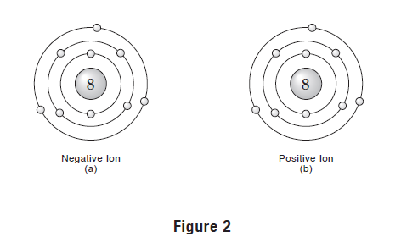

1.3 Static Charges
Positive and negative ions that have more or fewer than its normal number of electrons are called charged bodies. One way to create charged bodies is by the formation of static electricity. By rubbing a rubber rod with fur, as shown in Figure 3a, the rod gains some electrons from the fur and becomes negatively charged. If a glass rod is rubbed with silk, as shown in Figure 3b, the rod becomes positively charged because it gives up some of its electrons to the silk.

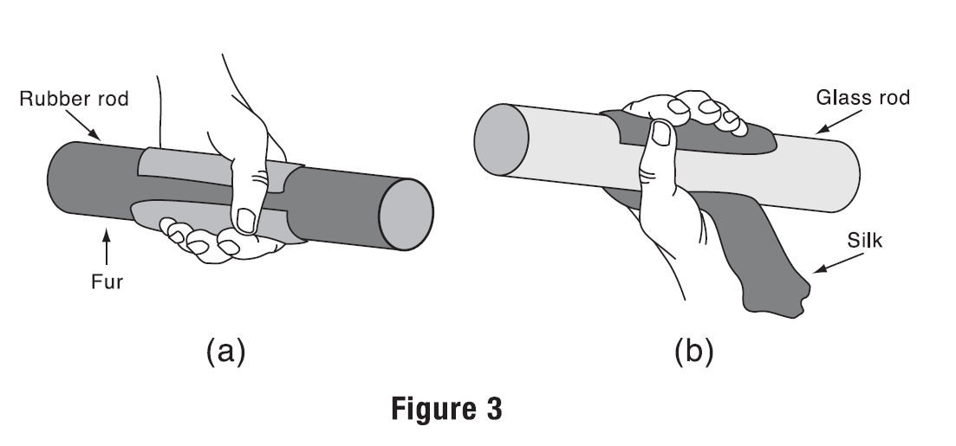

1.4 Electricity Values
There are various quantities that have a specific function associated with electricity. These quantities include voltage, current, and resistance. In this section, a definition of each quantity is given, symbols used to identify them are shown, and units of measurement that represent their magnitude are presented.

1.5 Voltage
The difference in strength between the charges of two bodies is called potential difference. When there is an electric path between the charged bodies, electrons will flow from the negative to the positive charged bodies until they are equalized. When there is no path for electricity to flow, the potential difference still exists. An example of charged bodies with no path for electrons to flow is a battery that has nothing connected between its terminals.
The force resulting from a potential difference is referred to as the electromotive force, abbreviated emf. A unit used to express potential difference is the volt, which can be measured by an instrument called a voltmeter. A volt, named in honor of Alessandra Volta who invented the first battery, is a unit of measurement for potential difference. Volts are also referred to as the electrical pressure in a circuit.
Volts, or voltage, is designated as either E or V. Specifically, the letter E is used to express voltage in a formula, such as E = 10v. The letter V is used to express the number of volts at a specific component in a circuit.

1.6 Current
Electrical current is the flow of electrons from one atom to the next through a medium, such as a gas, liquid or solid material. In electrical circuits, the current flows through various types of conductors made of solid materials, such as copper wires, printed circuit tracks, switch contacts, and various types of components. The movement of electrons from one location to another is caused by the pressure created by a difference of potential (voltage) between the locations of two bodies that have different charges.
Electric current is more accurately defined as the rate of charge flow. The basic unit of measurement for current flow is the ampere, abbreviated amp, and designated by the letter A. One amp refers to the amount of current that flows through a conductor when 6.24 x 1018 electrons move past a given point in one second. When making mathematical calculations involving current, amps is designated by the letter I for “intensity”.

An instrument called an ammeter is commonly used to measure amperes.

View the following URL to learn about electricity:

http://www.wisc-online.com/objects/viewobject.aspx?id=DCE14605

1.7 Resistance
All materials have some opposition to current flow. This opposition is called resistance. The amount of resistance of a particular material is determined by its atomic structure, such as the number of shells and the number of electrons it has in its outer shell. Based on these two factors, each type of material has a different amount of resistance. A conductor, such as copper wire, has low resistance because there is only one electron in its outer shell. Wires are usually encased inside an insulating material that does not easily allow current to flow through it. An insulator has high resistance because some of them have 8 electrons in the outer shell. The insulation protects wires from deteriorating when exposed to the environment, prevents the passage of current from one to another conductor if they are in contact with each other, and avoid electrical shocks to humans when they touch or handle wires.
The unit of measurement for resistance is the ohm, which is symbolized by the Greek letter omega Ω. An ohm is defined as the amount of electrical resistance that allows 1 amp of current to flow when 1 volt is applied. The letter R, which stands for resistance, is used to represent ohms when mathematical calculations are made. Current always takes the path of least resistance. An instrument called an ohmmeter can be used to measure the resistance of components, conductors or circuits.

Question: What path will electricity usually take?
Answer: The path of least resistance.

1.8 The Relationship between Voltage, Current, and Resistance
The current in a circuit is directly proportional to voltage, and inversely proportional to resistance. The term directly, refers to how one quantity affects another quantity the same way. For example, if one quantity increases, the other quantity will increase. On the other hand, if one quantity decreases, the other will also decrease. The term inversely refers to how one quantity effects another quantity the opposite way. For example, if the first quantity increases, the other will decrease. Conversely, if the first quantity decreases, the other quantity increases.

View the following URL to learn more about the relationships between voltage, current and resistance:

https://www.wisc-online.com/learn/career-clusters/stem/dce901/voltage-resistance-and-current-relationships

Note: The amount of current that is conducted is determined by the amount of voltage
that is applied, and the amount of resistance that impedes the flow.

Review Activity
- The nucleus of an atom consists of _____.
- Electrons and protons
- Electrons and neutrons
- Protons and neutrons

- An atom that has ______ electron/s in its outer shell is the best conductor.

- The neutron in an atom has a negative charge? True or False

- A material made up of atoms with _____ electrons in its outer orbit is an insulator.
- 1
- 4
- 8

- An atom that has more electrons than protons is a _____ charged ion.

- _____ is referred to as electrical pressure.
- Coulombs
- Voltage
- Current
- Joules

- Current cannot exist without voltage. True or False

- The letter ______ is used to identify current

- The unit of measurement for resistance is the ______.
  - Volt
  - Amp
  - Joule
  - Ohm

- The amount of current flow is _____.
- directly proportional to the resistance in the circuit
- inversely proportional to the applied voltage
- directly proportional to the applied voltage

1.9 Methods Used to Produce Voltages
All electrical devices require current flow through conductors and components to perform work. Current can only flow when there is a voltage present. By purposely adding electrons or removing them from atoms to cause an unbalanced condition, a voltage source can be created to provide the energy required by electrical and electronic devices. There are six different ways to produce a voltage:
- Friction (static electricity)
- Chemical energy (batteries)
- Mechanical energy (generators)
- Pressure (Piezoelectricity)
- Heat (thermocouple)
- Light (solar)

View the following URLs to learn about electricity:

https://www.wisc-online.com/learn/career-clusters/stem/dce15811/what-is-electricity

https://www.wisc-online.com/learn/career-clusters/stem/dce702/methods-of-producing-electricity

1.10 The Basic Electrical Circuit
The voltage produced by one of the sources of electricity is put to work by being used in a circuit. Electrical circuits may be simple or complex. An example of a simple circuit is a flashlight. An industrial machine is more complex, and is made up of one or more sophisticated circuits. Any type of circuit must have the following basic components, which are shown in Figure 4. There must be a source, path, a load, and some type of device to control the circuit.
- The source produces a voltage by converting one type of energy, such as thermal, chemical, or mechanical energy into electricity. Batteries, solar panels and power plant generators are examples of sources.
- The path directs the flow of electricity through the circuit. Copper wires or printed circuit paths are examples of circuit paths.
- The load is a device that uses energy supplied by the source to perform some type of work. The load performs work by converting electrical energy into other forms of energy, such as heat, light, or mechanical motion.
- The control component adjusts the current flow. An example of a control device that turns electricity on or off is a switch. When the switch is open, there will be no current flow because it breaks the circuit path. Closing the switch will complete the path for current flow in the circuit. Another type of control device is a dimmer switch that adjusts the magnitude of current flow, causing the light intensity to vary. F
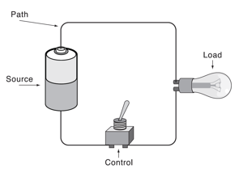
Figure 4
Electrical equipment, no matter what their function is, have one thing in common. They are designed in various ways to control the flow of current. This control is made possible by configuring the circuit paths to direct the flow of current, and to use a variety of components to alter the current so that the system operates to perform the function for which it is intended. The various types of circuit path configurations and the components used in their construction is covered in textbooks or electricity courses.

Question: What three things does a basic electrical circuit need to function correctly?
Answer: A source, a load, and wires.

1.11 Series and Parallel Circuits
Most electronic equipment, simple and complex, have series circuits and parallel circuits.
A series circuit is configured so that there is only one path for current to flow. Figure 5 shows a series circuit consisting of a power source, a switch that functions as a control device, and a lamp which is the load. With the switch closed, the lamp turns on as current flows through the entire circuit. If the switch is opened, the conduction path to the lamp will be broken and the lamp will be turned off.
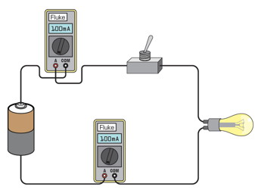

Figure 5

Because there is only one path, current is the same at any point in the circuit. If a conductor or a component opens intentionally, or is broken for some reason, current will stop flowing throughout the circuit. An unlimited number of components can be connected in a series circuit providing that the power source can provide a large enough current flow that is required by the load devices. As current flows through a series circuit, it encounters an opposition by various components, such as resistors. As each resistor creates a restriction to flow, a pressure difference, or voltage drop develops across it. The sum of the voltage drops across the resistors in a series circuit is equal to the voltage applied by the power source.
A parallel circuit has two or more paths through which current can flow. Each parallel path is called a branch. An example of a two-branch parallel circuit is shown in Figure 6. When current from the negative terminal of the power source reaches point A, there are two paths for current to flow. Some of the current flows through light 1 and the remaining current flows through light 2. Upon reaching the junction at Point B, the currents from each branch combine and flow to the positive terminal of the power source. Additional lamps can be connected in parallel across the first two branches.
In a parallel circuit, the total current flow is equal to the sum of the currents through all of the branches. The amount of current that leaves the source also returns to the source.
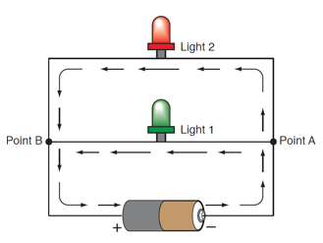

Figure 6

The voltage across any given branch of a parallel circuit is the same as the supply voltage, and equal to the voltage across each of the other parallel branches.
Whenever the resistance of a component in one branch changes or is turned off, it has no effect on the currents and voltages at the remaining branches. For this reason, electrical circuits in homes are connected in parallel. Each light fixture and receptacle is supplied with 120 volts AC, as shown in Figure 7.
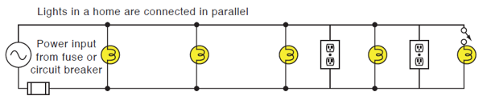
Figure 7

1.12 Grounding Devices
Grounding refers to making an electrical connection to some type of grounding device. There are two types of grounding devices, earth ground and chassis ground.
Grounding is commonly used for two purposes. First to provide a circuit path and second, to provide protection if a short circuit condition develops.

Earth Ground
An earth ground is one type of ground, and is capable of being used as a conductor in a circuit. A metal pole is embedded into the earth that makes the connection. A wire connected to the end of the pole sticking out of the ground goes to the bus bar in the electrical box. The earth is also used to replace power transmission line wires. If the earth was not used, two wires would be required to conduct electricity between the power generating plant and the end user, as shown in Figure 8a. By pounding poles into the ground at both the power plant and a home, one of the two transmission wires can be eliminated. The earth ground potential is always 0 volts.
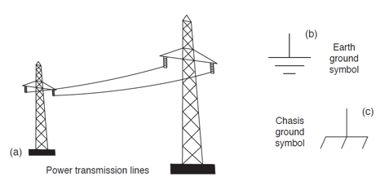

Figure 8

Chassis Ground
A chassis ground is used in automobiles and various types of equipment made with metal. The schematic symbol for a chassis ground is shown in Figure 8c.
The frame of an automobile is used as a chassis ground. A grounding wire from the negative terminal of the battery connects directly to the car frame. A hot wire goes from the positive terminal of the battery, through a switch and to the head and tail lights of the car. Instead of using a return wire from the lights to the negative terminal of the battery, the car frame is used instead as an alternative conductor. A ground wire from the negative terminal of the battery connects directly to the car’s chassis in the engine compartment, and ground connections are made at the socket of each light bulb. Using the chassis replaces a significant amount of return wires, which reduces the cost of electrical wiring in each automobile.

View the following URL regarding alternating current

http://www.wisc-online.com/objects/viewobject.aspx?id=ACE11605

Review Questions
- A dimmer switch in an electrical circuit is primarily considered a _____ in an electrical circuit.
  - source
  - load
  - conductor
  - control device

- When a switch in an electrical circuit is in a position where it does not pass current, the circuit to which it is used is considered ______ (open, shorted).

- A voltage is produced by a generator using which method of producing electricity?
- Chemical
- Friction
- Piezoelectricity
- Mechanical

- The chemical method of producing electricity is the only one capable of storing a voltage. True or False

- A series circuit has how many paths for current to flow through?

- Current that flows in a series circuit ___ (is, is not) the same through all of the components.

- The amount of current that flows in a series circuit is determined by _____.
- the magnitude of the applied voltage.
- the amount of total resistance.
- Both a and b

- The sum of the voltage drops in a series circuit ______ (is, is not) equal to the applied voltage.

- Each path in a parallel circuit is called a _____.

- The voltage across a branch in a parallel circuit is _____ the voltage of the power supply.
- the same as
- different than

- Earth ground potential is always 0 volts. True or False

- Current is capable of flowing through ground. True or False
1.13 Ohm’s Law
The manner in which the three electrical quantities, voltage, current and resistance affect one another is predictable. Therefore, they can be expressed in mathematical equations known as Ohm’s law formulas. Ohm’s law calculations are used to determine the value of one circuit quantity when the other two are known. The calculations can be used to find the value of an entire circuit, portion of a circuit, or a single component.
Since there are three electrical quantities, there are three Ohm’s law formulas that pertain to each one. The letter of the alphabet used to represent voltage, resistance, and current. Other letters of the English and Greek alphabet are listed after the numerical values obtained by calculations to represent the value of each electrical quantity.

REPRESENTATIONS
Formulas Quantities
VOLTAGE E V
RESISTANCE R Ω
CURRENT I A

The three different Ohm’s Law formulas are:

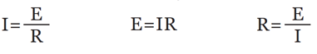

Remembering Ohm’s Law Formulas
To help remember the three Ohm’s law equations, the circle in Figure 9 is provided. To use the circle, cover the quantity that is to be found. The remaining letters indicate if the two remaining quantities should be multiplied or divided.

Ohm’s Law Formula for Amperage
The following formula is used to find current in any circuit in which voltage and resistance are known.

I = _E_
R

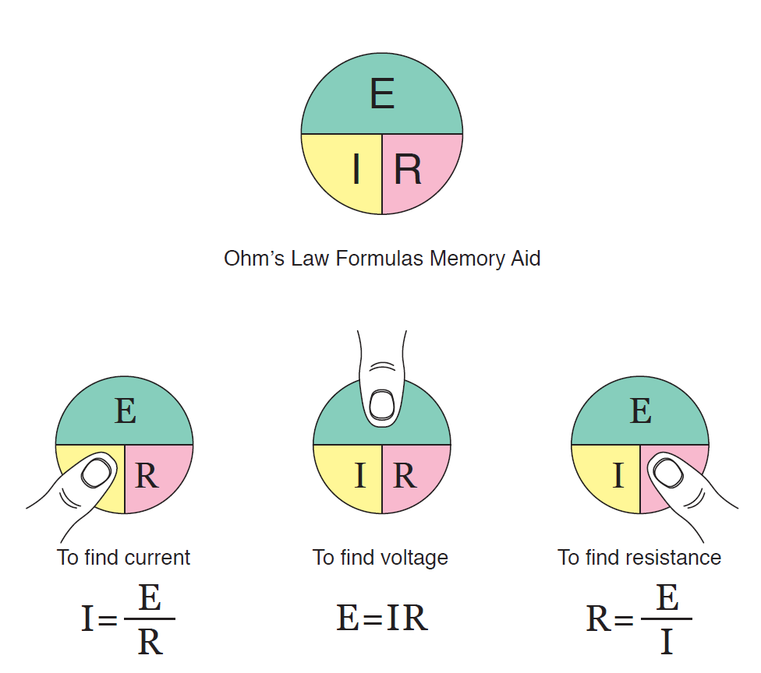

Figure 9

Figure 10 shows a circuit in which the values of voltage and resistance are given. To determine the current value, place the known value into the formula.
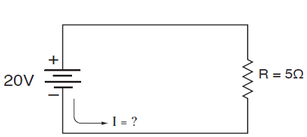

Figure 10

I = _E_ = _20_ = 4A
R 5Ω

The calculations determine that 4 amps flow through the circuit with 5 ohms of resistance when 20 volts are applied.

Ohm’s Law Formula for Voltage
The following formula is used to find voltages in any circuit in which current and resistance values are known.

E = I x R

Generally the times sign (x) is omitted, so the formula is also written as E = IR

Figure 11 shows a circuit on which the resistance and current values are given. To determine the voltage, place the known values into the formula:
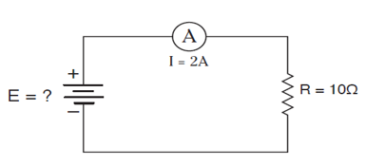
Figure 11

E = IR
= 2A x 10Ω
= 20V

The calculation determines that 20 volts causes 2 amps to flows through a circuit with 10 ohms of resistance.

Ohm’s Law Formula for Resistance
The following formula is used for finding resistance when the value for voltage and current are known.
R = _E_
I
Figure 12 shows the circuit in which the voltage and the current are given. To determine the resistance value, place the known values into the formula, and then make the calculation.
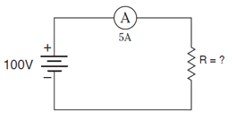
Figure 12

R = _E_
I

= _100V_
5A

= 20Ω

The calculation determines that 20 ohms of resistance causes 5 amps to flow through the circuit when 100 volts is applied.

1.14 Direct Current (DC) and Alternating Current (AC)
Direct current flows through a circuit in one direction, from negative to positive because the polarity of the source remains unchanged, as shown in Figure 13a. The flow of direct current graphically shown in Figure 13b, is usually steady and constant because of a DC source that has a fixed value. Most of the circuitry inside electronic equipment, such as consumer electronics, computers, monitors in hospitals, and automobiles are powered by DC supplies. Also, DC batteries are used almost exclusively to power portable devices.

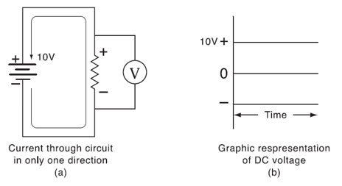
Figure 13. DC Current

There are electrical devices and circuits that also use power sources which supply alternating current (AC), where current repeatedly reverses direction, first flowing one way, and then changing and going in the opposite direction. Figure 14a graphically shows the characteristics of alternating current. At any instant, the AC power source provides a voltage of one polarity, causing current to begin flowing in one direction. The current increases from zero to a maximum value and then drops back to zero. At some later instant, the polarity of the applied

voltage changes, current increases from zero in the opposite direction, to some maximum level before it drops back to zero.
The value of AC current or voltage is commonly shown as a waveform called a sinusoidal, or sine wave, as shown in Figure 14b. The horizontal axis is divided into segments of time, such as seconds.
Alternating current is primarily used to provide electrical power to factories, commercial buildings and residential properties for three reasons. First, AC power is easily produced by generators. Second, AC current can be transmitted over long distances more efficiently than DC power. Third, AC power can be converted to direct current more easily than converting DC to AC.

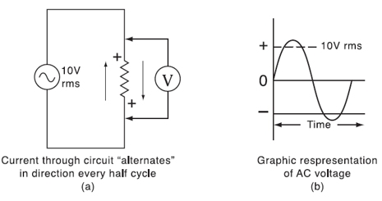

Figure 14. AC Current

Review Questions
- Ohm’s law verifies that the current is ______ proportional to resistance.
- directly
- inversely

- A letter that represents voltage measurements is _____.

- What is the current flowing through a circuit with 200 volts applied and 3.3 k ohms of resistance?

- What is the voltage applied to a circuit with 2.7k ohms of resistance when 20 mA flows through it?
- 7.4 volts
- 54 volts
- 135 volts
- 540 volts

- What is the resistance of a circuit that has 200 milliamps flowing through it when 50 volts is applied?
- 250 ohms
- 4k ohms
- 8k ohms
- 25k ohms

- ______ current flows in only one direction.

- AC current can be transmitted over long distances more efficiently than DC.
True or False

- Which conversion is the easiest to achieve?
- DC to AC
- AC to DC

- The horizontal axis of a sine wave represents time. True or False

- Hazards of Electricity
There are many different types of accidents that can occur in the work place, but electrical shock is one of the deadliest accidents that can happen to production workers, maintenance technicians, and other personnel who are exposed to electricity is some way.
Electricity is a primary energy source in a manufacturing facility. In fact, over 60 percent of electricity produced at power plants is consumed by electrical motors. In an industrial setting, both low and high voltages are used to run the equipment. The voltage levels used are determined by the power requirements of the devices that consumes the electricity. While different definitions exist for the exact voltage range covered by low voltage and high voltage, the National Electrical Code states that low voltage is any voltage less than 600 Volts Alternating Current (VAC) and high voltage is any voltage equal to or greater than 600 VAC.

Electrical shock: All voltages are dangerous

Electricity is a very safe form of energy when the devices, power tools, equipment and systems powered by it is designed, built and used properly. However, this energy source can be dangerous and therefore create hazardous conditions resulting in personal injury. This is why it is so important for technicians to identify and understand the hazards of electricity, inspect equipment before they use it, and use the equipment correctly.

The hazards of electricity include:

- Electric Shock and Burns
- Fires
- Explosions
- Arc-Blast (or Arc-Flash)
These hazards are usually created by human error and improper use, malfunction of equipment, poor design of equipment, disregarding safe practices, or a combination of these and other things. The following information describes the types of electrical hazards and explains various precautions that can minimize the dangers from electricity.

2.1 Electric Shock and personal injury occurs when some part of the body
becomes part of an electrical circuit, enabling current to pass through by entering at one
point and exiting at a different location, such as the ground on which a person is
standing. Current flows through the human body because it is made up of water
chemicals and minerals, which makes it a good conductor. If a person’s the body has a
low resistance to allow current flow through it, the effect could be one or a combination
of many things from a slight tingle to death.

The primary factors that determine the severity of a shock are:
- The amount of current flowing through the body.
- The path the current takes through the body.
- The length of time the body is in the path of electrical flow

The harmful effects resulting from an electrical shock will vary somewhat
with age, gender, and physical condition of one’s body.

Amount of Current
One of the variables that determines the amount of current is the body’s resistance.
Keep in mind that the real measure of a shock’s intensity lies in the amount of amps forced through the body, and not the voltage. The amount of current that flows through an individual is primarily determined by the resistance of their body. Because every human body is built differently, everyone will have a different level of resistance. The range can be from as little as 500 ohms to many thousands of ohms. This is why a similar voltage shock can feel minor to one person and be deadly to another. Any electrical device under certain conditions can transmit a fatal current.
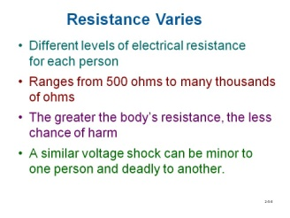

  - Because the skin offers most of the body’s electrical resistance, the point of electrical contact with the skin will determine the amount of shock received. Remember, the higher the resistance, the less sensitive it is to exposure to current, which means a lower amount of the shock potential.

  - Resistance increases if you are shocked in an area that has thick, callused, or dry skin.

  - If the Resistance decreases, the current and sensitivity to shock increases. The resistance to current flow decreases if the electricity enters the body in an area of thin skin, if the skin is wet or sweaty, or if the skin is broken.

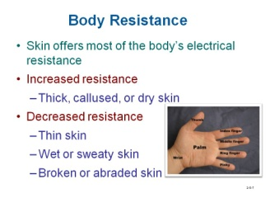

How Different Current Levels Affect the Body
Electricity effects the body in at least three ways.
1. It causes the body muscles to contract.
2. It harms or interrupts the proper functioning of the nervous system and heart.
3. It subjects the body to intense heat.

There are no absolute values as to the amount of current that flows through the body
and what kind of effect it will have. The following information provides a general
relationship between the degree of injury to the body based on the amount of electricity
it is subjected to at different current levels. The mA listed after the number refers to
milliamps, or 1-thousanth of an amp. The A listed after the number indicates amps.

1mA
A faint tingle.

5mA
A slight shock that is uncomfortable but not painful. If a technician is on a ladder or an elevated surface at the time of a shock, the resulting fall could cause serious injuries or even death.

10-30mA
The shock is painful. This level of current can cause an involuntary contraction of the muscles to occur and therefore the person may not be able to release the handhold on the conductor and stop the flow of electricity. This type of shock is underrated. However, as the duration of current flow increases, the severity of the shock becomes worse and death could result if help is not available to stop it. If another person grabs the victim in an attempt to release him or her from the conductor, it is possible that the same thing will happen to the rescuer.
Because of the physiological and chemical nature of the human body, five times more direct current than alternating current is needed to freeze the body to an electric conductor. One of the most dangerous ac frequencies is 60 hertz (cycles per second). Unfortunately, this is the frequency normally used in residential, commercial, and industrial power lines.

30-75mA
The shock is very painful. Respiratory center paralysis develops, in which the
muscles that control breathing are interfered with and cannot move. Death can occur
because the person cannot breathe.

75-200mA
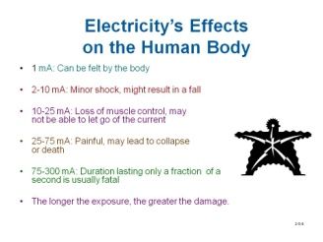
The shock is extremely painful. Ventricular fibrillation develops, which is when the walls of the ventricles in the heart cause its beating pattern to become elevated to a level that is too fast for normal pumping action. The result is that the heart pools the blood in place and therefore it is not circulated throughout the body. Because there is a decrease in blood flow to vital organs, death can occur if current is not removed in a few minutes.

200mA-4.3A
The shock can be so severe that the heart will stop and fibrillation will not take place.

10A
Current is high enough to cause severe burns to the skin. Electrical burns are most commonly sustained on the hands from touching electrical wiring or equipment by accident, although large portions of the body can also get burnt. High amounts of current that enter the body, can cause injuries that cannot be seen, such as internal hemorrhaging or damage to tissue, nerves or muscles. If the current passes through vital organs, they may no longer function properly. Cardiac arrest is probable if the current reaches the heart. Secondary injuries could result from electrical shock at these current levels due to a person’s reaction, such as cuts, bruises or broken bones.

Note: Never touch a person who is being shocked with your bare hands. Use a piece of dry, non-conducting material to pry and/or pull him/her away from the electrical current. Ultimately, the best method is to shut off the source of electricity, if possible.

The table in Table 5-1 shows the amperages drawn by a variety of electric power tools and equipment.

The Path Current Takes Through the Body
The damage from shock also depends on the number of vital organs in the current path, and is especially dangerous if the reaches the heart. When current becomes very high, it can destroy the tissue of these vital organs enough so that they will no longer function properly. A high enough current will create enough heat to burn the part of the body it uses as the path it is conducting through.

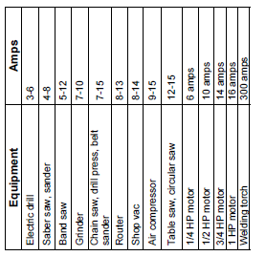
Table 5-1

Length of Time Current Flows
A low voltage can cause as much injury as a high voltage. The degree of injury is proportional to the length of time the current flows through the body of a person. The ranges of current and how they affect the body previously listed is based on the current flowing for a duration of 60 seconds. However, if the current flows for a longer amount of time, the severity of the shock increases.

2.2 Fires – One of the most common reasons why fires start is because there is a malfunction of electrical equipment, or something electrical is misused. In many cases, the problem causes a condition where there is high a very high amount of current flow caused by a condition called a short. Another common cause is when there is a high resistance to the current and enough voltage to force it to flow. Broken switches or plugs, and loose connections can cause a circuit to overheat. In both situations, damage and fires can occur as too much current flows through wires, causing them to overheat, melt, or ignite flammable materials around them.

Technicians should familiarize themselves with all firefighting equipment and fire regulations at the working facility. For example, in case of electrical fires, the following steps should be taken at once:

1. De-energize the circuit
2. Call the fire department
3. Control or extinguish the fire with the correct type of fire extinguisher
4. Report the fire to the appropriate authority

For combating electrical fires, use a CO₂ (carbon dioxide) fire extinguisher and direct it toward the base of the flame. Never put water on an electrical fire because it can conduct electricity. Carbon tetrachloride should never be used on fires because it changes to phosgene (a poisonous gas) on contact with hot metal, and even in open air this creates a hazardous condition. The foam type of fire extinguisher also should not be used, because foam conducts electricity.

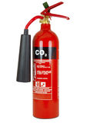

Explosions – When electricity creates a spark or if a conductor becomes overheated due to excessive current, an ignition source is provided to cause an explosion if exposed to an atmosphere that has a combustible gaseous mixture.

Arc-Blast – Also known as an arc-flash, an arc-blast is a condition where electricity flows through the air from one conductor to another. They can occur in factory power panels or equipment that run at high voltages, such as 480 volts or greater. Arc flashes occur for a variety of reasons that are preventable, such as:
- Workers accidently dropping tools on non-insulated conductors
- Improper use of test equipment
- Neglect, such as allowing dust to collect, or not tightening loose connections

Arc flashes occur because electricity seeks to escape through the air from one conductor to another conductor. High voltages are required to create this condition because of the force required to cause electricity to go through an air gap. Arcs that have enough energy can ionize the air. When it does, the resistance of the air drops and becomes a good conductor, causing the current to elevate to a level that enables a massive amount of energy to be released. The temperature of the arc can reach 35,000 degrees Fahrenheit, or roughly 4 times that of the Sun. Surfaces of nearby people and objects absorb some of this heat and can receive extensive injury or damage. The heat can also cause the metal that is conducting the current to vaporize and create a blast of molten metal, and a powerful shock wave of air that causes further destruction.
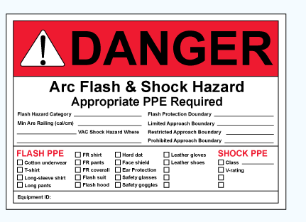

View the following URL to learn about more about arc flashes:

http://www.msamc.org/arcflash/index.html

Alternate URL
https://www.softchalkcloud.com/lesson/serve/i0Vlba4UmKTXI5/html

Review Questions

- Only high voltages are dangerous. True or False

- The primary factor that determines the severity of a shock is ______.
a. amount of current that flows
b. the path current takes
c. the duration of the current flow
d. All of the above

- The term ______ refers to a condition where the heart rate flutters and therefore current is not sent throughout the body.
a. Ventricle fibrillation
b. respirator center paralysis

- When finding a person receiving a shock, the first step should be to grab the victim to pull the person free of the energy source.
True or False

- The type of extinguisher to use fr electrical fires is _______.
a. CO₂
b. water
c. carbon tetrachloride

- Arc flashes can create heat at a higher temperature than the sun.
True or False

3. Ways to Minimize Electrical Hazards
Hazards from electricity cannot be totally be prevented, but there are measures that have been established to minimize their harmful effects, such as incorporating:
- Protection Devices
- Following Safety Procedures

3.1 Protection Devices
In addition to the basic components of an electrical circuit, the source, path, load and control, protection devices are often included to prevent damage, personal injuries, or fires. Electricity will almost always travel the path of least resistance. Given the opportunity, electricity will short circuit or bypass the piece of machinery you were intending to turn on. Circuits in equipment are designed with a certain amount of resistance, and when that resistance is bypassed, the wiring may become overheated or a shock hazard may develop due to a higher than normal current. Protection devices and voltage/current ratings of components and conductors have been engineered to prevent or reduce the effects of a condition where the resistance to current flow is lower than it is intended to be.
Protection devices include circuit protection components and elements, wires that are designed to handle currents and voltages at specific rated levels, and grounding equipment that are engineered to prevent shock hazards.

    - Circuit Protection – Circuit protection devices are designed to automatically break open the circuit and shut off the flow of electricity as soon as the current reaches a dangerous level. These dangerous levels are reached in the event of a ground-fault, overload, or short circuit condition in the wiring system Fuses, circuit breakers, and ground-fault circuit interrupters (GFCIs) are three examples of such devices. Also, these protection devices switch the circuit off much faster than how quickly a human can respond.

View the following URL to learn about circuit opens and shorts:

https://www.wisc-online.com/learn/career-clusters/stem/amt2404/electrical-opens-and-shorts

Fuses have two connecting points with a metal conduction element between them that has a low melting point. Fuses are available at various current ratings. When the current in a circuit exceeds the 10 amp rating level of a fuse for example, the element will melt and open the current path. An application of circuit protection is when a defective charging device is plugged into the cigarette lighter socket of an automobile, causing current to exceed the rating of the fuse. The advantage of a fuse is that it responds more quickly than other circuit protection devices, such as a circuit breaker, which is a desirable

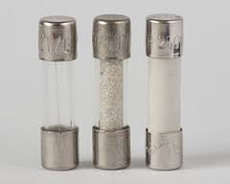

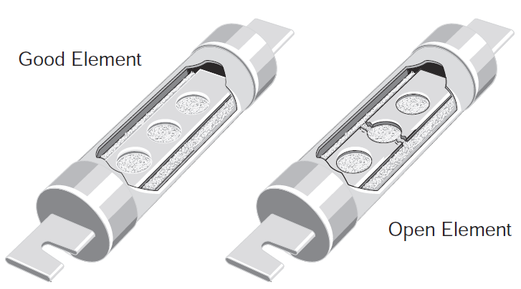

Fuses

characteristic for some types of equipment. The term used for a fuse when it opens is that it “blows”.

Circuit breakers are the protective devices that most people are familiar with in residential and commercial buildings. Circuit breakers, like fuses, allow a certain amount of amps to flow in the circuit before blowing, tripping, or breaking the circuit.
Most of the common circuit breakers, similar to the one shown in Figure 15a, provide a means to manually energize and de-energize a circuit, and are capable of being reset after a fault condition has been corrected. These capabilities are provided through use of an operating handle, as shown in Figure 15b. Another capability are that these circuit breakers are trip free, meaning that they cannot be prevented from tripping by holding or blocking the operating handle in the “ON” position. There are three positions of the operating handle: “ON” (contacts closed), “OFF” (contacts open), and “TRIPPED” (mechanism in tripped position, contacts open). This type of circuit breaker is reset after a trip by moving the handle to the “OFF” position and then to the “ON” position.

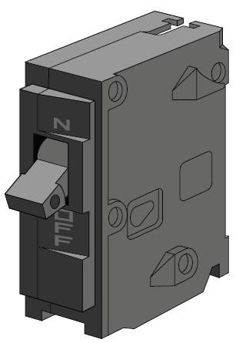 (a)

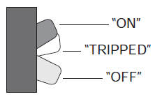 (b)

Figure 15. Circuit breaker

There are several types of circuit breakers. One of them shown in Figure 16a, is a thermal breaker that has a bimetal strip inside through which the circuit current flows. When the current exceeds the amperage rating of the breaker, the strip causes a spring loaded switch to open and break the circuit. Figure 16b shows what happens when excessive current flows through the bimetal strip made of two dissimilar metals bonded together. As current rises, both metals heat up. Because the metals are not the same, they expand at different rates, causing the strip to curl. When it bends a predetermined distance, the bimetallic strip shown in Figure 16c, rotates a movable part of the trip mechanism far enough to cause it to unlatch and open the contacts.
After the circuit breaker’s contacts have been open, the bimetallic strip cools and becomes straight again. This allows a circuit breaker to be manually reset once the over current condition has been corrected.
An advantage of a circuit breakers over fuses is that when they are tripped, breakers can be reset instead of being replaced.

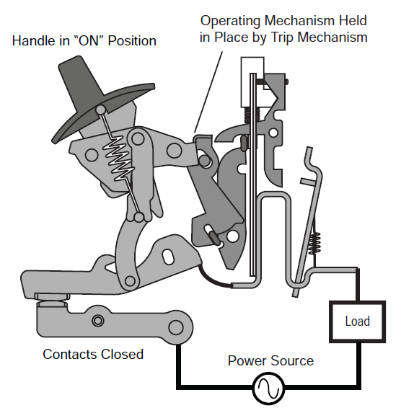 (a)

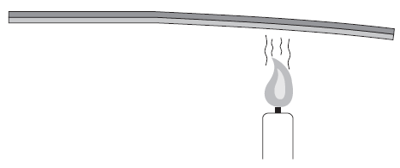
(b)

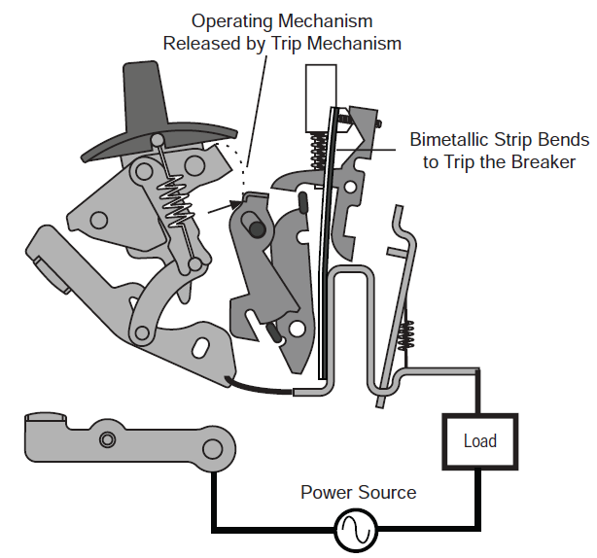 (c)

Figure 16. Circuit breakers

Fuses and circuit breakers are usually installed at the sources of the electrical power.

The following practices and precautions should be followed when working with
fuses or circuit breakers:

    - You can energize (close) or de-energize (open) a circuit with equipment such as switches or breakers.

    - Do not open or close circuits by installing and removing fuses.

    - If a circuit breaker device is tripped, an authorized worker should inspect the system before manually re-energizing the circuit. A short or other electrical hazard may need to be repaired.

Question: What are the devices to protect circuits called?
Answer: Circuit breakers and fuses.

View the following URL to learn why a fuse is blown or circuit breaker is tripped when current exceeds the rating of these protection devices.

https://www.wisc-online.com/learn/career-clusters/stem/dce602/circuit-protection

Ground fault circuit interrupters (GFCI) are another device commonly used to prevent electrical shock. GFCIs are usually installed according to electrical code in a wall-mounted receptacle in an area where electricity and water are likely to contact each other. That is why they are often located in bathrooms and kitchens.
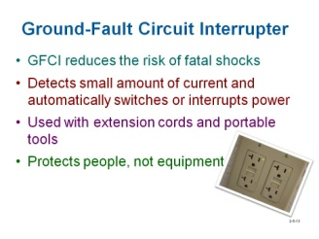
A GFCI monitors electric current and can switch a circuit off before injury can occur. It is a small, fast-acting device that senses small current leakages to ground. Within 1/40th of a second, it shuts off electricity and interrupts the current flow. A GFCI is designed to provide protection from shocks that have the potential to kill. Even though GFCIs are not intended to protect tools or equipment, they should be used with power tools and extension cords. However, in order for the GFCI to work correctly and protect the user, it must be located at the power source not at the end of the extension cord.

View the following URL to learn more about ground-fault interrupters:

http://www.wisc-online.com/objects/viewobject.aspx?id=IAU14408

Question: Where should the GFCI be located?
Answer: At the power source, the receptacle.

Question: What does a GFCI protect?
Answers: A GFCI is designed to protect the user, not the tool.

Question: What does a GFCI do?
Answer: A ground-fault circuit interrupter senses a small amount of current and trips, or opens the circuit, to prevent damage.

Question: Can you prevent static electricity with a GFCI?
Answer: No. Static electricity does not flow in a current.

Rated Wires - Voltage is the pressure that causes current to flow. Controlled voltages at levels used by electronic devices enable electrons to flow through conductors. At these voltage levels, current will not flow through a substance that is an insulator. An insulator is any material with high resistance to electric current, such as rubber, asbestos and plastic that are put on conductors to prevent shock, fires, and short circuits. However, whenever a voltage is great enough, current can even flow through a substance that does not allow current to flow easily, such as when lightening occurs, where a bolt of electrons flow through air which is not a good conductor. Over time, the insulation on wires may deteriorate due to environmental conditions, or be worn through when rubbing against something solid due to vibration. Therefore, before technicians work on energized equipment, it is always a best practice to assess the overall condition of their wires. Frayed wires and cracked insulation could be a personal safety hazard that could lead to electric shock, fires, or short circuits.

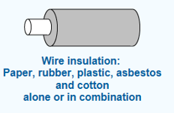

The wire and its insulation should be suited for the conditions in which it is being used. The diameter of wires determine how much current they can conduct. If the diameter of the wire is too small for the amount of current flowing through it, the

metal will heat up to a temperature that will cause the insulation, wire, or both to melt and possibly created a fire. Wires have a gauge (AWG) which represents its

size, and is used with NEC (National Electrical Code) tables to determine the proper size wire that is needed to handle the amount of current required for an application.

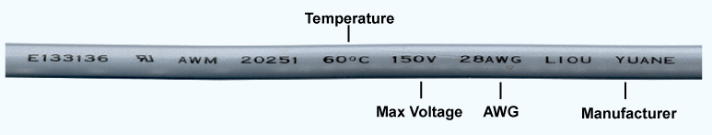

Some wires have a breakdown voltage rating printed on the insulation. This

value indicates that the insulation may be damaged and not provide protection

from fire or shock when a voltage applied to the wire exceeds this level. Also

printed on the insulation is the maximum temperature it can be exposed to. If this

temperature is exceeded, the insulation may break down and be permanently

destroyed.
These voltage, current and temperature ratings for wires should be observed
and not be exceeded.

View the following URL to learn about wires:

https://www.wisc-online.com/learn/career-clusters/stem/dce6403/wires

    - Grounding Equipment - In certain situations, some types of electrical equipment or tools should always be grounded, meaning that a wire runs directly from the machine to the earth or ground. The main purpose having a connection to ground is to avoid a shock hazard in the event of a short circuit situation. When this condition arises, the electrical current will go to ground through the grounding system rather than through the human body. Therefore, the chance for painful shocks or death by electrocution is reduced. The earth, which forms the ultimate ground, has the ability to absorb or dissipate electrical charge.
The use of three-pronged plugs on electrical tools and appliances is one common method of grounding. The third prong provides a path to ground along which the electrical current travels. Equipment with damaged grounding connectors should not be used. The three-prong plug must never be altered by cutting off the grounding prong so that it can plug into a two-prong receptacle. This practice is not safe because if you are touching an ungrounded tool or

equipment, the equipment safeguard is being bypassed and you become the path of least resistance.
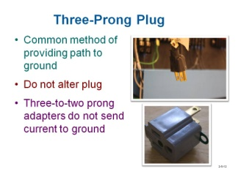

Electric Shock

WARNING - The three-to-two-prong adapter interrupts the grounding connection. The adapters are not designed to send the current to ground if there is a problem.

Grounding equipment – Almost all electrical equipment is designed with some sort of grounding system.

View the following URL to learn about how three-prong plugs minimize shock hazards:

????? New learning object??

Question: If a dump truck touched high-voltage power lines when the operator raised the bed to unload the contents, would the driver be electrocuted?
Answer: No. The large rubber tires would prevent the voltage from reaching the ground and forming a completed circuit (much like birds sitting on a wire).

Question: Under what conditions would the driver risk his life?
Answer: If the driver were to step out of the truck, he would be electrocuted as soon as his foot touched the ground.

Here are some telltale signs that an electrical hazard condition may exist:

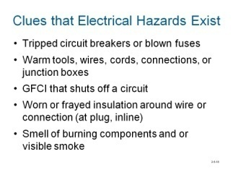

3.2 Following Safety Procedures
Every person who works with electrical equipment should be constantly alert to the hazards to which they may be exposure and to be capable of rendering first aid in case of injury. When working with or around any electrical equipment, there are some fundamental precautions and specific safety procedures that should be followed such as:
Remove all rings, wristwatches, or metal chains – If these items make contact with any conductors that are live while making measurements with test equipment, the probability of a significant electrical shock is increased. For the same reason use insulated flashlights of the molded type and handtools that have insulated handles.
Consider the consequences of each act - There is never a reason for taking chances that could endanger your life or that of others.

Keep away from live circuits - Do not change parts or make adjustments inside the equipment unless the power is shut off. Do not expose equipment unnecessarily, even in a dead circuit. Keep the doors and fuse boxes closed except when you are working inside them or replacing fuses.
Never work alone around high-voltage circuits – Always have another person (safety observer) who is qualified in first aid for electric shock present at all times. Be sure he/she knows the circuits and locations of switches controlling the equipment so he/she can pull the switch immediately if anything unforeseen happens.
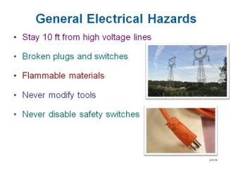

Do not tamper with interlocks - Interlocks are safety devices such as switches or connectors that break the circuit and shut off power when access panels are removed or cabinet doors are opened. They should never be modified to force the power on when it should be turned off.

Never allow yourself to be grounded - Ensure that you are not grounded whenever you are servicing energized equipment, and be sure to stand on some form of non-conductive material, such as an insulated mat or wooden platform.

Do not energize electrical equipment around water. Water is capable of conducting electricity and is dangerous when working around energized equipment. If working in an area where there is a water spill, remove it before proceeding.

Follow the one-hand rule - Avoid any direct contact with exposed equipment. If it is necessary to touch something or to open and close circuit switches, use only one hand. Keep the other behind you or in your pocket, so that there is no danger of accidentally touching an energized circuit with both hands at once, which would allow current to pass through the chest and heart. Also when working under these conditions, keep your clothing, hands, and feet dry.

Be prepared as much as possible - Before you begin work on any electrical equipment, take time to carefully study the schematics and wiring diagrams of the entire system, noting what circuits must be de-energized in addition to the main power supply. Remember that electrical equipment frequently has more than one source of power, and opening panels with safety or interlock switches will not necessarily kill all circuits in a piece of equipment.

Follow the 10 foot rule - Always stay at least 10 feet away from high-voltage power lines. High-voltage lines are bare conductors, so contacting them with a ladder, boom lift, scissor lift, bucket truck, etc., will cause electrical shocks.

Following these basic electrical safety rules is a sound prescription for the prevention of serious injury or death. Understanding the nature of electricity and exercising personal vigilance and practicing safe working habits caution is the most effective safeguard to reduce the probability to receive an electrical shock in the workplace. .

Review Questions
- As the _____ of a wire increases, its resistance decreases.
  - length
  - diameter
  - temperature
  - gauge value

- Insulation of wire is commonly rated at the ______ it can withstand before breaking down.
a. current
b. temperature
c. voltage
d. All of the above

- In an electrical circuit, _____ occurs when the circuit is broken.
a. a short
b. an open

- One advantage of the ____ is that it reacts and breaks the circuit with a very fast reaction time.
a. fuse
b. circuit breaker

- The _______ is a protection device that is used when electricity is used around water.
a. fuse
b. circuit breaker
c. GFCI

- The smaller the diameter of a wire, the _____ current it can carry.
a. less
b. more

- The primary function of a Ground Fault Interrupter is to protect against shocks instead of preventing equipment damage. True or False
.
- Always stay at least _____ feet away from high-voltage power lines.
a. 5
b. 10
c. 50
d. 100
4. OSHA Requirements
OSHA is involved with electrical safety in a variety of ways. They provide training, guidelines and enforce some regulations.

4.1 Training – OSHA’s 29 CFR 1910 Subpart S discusses, among other things, the electrical safety training requirements intended to keep employees safe around workplace electricity. Electrical safety training teaches safe practices for those expected to work with electric equipment. Only trained and authorized employees should repair and troubleshoot electrical equipment.
To protect workers against serious electrocution hazards such as death and burns, OSHA requires significant electrical safety work training. Training regulations exist for both “qualified” workers (those whose contact with electrical equipment exposes them to the greatest hazards) and “unqualified” workers (those who ordinarily would have little exposure to electricity).

Qualified workers – These workers are allowed to work on or near exposed, energized electrical equipment. They receive additional detailed training that includes:

    - how to identify exposed electrical equipment and parts,

    - how to properly lockout or tagout equipment, and

    - how to safely work around electrical equipment.
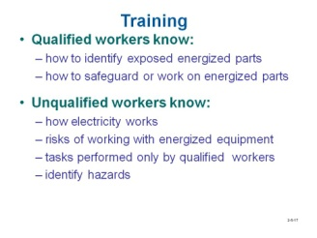

Unqualified workers – These workers are not permitted to work on or near exposed energized electrical equipment. However, they receive similar training to that which has been discussed in this module. This training includes:

    - how electricity works,

    - how electricity can contact and harm the human body,

    - which tasks require a qualified worker to perform, and

    - how to identify potential electrical hazards and how to use equipment and machinery that is powered by electricity.

4.2 Guarding
The National Electrical Code (NEC) requires that any electrical systems with live parts operating 50 volts and over: “shall be guarded against accidental contact by approved enclosures…" [NEC 110.27 (A)]. To provide this guarding requirement, these guidelines should be observed:

1. | By location in a room, vault, or similar enclosure that is accessible only to qualified persons.
2. | By suitable permanent, substantial partitions or screens arranged so that only qualified persons have access to the space within reach of the live parts.
3. | By location on a suitable balcony, gallery, or platform elevated and arranged so as to exclude unqualified persons.
4. | By elevation of 2.5 m (8 ft.) or more above the floor or other work surface.

NEC 110.27 (A) 1-4

The NEC also requires that workers are given fair warning: “Entrances to rooms and other guarded locations that contain exposed live parts shall be marked with conspicuous warning signs forbidding unqualified persons to enter." [NEC 110.27 (C)]. As a production worker or technician, you could be one of the authorized persons. These locations will most likely be locked, and entrance to them will only be allowed as necessary.

5. First-Aid Response to Electrical Shock
In the event of an electrical shock, the following steps should be taken in the following sequence order by someone who is able to render aid to the victim:

Step 1. If someone is being electrically shocked, turn off the power switch or circuit
breaker if it is near you. Even if the power source cannot be shut off quickly, it
is important to act fast. Remove the victim from electrical contact, but DO NOT
do so with your hands because electricity transfers from one person to another
based on contact. Use a stick, rope, belt, coat, blanket or any other non-metallic
material to drag or push the victim to safety.

Step 2. Once the victim is removed from the electrical source, summon medical
help. The best way to make sure help arrives is to point to one person and gain
eye contact with that person while telling them to call 911 for help. Ask if they
understand. Instruct them to return to inform you that the call has been
made. If they do not return in a few minutes, repeat this instruction with another
person.

Step 3. Check for breathing. If breathing has stopped, immediately begin CPR
procedures even if life signs are not apparent. CPR should continue until
either normal self-respiration has begun, or you are instructed to stop when
trained medical personnel arrive.

Step 4. If the victim is breathing (naturally or after CPR is applied), treat for traumatic
shock. Some degree of traumatic shock is usually present after any moderate
to severe injury. Even when shock is not immediately evident, it can develop
hours after the injury. Cover the victim with a coat or blanket to conserve body
heat; then loosen any clothing around the neck, chest, and abdomen to
promote unrestricted respiratory functions. Keep the victim quiet and prevent
any unnecessary movement. After electrical shock, the heart is weakened;
sudden muscular effort or activity may result in heart failure. Patients who
have received severe electrical shock have been known to die from the effects
of the shock or injury even after they have been revived.

Step 5. Remain with the victim and monitor vital signs until medical help arrives.
Do not administer any medication.

6. Static Electricity Hazards

  - Static Electricity – Static electricity is electricity that does not flow in a circuit. It is generated by rubbing two objects together (one object is non-conductive). The adhesive forces between the two objects, as associated with friction, generate attraction because the substance with an excess of electrons transfers them to the positively charged substance. Substances (insulators) that do not conduct electricity are good at holding an electrostatic charge. Rubber, plastic, glass, or ceramic are examples of insulators. A static ‘shock’ is caused by the neutralization of charge built up in the body from contact with nonconductive surfaces.
Note: When the charge becomes high enough, it jumps through the air and can
ignite a flammable substance.
    - Preventing static electricity – Ground the static charge by touching a grounded appliance, wiring a ground circuit, or by applying a neutralizing charge.

Static charge accumulates in areas where the charge cannot
escape. When working with sensitive electrical components or volatile materials, such as papers/powders or flammable liquids, sparks and electrical discharge can cause catastrophic failure in sensitive electrical components and ignite volatile substances. Take the following steps to eliminate static electricity:

      - Grounding points – Wire work surfaces to grounding points. Resistive “Touch Me First” grounding pads let users drain off any static charge they have accumulated without causing a spark or a shock.

      - Wristbands – Wear static control wristbands, which are wired to grounding points. DO NOT wear static control wristbands when working on CRT (cathode ray tube) televisions or computer monitors. CRT monitors operate at very high voltages – as high as 40,000 volts – and can hold these voltages for an extended period of time, even when unplugged. If you touch the anode (a positively charged electrode) of the monitor while you are grounded to the CRT’s chassis by a wristband, death can result.

      - Touch grounded object – If nothing else is available, touch a grounded metal object once in a while to remove any charge from your body. Touching a water spigot works well, as the metal plumbing system is usually grounded. This will not be effective in newer structures that use PVC piping.

      - Mats – Use rubber floor mats near machinery.

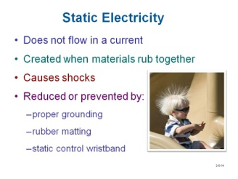

Question: Is static electricity essentially harmless?
Answers: No. Static electricity around electrical equipment or flammable gasses can cause equipment damage, gas explosions, and bodily harm.

Review Questions

- After a victim has received a shock, one of the priorities of the rescuer is to find out what medication the person takes, and immediately help the person take it to prevent him or her from going into shock.
True or False

- _____ are good at holding an electrostatic charge.
a. Conductors
b. Insulators
c. Magnets
d. Superconductors

- Electrostatic charges are eliminated by drawing off electrons to ground.
True or False

- OSHA requires electrical training for _____ workers.
a. qualified
b. unqualified
c. Both A and B
d. Neither A or B

Chapter Questions
            - Which of the following is considered a secondary energy source?
a. Natural gas
b. Electricity
c. Nuclear power
d. Coal

            - The ______ orbits the nucleus of an atom
a. electron
b. proton
c. neutron
d. nucleus

            - An atom with how many electrons in its outer shell is the best conductor of Electricity?

            - When a balanced atom loses an electron it becomes a ____ (negative, positive) ion.

            - Current can exist without voltage. True or False

            - Current is the movement of _____ (protons, electrons).

            - A ____ produces electricity using pressure.
a. generator
b. piezoelectric device
c. thermocouple
d. photovoltaic

            - A. ____ is an example of a control device in an electrical circuit.
a. switch
b. lightbulb
c. battery
d. wire

            - The letter _____ is used to represent current flow in a circuit.
a. I
b. C
c. R
d. P

            - The symbol Ω is used to represent resistance in an electrical circuit. Ture or False

            - Which factor will cause the resistance of a wire to increase?
a. decrease in its length
b. an increase in its diameter
c. an increase of its temperature
d. using silver instead of copper

            - When a switch is in a position that causes current to flow, the circuit in which it is connected is open.

            - A grounding device ______.
- acts as if it conducts electricity
- is a power source
- acts the same as a circuit breaker
- is considered a loading device

            - A _____ responds to excessive current more quickly that a ______ in response to excessive current conditions.
a. fuse, circuit breaker
b. circuit breaker, fuse
c. human, fuse
d. human, circuit breaker

            - The term ________ (directly, inversely) proportional refers to the value of one quantity affecting the value of another the same way by the same ratio.

            - If V doubles, I halves if R is not changed. True or False

            - The resistance in the circuit is how many ohms when the applied voltage is 18 volts and the current is 20mA?

            - 18. The voltage of a circuit is ______ volts when its resistance is 10k ohms and the current is 500 uA.
- 5
- 50
- 500
- 2000

            - The sum of the currents through all of the components in a series circuit equals total current. True or False

            - Which statement is true about a parallel circuit?
a. A parallel circuit is configured so that current has one or more paths for current to
flow.
b. The total current in a parallel circuit is equal to the sum of the branch currents.
c. In a parallel circuit the current in each branch is directly proportional to the
resistance of the branch.
d. The source voltage is equal to the sum of all the voltage drops across each
branch in a parallel circuit

            - The horizontal axis of a sine wave indicates _____.
a. polarity
b. voltage amplitude
c. current amplitude
d. frequency

            - If the current is at a greater level than what the wire conductor is it is designed for, it could ____.
a. overheat and open
b. cause a short
c. overheat and start a fire
d. Any of the above

            - Electrical current takes the path of least resistance.
a. True
b. False

            - According to the NEC (National Electrical Code) a voltage greater than _____ volts is defined as High Voltage.
a. 120
b. 230
c. 460
d. 600

            - A current as low as _____ can cause cardiac arrest.
a. 100 milliamps
b. 1 amp
c. 5 amps
d. 10 amps

            - The real measure of the intensity of an electrical shock lies in the amount of _____.
a. voltage
b. amps forced through the body

            - Ventricular fibrillation is the _____.
a. stoppage of the heart
b. loss of regular heart rhythm
c. Both a and b
d. Neither a or b

            - Current cannot flow through a substance that is considered an extremely poor conductor, even if the voltage is great enough. True or False

            - Static electricity _____ flow in a circuit.
a. does
b. does not

30. _____ are used to minimize the build-up of static electricity.
a. Grounding pads
b. Grounded wristbands
c. Rubber floor mats
d. All of the above

Review Question Answers
1. c
2. One
3. False
4. c
5. Negative
6. b
7. True
8. I
9. d
10. c
11. b
12. open
13. d
14. True
15. one
16. is
17. c
18. is
19. branch
20. a
21. True
22. True
23. b
24. e
25. 61mA
26. b
27. a
28. True
29. True
30. b
31. True
32. False
33. d
34. a
35. False
36. a
37. True
38. b
39. d
40. b
41. a
42. c
43. a
44. True
45. b
46. False
47. b
48. True
49. c

SAFETY DISCLAIMER:
M-SAMC educational resources are in no way meant to be a substitute for occupational safety and health standards. No guarantee is made to resource thoroughness, statutory or regulatory compliance, and related media may depict situations that are not in compliance with OSHA and other safety requirements. It is the responsibility of educators/employers and their students/employees, or anybody using our resources, to comply fully with all pertinent OSHA, and any other, rules and regulations in any jurisdiction in which they learn/work. M-SAMC will not be liable for any damages or other claims and demands arising out of the use of these educational resources. By using these resources, the user releases the Multi-State Advanced Manufacturing Consortium and participating educational institutions and their respective Boards, individual trustees, employees, contractors, and sub-contractors from any liability for injuries resulting from the use of the educational resources.

DOL DISCLAIMER:
This product was funded by a grant awarded by the U.S. Department of Labor’s Employment and Training Administration. The product was created by the grantee and does not necessarily reflect the official position of the U.S. Department of Labor. The Department of Labor makes no guarantees, warranties, or assurances of any kind, express or implied, with respect to such information, including any information on linked sites and including, but not limited to, accuracy of the information or its completeness, timeliness, usefulness, adequacy, continued availability, or ownership.

RELEVANCY REMINDER:
M-SAMC resources reflect a shared understanding of grant partners at the time of development. In keeping with our industry and college partner requirements, our products are continuously improved. Updated versions of our work can be found here: http://www.msamc.org/resources.html.

