Safety Awareness
Unit 3
Personal Protective Equipment (PPE)
and Programs

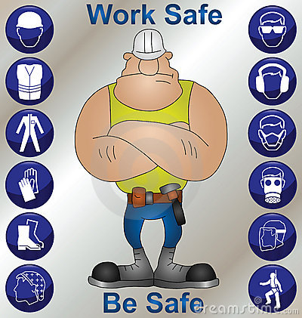

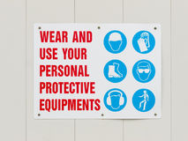

LEARNING OBJECTIVES:

  - List the agencies that are responsible for various types of PPE regulations and enforcement.

  - Describe how to conduct a hazard assessment inspection/evaluation and who is responsible for conducting it.

  - Explain the responsibilities of the employee after being trained on PPE gear.

  - List the hazards that the eye and face are subjected to, what kind of injuries that occur, and identify they types of PPE eye protection that must be worn for each situation.

  - List the hazards that the head is subjected to, what kind of injuries that occur, and identify they types of PPE head protection that must be worn for each situation.

  - List the hazards that the feet are subjected to in the workplace, what kind of injuries that occur, and identify they types of PPE foot protection that must be worn for each situation.

  - List the hazards that the hands are subjected to in the workplace, what kind of injuries that occur, and identify they types of PPE hand protection that must be worn for each situation.

  - List the hazards that the ears are subjected to in the workplace, what kind of injuries that occur, and identify they types of PPE ear protection that must be worn for each situation.

  - List the types of breathing hazards that the worker can be subjected to in the workplace, what kind of injuries that occur, and identify they types of PPE respirator equipment that must be worn for each situation.

  - List the hazards that the entire body is subjected to, what kind of injuries that occur, and identify they types of PPE clothing that must be worn for each situation.

  - Demonstrate the proper method for placement and removal (donning and doffing), ensuring proper fit, cleaning, maintenance, and storage of PPE equipment.

Allocating Learning Time
10 days

Orientation
In this unit, we will discuss how to select the proper personal protective equipment (PPE), each component of the PPE, the function of these components, their use, and how and when to wear these components. We will also discuss information on hearing, sight, and respiratory protection. Remember, safety is the company’s primary concern. An employee who knows the proper use and wear of PPE can save lives and reduce injury and illness of employees, thereby reducing medical cost, lost time, and even unemployment and workers’ compensation costs.

- Introduction

Safety is every employer’s primary concern and priority. Failure to enforce safe work practices can result in high workers’ compensation premiums, medical costs, and the attention of OSHA. These costs, in addition to possible litigation by injured employees and reduced profits, can result in a company being shut down. All production technicians are responsible for ensuring that their work environment is safe. To do this, the production technician must know what to look for, what is available, and the regulations that govern these safety requirements.
To help ensure that workers are kept safe from danger especially in the workplace, various types of personal protection equipment have been designed for all parts of the body that are vulnerable to harmful exposure. In this unit, these types of PPE devices will be described.

- Hazard Assessment and Equipment Selection

The purpose of a hazard assessment is to evaluate the workplace and its job functions to see if employees are exposed to hazards. This assessment procedure should be performed at each work station and throughout the work facility by qualified safety personnel who have received training to perform this function. Whenever there are hazards identified, it should be determined which types of personal protective equipment (PPE) should be selected and used to prevent injury or death.
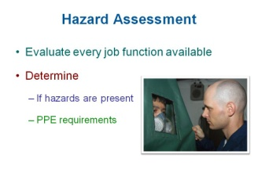

3. Assessment Documentation
OSHA requires certification proving that a workplace PPE hazard assessment has been completed by the employer. The certification must identify the following:
- Workplace
- Department
- Area or job function that was evaluated
- Person(s) who conducted and certified the hazard assessment
- Assessment completed
- The type of PPE that was selected to protect against the hazards identified during the assessment.

4. Employee Training
After the hazard assessment is completed and the specific PPE usage is determined, the employees who will be effected must be trained in the use, wear, and maintenance of PPE. Therefore, OSHA requires that employees:
- know when PPE is necessary to protect them against the hazards of their job,
- can demonstrate the proper use of PPE before starting a job requiring PPE,
- can determine what type of PPE will protect against the hazards of their job,
- understand PPE limitations such as knowing that regular sunglasses are not intended for welding or that leather work gloves will not protect against acids or caustic liquids,
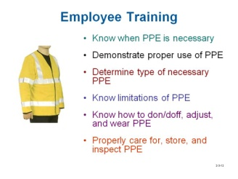

- be able to properly put on, remove, and wear the PPE that has been selected; PPE not worn properly cannot correctly protect the employee, and

- understand how to care for and store their PPE, how to inspect it for damage, and know when PPE should be discarded because it no longer functions correctly. PPE has limitations. Employees must know that a chemical glove will not protect against all chemicals or that bump caps will not protect against falling objects.

Additional training or retraining must occur when:

- changes in the workplace render the previous PPE obsolete,

- changes in the types of PPE render previous training obsolete, and/or

- the employee fails to wear, care for, and maintain PPE correctly.

The employer is required to maintain training documentation, certifying that each affected employee has received and understood the required training. This training documentation contains the name of the employee, the dates of training, and the subject of the training.

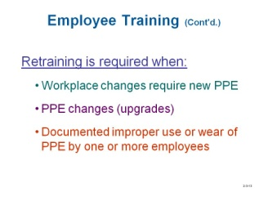

Review Questions

            - Who is responsible for ensuring that workers are safe in the workplace?
- OSHA
- Employers
- Production technicians
- All of the above

- The purpose of ______ is to evaluate the workplace to determine if employees are exposed to hazards
- the employee training program
- a hazard analysis
- PPE
- FIFO

- OSHA requires certification proving that a workplace PPE hazard assessment has been completed by ______.
- an OSHA official
- the employee
- the employer
- a third party consultant

- OSHA requires that employees who work in hazardous conditions be trained in the _______ of PPE.
- use
- wear
- maintenance
- All of the above

- Which function should be performed first?
- Performing a hazard assessment
- Completing the assessment documentation
- Providing employee training
- OSHA authentication

5. Eye and Face Hazards
Eyesight is one of our senses that enables an individual to perceive the size, shape, and color of objects. As a result, the information eyesight provides to the brain helps to process what is occurring in the environment around you.
One of the most important safety rules followed in the workplace is the requirement to protect the eyes from injury. When injuries do occur, a study revealed that three out of five workers suffering eye injuries were not wearing eye protection equipment. Also, if injuries did occur even when eye protection was being worn, half of those who got hurt were wearing the wrong type of safety eyewear. Unfortunately, many of these eye injuries result in permanent loss of sight.
Since the majority of eye injuries can be prevented by wearing appropriate protective eyewear and following basic safety rules, it is important to train workers on safe eye protection practices.

OSHA requires that, at a minimum, eye and face hazard assessments look for the following hazards:

- flying particles, such as wood chips from a saw or metal fragments from grinding, cause the majority of eye-related injuries by penetrating or cutting the eye;

- exposure to molten metal that might splash and damage the eyes or burn the face;

- liquid chemicals, a very common eye and face hazard;

- vapors or gases, many of which can cause eye redness or irritation; propane – used to power many forklifts – is very cold and can cause severe eye damage;

- caustic liquids and acids, which are especially dangerous because of the extreme damage they can do if the eyes and face are not protected; and

- “light radiation” injury, which refers to the bright light that comes from welding and cutting operations.

Eye injuries can also be caused by:
- Contact with objects, like pipes or blunt tools;

- Sharp or pointed tools, such as nail guns. Awls and screwdrivers which can puncture or scratch the eye;

- Welding hazards that produce and spew hot sparks;

- Laser hazards where non-ionizing radiation is emitted

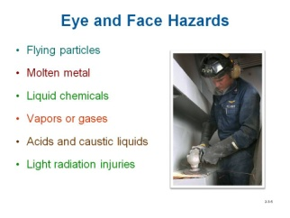

6. Eye and Face Protection
Various types of devices have been designed to protect eyes from harm, especially in various workplace conditions. All eye and face protection approved for use in the workplace will be marked “Z87”, which means that it has been designed according to the American National Standards Institute’s (ANSI) American National Standard Practice for Occupational and Educational Eye and Face Protection, (Z87.1-1989).

  - Specific Uses
Several types of safety devices are used to protect eyes and the face for different types of applications. Prescription street glasses, sunglasses and contact lenses are not included as safety wear because they do not provide adequate protection.

    - Safety glasses with side shields – designed to protect against the frontal or side impact of flying objects, such as metal fragments and wood chips. Their lenses are much stronger that the lenses of regular glasses.

    - Goggles – designed to protect the eyes from dust, liquid materials, mists, as well as chemical gases, fumes and vapors by fitting snugly. Goggles intended for dust may have a foam lining to make them more comfortable to wear and still keep out dust. Goggles intended for liquid chemicals must have a chemical-resistant seal that adheres to the technician’s face. To prevent fogging, these goggles have ventilation holes;

    - Face shields – designed to protect technicians from flying debris, hot slag, chemical splashes, and molten metal. The face shield selected must be appropriate for the hazard. A face shield intended to protect against flying particles, such as metal chips and particles from grinding, may not be suitable when working with molten metal. Also, they are devices that provide extra protection and therefore should not be worn alone. Instead, they should be worn with safety glasses underneath to ensure full protection.

    - Shaded filter lenses – worn to protect technicians from potentially harmful light radiation, such as from welding operations. Technicians exposed to this hazard need filter lenses with a shade number appropriate for the hazard.

    - Prescription safety glasses – these should be purchased and worn.

    - Eyewear for Laser Use – Exposure to powerful laser beams consisting of non-ionizing radiation can severely burn the retina and cornea of the eyes. Glasses with special lenses with filters should be used when working around lasers. These lenses are categorized based on the types of laser being used, such as Class 3b or Class 4.

    - Eyewear for Welding – When welding, both safety glasses and a shield should be worn. The glasses block the flying sparks from hitting the eyes, and the face shield screens the ultraviolet light (welding flash). A special lens is required to protect the eyes from the glare and radiation emitted by the arc. This lens can be placed on the shield or the safety glasses.

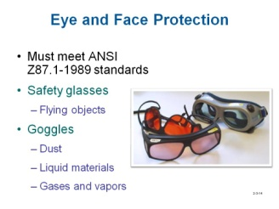

7. Wear and Care of Eye Protection

A. Wearing Eye Protection
It is the responsibility of the employer to assess the hazards on the workplace and then determine what types of equipment should be worn by employees. Then the employee should receive training on the proper use of the eye and face protection devices they will be required to wear. The following list provides some of the rules employees will learn about in their training:
  - Eye and face protection should fit comfortably. Eyewear should not pinch the nose or put pressure on the head. If it is not comfortable, employees are less likely to wear it.
  - Vision should not be blocked or distorted as this situation can increase the probability of an accident occurring.
  - Putting on, removing, and wearing eye protection requires common sense. Just remember to put it on before being exposed to the hazard. This seems like an obvious statement, but many eye injuries occur each year because the technician forgot to put on the eye protection before starting the job.
  - Clean equipment after each use. If exposed to dust or liquid chemicals when wearing goggles, be sure to clean the top rim of the goggles before removing them. This will prevent any accumulations of dust or chemicals from dripping or falling into your eyes when the goggles are removed.

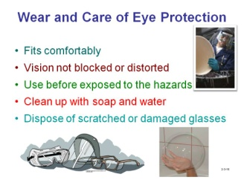

B. Caring for Eye Protection

  - Keep eye and face protection clean so your vision is not blurred or blocked.
Clean them with running water and air dry to prevent scratching. Soap and water is the most common way to clean eye and face protection. Special cleaning products that contain anti-fog chemicals can also be purchased.

  - Dispose of eye and face protection when it becomes scratched and distorts your vision or becomes otherwise damaged so it does not fit correctly or adequately protect against the hazard.

C. Additional Safeguards

  - If a workstation has a transparent safety barrier, always stay behind it while working.

  - When working with chemicals, refer to the Material Safety Data Sheet (MSDS) that may provide information on appropriate safety eyewear that should be used, chemical properties, and first-aid measures that should be followed.
  - Eye wash stations should be located near any facilities that use chemicals. If a chemical splashes in your eyes, quickly move to the station, look directly into the stream of water and hold your eyes open with your fingers. Flush for 15 minutes and then go immediately to get medical attention.

  - Use machine guards whenever available, such as on a grinding wheel where the sparks are blocked from flying.

  - Follow all posted safety rules and safety procedures.

8. Head Hazards
Head injuries can be relatively minor, or can be very serious by being fatal, or
causing the victim to become disabled by losing their cognitive functions.
OSHA requires that an assessment be conducted by the employer to look for head-related hazards in the workplace. The assessment must determine if the job exposes technicians to objects that could potentially fall from above. If employees work in an area where other technicians are above them, on catwalks or mezzanines, the potential for falling objects exists. Additionally, if employees are potentially exposed to electrical conductors, they must protect their heads with appropriate (i.e., non-metal) hard hats. Theses hats lesson injury because the outer shell and inner suspension work together to absorb impacts.

The following are the primary causes of head injuries:
- Falling objects
- Exposed electrical conductors
- Burn hazards
- Low-hanging obstructions, as when an employee walks or crawls under equipment to clean or perform maintenance
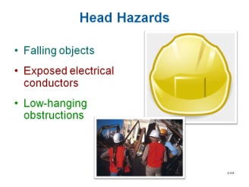

9. Head Protection Safety

Hard hats require a hard outer shell and a shock-absorbing lining. The lining should incorporate a head band and straps that suspend the shell from 1 to 1-1/4 inches away from the user’s head to provide shock absorption during impact and ventilation during wear. Protective helmets purchased after July 5, 1994, must comply with ANSI Z89.1-1986, whereas those purchased before this date must meet the ANSI Z89.1-1969 standard. Inside of any protective helmet, you should see a label showing the manufacturer’s name, the ANSI standard it meets, and its class.

NOTE: Helmets must be worn as designed to be in compliance with ANSI standards. Do not wear helmets backwards.

Employers must make sure that hard hats continue to provide sufficient protection to employees by training employees in the proper use and maintenance of hard hats, including daily inspection.

Remove hard hats from service if the suspension system shows signs of deterioration or no longer holds the shell away from the employee’s head. Also make sure the brim or shell is not cracked, perforated or deformed or shows signs of exposure to heat, chemicals, or ultraviolet light.

Limit use of paints and stickers, which can hide signs of deterioration in the hard hat shell. Paints, paint thinners, and some cleaning agents can weaken the shell of the hard hat and may eliminate electrical resistance.

There are many types of hard hats, all of which serve as the primary source of head protection. The two most common types follow.

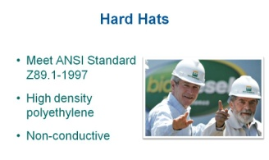

A. Types of Hard Hats

(1) The most common type of hard hat (ClassA/G) made of high-density polyethylene – it is lightweight, yet strong enough to protect the head from the impact and penetration of falling objects, and electrical hazards from lower voltages. Hard hats used in the workplace must be designed according to the ANSI Z89.1-1997 standard. Protective hard hats will be marked with “Z89” to show that they meet these standards.

(2) Non-conducting (Class B/E) hard hats – these are specifically designed to reduce electrical shock from higher voltages, such as power lines. Caution: Do not assume that a hard hat will protect against electrical hazards just because it is made of non-conducting material(s).

(3) Conductive (Class C) hard hats – These hats are designed to offer
protection from the force of impact and penetration by falling objects. They
are used when there is no danger from falling hazards.

Some of these hats are designed to accept attachments such as face shields,
hearing protection, winter liners, or lamps. To prevent the hat from providing all of
the protection it is designed for, always follow the manufacturer’s instructions

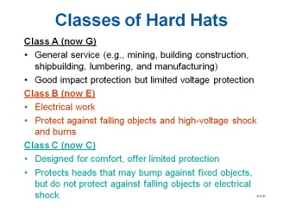

B. Hard Hat Wear and Care
Each worker required to wear a hard hat must receive training in the proper use of head protection, such as:

  - Head protection should fit comfortably. Hard hats are available with many different types of suspension systems (the webbing and strapping materials that hold the shell of the hat snugly to the wearer’s head). Employees should be trained on how to properly put on, take off, and adjust the suspension to ensure a proper fit.

  - Nothing should be worn under the hard hat (e.g., ball cap, sweater cap) as this can interfere with the fit and effectiveness of the hard hat.

  - Clean the hard hat regularly with soap and water. Scrub and rinse the shell with clear hot water (about 140 degrees).

  - Limitations of head protection.

  - Inspect hard hats before every use. Check for cracks or any other signs of damage that could weaken the hard hat. Inspect the suspension system for cracks, worn straps, or any other damage. Make sure the suspension system has been installed properly in the hard hat and not put on backwards.

  - Use hard hats for their intended purpose, which is to protect your head. Using hard hats as a seat or step stool may reduce their strength, rendering them inadequate for head protection.

  - Do not store the hat where it is exposed to sun for an extended period of time, such as under the rear window of a car. The ultraviolet rays from the sun can degrade the material the hat is made from. Signs of damage id dulling, chalking or flaking on the surface of the shell.

  - Do not paint or place decals on the hard shell because it can deteriorate when exposed to some types of adhesives and liquid chemicals.
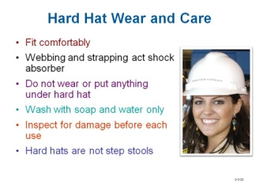

Review Questions

- PPE equipment marked “Z87” pertains to _____.
- hand protection
- body clothing
- head protection
- eye and face protection

- The primary use of _____ is to protect the eyes from flying particles.
- safety glasses
- goggles
- face shields
- Any of the above

- Face shields are often worn as additional protection over goggles or safety glasses, but should be worn as the primary eye protection.
True or False

- PPE marked “Z89” pertains to _____.
- hand protection
- body clothing
- head protection
- eye and face protection

- Class _____ hard hats protect against electrical hazards.
- A
- B
- C

- If the hard had fits comfortably, it is acceptable to wear a sweater cap underneath.
True or False

10. Foot Hazards
One of the most common hazards in the workplace is injury to the foot. Many of these injuries occur because no precautions are taken to protect them before the incident. Feet are subject to fractures, sprains, cuts, burns, punctures and frostbite when exposed to extremely cold temperatures. However, the most common source of foot injury is from heavy objects falling or rolling onto the foot.
OSHA requires that the employer assesses the hazards in the workplace to determine if and where foot protection is needed. For those employees who need foot protection, they should then be trained in the proper use of foot protection, such as:
- When to wear protective footwear
- What type of footwear to use for specific applications
- Protective footwear limitations
- How to inspect footwear
- How to care for and maintain footwear

Foot protection will depend on:
- The frequency of the employees’ exposure to foot injury
- The employer’s accident experience
- The severity of any potential injury that could occur

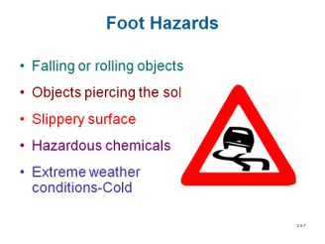

11. Foot Protection

There are 26 bones in the foot. Together, they support the weight of the entire
body. Whenever a foot is hurting, the entire body aches. Because we depend so much on the feet, it is important to keep them healthy and from injury.
In many workplace situations, there are different ways in which the foot can be injured. To prevent from hurt, there are different types of footwear available for different types of hazardous situations. The following information identifies
various types of footwear used to prevent harm from specific hazards.

- Types of Foot Protection

  - Steel-toed work boots or shoes protect against hazards such as falling or rolling objects. The upper part of the foot, the metatarsal, may also require protection from falling or rolling objects; therefore, boots may be purchased with metatarsal protection.

  - Footwear should also protect the ankle from rolling objects. Some footwear is made with steel in the heel and along the ankle to protect the ankle from twisting or becoming damaged.

  - Footwear is also available with puncture-resistant soles to prevent injury by stepping on something sharp.
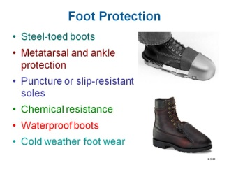

B. Wear and Care of Foot Protection

  - Just like everyday shoes, work footwear must be comfortable.

  - Footwear should be inspected before each use.

  - Employees should wear shoes or boots with slip-resistant soles when the workplace has wet or slippery floors.

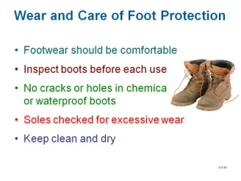

  - Employees exposed to liquid chemicals, acids, or caustics need appropriate chemical-resistant boots. The boot manufacturer can provide the necessary chemical-resistance information. Chemical-resistant footwear should be checked for holes or cracks.

  - Employees working in wet or muddy conditions should have water-resistant boots made of rubber or neoprene to keep their feet dry. Waterproof footwear should also be checked for holes or cracks.

  - Employees who work outside in cold climates, in refrigerated environments, or when production floor temperatures are cold, should wear footwear equipped with special insulated liners.

  - Soles, especially those that are slip- or puncture-resistant, should be checked daily for excessive wear.

  - Footwear should be kept clean and dry. Mud, dirt, or chemicals should be washed off after each use to keep the footwear in good condition.

12. Hand Hazards
The hand is the most used part of our body when manual labor in the workplace. In fact, one of the units in this safety course is titled “Handtools”, which is devoted to describing the proper use of these instruments that rely on hands to operate them. Because the hands are used so extensively, the likelihood of being injured is more probable than other parts of the body. The most common hazards to hands are:

- Mechanical Hazards
These types on injuries are usually caused by using handtools and machinery. The types of injuries that they cause are:
- Cuts or lacerations
- Abrasions
- Punctures
- Crushing

- Skin Absorption or Damage – The workplace must be evaluated to determine if employees’ hands are exposed to harmful substances that might be absorbed through, or damage, the skin. Harmful substances include, but are not limited to the following:

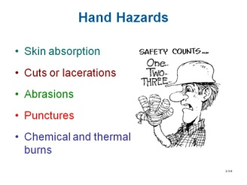
  - Liquid and solid chemicals

  - Fertilizers

  - Paints

  - Cleaners

- Environmental Hazards
These types on injuries are usually caused by exposure to extreme heat or cold, electricity, and materials handling.

13. Hand Protection

OSHA requires that the employer assesses the hazards in the workplace to determine if and where hand protection is needed. Employers should choose appropriate hand protection based on the tasks to be performed, conditions present, duration of use, and the actual hazards and potential hazards identified.

A. Types and Uses of Hand Protection

(1) Chemical-resistant gloves

    - Chemical-resistant gloves must protect against the specific chemicals being used. Gloves can be made of rubber, latex, Viton®, butyl, nitrile, neoprene, or PVC. They are graded by the manufacturer for deterioration, breakthrough time (the time between the initial contact of a chemical on the surface of a glove and the presence of the chemical on the inside of the glove), and permeation rate (the rate at which the chemical passes through the glove material once breakthrough has occurred). Manufacturers should provide a chemical-resistance chart.

    - Chemical-resistant gloves should also be evaluated for resistance to abrasions, cuts, punctures, and flexibility, and should be the appropriate length. For example, employees dipping hands and arms into chemicals will require gloves of the appropriate length.
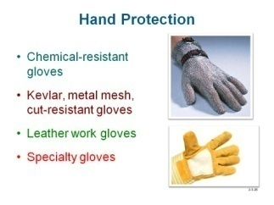

(2) Cut/puncture-resistant gloves
    - Employees working with saws, using knives, or handling glass should wear cut- or puncture-resistant gloves. Steel mesh gloves are effective when working with sharp blades. Some gloves have steel wires, staples, or small plates woven into the material. Materials such as Kevlar provide good cut resistance. Cut-resistant sleeves are also available to protect arms and shoulders.
    - The most common gloves used to protect hands from cuts and scrapes are typically made of leather or canvas and may also be coated with materials that improve grip.

(3) Cloth, leather, pigskin gloves

    - Employees who may be exposed to burns should wear gloves made of terry cloth, leather, or pigskin. Use heavy fabric or leather gloves to handle drums or stack pallets. Welders may also need sleeves, leather aprons and gloves, or other clothing to protect them from burns.

    - Employees working with ovens or other hot equipment need thermal mittens designed to protect against the maximum temperatures they will be exposed to. Technicians in foundries or steel mills need aluminized gloves.

    - Employees exposed to cold conditions need gloves with liners.

(4) Specialty gloves

    - Electricians need lineman gloves, which are designed to protect against different levels of voltage.

    - High-voltage gloves are black rubber with a red interior so any cuts or damage to the outside layer can be easily seen. Liners are worn under the gloves to absorb perspiration.
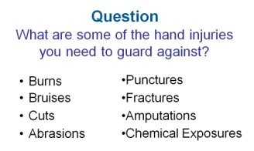

B. Wear and Care of Hand Protection
For those employees who need hand protection, they should then be trained in
the proper use of hand protection, such as:

(1) Comfort – hand protection should fit comfortably and should not be so tight that it limits hand movement or so loose that it presents a hazard of being snagged or reduces the employee’s ability to move freely.
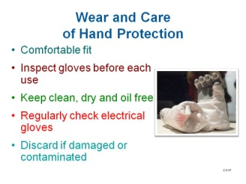

(2) Inspection – perform glove inspections before each use.

    - Inspect chemical gloves for cracks, holes, cuts, or other signs of damage.

    - Inspect cut-resistant gloves for cuts or wear.

    - Normal work gloves should be checked for unusual wear or other damage.

    - Electrician’s gloves should be checked for cuts or scrapes.

    - Aluminized, heat-resistant gloves should be checked for abrasions to the outside surface and damage to inner linings.

(3) Cleanliness – all gloves should be kept clean and dry. Chemical-
resistant gloves must be decontaminated after every use.

(4) Disposal – discard gloves if they are damaged or contaminated.

(5) Inspection – perform glove inspections before each use.

    - Inspect chemical gloves for cracks, holes, cuts, or other signs of damage.

    - Inspect cut-resistant gloves for cuts or wear.

    - Normal work gloves should be checked for unusual wear or other damage.

    - Electrician’s gloves should be checked for cuts or scrapes.

    - Aluminized, heat-resistant gloves should be checked for abrasions to the outside surface and damage to inner linings.

(6) Cleanliness – all gloves should be kept clean and dry. Chemical-
resistant gloves must be decontaminated after every use.

(7) Disposal – discard gloves if they are damaged or contaminated.

C. OSHA Requirements – At a minimum, a hand hazard assessment should look for the following:

  - Machines or equipment that could cause severe cuts or lacerations should have appropriate guarding.

  - Cutting equipment, such as saws or drills, which can cause severe injury if a hand is placed in the way of sharp surfaces or equipment edges.

  - Hand tools, such as box cutters, which can also cause cuts.

  - Straps or wires used in packaging boxes, which can cause lacerations if handled improperly.

  - Sanders, grinders, conveyor belts, rotating shafts (cams, flywheels), scrap metal, or broken glass, which can cause severe abrasions or cuts if the equipment is not guarded, or if items are handled with unprotected hands. Abrasions include mild skin scrapes, severe skin scrapes, skin tearing, and skin removal (called de-gloving).

  - Machines and tools – such as drills, nail guns, and screwdrivers, which can cause punctures. Even metal and wood slivers can cause deep punctures and infection.

  - Handling acids, caustics, and many cleaning chemicals, which can cause chemical burns. The severity of the burn depends on the concentration of the corrosive chemical.

  - Welding, cutting, and brazing operations, which can cause thermal burns. Boilers and other types of steam equipment with hot tanks and pipes can cause burns. Some industries use ovens for baking, drying, or annealing (the process of heating to change the strength or properties of a material), all of which present potential burn hazards.

  - Other hazards might include repetitive motion, or exposure to vibration.

Also, DO NOT wear gloves where they could get caught in moving machine parts

Review Questions

- Boots used in industry to protect against foot injury have _____.
  - steel toes to protect against faulty objects
  - steel heel and sides to protect the ankle
  - puncture resistant soles
  - Any of the above

- Steel-toed boots protect against _____.
- ankle strains
- punctures
- chemical spills
- falling or rolling objects

- Punctures usually occur from and object that penetrates to shoes _____.
- from the side of the foot
- by stepping on something sharp
- from the top of the foot
- by an object that is rotating

- The most common gloves used to protect hands from cuts and scrapes are typically made of _____.
- neoprene
- slippage
- leather
- steel mesh

- Gloves made of _____ are used to protect against chemicals being exposed to hands.
  - latex
  - canvas
  - leather
  - steel mesh

- Gloves used for working with high voltages are made of _____.
  - leather
  - rubber
  - thick canvas
  - latex

14. Hearing Protection
Hearing loss occurs gradually as we age. This loss is accelerated by an increase of the frequency and amplitude of load noises, especially those often encountered in the workplace from various types of machinery. Noise induced hearing loss is caused by sound power levels greater than 85 decibels average over an eight-hour period.
Protection PPE equipment should be worn whenever sound levels make communication difficult or where warning signs are posted.
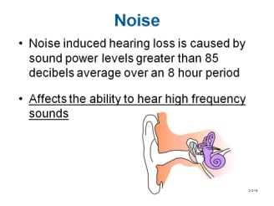

A. Types of Hearing Loss – When describing hearing loss, we generally look at three attributes: type of hearing loss, degree of hearing loss, and the configuration of the hearing loss. Hearing loss can be categorized by where or what part of the auditory system is damaged. There are three basic types of hearing loss:

(1) Conductive hearing loss – a condition that interferes with the transmission of sound through the outer and middle ear to the inner ear.

(2) Sensorineural hearing loss – more commonly referred to as “nerve deafness” and caused by damage to the inner ear, acoustic nerve, or both.

(3) Mixed hearing loss – involves two or more types of hearing impairment, such as when conductive and sensorineural hearing loss are present in the same ear.

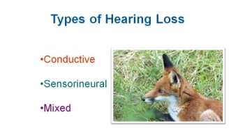

Generally, hearing loss affects the ability to hear high frequency sounds.

- Types of Hearing Protection
Hearing protection includes ear plugs and earmuffs that are intended to reduce the intensity or loudness of sound. Be sure they fit properly and that the seals are tight.

(1) Ear plugs – these come in various pre-made shapes and sizes; they can also be custom-made by taking an impression of the ear. Typically the plugs are placed into the ear canal so they totally block the canal, thereby reducing noise levels by 15-30 decibels (dB), depending on how they are made and fit.

(2) Ear muffs – these fit completely over both ears. They must fit tightly so sound is blocked. Like earplugs, muffs can reduce noise levels by 15-30 dB, depending on how the plugs are made and fit.

(3) Ear plugs and ear muffs – can be used together to achieve even greater sound reduction. Use of ear plugs and ear muffs in combination is recommended when noise exposure is particularly high.

(4) Cotton – since cotton can only reduce noise levels by 5-7 dB, it is not considered appropriate ear protection.

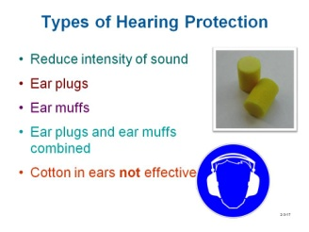

Visit the following URL to learn more about face and ear protection:

https://www.wisc-online.com/LearningContent/mtl2502/MTL2502/MLT2502.htm

15. Clothing
OSHA does not have specific assessment criteria for hazards to the body, arms, legs, etc. However, being aware of the following issues will help evaluate jobs that pose potential hazards so employers can properly select the type of clothing that employees can and cannot wear to work.

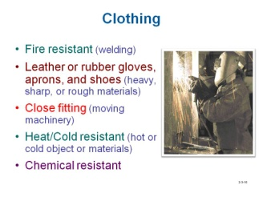

- Welders often need to wear fire resistant clothing, such as leather aprons and leather welding gloves, to prevent burns from the sparks generated by welding operations.

- Employees who work with heavy, sharp, and rough materials or objects, and are subject to cuts or abrasions on the body, arms, or legs, often wear aprons, gloves, and shoes made of leather or rubber.

- Technicians operating moving machinery should not wear loose clothing that may get caught in the machinery.

- Employees who work around, or with, hot or cold materials and objects are subject to skin damage. Employees who work around steam lines or in refrigerated environments may need protective equipment or clothing.

- Employees who work with chemicals may need to wear protective clothing, in addition to protective gloves, boots, and eyewear.

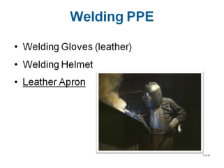

16. General Work Clothing Guidelines
There are some general guidelines regarding clothing that should be followed to prevent
injury.

- Long-sleeve shirts and long pants protect against skin damage resulting from contact with hot or cold objects and sharp or rough materials, such as wood or metal.

- Loose clothing and jewelry are prohibited for employees exposed to moving machinery because the machinery might grab loose sleeves, ties, lapels, cuffs, watches, bracelets, or rings and pull employees into machines.

- Employees working in cold environments should wear coats and pants that are made for cold weather conditions.
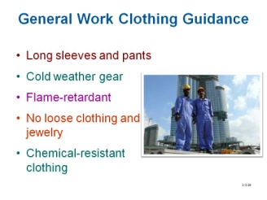

- Welders and grinders should wear flame-retardant clothing.

- Employees working with chemicals should wear appropriate chemical-resistant clothing that protects against the specific chemical they are using.

Review Questions

- Sound levels greater than _____ decibels over an eight-hour period can cause hearing loss.
  - 7
  - 15
  - 30
  - 85

- _____ hearing loss involves two or more types of hearing impairment present in the same ear.
  - Conductive
  - Sensorineural
  - Mixed
  - Accuneural

- Generally, hearing loss affects the ability to hear _____.
  - low frequency sounds
  - high frequency sounds
  - music
  - if something breaks on a production machine

- Welders should use gloves and aprons made of _____ to protect them from being burnt.
  - rubber
  - canvas
  - leather
  - materials with liners

- _________ should not be worn when exposed to moving machinery.
  - Loose clothing
  - Jewelry
  - Long hair or ponytails
  - Any of the above

17. Respiratory Hazards
Whenever ventilation or other engineering controls are not adequate to keep the air that employees are breathing safe, a respirator is capable of protecting the lungs from harm.
Employers are required to establish a program to protect their respirator-wearing employees from injuries that can result in lost time and adverse long-term health hazards. Currently, over five million respirator wearers work in an estimated 1.3 million general industry, construction, shipyard, longshoring and marine terminal workplaces. Respiratory protection training is essential to meeting this goal.

A. Respiratory Basics – During respiration, oxygen and carbon dioxide gases are exchanged between the atmosphere and the body. The respiratory system combines with the circulatory system (the heart and blood vessels) to help deliver life-giving oxygen to the cells of the body. Since the respiratory system is a complex one, we will limit the respiratory discussion in this lesson to the lungs.
As Figure 3-1 portrays, each time you inhale, air, which contains oxygen,
passes into the lungs. Oxygen in the blood is delivered to the body’s cells,
through the alveoli, which are tiny sacs in the lungs. The oxygen and glucose in
the cells undergo a series of reactions to provide energy to cells. When you
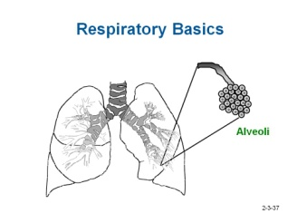

Figure 1

exhale, the waste product (carbon dioxide) of the reactions in the cells is carried out of the lungs through the alveoli.

Visit the following two URLs to learn more about respiratory basics:

http://www.wisc-online.com/objects/viewobject.aspx?id=AP15104
http://www.wisc-online.com/objects/viewobject.aspx?id=AP2404

B. Types of Respiratory Hazards
There are several types of contaminants in the air that can cause harm to a person breathing it, which includes:
(1) Gases –generally used in a compressed form. Chemical processes and high heat can release them. Gases can affect all routes of entry.
(2) Vapors – formed by evaporation of liquids or solids. The amount usually depends upon exposed surface area, temperature, and vapor pressure. Many vapors can be deadly.
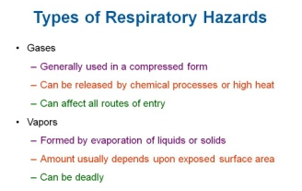

(3) Fumes – can be metallic and formed by welding, cutting, or brazing operations. These types of fumes are extremely hazardous to inhale.

(4) Air particulates – can be comprised of solid or liquid particles that are suspended or dispersed in air. Particulates can be explosive and hazardous to breathe.
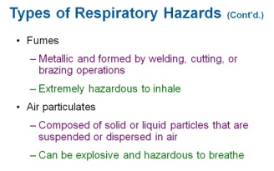

(5) Atmospheric hazards – may expose employees to risk of death, incapacitation, inability to self-rescue, injury, or acute illness from one or more of the following causes:

    - flammable gas, vapor, or mist exceeding 10% lower exposure limit (LEL),

    - airborne combustible dust in excess of the LEL,

    - oxygen concentration – by volume – in the air below 19.5%,

    - oxygen concentration – by volume – in the air above 23.5%,

    - concentration of any substance exceeding the PEL, or

    - other atmospheric conditions considered Incident Dangerous to Life or Health (IDLH).

Note: The normal oxygen concentration – by volume – in the air is 21%

Note: An IDHL level poses an immediate threat to life, causes irreversible adverse health effects, or impairs an individual's ability to escape from a dangerous area.

18. Types of Respirators
There are three categories of respirators. The one that is used is determined by the type of contaminant that is in the air. They include
- Air-purifying
- Supplied-air
- Self-contained breathing apparatus

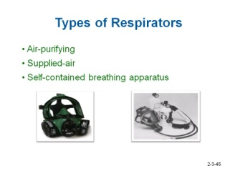

A. Air-Purifying Respirator (APR) – The APR is used where there is enough oxygen present but the air is contaminated with gases, vapors, or dust. These respirators filter out dangerous materials or divert air through a chemical filter. They do not produce oxygen.

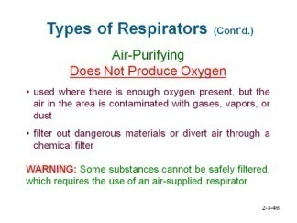

(1) Mechanical-filter respirators:
    - remove particles from the air,
    - may have disposable filters for dust, or
    - may have a half-face or full-face facepiece.

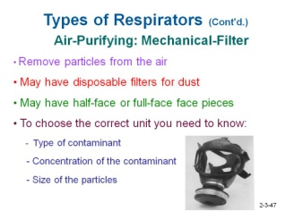

(2) Chemical cartridge respirators are used for low concentrations of organic gases, pesticides, or paint vapors. In addition, they:

    - may have a half-face or full-face facepiece,

    - must be correct for type of contaminant (types of cartridges vary),

    - should only be used with contaminants with warning odor or irritation, allowing the wearer to be aware of a cartridge failure, and

    - are not for use against highly toxic gases.
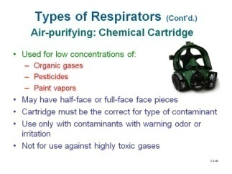

(3) Gas-mask respirators:

    - protect against certain gases and particles, and

    - usually have full-face facepieces and chin-mount canisters.

(4) Powered air-purifying respirators are usually hooded and:

    - protect against certain gases and particles,

    - have a battery-powered motor that draws air through the filter.

To choose the correct unit you must know the type of contaminant, concentration of the contaminant, and the size of the particles.
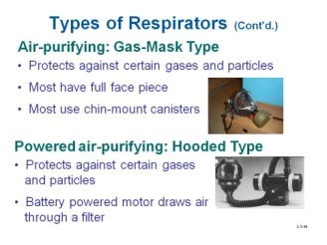

B. Supplied-Air Respirators – The SAR is used whenever there is not enough oxygen and the concentration of the airborne substances present is not IDLH. All respirators must be approved for the contaminant for which the employee is exposed to. Approval is decided jointly by the NIOSH and the Department of Labor’s Mine Safety and Health Administration.

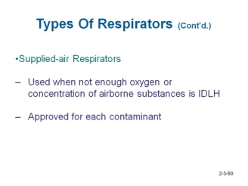

C. Self-Contained Breathing Apparatus – The SCBA uses a source of breathable air carried by the wearer. Although this greatly enhances the mobility of the wearer, it limits the duration of protection. At a moderate work rate, using approximately 40-liters per minute volume, most SCBA units have a duration time of 30-60 minutes. An SCBA consists of the following:

  - facepiece,

  - breathing tube,

  - air supply tube,

  - regulator,

  - exhalation valve, and

  - air cylinder and valve.

These respirators should be inspected monthly, and air cylinders should be kept fully
charged.

WARNING Some substances cannot be safely filtered. In those cases, you are required to wear an air-supplied respirator.
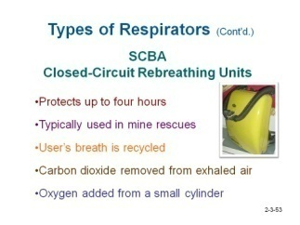
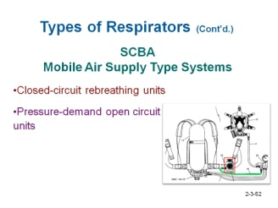

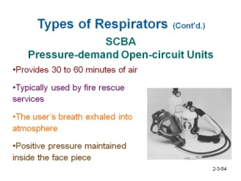

It is the responsibility of the employer to select the proper respirator to match its
capabilities and limitations so that it will protect the employee from the hazards on the
job. All respirators in the workplace must be certified by the National Institute for
Occupational Safety and Health (NIOSH) and must be used as they are intended to be
used.

Review Questions
- The concentration of oxygen in the air that is required for humans to safely breathe is ___ percent.
  - 100
  - between 96-98
  - between 87-92
  - between 19.5-23.5

- The OSHA PEL allows workers to be exposed to harmful air if it is under a certain level.
True or False

- The alveoli in the lungs are cells that transmit _____.
  - oxygen to the blood
  - waste to the lung for exhalation
  - Both A and B
  - Neither A or B

- ______ are formed by evaporation of liquids or solids.
  - Fumes
  - Gases
  - Vapors
  - Condensation

- Mechanical-filter respirators filter out _____.
  - dust
  - gases
  - vapors
  - All of the above

- There are some air-purifying respirators that use a cartridge that will filter out all types of chemical contaminants. True or False

- An air-supplied respirator is used when the _____.
  - oxygen level in the industrial environment is too low
  - level of chemicals in the environment is too high
  - Either A or B

- The _______ has its own source of air.
  - SAR
  - Self-contained Breathing Apparatus
  - APR
  - cartridge filtered canister

19. General Respiratory Protection Program Requirements

A. Employer Responsibilities – As part of a general respiratory protection
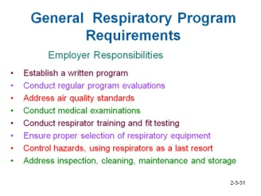
program, an employer must:

B. Respiratory Protection Training Requirements – Per OSHA requirements, employers must establish training programs that establish proficiency. At a minimum, respiratory protection training for employees must be conducted prior to a job assignment and should explain:

  - The operation, capabilities, and limitations of the equipment involved

  - The reason why respiratory protection is required

  - Why a particular respirator has been selected

  - Proper maintenance and storage of respirators

  - Inspection, donning, fit checks and proper wear

  - The nature, extent and effects of respiratory hazards

20. Inspection of Respiratory Equipment
After employees are properly trained to use respiratory equipment, it is their responsibility to follow certain procedures to ensure they are protected, such as:

A. Inspection Before Use
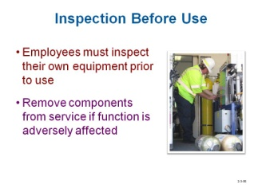

  - If equipment is found to be damaged or unusable, tag the equipment and keep it separated from in-service respirators.

  - Inspect equipment before each use (without exception).

  - Consider the effects (e.g., dry rot to rubber seals, cracked breathing tubes, and expired canisters) on equipment stored for long periods of time.
Question: What components of the respirator should be inspected to ensure that they are working properly?
Answer:
    - Inhalation valves • Head straps
    - Exhalation valve • Faceplate
  - Remove contaminated equipment from service immediately.

B. Fit and Comfort – Before use, the individual must assess the fit and comfort of the unit, which includes checking for:

  - position of the mask on the nose,

  - room for eye protection, and to be able to talk

  - position of mask on face, chin and cheeks,

  - make sure facial hair or sideburns do not impede sealing the surface of the mask and skin

  - adequate strap tension, not too loose or overly tightened,

  - fit across the bridge of the nose,

  - proper size to span distance from nose to chin,

  - tendency of respirator to slip, and

  - self-observation in a mirror to evaluate fit and respirator position.

  - The ultimate fit test is to perform exercises while wearing the respirator
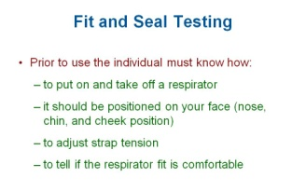

Question: How often should your respirator be fit-tested?
Answer: Once every calendar year.

Question: Why every year instead of 3 to 5 years?
Answer: People lose or gain weight; their faces may change from the weight difference. Medical conditions change from year to year. Accidents may change the sealing surface of the face.

C. Pressure Checks – Once the user has determined that the unit fits properly and is comfortable, s/he should perform the OSHA required positive and negative pressure checks or the respirator manufacturer’s recommended seal check method. This kind of pressure check is not a substitute for the qualitative or quantitative fit tests described below.

(1) Positive pressure check

    - Close off the exhalation valve and exhale gently into the facepiece.

    - The face fit is considered satisfactory if a slight positive pressure can be built up inside the facepiece without any evidence of outward leakage at the seal. For most respirators, this method requires the wearer to first remove the exhalation valve cover before closing off the exhalation valve and then carefully replacing it after the test.
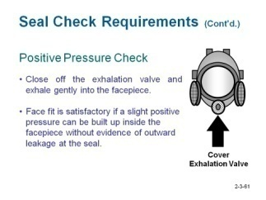
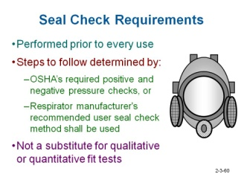

(2) Negative pressure check

    - Close off the inlet opening of the canister or cartridge(s) by covering with the palm of the hand(s) or by replacing the filter seal(s).

    - Inhale gently so the facepiece collapses.

    - Hold breath for ten seconds.

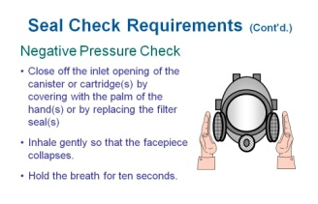

D. Qualitative and Quantitative Testing – These are two methods of testing that the respirator fits and seals properly so when the wearer is exposed to hazardous agents in the atmosphere s/he will be protected. Fit testing must be done prior to using a respirator so you can determine if a proper seal has been achieved while you are in a safe environment, before you are exposed to hazardous elements. Performing a fit test ensures that the mask does not leak, which in turn, ensures your safety.

(1) Qualitative fit testing – These procedures rely on a subjective sensation (taste, irritation, smell) of the respirator wearer to a particular test agent. It is a pass/fail fit test to assess the adequacy of a respirator fit that relies on the individual’s response to the test agent. The qualitative fit test is also referred to as the “gas chamber test.” This type of test is used in the military, and by police and fire departments to enforce the importance of wearing gas masks. OSHA sets forth mandatory procedures for conducting qualitative fit testing. This testing is required upon issue of respiratory equipment. Only irritant smoke or banana oil can be used for the test. Before being released from the test, the participant must recite a standard phrase, count backward from 100, or perform some other task to prove that they are not being affected by the test agent.

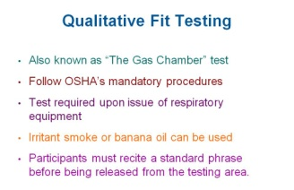

(2) Quantitative fit testing – Per OSHA’s mandatory procedure, a quantitative fit test is an assessment of the adequacy of respirator fit by numerically measuring the amount of leakage into the respirator. This test measures the concentration of irritant inside the mask using instrumentation and personnel responses.
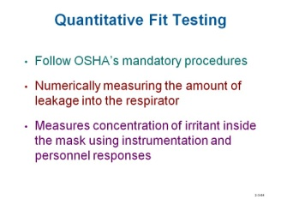

Question: What is quantitative fit testing?
Answer: An assessment of the adequacy of respirator fit by numerically measuring the amount of leakage into the respirator

The ultimate evaluation is to use a chemical agent to perform determine if the respirator is working properly.

27. Cleaning and Disinfecting Considerations
To ensure that the life of the respirator is prolonged and does not deteriorate, it is
important to clean and store it properly. Also, cleanliness is needed to keep it sanitized.

A. Cleaning the Respirator – Scrub respirators in detergent and warm water. Treat with disinfectant (only if recommended by manufacturing guidelines). Rinse thoroughly to remove detergent and disinfectant. Air-dry, do not dry rubber under heat or sunlight. Never use solvents to clean plastic or rubber. Note: For SAR and SCBA units consult the manufacturer’s guidelines for cleaning and disinfecting procedures.
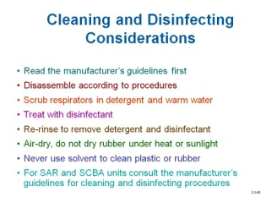

Question: Why are some solvents not appropriate to use when cleaning a respirator?
Answer: Solvents can deteriorate the rubber, causing it to be ineffective when stretched over head or making a seal to the face.

B. Storage Considerations

- Protect the respirator from sunlight, heat, cold, moisture, dust, and chemicals, as these elements can cause many of the components to become brittle and crack, rendering the unit unserviceable.

- Place respirators in individual, sealable plastic bags to protect them from dust and light, and store it in a way that the natural shape is retained.

Question: What effect do ultraviolet rays have on rubber products?
Answer: They dry out the rubber and make it brittle, causing it to crack when stretched over the wearer’s head.

Review Questions

- A respirator should be fit-tested _____.
  - Once every year
  - Only when the user feels it needs to be done
  - Once every 3 years
  - only once

- ______ is primarily responsible for inspecting respirator equipment on a regular basis.
- OSHA
- The employer
- The employee
- All of the above

- A _____ pressure check involves closing off the exhalation valve and exhaling gently into the facepiece.
  - negative
  - positive
  - Both A and B
  - Atmospheric

- _____ is an assessment of the adequacy of respirator fit by numerically measuring the amount of leakage into the respirator.
  - Qualitative fit testing
  - Quantitative fit testing
  - Negative pressure testing
  - Positive pressure check

- The best way to clean plastic or rubber is by using solvents. True or False

Summary

Your safety is your employer’s number one priority. To this end, your ability to assess existing hazards, and take appropriate action to reduce the risk to you and your co-workers, is the most valuable tool you can bring to the workplace. Selecting the right tool for the job includes selecting the correct personal protective equipment, knowing how to identify it for function and use, inspecting it for wear and comfort, and maintaining it for future use are key safety skills.

Per OSHA standards, a company must establish a written respiratory protection program. Training shall consist of knowing how to properly fit a respirator, how to check the seal to one’s face, and what to expect if a respirator does not achieve a proper fit. The respiratory program must be evaluated each year to keep up with changes in the industry, new technology, and safety regulations/standards.

Unit Chapter 3 Questions/ Chapter 3 Test
            - _____ is the cause of the greatest number of eye injuries.
- **Flying particles
- Liquid splashes
- Vapors or fumes
- Light radiation

- The primary use of _____ is to protect the eyes from dust, liquids, gasses and vapors.
              - safety glasses
- ** goggles
- face shields
- Any of the above

- Eye protection with a shaded filter lens is used for _____ applications.
              - photography
              - ** welding
              - foundry
              - laser cutting

- Generally, hearing loss affects the ability to hear _____ frequencies.
              - low
              - midrange
              - ** high
              - ultrasonic

- All hard hats made of a non-conductive material will protect against electrical hazards.
              - True
- ** False

- Specifically-designed PPE footwear used by workers in industry can be purchased with which of the following features?
              - steel toes
- slip-resistant soles
- steel heels
- metatarsal protection
- ** Any of the above

- Gloves made of _____ are used to protect against sparks from welding.
              - latex
              - canvas
              - ** leather
              - rubber

- Cleaners, fertilizers, chemicals and paints can _____.
              - damage the skin
              - be absorbed through skin
              - ** Both a and b
              - Neither a or b

- A workplace PPE hazard assessment document identifies the _____.
              - department
              - job functions that was evaluated
              - person who conducted the assessment
              - ** All of the above

- Work gloves made of leather protects against acids and caustic liquids.
              - True
- ** False

- Eye wash stations should be located near any facilities that use ______.
- ** chemicals
- dust
- vapors
- abrasive particles

- _____ hearing loss, more commonly known as nerve deafness is caused by damage to the inner ear, acoustic nerve, or both.
              - Conductive
- ** Sensorineural
- Accuneural
- Mixed

- Some ear plugs can reduce noise levels the same amount as ear muffs.
- ** True
- False

- Class _____ hardhats protect the head against impact and penetration of falling objects.
- ** A
- B
- C
- D

- A class _____hardhat is designed for comfort and protects the head from minor impact.
              - A
              - B
              - ** C
              - D

- PPE marked with _____ pertains to head protection.
              - Z87
              - Z88
              - ** Z89
              - Z09

- The soles of industrial boots and shoes are designed to be ______.
              - slip-resistant
              - puncture-resistant
              - ** Both a and b
              - Neither a or b

- Most foot injuries can be prevented by wearing shoes that _____.
              - have insulated liners
              - are chemical resistant
              - have puncture and slip resistant soles
              - **have steel toes

- Employees who work with heavy, sharp and rough materials or objects should wear aprons, gloves, and shoes made of ______.
- leather
- rubber
- heavy canvas
- **Either a or b

- All respirator and filtering facepieces used in the workplace must be certified by _____.
              - OSHA
- **NIOSH
- the EPA
- IDLH

- Gasses are ______.
              - Small particles of solids or liquids suspended and dispersed in air.
              - formed by the evaporation of solids or liquids.
              - often created by cutting, welding, or brazing of metallic materials.
              - ** formed by chemical processes or high heat.

- What components of a respirator should be inspected before being used?
              - Inhalation valves
              - Exhalation valves
              - Head straps
              - ** All of the above

- An APR is used when there is enough oxygen by filtering out the air that contains harmful _____.
              - gases
              - vapors
              - dust
              - **All of the above

- A _____ seal check performed on a respirator involves exhaling while blocking the exhalation valve.
              - negative
- ** positive

- The _____ respirator fit testing procedure, also known as the “gas chamber test”, relies on taste, irritation, or smell of the wearer while the test is conducted.
- ** qualitative
- quantitative

Review Question Answers

1. D
2. B
3. C
4. D
5. A
6. D
7. A
8. True
9. C
10. B
11. False
12. D
13. D
14. B
15. C
16. A
17. B
18. D
19. C
20. B
21. C
22. D
23. D
24. True
25. C
26. C
27. A
28. False
29. C
30. B
31. A
32. C
33. B
34. B
35. False

SAFETY DISCLAIMER:
M-SAMC educational resources are in no way meant to be a substitute for occupational safety and health standards. No guarantee is made to resource thoroughness, statutory or regulatory compliance, and related media may depict situations that are not in compliance with OSHA and other safety requirements. It is the responsibility of educators/employers and their students/employees, or anybody using our resources, to comply fully with all pertinent OSHA, and any other, rules and regulations in any jurisdiction in which they learn/work. M-SAMC will not be liable for any damages or other claims and demands arising out of the use of these educational resources. By using these resources, the user releases the Multi-State Advanced Manufacturing Consortium and participating educational institutions and their respective Boards, individual trustees, employees, contractors, and sub-contractors from any liability for injuries resulting from the use of the educational resources.

DOL DISCLAIMER:
This product was funded by a grant awarded by the U.S. Department of Labor’s Employment and Training Administration. The product was created by the grantee and does not necessarily reflect the official position of the U.S. Department of Labor. The Department of Labor makes no guarantees, warranties, or assurances of any kind, express or implied, with respect to such information, including any information on linked sites and including, but not limited to, accuracy of the information or its completeness, timeliness, usefulness, adequacy, continued availability, or ownership.

RELEVANCY REMINDER:
M-SAMC resources reflect a shared understanding of grant partners at the time of development. In keeping with our industry and college partner requirements, our products are continuously improved. Updated versions of our work can be found here: http://www.msamc.org/resources.html.

