Unit 1- OSHA Standards and Inspections
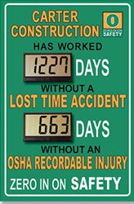- 1 -

LEARNING OBJECTIVES:

- Examine the purpose of OSHA.

- Identify the elements of the OSHA Program.

- Describe employer and employee duties and responsibilities under OSHA.

- Discuss the elements of the OSHA General Duty Clause.

- Describe how OSHA determines which facilities to inspect.

- Discuss how facilities prepare for inspections.

- Describe the inspection process.

- Discuss the inspection process, how the inspection will be concluded, what happens if a citation is given and/or penalties assessed, and what actions are required to abate violations.

ALLOTTED LEARNING TIME:
7 days

Orientation to Safety Awareness
The Occupational Safety and Health Administration (OSHA) has been in existence since 1971. In this unit the history of OSHA will be discussed along with its mission, how OSHA develops and enforces safety standards, how the agency determines which workplaces to inspect, and OSHA’s impact on the workplace. The General Duty Clause of the Occupational Safety and Health Act of 1970 will also be covered, which is a key part of the foundation of all that OSHA has built and established in terms of guaranteeing a safe and healthful workplace.
Finally, information about what to expect, how to prepare a workplace facility, and how to assign key personnel critical assignments for an OSHA inspection, will be provided.

1. Introduction
On December 29, 1970, President Richard Nixon signed the Occupational Safety and Health Act. Known initially as “the safety bill of rights,” the Act established three government agencies and charged them with ensuring safe and healthful conditions for working men and women.
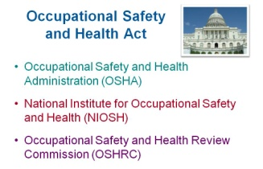

Occupational Safety and Health Administration (OSHA) – OSHA was established within the Department of Labor and was charged with setting and enforcing workplace safety and health standards.

National Institute for Occupational Safety and Health (NIOSH) – The NIOSH was established as part of the Department of Health on to conduct research occupational safety and health.

Occupational Safety and Health Review Commission (OSHRC) – The OSHRC was established as an independent agency to act as a judge when enforcement actions by OSHA are challenged by employers.

Review Questions
- The agency that conducts research on occupational safety and health.
- OSHA
- NIOSH
- OSHRC
- CSHA

- The agency that enforces workplace safety is _____.
- OSHA
- NIOSH
- OSHRC
- CSHA

- The agency that acts as a judge when enforcement action by OSHA are challenged by employers.
- OSHA Justice Division
- NIOSH
- OSHRC
- CSHA

- The _____ agency is part of the Department of Health.
- OSHA
- NIOSH
- OSHRC
- CSHA

2. Background Information
The number of worksites covered by OSHA has more than doubled from 3.5 million in 1971 to 8.9 million in 2007. U.S. employment increased from 56 million in 1971 to 135 million in 2007. In 1970, it was estimated that over 13,000 workers were killed due to illness or injury caused by unsafe working conditions.

By 2008, fatalities in U.S. workplaces had been reduced by more than 60 percent to approximately 5,071. These dramatic reductions in occupational fatalities, injuries, and illnesses have occurred despite a dramatic increase in the number of employees and worksites covered by OSHA. Federal OSHA oversees 26 state-run OSHA programs within the U.S., Puerto Rico, and the Virgin Islands. These states and jurisdictions have decided to develop and operate their own OSHA programs. The state programs must meet certain federal OSHA requirements and implement safety standards that are equal to or more effective than the federal safety standards.

3. OSHA’s Mission
OSHA’s current mission is “to assure safe and healthful working conditions for working men and women; by authorizing enforcement of the standards developed under the Act; by assisting and encouraging the States in their efforts to assure safe and healthful working conditions; by providing for research, information, education, and training in the field of occupational safety and health.”

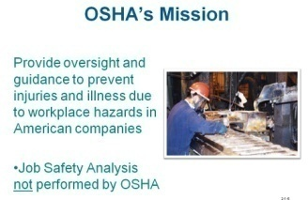

4. OSHA’s Strategies
OSHA has developed a number of strategies to help further reduce workplace injuries, illnesses, and deaths. These include:
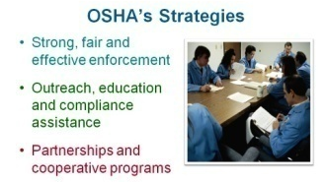

Strong, Fair, and Effective Enforcement – The foundation for the protection of the safety and health of the nation’s workforce is enforcement. A strong, fair and effective program, it works with employers seeking to comply with OSHA standards. This enables OSHA to allocate much of its enforcement resources on hazardous industries where illness and injury rates are still above the norm.

Outreach, Education, and Compliance Assistance – OSHA actively pursues outreach and education programs geared towards providing compliance assistance to employers. It does this with a portfolio of approaches such as interactive e-tools to address specific hazards, print and online publications, a toll-free call center (available twenty-four hours a day, seven days a week) and free workplace consultations. These services are available in both English and Spanish. For more information on OSHA, please visit www.osha.gov.

Partnerships and Cooperative Programs – Using OSHA’s Alliance Program the industrial-educational community can collaborate to reduce and prevent illness and injuries. The Strategic Partnership Program is a long-term cooperative effort that addresses improved workplace safety and health. Both the Safety and Health Achievement Recognition and Voluntary Protection Programs are incentive and/or recognition-based efforts that target exemplary achievement in safety and health.

5. OSHA Inspections
OSHA continues to conduct inspections and issue penalties to employers that do not have adequate safety and health programs.
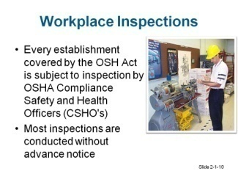

- What Prompts an Inspection? – Each year, inspectors from both federal and state OSHA offices inspect thousands of companies and issue thousands of violations that carry millions of dollars in penalties. Several events can prompt an OSHA inspection, including:

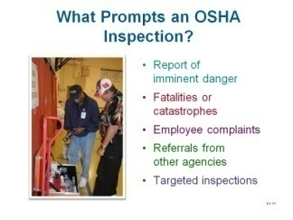

(1) Report of imminent danger at a workplace – An OSHA inspector promptly inspects the workplace to prevent a possible death or serious injury.

(2) Fatalities or catastrophes – An event where multiple people are hospitalized also prompt an OSHA inspection. Employers are required to call OSHA within eight hours of an incident where a fatality occurred, and which involved the hospitalization of three or more employees. Some states require companies to report if only one or two people are hospitalized.

(3) Employee complaints – If an employee contacts OSHA to report a complaint, an inspection will be quickly initiated. Sometimes the agency will merely write a letter, requesting information from the employer. If the agency is satisfied with the reply they receive from the employer, no further action will be taken; otherwise an inspector will visit the business.

(4) Referrals – Referrals from other government agencies or other inspectors will prompt inspections.

(5) Targeted inspections – OSHA has programs that track accidents, injuries, and illnesses. The agency uses this information to target facilities in high hazard industries or individual facilities that have a high injury and illness rate.

- OSHA’s strategy is to use site-specific data to profile and then target workplaces where most of the injuries and illnesses occur. OSHA would rather focus its enforcement actions on facilities that are on this high hazard list rather than on companies that appear to have good safety records.

- OSHA has also conducted data collection initiatives in order to develop these hazard profiles for specific workplaces. Data used might include OSHA recordable accidents, history of accidents, costs of workers’ compensation, employee complaints, etc.

- OSHA has limited resources and limited Compliance Safety and Health Officers (CSHOs) and cannot inspect every workplace that is required to comply with OSHA regulations.

- OSHA has selected certain industries, on the basis of Standard Industrial Classification (SIC) codes, with high time-loss injury-incident rates or that have a history of a large number of OSHA citations from past inspections.

Review Questions
- To reduce workplace inquiries, illnesses and death, OSHA has developed which strategy?
- Enforcement
- Education
- Partnership and cooperative programs
- All of the above

- Which type of event prompts an OSHA inspection?
- A report of imminent danger at a workplace
- A fatality or catastrophe at a workplace
- An employee complained
- All of the above

7. OSHA conducts targeted inspections based on companies where _____.
- most of the injuries and illnesses occur.
- there is many employee complaint reports
- there is a high number of OSHA citations
- All of the above

8. A CSHO is a _______ _______ _______ _______.

B. Preparing for an Inspection – When a CSHO from an OSHA office enters your business, you may feel and/or find yourself and your company unprepared. The strength of these feelings will depend on the quality of your company’s safety program. If your safety program requires improvement, your misgivings may be justified. However, if you have an effective safety program, you may see the inspection as an opportunity to demonstrate your hard work and commitment to safety.
Ultimately, the best form of preparation for an inspection is to have a quality, comprehensive safety program that involves all employees and provides evidence to the CSHO that your company is committed to improving the safety and health of your workplace.

(1) OSHA Inspection Action Plan (IAP) – Now that you know why OSHA might select your facility for an inspection, you should take steps to prepare your facility and personnel. Having an IAP in place will help your company successfully manage an OSHA inspection. To ensure that the inspection is successful, the IAP should focus on three key areas:
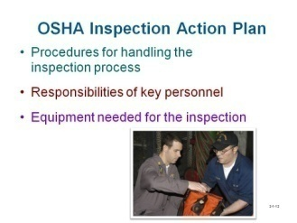

How will your company manage the inspection process?
      - Who will be called when the CSHO arrives? And when the inspection goes smoothly?
      - Where is the paperwork the CSHO may ask for?
      - By which route will you guide the inspector through your facility?
      - Where will the opening and closing conferences take place?

Determine the responsibilities of key individuals in your facility.
      - Who will escort the CSHO through the plant?
      - Who will be responsible for providing documentation to the CSHO?
      - Who will take the minutes of the meeting?

The IAP should also explain what equipment is necessary for an inspection.
      - Is a camera needed?
      - Is notepaper available?
      - Do you have required personal protective equipment (PPE) available for the CSHO to wear?

Remember that the focus of your safety resources should be on developing an effective safety program. Having an excellent IAP will not compensate for a poor safety program. Note that your facility may have an IAP for your review; contact your safety engineer for more information.
(2) The inspection tool box – Another part of preparing for an OSHA inspection is assembling an inspection tool box, which contains items you will need during the inspection.

The tool box should include:
- A camera so you can take pictures of what the CSHO takes pictures of or focuses his or her attention on

- Clipboards, notepads, and plenty of pens

- Flashlights

- Extra PPE for the inspector and key personnel to ensure that they have the right equipment available before entering the facility

- Current facility maps to help orient the CSHO to your facility and understand how your operation is organized.
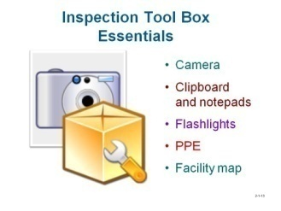
Additional information that might also be contained in the toolbox includes the location of monitoring equipment (include extra keys in the tool box if the equipment is locked up) and the location of important safety documents (again, provide keys for filing cabinets if necessary).

(3) Be prepared when the CSHO arrives – Employees should be trained on what to expect and what they should do when a CSHO arrives.
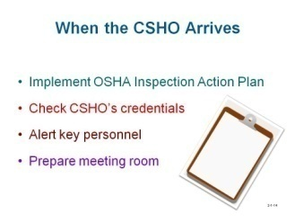

Employees must be trained on the company’s OSHA IAP – the first person to greet an OSHA CSHO is usually a receptionist. The receptionist must be familiar with the IAP so he or she knows which personnel to contact, how to prepare a meeting room, etc.

Check the CSHO’s credentials – you may verify the credentials by calling the nearest federal or state OSHA office. The phone number should be listed in your OSHA IAP.

Ensure that key personnel are contacted as soon as the CSHO arrives – the OSHA inspector will want to meet with the owner, general manager, or person in charge of the operations at your facility. Other key people to contact might include your safety director, human resources manager, production manager, engineering manager, and safety consultant.

Sanitize the meeting area – before leading the CSHO into a meeting room, make sure the room is sanitized. Erase any notes on black or whiteboards, remove papers from previous meetings, and make sure no extra information is in the room.

(4) Documentation requested – Be prepared to provide documentation on your safety program.
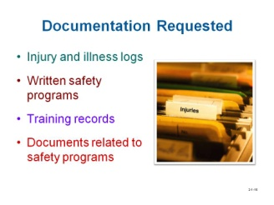

The inspector may request to see any of the following:

- Log of work-related injuries and illnesses, OSHA Form 300

- Company’s written safety program, training, documentation, etc.

- Documentation of employee safety training

- Documents relating to specific safety programs, such as:

  - Material Safety Data Sheets (MSDSs)

  - lockout/tagout assessments

  - respirator fit tests, and

  - PPE assessments.

In that regard,
  - Consider asking for a written list of the documents the inspector will require to ensure that there is no confusion.
  - Do not give the inspector a stack of safety documents. Give one file or document at a time as requested to keep the inspection focused on one aspect at a time.
  - Take careful note of the documents the inspector reviewed.

(5) What is the inspector looking for?

- Documents that cover all phases of OSHA standards, including the requirements of written plans and training. Retention of record storage is determined by either federal or state regulation. In absence of these guidelines, company policy will dictate retention requirements.
- Evidence of employee participation and acceptance, including safety committees, employee teams charged with developing safety programs or procedures, safety suggestion programs.
- Evidence of substantiated management commitment and leadership.
- Demonstrated use of PPE, where required, on the production floor, and management actively correcting employees who do not follow safety rules.
- Clear evidence of a safety culture as well as “good faith” efforts to correct safety hazards and provide a safe work environment

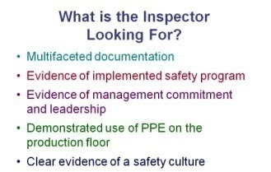

If the inspector finds most of these components in your safety and health program, he or she may feel that your company is dedicated to the safety and health of your employees, and a continuation of the inspection is not warranted.

Review Questions
- An OSHA inspection plan should focus on ______.
- inspection process procedures
- responsibilities of key personnel
- equipment needed for the inspection
- All of the above

- The equipment that should be available in a company’s inspection action plan should be ______.
- a camera
- notepaper
- PPE (Personal Protection Equipment) to wear
- All of the above

- The receptionist should be one of the individuals trained for properly implementing the company’s inspection action plan. True or False

- An OSHA inspector may request to see what type of document?
- OSHA form 300 (log of work-related injuries and illnesses)
- Company’s written safety program and training materials
- Employer safety training records
- All of the above

- The inspection by a CSHO may be cut short if there is enough evidence that the company is dedicated to the safety and health of the employees.

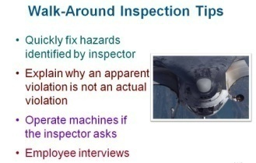
It is also important to know and understand what will happen during the facility walk-around inspection, how the inspection will be closed out, what happens if the company is given a citation and/or penalties, and what actions are required to abate violations.
(6) Walk-around inspection tips – During the walk-around, the inspector will point out minor hazards (as well as major violations), ask questions about machines, and even talk with employees. How you handle these events can affect the outcome of the inspection.

Hazards – When the CSHO identifies a hazard that can be quickly fixed, you should immediately fix it, or alert an employee in the area that there is a safety hazard that must be fixed. This response is a positive reaction to an issue that concerns the inspector. Although the hazard may not be something for which you would be issued a violation, fixing the hazard demonstrates a “good faith” effort, and a commitment to safety and health.

Violations – If the CSHO points out a situation that is an apparent violation and you have information that makes a case for that situation not being an actual violation, you should share it with the inspector. However, this should not be done unless you have performed studies or have special knowledge about the situation. Without sufficient knowledge, you will just demonstrate to the inspector that you were aware of a hazard and did nothing about it.

Equipment operation – The OSHA inspector may also want to see how some of your machines work if they are not operating during the walk-around. Note that you are not required to run a machine just because the inspector asks. However, refusing to do so may prompt the inspector to return again for another inspection to see the machine in operation. It is recommended that you operate machines for the CSHO when requested unless it is blatantly unsafe to start up the machine, or the machine is currently locked out for repair.

Employee interviews – The CSHO will likely want to speak with a few employees. Sometimes the inspectors will ask the employer to select employees from different areas in the facility and send them to a conference room for private interviews.
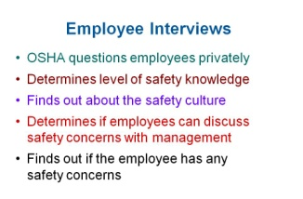

The inspector may also select employees on the production floor and interview them during the walk-around.

      - The CSHO has the right to question employees privately.

      - The company cannot take action against an employee who speaks with the OSHA inspector or force the employee to share what was discussed in the interview.

      - The CSHO will try to determine the employee’s level of safety knowledge, which will reflect on the quantity and quality of safety training that the employee has received.

      - The CSHO may also ask questions in an attempt to understand the safety culture at your company.

      - The CSHO will also want to ensure that employees feel comfortable discussing safety concerns with management, and that employees feel that management makes an effort to resolve safety issues.

      - Finally, the inspector will usually ask the employee if he or she has any specific safety concerns.
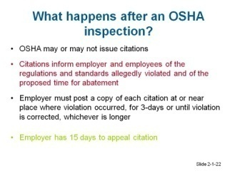

(7) Citations and penalties – There are several levels of citations, ranging from those that carry no monetary fine to those that carry substantial monetary penalties, or even imprisonment of the violation is serious enough.
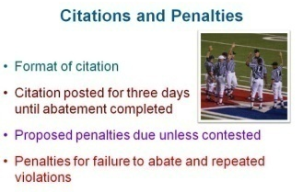
During the closing conference, the inspector will discuss the format of the citation and the fact that it will arrive by certified mail. The inspector will also remind the company’s representative that the company is required to post the citation for a minimum of three days, or until abatement is completed (if abatement requires more than three days), near the area where the violation was found.

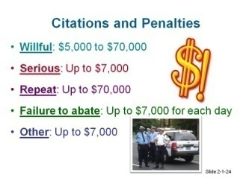
All proposed penalties for the violations are due immediately unless the violations and citations are contested. The inspector will discuss penalties for failure to abate as well as penalties for repeated violations. The citation will also provide information regarding these issues. The amount of the penalty depends on the type of citation(s) issued to the company. The penalty costs break down as follows:

A “willful” violation – when the employer intentionally and knowingly commits a safety violation. The fines levied can range from $5,000 to $70,000 per incident, depending on the severity of the violation.

A “serious” violation – when there is substantial probability that death or serious physical harm could result and the employer knew or should have known of the hazard. Fines levied can be up to $7,000 per incident.

A “repeat” violation – when a substantially similar violation is found upon a subsequent or follow-up inspection to previous violations. Fines levied can be up to $70,000 per incident.

A “failure to abate” penalty – occurs when the violation is not corrected and continues past the designated abatement date. Fines levied can be up to $7,000 per day for every day past the established deadline date.

“Other” violations – these have a direct relationship to job safety and health, but probably would not cause death or serious physical harm. Fines levied can be up to $7,000 per incident.

(8) Abatement – Abatement refers to the correction of the safety or health hazard that led to an OSHA citation. Abatement requires the company to take the below steps.

- Correct the hazard.
- Certify that the hazard has been corrected.
- Notifies company employees and department representatives of the corrective action.
- Send appropriate documentation to OSHA indicating hazard abatement.
- Tag any cited, moveable equipment with a copy of the citation or a warning tag
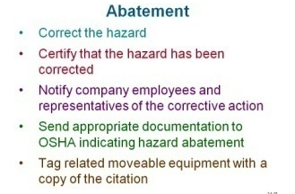

If you are not sure how to abate a certain violation, ask the inspector if he or she can share methods that other companies have used to abate similar violations in their facilities. When required, submit progress reports on certain long-term or complex abatement issues to show that your company is making strides toward successful abatement of the hazard(s). You may also request that OSHA extend or modify your abatement dates. Submit your request in writing. It will usually be granted provided that you are making progress toward abatement. If you are nearing the abatement date, contact the inspector and inform him or her of the situation.
An employer has 15 days to appeal a citation after it is issued.
Review Questions
- The term abatement regarding OSHA refers to ______.
- not correcting a violation
- correcting a hazards violation
- receiving a hazards citation
- receiving a warning

- During a walk-around inspection, a hazard identified by the CSHO should not be fixed immediately, even if it is a minor one. True or False

- If the CSHO points out a violation, a company employee is allowed to immediately contest the decision.
True or False

- The company is required to post a citation for a minimum of ______.
- 24 hours
- 3 days
- 1 day
- 1 month

- A citation may result in a penalty of up to $70,000 under which condition?
- The violation is willful
- A violation is repeated
- Both A and B
- The violation is deemed serious

- An appeal by an employer to an OSHA citation is ______.
- 15 days
- 30 days
- 60 days
- 1 year

- The abatement process does not require that the ______.
- company correct the citation
- CSHO return for another inspection
- company send appropriate documentation to OSHA
- company certify the hazard has been corrected

6. OSHA Standards and Safety Inspections Development
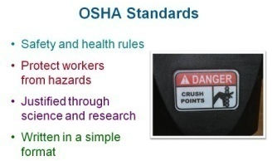
OSHA has developed and implemented a number of standards that provide safety and health rules for workplaces in general industry, construction, and maritime industries. The intent of these standards is to protect workers from specific hazards identified in the workplace. OSHA’s standards must be justified through sound science and research to prove that there is a problem in the first place and then demonstrate that the safety standard will effectively reduce workplace injuries, illnesses, and deaths. Cost analyses are conducted on the standards to demonstrate the costs of compliance as well as how much money will be saved by employers that implement the standard. The OSHA standard must be written in a format that is easy to understand and implement.

OHSH Standards can be obtained from a variety of sources:
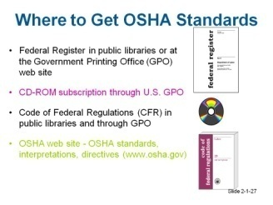

A. General Duty Clause – OSHA’s General Duty Clause is not a safety standard; it is a section of the original Occupational Safety and Health Act. It appears in Section 5 of the Act, entitled “Duties.” The General Duty Clause is the foundation of all current and future safety standards. Basically, the clause requires all employers to furnish a workplace that is free from recognized hazards. Therefore, employers must evaluate the workplace in an attempt to find workplace hazards and then take steps to abate those hazards.

The safety standards take the basic premise of the General Duty Clause and focus on specific workplace hazards such as hazardous chemicals. If no specific safety standard covers a workplace hazard found by an OSHA inspector, the company may be cited under the General Duty Clause for failure to provide a workplace that is free from recognized hazards. OSHA inspectors frequently cite employers for violations of the General Duty Clause.

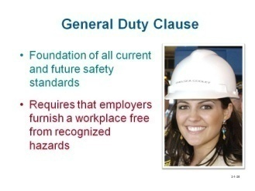

The General Duty Clause also requires employers to comply with all safety and health standards that OSHA develops and implements. Not only must the company provide a workplace free of recognized hazards, the company must also follow all of the requirements of each specific OSHA safety standard. These specific standards define some workplace hazards, provide ways for employers to recognize and prevent those hazards, and also provide employee training.
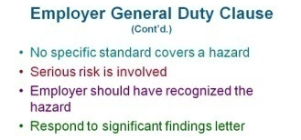

- Employer Responsibilities – OSHA inspectors may cite employers for violations of the General Duty Clause. However, before the General Duty Clause can be used to cite an employer, the inspector is required to verify that a hazard meets three specific criteria:
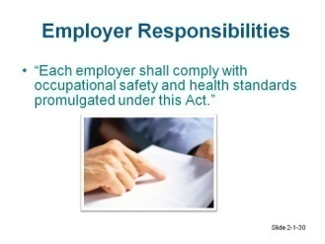

- There can be no specific standard that covers the hazard. For example, the hazard is not covered by the requirements in the Hazard Communication Standard, Lockout/Tagout Standard, Confined Space Standard, etc.
- The hazard must present a serious risk of injury or death to employees.
- The hazard should have been recognized by the employer, which means that the employer has not adequately evaluated the workplace for potential hazards.

If all three of these criteria cannot be met, the inspector cannot cite the employer under the General Duty Clause. However, the inspector will send the employer what is called a “significant findings letter” that describes the hazard and suggests that the employer correct the problem before an employee becomes injured. Employers often take this letter quite seriously and will correct the hazard, along with sending OSHA periodic updates on the progress of the abatement.

- Employee Duties and Responsibilities – The General Duty Clause also provides information regarding employee duties and responsibilities.

Duties – Employees are required to comply with all of the occupational safety and health standards, rules, and regulations that OSHA develops and implements. Therefore, if the employer is required to provide PPE according to an OSHA safety standard, then the employee is required to wear that PPE.

Responsibilities – OSHA also makes employees responsible for safety in their workplace as follows:

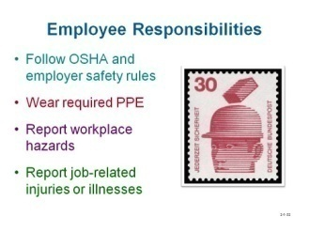

- Employees must follow all of the requirements of OSHA’s specific safety standards as well as any safety rules established by the employer.

- Employees must wear the PPE that is required by OSHA Standards and Safety Inspections and employer safety rules.

- Employees are expected to report all recognized workplace hazards to their employer so steps can be taken to abate the hazard.

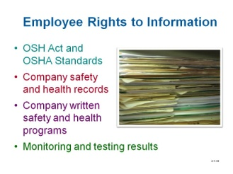
- Employees are also expected to report all job-related injuries or illnesses so the employer can record and investigate the incident, and take steps to prevent similar incidents from occurring in the future.

Employee Rights to Information – Employees have a right to have or review copies of the OSH Act as well as copies of all OSHA safety standards

Additionally, employees have rights to the following:

- Review company safety and health records, specifically the OSHA 300 Log on which employers, with 11 or more employees, are required to record all workplace injuries that require time loss, restricted duty, or medical treatment. The OSHA 300 Log must be updated throughout the year and an annual summary must be posted during the entire month of February for employees to review. More info on the log can be found at http://www.osha.gov/recordkeeping/new-osha300form1-1-04.pdf.
- Review the written safety and health programs the company has developed in response to specific OSHA Standards and Safety Inspections. In fact, employees should be involved in writing the safety programs for the company.

- Review workplace monitoring and testing results such as noise and chemical exposure monitoring.

- Other Employee Protection Provided by OSHA – OSHA also protects employees from being singled out, threatened, or fired for taking actions in relation to OSHA or workplace safety. This protection ensures that the employees have the right to:
Complain to OSHA about safety concerns or to request that OSHA evaluate a workplace and look for hazardous conditions or violations of OSHA Standards and Safety Inspections.

Participate in OSHA inspections by asking the inspector questions, providing answers to the inspector, or even pointing out specific hazards or safety concerns to the inspector.

Discuss safety concerns with other employees without fear of retribution.

Ask their employer to fix unsafe conditions.
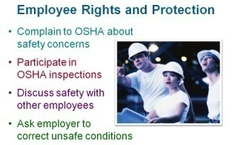

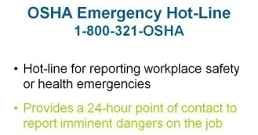

Review Questions
- OSHA has developed and implemented a number of standards that provides safety and health rules for which types of workplaces?
- general industry
- construction
- maritime industries
- All of the above

- OSHA’s General Duty Clause ______.
- is not a safety standard
- is a section of the original Occupational Safety and Health Act
- requires all employers to furnish a workplace free from recognizing hazards
- Both B and C

- The General Duty Clause ______.
- requires employees to comply with safety and health standards created by OSHA
- requires that employers identify hazards in their facilities and abate them
- Both A and B
- is defined as the citation issued by OSHA for a violation

- Under the General Duty Clause, an employer receives a citation if the hazard ______.
- is not covered by an OSHA standard
- presents a serious risk of injury or death
- should have been recognized by the employer
- only if all three of the above can be identified

- The General Duty Clause requires that ______ comply with safety and health standards created by OSHA.
- employers
- employees
- Both A and B
- inspectors

Summary
An effective safety program is a vital part of a company’s success. Violations are costly and time consuming. Since time is money for any manufacturer, having a working knowledge of OSHA requirements and safety standards, and a proven inspection action plan ensures that your company maintains the highest safety standards and will save time and reduce confusion on who to call and what to do when an inspector arrives un-announced.

Remember, OSHA exists to save lives and prevent injuries. OSHA’s mission is to ensure that employers furnish a workplace free of hazards. It is every employee’s responsibility to follow OSHA safety standards, report violations, and correct discrepancies when they occur.

During an inspection, take notes and ask questions. Pay close attention to what the inspector is looking at or taking pictures of. Answer only the questions he or she asks. Document everything, using the same methods used by the inspector. Put all of this data in a special “Inspection” folder for later review. During the walk-around, repair the quick fix hazards on the spot and report any that you cannot fix.
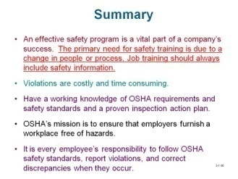

If your company is cited, respond to the citations immediately. Do not let the time frame for redress pass if you disagree with the inspector. OSHA uses various methods to ensure compliance and promote education of safety requirements, including, enforcement, partnership, safety standard development, and outreach programs.
Chapter Questions/Unit Exam

- The agency formed by the Occupational Safety and Health Act of 1970. _____.
  - OSHA
  - NIOSH
  - OSHRC
  - All of the above

- Federal OSHA oversees state-run OSHA programs in how many states?
- 0
- 26
- 41
- 50

- The OSHA representative who performs the inspection at the workplace is called the_____.
- OSHAR
- CSHO
- CSHAO
- NIOSHR

- When an OSHA inspector arrives, the receptionist should _____.
- request identification
- verify the credentials by phoning the OSHA office
- contact key personnel in the company
- All of the above

- An OSHA inspection tool box should include _____.
- a clipboard
- a flashlight
- a facility map
- PPE (Personal Protection Equipment)
- a camera
- All of the above

- The type of document companies have that do not pertain to their safety programs is _____.
  - Material Safety Data Sheets (MSDSs)
  - PPE assessments
  - Financial statements
  - Lock-out/tag-out assessments
  - Respiration fit tests

- The companies that OSHA selects for inspection are exclusively done at random.
  - True
  - False

- An appeal to an OSHA citation must be submitted within _____ days.
  - 3
  - 15
  - 30
  - 45

- A citation from OSHA must be posted _____.
  - for 3 days
  - until abated
  - Both a and b
  - permanently

- A CSHO does not look for what kind of evidence during an inspection?
  - An implemented safety program
  - A quality control program
  - Commitment and leadership by management toward safety
  - Use of PPE on the production floor

- Under no circumstances can the CSHO be refused when making a request to observe a machine operate.
  - True
  - False

- An OSHA inspector cannot issue a violation to a company for their lack of management commitment to safety, or an inadequate safety culture, because either one is not measureable.
  - True
  - False

- An OSHA citation is sent to the company by _____.
  - UPS
  - FedEx
  - certified mail
  - a telegram

- The failure to abate a violation can result in a fine as much as _____ per day.
  - $1000
  - $5000
  - $7000
  - $70000

- Extremely serious OSHA violations by employers can result in their imprisonment.
  - True
  - False

- The term that pertains to correcting an OSHA hazards violation.
  - Censorship
  - Proctoring
  - Abatement
  - Entitlement

- It is possible to extend an abatement due date.
  - True
  - False

- Who is primarily responsible for evaluating the workplace in an attempt to find workplace hazards?
  - OSHA
  - The employer
  - An independent agency
  - The production workers

- A “significant finding letter” issued by an OSHA inspector is considered a citation.
  - True
  - False

- Under the General Duty Clause, employees are not required to _____.
  - follow OSHA and employer safety rules
  - wear required PPE
  - report workplace hazards
  - report job-related injuries or illnesses
  - identify and abate safety hazards

- Companies with _____ employees are required to use an OSHA 300 log.
  - any number of
  - a minimum of 11
  - a minimum of 50
  - a minimum of 100

- Employers are required to post the OSHA 300 log during which month of the year?
  - January
  - February
  - July
  - December

- An OSHA form 300 is a document that _____.
  - logs work related injuries and illnesses
  - records the violation identified during an inspection
  - identifies an element of a company’s safety program and the individual responsible for each one.
  - lists the items in an inspection tool box

- Under OSHA’s employee protection policy, employees are not protected if they _____ about safety concerns.
  - complain to OSHA about safety concerns
  - participate in OSHA inspections
  - discuss safety concerns with other employees
  - ask the employer to fix unsafe conditions
  - None of the above

- OSHA provides a 24/7 toll free phone service.
  - True
  - False

Review Question Answers
  - B
  - A
  - C
  - B
  - D
  - D
  - D
  - Compliance Safety and Health Officer
  - D
  - D
  - True
  - D
  - True
  - B.
  - False
  - True
  - B
  - C
  - A
  - B
  - D
  - D
  - C
  - D
  - C

SAFETY DISCLAIMER:
M-SAMC educational resources are in no way meant to be a substitute for occupational safety and health standards. No guarantee is made to resource thoroughness, statutory or regulatory compliance, and related media may depict situations that are not in compliance with OSHA and other safety requirements. It is the responsibility of educators/employers and their students/employees, or anybody using our resources, to comply fully with all pertinent OSHA, and any other, rules and regulations in any jurisdiction in which they learn/work. M-SAMC will not be liable for any damages or other claims and demands arising out of the use of these educational resources. By using these resources, the user releases the Multi-State Advanced Manufacturing Consortium and participating educational institutions and their respective Boards, individual trustees, employees, contractors, and sub-contractors from any liability for injuries resulting from the use of the educational resources.

DOL DISCLAIMER:
This product was funded by a grant awarded by the U.S. Department of Labor’s Employment and Training Administration. The product was created by the grantee and does not necessarily reflect the official position of the U.S. Department of Labor. The Department of Labor makes no guarantees, warranties, or assurances of any kind, express or implied, with respect to such information, including any information on linked sites and including, but not limited to, accuracy of the information or its completeness, timeliness, usefulness, adequacy, continued availability, or ownership.

RELEVANCY REMINDER:
M-SAMC resources reflect a shared understanding of grant partners at the time of development. In keeping with our industry and college partner requirements, our products are continuously improved. Updated versions of our work can be found here: http://www.msamc.org/resources.html.

