- Access the Course Sites page by following this link: http://go.dtcc.edu/GettingPrepped
- Follow the steps to “Self-Enroll” if you are a new user, or “Login” with your username and password if you are a current Course Sites member. At this time, there is no cost to enroll. The enrollment/login page looks like this:
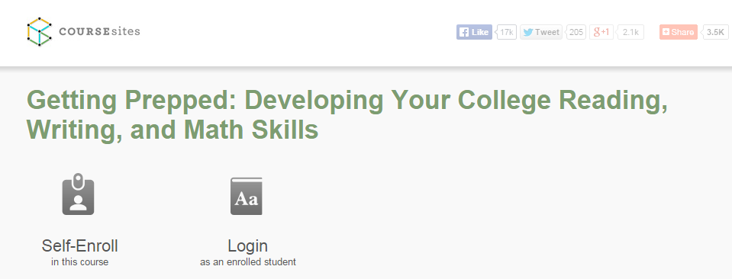
- Once you enter the “Getting Prepped” site, begin with the syllabus and the “Welcome” video. The home page of the site looks like this:
