Adult Learning
Academy

Pre-Algebra Workbook
Unit 2: Fractions

Debbie Char and Lisa Whetstine
St. Louis Community College
First Version: 01/12/2015

Unit 2: Fractions
Unit 2 Learning Objectives | 1
Unit 2 Video & Exercise List | 2
2.1 Famous Equivalent Fractions | 4
2.2 Color Matching: Equivalent Fractions | 5
2.3 Fraction Mnemonics | 6
2.4 Fraction Quiz | 7
2.5 Incredible Growing and Shrinking Numbers: Fractions | 8
2.6 Healthcare Applications | 9

MoHealthWINs
This workforce solution was funded by a grant awarded by the U.S. Department of Labor’s Employment and Training Administration. The solution was created by the grantee and does not necessarily reflect the official position of the U.S. Department of Labor. The Department of Labor makes no guarantees, warranties, or assurances of any kind, express or implied, with respect to such information, including any information on linked sites and including, but not limited to, accuracy of the information or its completeness, timeliness, usefulness, adequacy, continued availability, or ownership.
Unless otherwise noted this MoHealthWINs material by St. Louis Community College is licensed under a Creative Commons Attribution 4.0 International License.

Adult Learning Academy
Pre-Algebra Workbook
Unit 2: Fractions

Learning Objectives
- Understanding & Identification:
- Recognize proper fractions, improper fractions, and mixed numbers
- Identify the numerator and denominator of fractions; understand how they relate to part and whole
- Plot Fractions on a number line
- Conversions & Comparisons:
- Recognize and write equivalent fractions
- Reduce fractions and simplify to lowest possible terms
- Convert between improper fractions and mixed numbers
- Rewrite unlike fractions, using the lowest common denominator (LCD)
- Describe, order and compare fractions
- Operations with Like and Unlike Fractions:

- Add fractions
- Subtract Fractions
- Multiply Fractions
- Divide Fractions
- Follow order of operations rules when performing calculations with fractions
- Operations with Mixed Numbers:
- Add mixed numbers
- Subtract mixed numbers
- Multiply mixed numbers
- Divide mixed numbers
- Follow order of operations rules when performing operations involving mixed number
- Word Problems:
- Solve basic word problems that use fractions and mixed numbers, including applications to the healthcare industry, and those involving area and perimeter

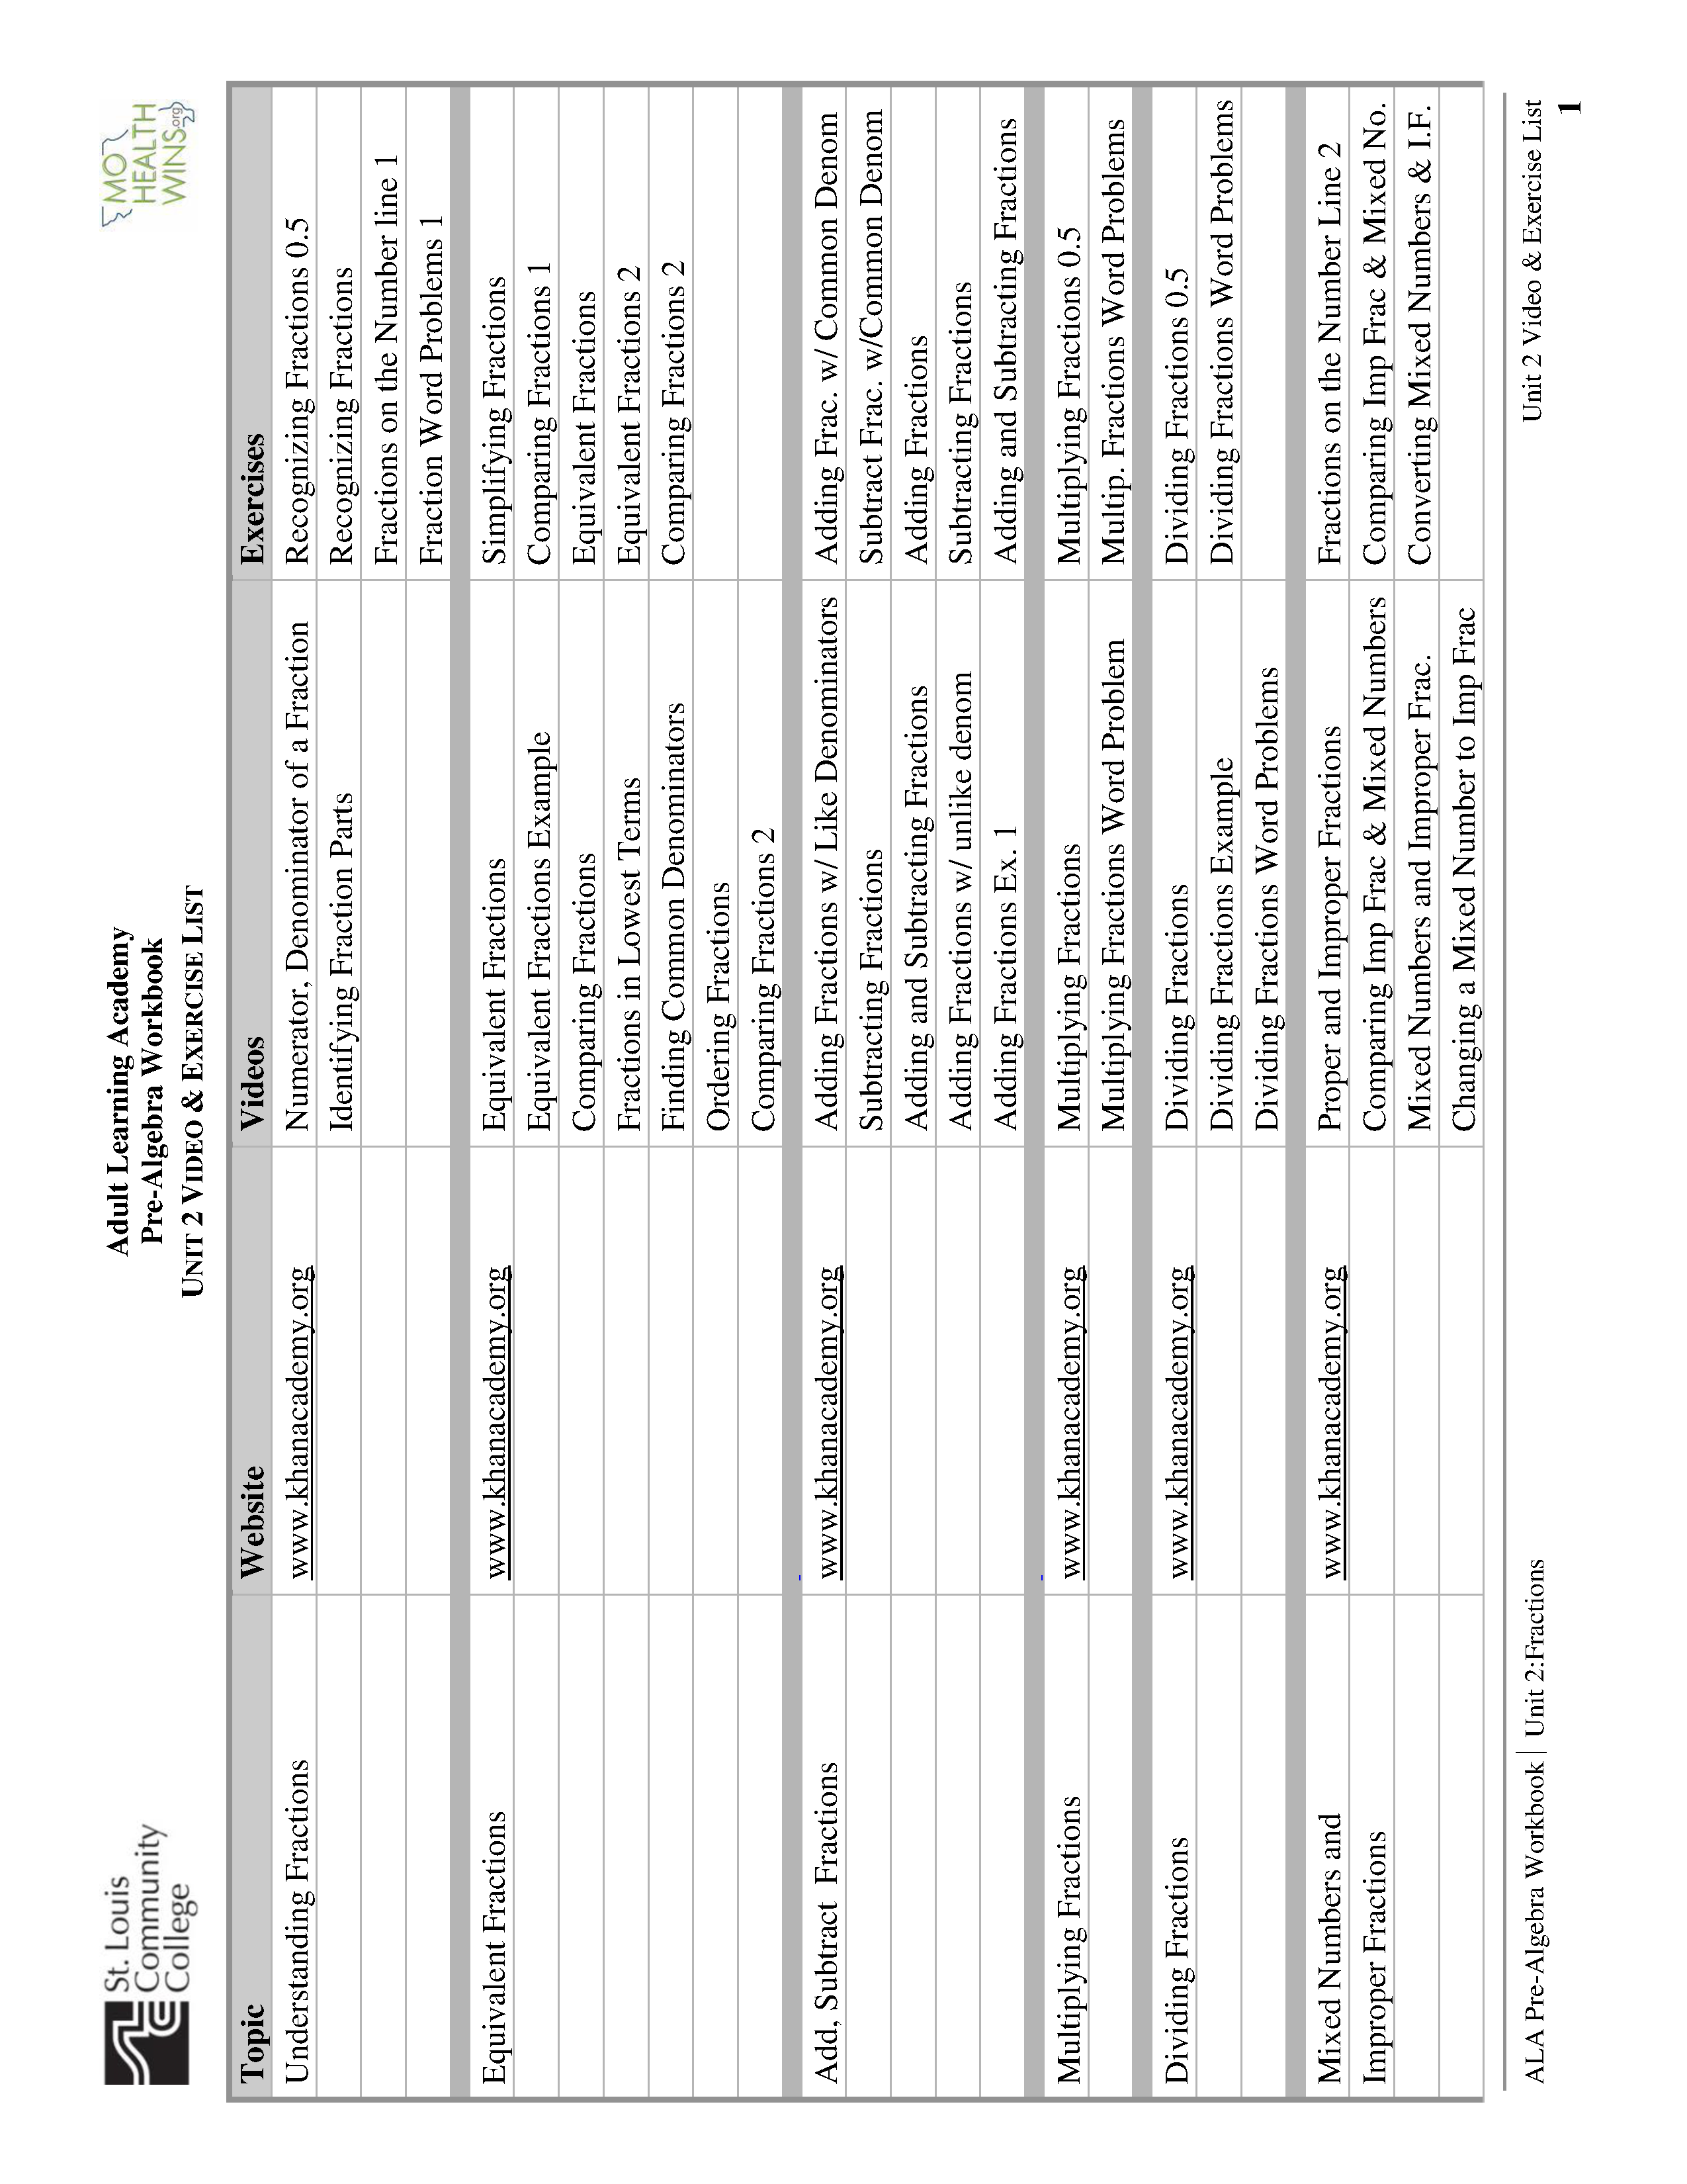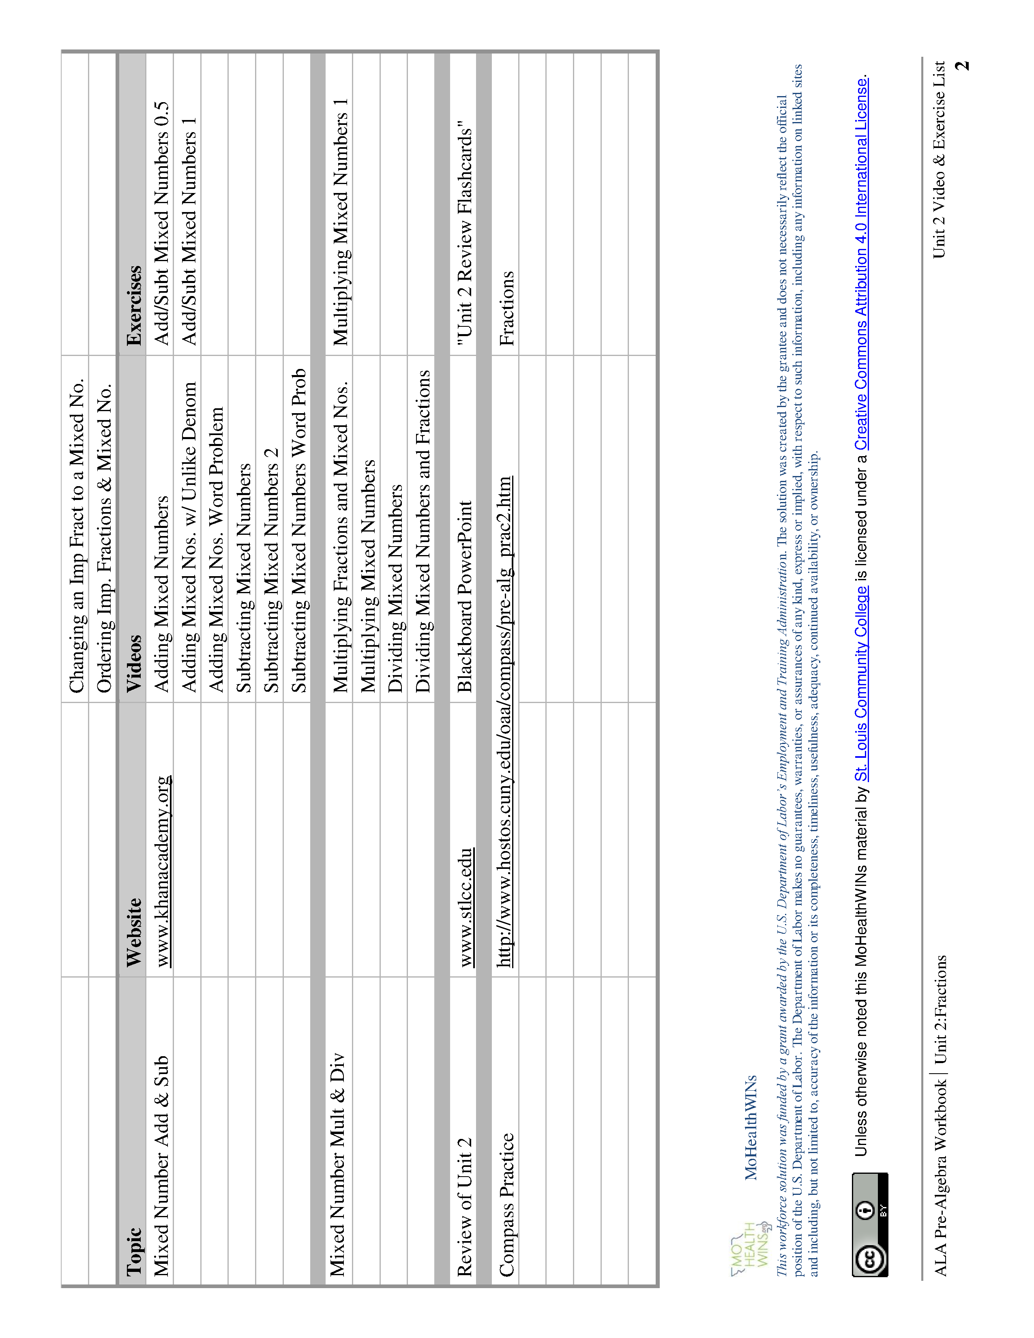

Adult Learning Academy
Pre-Algebra Workbook
2.1 Famous Equivalent Fractions

Write five fractions that are equivalent to each number:

$$\frac{1}{2}$$ | $$\frac{1}{4}$$
$$\frac{3}{4}$$ | 0
1 | 2
To create equivalent fractions, M_________________ the N___________________ and the D_____________________ by the S_____________ number. This is the same as multiplying the fraction by _______, which does not change its value.

Adult Learning Academy
Pre-Algebra Workbook
2.2 Color Matching: Equivalent Fractions
Color all equivalent fractions the same color.
$$\frac{150}{100}$$
$$\frac{10}{5}$$
$$\frac{3}{2}$$
$$\frac{16}{8}$$
$$\frac{3}{3}$$
$$\frac{100}{100}$$
$$1\frac{1}{2}$$
$$\frac{4}{3}$$
$$\frac{0}{3}$$
$$\frac{12}{8}$$
$$\frac{1}{2}$$
$$\frac{0}{100}$$
$$\frac{50}{100}$$
$$\frac{2}{1}$$
$$\frac{3}{0}$$
$$\frac{50}{25}$$
$$1\frac{1}{3}$$
$$\frac{400}{300}$$
$$\frac{20}{15}$$
$$\frac{75}{50}$$
$$\frac{50}{50}$$
$$\frac{15}{30}$$

Adult Learning Academy
Pre-Algebra Workbook

2.3 Fraction Mnemonics

FRACTION RAP

When you’re adding up or taking away fractions, don’t be a hater!
Bottom number’s got to be the same—COMMON DENOMINATOR!

Multiply fractions, no big problem
Top times top and bottom times bottom

Dividing fractions, easy as pie
Flip the second and multiply!

THE BIRTHDAY SONG:

You must have common denominators
You must have common denominators
To ADD or SUBTRACT,
You must have common denominators!

KFC

To Divide Fractions, remember... KFC!!
Keep the first fraction the same.
Flip the second fraction.
Change the division to multiplication.

Adult Learning Academy
Pre-Algebra Workbook

2.4 Fraction Quiz

- Circle the GREATER number from each pair:

a) $\frac{1}{3}$ $\frac{1}{4}$

b) $\frac{3}{4}$ $\frac{4}{3}$

c) $\frac{7}{8}$ $\frac{6}{8}$

d) $\frac{11}{10}$ 1

e) $\frac{1}{2}$ $\frac{3}{8}$

f) $\frac{5}{5}$ $\frac{5}{1}$

- Color $\frac{1}{3}$ of the candy bar:

- Color $\frac{2}{6}$ of the candy bar:

- Color $\frac{1}{2}$ of the candy bar:

- Cross out the fraction that is UNDEFINED:
$\frac{5}{0}$ $\frac{0}{5}$

- What is half of $\frac{2 }{3}$?
- Circle ALL the fractions that equal one half:
2 1 8 10
1 2 16 20

- Simplify. Write your answer in simplest form:

a) 1 + 3
4 4

b) 2 - 1
3 4

c) 2 3
3 4

d) 2 ÷ 3
3 4

e) $1 \frac{3}{4 }+2 \frac{1}{3}$

f) $1 \frac{3}{4} × 2 \frac{1}{3}$

g) $1\frac{3}{4} ÷2\frac{1}{3}$

Adult Learning Academy
Pre-Algebra Workbook
2.5 Incredible Growing and Shrinking Numbers

Grew or shrunk? Grew or shrunk?

$20 × \frac{1}{10}=$ ______ $20 ÷ \frac{1}{10}$ = _______
$20 × \frac{1}{2}$ = ______ $20 ÷ \frac{1}{2}=$ _______
$20 × \frac{3}{4}=$ ______ $20 ÷ \frac{3}{4}$ = _______
$20 × \frac{5}{5}=$ ______ $20 ÷ \frac{5}{5}$ = _______
$20 × \frac{5}{4}=$ ______ $20 ÷ \frac{5}{4}=$ _______
OBSERVATIONS:
When you multiply a number by a fraction < 1, it ______________________________________
When you divide a number by a fraction < 1, it _______________________________________
When you multiply a number by 1, it _______________________________________________
When you divide a number by 1, it _________________________________________________
When you multiply a number by a fraction > 1, it ______________________________________
When you divide a number by a fraction > 1, it _______________________________________

MoHealthWINs Adult Learning Academy

Pre-Algebra Workbook
2.6 Healthcare Applications

Scenario I: On the days when you are working as a CNA, this graph shows how your time breaks down for a 24-hour day:

a) Write each fraction and simplify:
What fraction of your time do you spend working?

What fraction of your time do you spend sleeping?

What fraction of your time do you have free?

Add the three fractions above. What is the total? Why does this total make sense?

*************************************************************************************
b) According to the graph, what fraction of the day are you AWAKE?

*************************************************************************************
c) What fraction of your DAY OFF do you spend working?

*************************************************************************************
d) Your friend spends $\frac{1}{6}$ of her day at work. How long is her shift?

*************************************************************************************
e) Your friend has $\frac{1}{5}$ of her day for free time. Who has more free time—you or her?

*************************************************************************************
f) You spend $\frac{2}{3}$ of your work time doing direct patient care. How many hours is this?

Scenario II: The storage shelf at work measures 6$\frac{1}{2}$ feet by 1$\frac{3}{4}$ feet.

1$\frac{3}{4}$ feet

6$\frac{1}{2}$ feet

a) You decide to attach a rim to go around the edge of the shelf to keep items from falling off. How many feet of rim should you order?

(Note: You are finding the PERIMETER of the rectangle. You can find it by adding up the lengths of ALL four of the sides.)

b) Rim material costs $4 per foot. How much will your rim cost?

c) You also choose to buy water-resistant shelf paper to protect the surface of the shelf. A roll of shelf paper covers 5 square feet. How many of rolls will you need?

(Note: You are finding the AREA of a rectangle. You can find it by multiplying the length of the rectangle by its width. Area is always measured in square units.)

*************************************************************************************
III. FACT: Cigarette smoke contains 4,800 chemicals, 69 of which cause cancer.

a) What fraction of the chemicals in cigarette smoke are carcinogenic?

b) What fraction of the chemicals in cigarette smoke are non-carcinogenic?

Scenario IV: As a therapist’s assistant, you need to make sure that patients get the exercise ordered by the therapist.

Your patient Fiona is supposed to get ¾ of an hour of exercise, 5 days per week. How much time should she spend exercising in a week?

This week, Fiona kept track of her hours of exercise in this table:

Monday | Tuesday | Wednesday | Thursday | Friday | Saturday | Sunday
$$\frac{3}{4}$$ | $$\frac{1}{2}$$ | $$\frac{2}{3}$$ | $$\frac{1}{4}$$ | $$1\frac{1}{2}$$ | $$0$$ | $$0$$

How many hours did Fiona exercise this week?

How many minutes of exercise did Fiona get this week?

What fraction of Fiona’s total exercise was done over the weekend?

Did Fiona get enough exercise this week? If not, how much more would she have needed to meet the therapist’s recommendation?

What is the MEAN amount of time Fiona exercised each of the five weekdays? (Don’t count the weekend!)

Fiona’s best friend Sharona got half as much exercise as Fiona did this week. How many hours did Sharona exercise?

Scenario V: You are in charge of medication. Fill in the following table:
Patient  Name | Number of  Doses Per day | Number of Pills per dose | Total number of pills  Per day
Foster | 3 | 1 ½ tablets
Grimes | 7 | ¾ tablet
Haike |  | 1 ½ tablets | 9 tablets
Iona |  | ¾ tablet | 6 ¾ tablets
Jones | 5 |  | 17 ½ tablets
Koric | 4 |  | 3 tablets

*************************************************************************************
VI. Graphic Practice:

a) How much does the item weigh? b) How full is the gas tank?
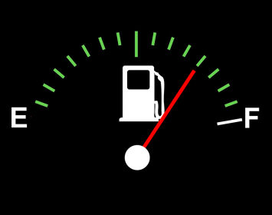
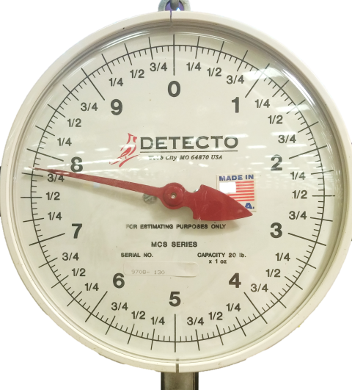

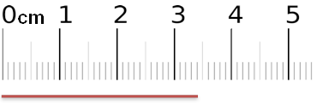
c) How long is the line segment?

Resources

Works used in VI. Graphic Practice
a) Fraction Scale by OER_Training is licensed under CC BY 4.0
b) Gas Gauge is a derivative of Fuel Gauge, which is available in the public domain under CC0 Public Domain
c) Line Segment is a derivative of 10cm ruler, which is available in the public domain

