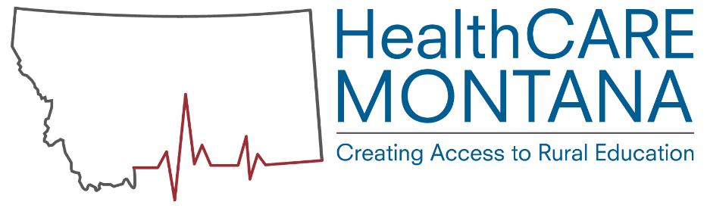Apprenticeship Development Steps

How to use this document: This document is designed to be an approximation of the steps involved in developing an apprenticeship program in healthcare! The process varies precipitously depending on several factors: whether an apprenticeship has already been developed in a chosen occupation, whether the employer has been an apprenticeship sponsor in the past, and the licensing & educational requirements for each occupation. Steps may be rearranged or omitted depending on the circumstances. This is a fluid process & we are adapting as we go. Please check BOX for new resources that are being added frequently. Thanks!

- Identify potential employer(s)
  - Staff responsible: WFC and/or AS. WFC performs assessment of whether a facility is a good; pass off to AS OR 2nd meeting with AS & WFC.
AS: Apprenticeship Specialists
WFC: Workforce Coordinator
HTS: Healthcare Transformation Specialist
CC: Career Coach
  - Documents used: Introduction to Healthcare Apprenticeship, Step 2, List of occupations, list of colleges and online courses available with timeline, 2 pagers for available occupations
  - Consistent messaging:
    - Not a program can simply be placed in the facility.
    - Apprentice still needs to gain admission into programs. Facility still needs to abide by all licensing/safety requirements.
  - Steps.
    - Schedule initial meeting with employer: WFC
    - Explain occupation options & determine occupation interest: WFC hand off to AS Discuss cost sharing, employer inputs and mentor feasibility
    - ID apprentice candidate search (in house at facility/ or local)
    - Enter visit into employer database
    - Follow-up strategy: WFC & AS
- Identify Educational Component
  - Step 2a: Match employer to established campus connection based on expressed interest
    - Staff responsible: AS, WFC, HTS, CC
      - Provide online course sources, matching schedules
      - MOU for roles and responsibilities between employer and institution when needed determined on a case-by-case by employer and/or institution
      - Example MOU in box.
    - Documents used: HTS use apprenticeship for campuses doc
  - Step 2b: ID curriculum (if not already established)
    - Staff responsible: AS as lead. WFC, HTS, CC serve as resources.
      - HTS is point of contact-they determine campus POC
      - Meet with potential partner schools, an appropriate staff
      - Inform of process, benefits and responsibilities: AS
      - ID online sources, matching schedules
      - Prepare student-apprentice for learning and program acceptance-CC, HTS, AS
      - Solidify partnership and next steps-AS
      - AS will do follow up
    - Documents used: HTS Use apprenticeship for campuses doc
  - Step 2c: Facility hosts relevant instruction in house
    - Staff responsible: AS
    - Steps:
      - Facility decides to deliver in house curriculum
      - AS verifies meets all licensing & educational requirements
    - Documents used: 2 pager on each occupation
- Check licensing requirements
  - Staff responsible: AS
  - Federal Apprenticeship standards, State standards, Board of Nursing, DPHHS, etc.
  - Develop basic course/ training outline and make sure it meets requirements
  - Send out to relevant parties i.e. HTS, WFC
- Adapt standard model for the occupation with OJT & Didactic specifics for the employer
  - Staff responsible: AS, with HTS helping find contacts, etc
    - Send to DLI Apprenticeship leadership & Colleges for approval through their system(s)
    - Document course options, etc. with DLI paperwork
- Employer identifies individuals to serve as mentors/supervisors
  - WFC, AS & HTS can assist with this
  - However, ultimately making sure corresponding to all licensing/educational requirements is the employer responsibility.
- Employer identifies apprenticeship candidates
  - DLI/HCMT representatives not directly involved, but can assist if the employer
  - AS makes sure employer understands the probation period. They are responsible for recruiting quality apprenticeship candidate. However, there is a period in which either party can cancel the apprenticeship agreement with no penalties.
- Consult with local Job Service and DLI
  - Staff responsible: AS, WFC, CC assist with contact info and resources
    - CC can provide referrals and resources to student
    - Discuss possibility of partnership with local Job Service and discuss apprenticeship sign ups
    - Inform leadership at DLI and discuss next steps
- Apprenticeship Registration (!)
  - Staff responsible: AS
  - Discuss roles and responsibilities with both employer, employer identified mentor and apprentice candidate: AS and employer
  - Another check for resources: for apprentice and employer candidacy through WIOA, VA, Voc. Rehab, AHEC resources, or other possible resources: CC
  - File pre-approval for relevant hours toward apprenticeship (if possible/pre-employed): AS
  - Have both parties sign all relevant paperwork: AS
  - Have DLI leadership sign all paperwork: AS
  - Input all information into MWorks for approval: AS
  - Mail out enrollment cards, copies of DLI signed paperwork, etc.: AS
- Educational component begins: Apprentice enrolls in related education program including any prerequisite requirements or facility hosts in house education.
  - Staff responsible: AS, HTS, CC if student involvement required
  - Update College/ University director of individual’s pending/potential enrollment and facility partner, when applicable (e.g. CNA): HTS
  - Apprentice completes pre-requisites & gains admission to program, when applicable (e.g. LPN).
  - College and Facility follow up discussions from MOU, mentor responsibilities: HTS
  - Contact relevant career coach for MCIS sign up, tutor support, next steps, etc.: CC
  - Have college registrar contact individuals to explain next steps, enrollment process with career coach support: HTS
- Periodic monitoring
  - Staff responsible: AS, HTS, CC and WFC
  - Provide assurance that follow up is indeed happening and on a regular schedule: all
  - Apprenticeship begins (initial visit to work out kinks) WFC & AS
  - Follow up to make sure hours are being recorded correctly by employer mentor AS or WFC
  - Secondary follow up to ensure proper communication between facility and college/institution
  - College/institution follow up to ensure proper enrollment of apprentices and their developments
  - Last follow up to make sure apprentices are on track with hours, course work: all
- Graduation of Apprenticeship/ Program graduation
  - Staff responsible: AS
  - Evaluate/calculate final hours towards apprenticeship
  - Input final hours to system
  - Meet with DLI leadership for verification and signatures
  - Mail out all certifications relevant to program
  - Any HCMT-specific recognition
- Fully skilled worker! Continues working with apprenticeship sponsor or seeks external employment
  - AS writes up any “best practices” and provides updates via steering committee & quarterly reports
  - Apprenticeship sponsor hopefully will hire apprentice full time but they are not required to unless is specified in apprenticeship agreement.

