GIST 1120 Final Project

Scenario
A small company called Green Aquaponics specializes in using beer brewing byproducts for their aquaponics systems, which produce sustainable fish and vegetables to a national restaurant chain.

Your mission
Green Aquaponics have hired you to help locate their newest operation and need a map showing high-density areas of breweries to maximize their aquaponics production. Running the point density analysis tool to produce a heat map of breweries in North American and Hawaii offers a potential solution.

Data to start with
The following data file was downloaded from The POI Factory (http://www.poi-factory.com/). Since 2006, POI Factory has provided a place where people get together to share GPS files and discuss a variety of interesting topics.
POI Factory requires an account to access data. Your instructor has already downloaded the breweries file you will need. Breweries.csv The file is located in the final project folder.
You will need to download ne_10m_admin_1_states_provinces_ file from Natural Earth. Below are illustrations as to where to find the file.
Make sure to save the file in the final project folder.
After downloading, you will need to right-click on the folder and choose extract all before you will be able to use the file.

Project requirements
- All data, maps, pdf’s must be saved in your final project folder.
- The map must show the locations of all breweries found in the source data.
- The map must be a point density map showing density of breweries in North America.
- The coordinate reference system of the map must be North America Albers Equal Area Conic (EPSG: 102008)
- Label the states, provinces, and regions.
- Insert beer image with location as to where you got the image.
- Map must have a meaningful title and appropriate legend.
- Map must include metadata information including the source of data and the projection information.
- Save the final map in the final project folder as initials_GIST1120_Final_Project. • File format of exported map must be a PDF.
- Submit PDF to Moodle by due date.
Store relative paths for the map document. (The instructor will not be happy if your map opens with exclamation marks by the layers and trust me you want a happy instructor.)

Project steps
- Download needed data from Natural Earth.
- Start a new map in ArcMap. Set the data frame coordinate system to North America Albers Equal Area Conic (EPSG: 102008). You can use the search box when setting the coordinate system to search for 102008.
- In map document properties check the box to store relative pathnames to data sources.
It’s imperative that you do this.
- Change the data frame background color to black.
- Bring in ne_10m_admin_1_states_provinces.shp.
- Build a query to only show the United States, Canada and Mexico.
- Change the symbology to a dark gray with a lighter gray border.
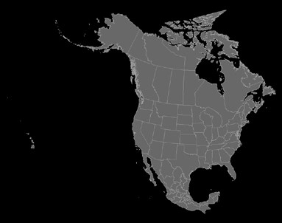
- Bring in the breweries.csv file.
- Right-click the csv file and choose display XY data.
- You will need to look at the table to see the appropriate fields to set for X field and Y field. There is no Z field.
- Choose the edit button to choose the coordinate system of the input data. Choose Geographic Coordinate Systems>World>WGS 1984. (When you have a table with latitude and longitude coordinates the coordinate system will be WGS 1984.)
- The layer that is created Breweries.csv Events is a temporary layer. You will need to export the data to create a permanent layer. Export the data has a shapefile saved in the final project folder. Save as initials_breweries.shp
- Once you have added the new shapefile to your map, remove the events layer and the csv file.
- Run the Point Density tool. Save the output raster to the final project folder. Save as initials_Brew_Density. Raster filenames cannot be longer than 13 characters.
- Change the symbology to the manual classification, 6 classes, with ranges set as shown in illustration.
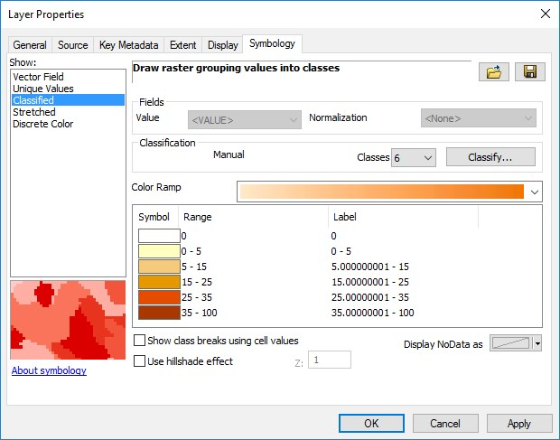
- Set transparency for raster layer to 50%.
- In layout view set go to the page and print setup. Put the printer on Adobe PDF, paper size to ANSI C, and orientation to landscape.
- Create the map layout. See illustration provided.
- Save the final map in the final project folder as initials_GIST1120_Final_Project.
- File format of exported map must be a PDF. Submit PDF to Moodle by due date.
Your finished map should look like the following map.
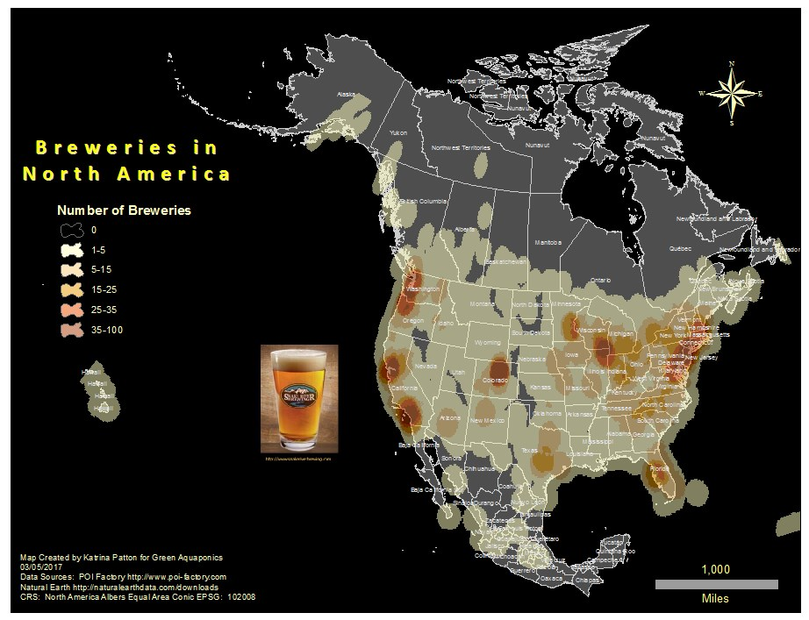
This work for “Mapping New Careers in Geospatial Technologies” is a derivative of "GST 102 (Spatial Analysis)" by National Information, Security, and Geospatial Technology Consortium (NISGTC) used under CC BY 4.0 and is licensed by Mapping New Careers in Geospatial Technology under a Creative Commons Attribution 4.0 International License.

This workforce solution was funded by a grant awarded by the U.S. Department of Labor’s Employment and Training Administration. The solution was created by the grantee and does not necessarily reflect the official position of the U.S. Department of Labor. The Department of Labor makes no guarantees, warranties, or assurances of any kind, express or implied, with respect to such information, including any information on linked sites and including, but not limited to, accuracy of the information or its completeness, timeliness, usefulness, adequacy, continued availability, or ownership.

