Marketing Materials
White Paper
TAACCCT Grant Round Three
South Dakota Allied Health Training Consortium

Southeast Technical Institute
2320 North Career Avenue
Sioux Falls, South Dakota 57107
605.367.7624
www.southeasttech.edu

This work is licensed under a Creative Commons Attribution 4.0 International License. This workforce product was funded by a grant awarded by the U. S. Department of Labor’s Employment and Training Administration. The product was created by the grantee and does not necessarily reflect the official position of the U.S. Department of Labor. The U. S. Department of Labor makes no guarantees, warranties, or assurances of any kind, express or implied, with respect to such information, including any information on linked sites and including, but not limited to, accuracy of the information or its completeness, timeliness, usefulness, adequacy, continued availability, or ownership. STI is an equal opportunity employer. Auxiliary aids and services are available upon request to individuals with disabilities.

Introduction
Southeast Tech is one of six educational institutions in the South Dakota Allied Health Training Consortium (SDAHTC). The first goal of the SDAHTC was to increase the number of adults earning certificates, degrees, diplomas, and nationally recognized certificates in two years. The first intervention to accomplish this goal was to create a marketing campaign utilizing a variety of formats to promote employment opportunities in healthcare careers. The challenge was finding effective ways to market the various programs, specifically to the rural communities.
Process
The marketing campaign started with the initial creation of the logo and theme for the consortium. The campaign then moved into the creation of products and included a variety of formats, including print, radio, open houses, and word of mouth. Examples are listed below and more are available at https://www.skillscommons.org/handle/taaccct/228 . The programs included in Southeast Tech’s campaign were Medical Coding (MC), Health Information Services (HIS), Certified Nursing Assistant (CNA), and Licensed Practical Nursing (LPN). MC, HIS, and LPN rolled out together and the CNA marketing happened on its own later.
Southeast Tech took the lead in working with an outside agency to create a logo and theme suitable for the needs of the consortium. Options were then presented and, with input, the design was finalized.

- Examples of the logo and theme include:
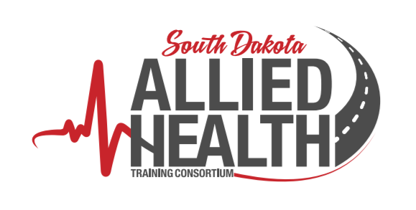
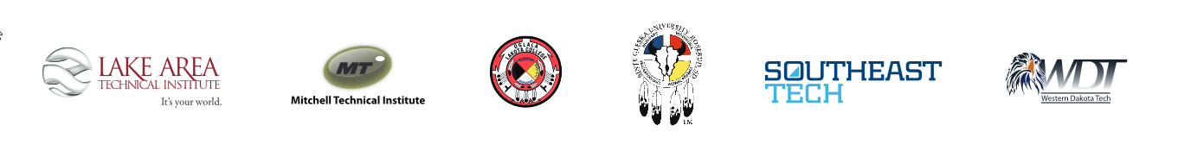
Southeast Tech utilized an advertising and marketing firm to initiate radio and Pandora ads as well as newspaper, billboard signs, and mailing lists. In house marketing and another outside agency helped create flyers, postcards, and brochures.
- Examples of radio marketing include:
SD Allied Health Training Consortium  “Vital Skills: Health Information Services” (Pierre)  :60 RADIO  Voice-over (female):  Build your new career in the “business” side of healthcare, with a skills-based education in Health Information Services. And now – for the first time ever – get your training right here, close to home in Pierre!  Indirect testimonial (female):  I’m organized and good with details… and I’ve always wanted a career in the medical field. Now I’m on track with technical training that really fits my life.  Voice-over continues:  This fall Southeast Tech is going on the road, bringing innovative H-I-S training to Pierre, where students will dig deep into medical records, billing & coding, scheduling, and insurance support. New classes are enrolling now!  Indirect testimonial (female):  . I can’t wait to start my future in healthcare. Getting started is easy… just go to SD Allied Health dot com  Voice-over continues:  Play a vital role in modern medicine with career opportunities in clinics, nursing homes, hospitals and other healthcare facilities. Learn close to home, to build a career close to home, or beyond!  Brought to you by Southeast Tech and the SD Allied Health Training Consortium – Innovate. Educate. Enhance.  Find out more at SD Allied Health dot com. | SD Allied Health Training Consortium  “Make a Difference: Licensed Practical Nurse” (Chamberlain)  :60 RADIO  Voice-over (female):  Make a difference for yourself and for others... with career training as a Licensed Practical Nurse. And now – for the first time ever – get your education right here, close to home in Chamberlain!  Indirect testimonial (female):  I’ve always wanted a career in the medical field. Now I’m on track with a solid program that really fits my life.  Voice-over continues:  This fall Southeast Tech is going on the road, bringing this dynamic hands-on LPN educational experience to Chamberlain. Classes are enrolling now!  Indirect testimonial (male):  For me, getting started was easy… just go to SD Allied Health dot com. Then after graduation, I’ll be a Licensed Practical Nurse.  Voice-over continues:  Training as an LPN prepares you for a rewarding career working in clinics, nursing homes, hospitals and other healthcare facilities. Learn close to home, to build a career close to home, or beyond!  Brought to you by Southeast Tech and the SD Allied Health Training Consortium – Innovate. Educate. Enhance.  Find out more at SD Allied Health dot com.

- Examples of Pandora marketing include:
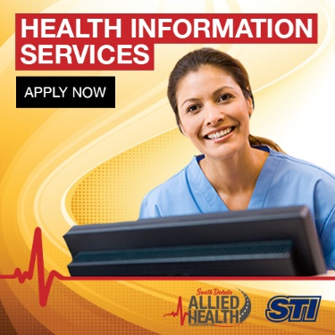 | 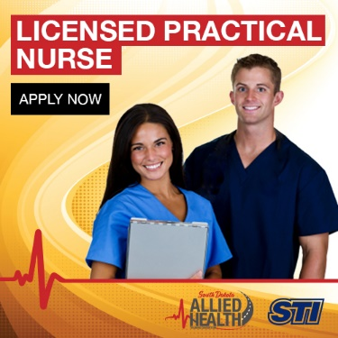
SD Allied Health Training Consortium  “Vital Skills: Health Information Services” (Pierre)  :30 PANDORA  Voice-over (female):  This summer, build your new career in the “business” side of healthcare, with a skills-based education in Health Information Services.  Southeast Tech is bringing innovative hands-on training program to Pierre, where you’ll learn by doing... working with medical records, billing & coding, scheduling, and insurance support.  Classes in Health Information Services begin in August. Enroll today at SD Allied Health dot com!  Brought to you by Southeast Tech and the SD Allied Health Training Consortium.  Click through to SD Allied Health dot com for more details. | SD Allied Health Training Consortium  “Make a Difference: Licensed Practical Nurse” (Chamberlain)  :30 PANDORA  Voice-over (female):  This summer make a difference for yourself and for others... with career training as a Licensed Practical Nurse.  Southeast Tech is bringing this dynamic hands-on LPN program to Chamberlain… where you’ll learn what it takes to succeed working inside clinics, nursing homes, and hospitals.  Become a Licensed Practical Nurse!  Classes begin in August. Enroll today at SD Allied Health dot com!  Brought to you by Southeast Tech and the SD Allied Health Training Consortium.  Click through to SD Allied Health dot com for more details.

- Examples of newspaper and flyer marketing include:
An example of newspaper marketing: | An example of a marketing flyer:
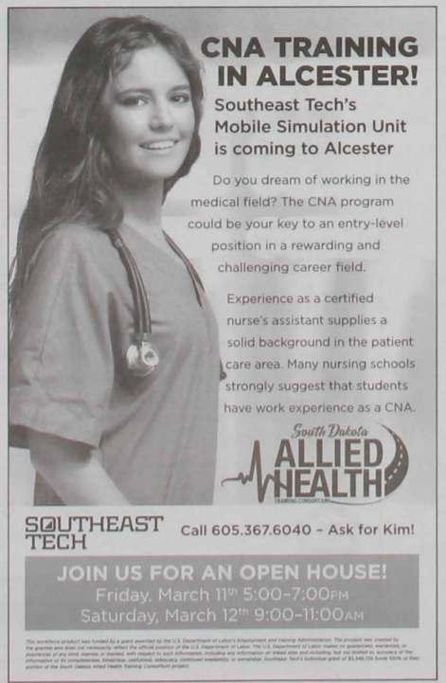 | 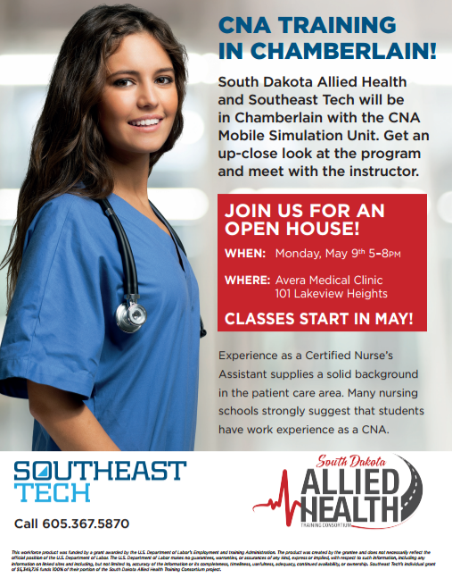

- Examples of billboard marketing include:
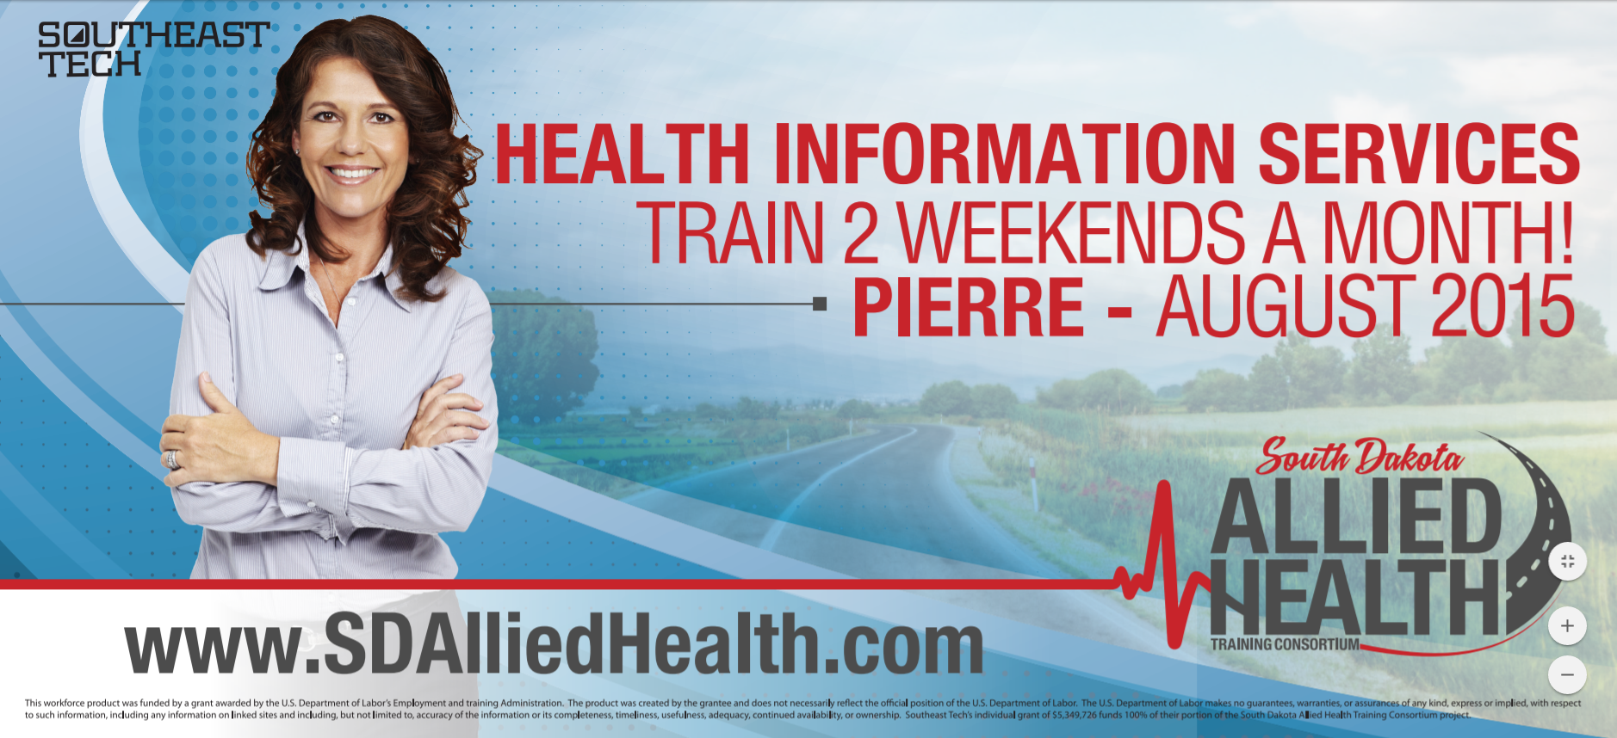
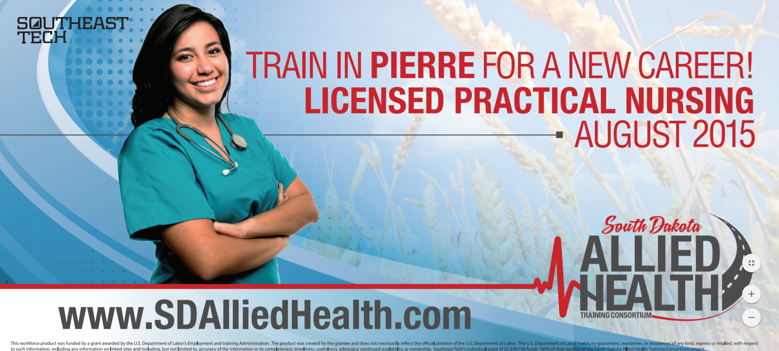

- An example of the inside and outside of a brochure:
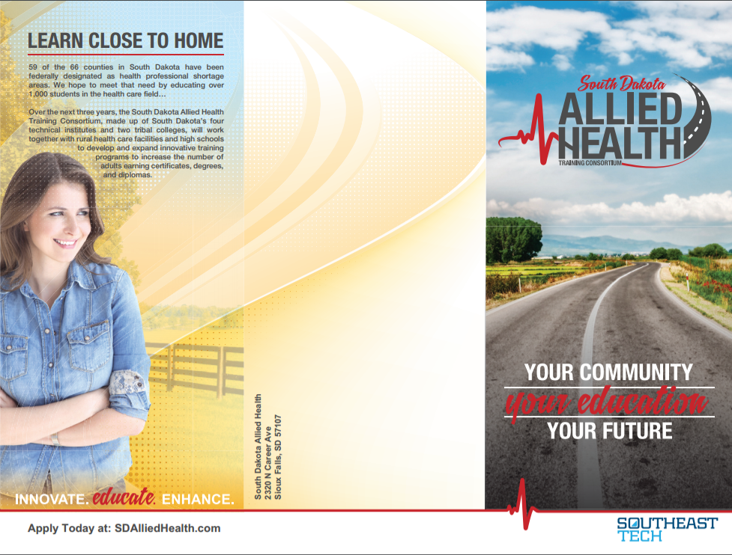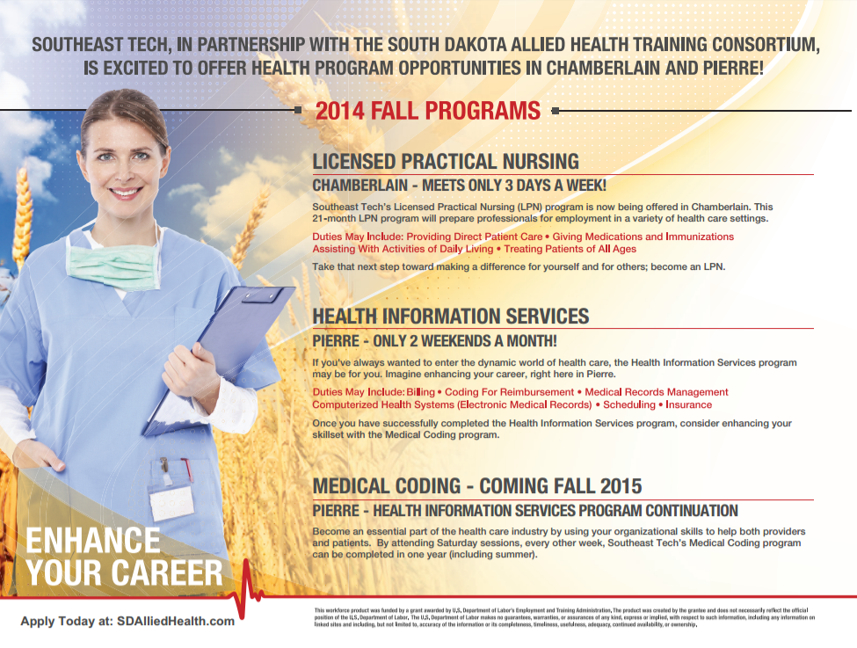

- An example of the front and back of a marketing postcard:
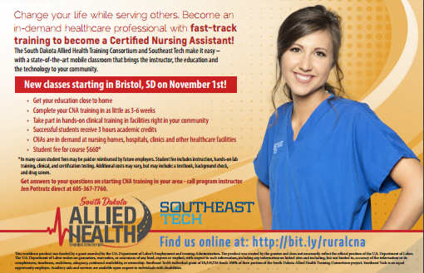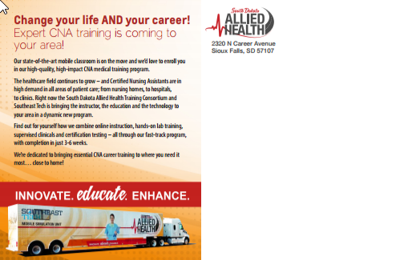

Other forms of advertising included the mobile simulation lab wrap, career camps, open houses, and a website.
- Below are the mobile simulation labs and their wraps:

Participating in various career camps and holding open houses were a good way to get interaction with the community and gain advertising opportunities through word of mouth.
- An example of the career camp participation flyer and of the open house flyer:
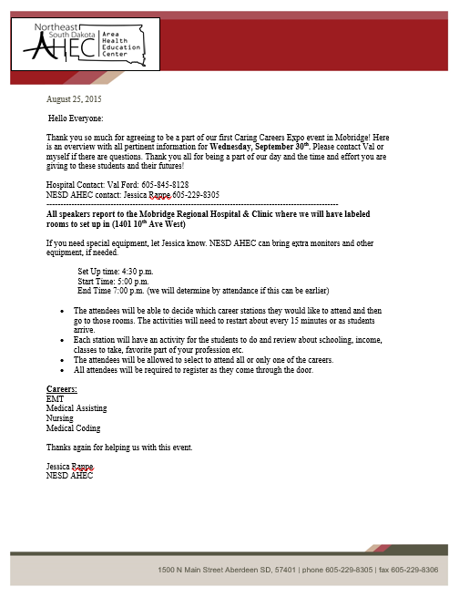 | 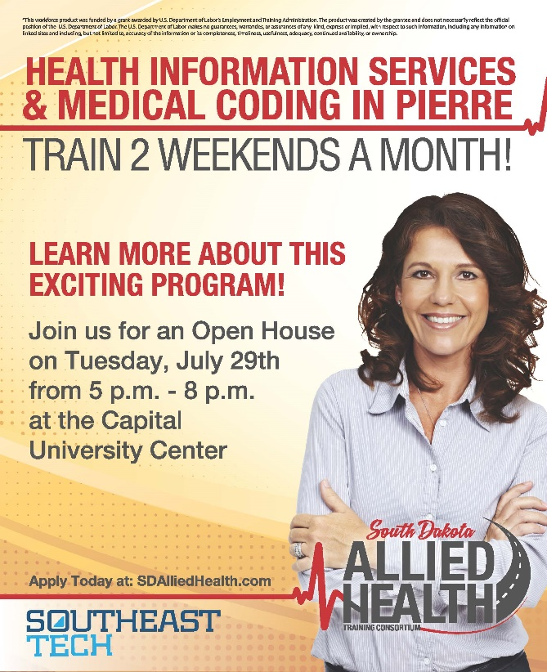

The website is for the SDAHTC in general and consists of:
- Home Page - general information
- Programs Page - links to the various programs offered by the consortium partners
- About Page - information related to the TAACCCT grant and the Rural Healthcare Initiative
- Partners Page - links to each of the consortium partners
- Events page - listings of various events
- Outcomes page - linked to the various projects (Reports, MOOC, Mobile Simulation Lab, and Simulation Classrooms)
- An example of the website marketing:
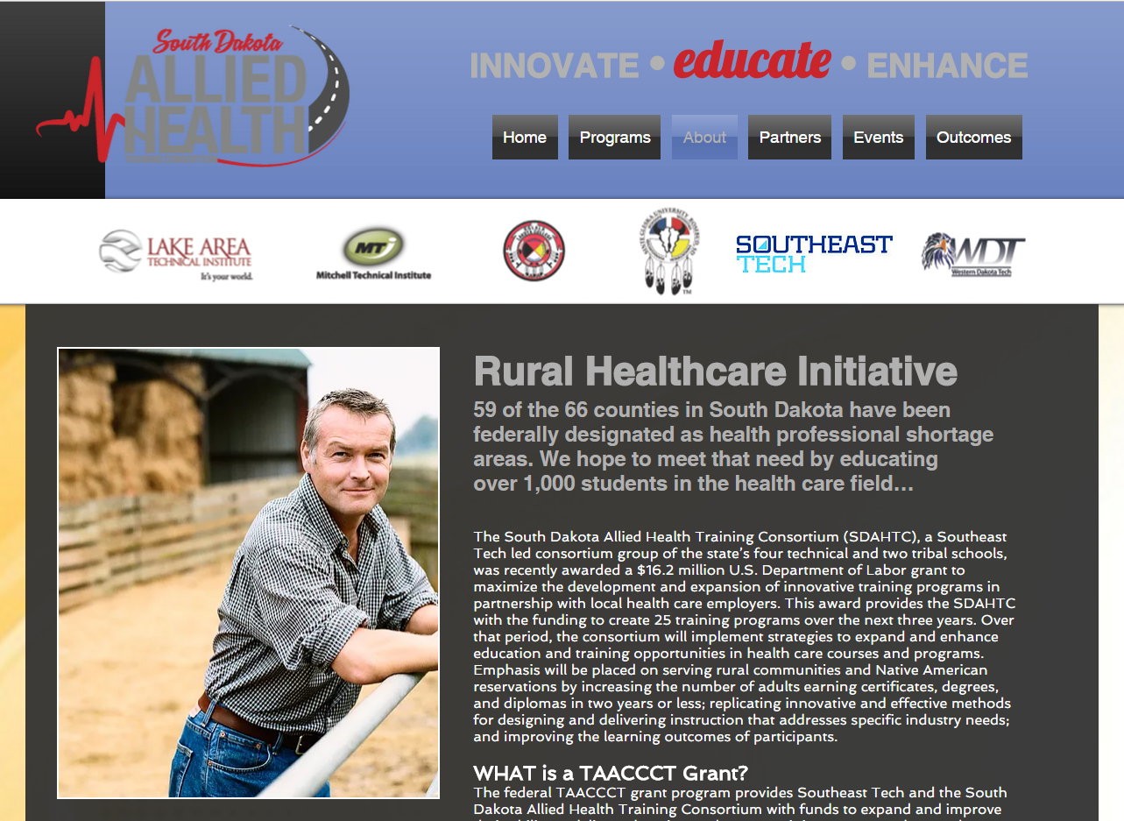
Effectiveness
According to a third party evaluator, survey results indicate the most effective forms of the initial marketing (in terms of students that actually enrolled) were through online information and word of mouth. The CNA marketing efforts gained exposure of the program, but did not add students to the enrollment count. Students served in this program were generally coordinated through an employer relationship or randomly without marketing influence. In the rural communities, especially, physical presence proved to be the most effective at engaging students and employers.
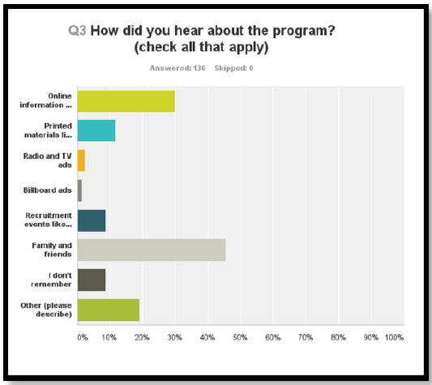
Conclusion
The SDAHTC was successful overall in creating a marketing campaign with various formats to promote healthcare careers and employment opportunities. The effectiveness of this intervention is not entirely clear, but does offer some value to those embarking on a similar project.

